Name: ___________________________________________________________ Period: ________ Due: ______________
The Selection Process:
Directional, Stabilizing and Disruptive Selection

Background: Natural selection acts on distributions of traits and normally produces a range of phenotypes. The “bell curve” to the right illustrates the normal distribution of traits within a population. Environmental conditions can change and a certain phenotype may become an advantage (more “fit”). Natural selection can change the distribution of a trait along 3 paths: directional, stabilizing, or disruptive selection.
1. Explain what the term “fitness” means and how it relates to natural selection.

2. Does natural selection act on genotypes or phenotypes?

3. Natural selection can act only on traits that already exist and it does not create new alleles. How do new alleles occur?

Multiple Choice: Please write the correct answer on the line using a capital letter.
_____ 4. Starlings produce an average of 5 eggs in each clutch. If there are more than five, the parents cannot adequately feed the young. If there are fewer than 5, predators may destroy the entire clutch. This is an example of-
a. disruptive selection b. stabilizing selection
c. directional selection d. none of the above
_____ 5. The occurrence of large or small beak sizes among seed crackers in the absence of medium-sized beaks is an example of-
a. directional selection b. stabilizing selection
c. disruptive selection d. none of the above
____ 6. A scientist measures the circumference of acorns in a population of oak trees and discovers that the most common circumference is 2 cm. What would you expect the most common circumference(s) to be after 10 generations of stabilizing selection?
a. 2 cm b. greater than 2 cm or less than 2 cm
c. greater than 2 cm and less than 2 cm d. can’t tell from the information provided

____ 7. Refer to question #6 above, but this time answer what you would expect after 10 generations of disruptive selection.
a. 2 cm b. greater than 2 cm or less than 2 cm
c. greater than 2 cm and less than 2 cm d. can’t tell from the information provided
_____ 8. Refer to question #6, but this time answer what you would expect after 10 generations of directional selection.
a. 2 cm b. greater than 2 cm or less than 2 cm
c. greater than 2 cm and less than 2 cm d. can’t tell from the information provided

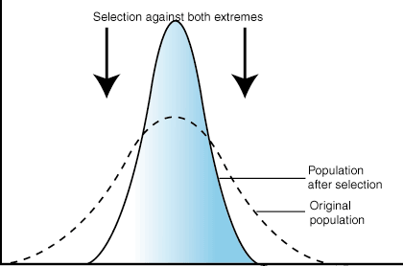
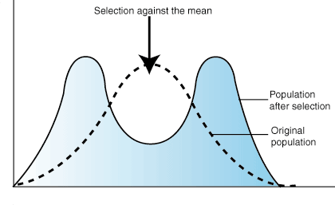
_____ 9-11. Label the 3 types of selection illustrated in the graphs below.
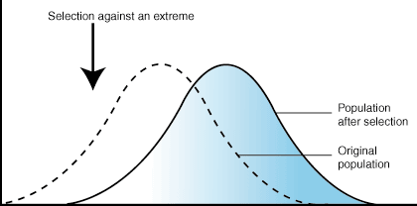

____________________________ ___________________________ __________________________
Selection Scenarios:
Each of the following is an example of stabilizing, disruptive or directional selection. Choose the correct term for each example, explain why it fits that category and sketch the appropriate graph. Your graph should have two lines on it: a dashed red line showing the original population and a solid blue line showing the new type of selection. The Y-axis should be labeled with the word frequency and the X-axis you will label based on the information provided in the example (the first one is done for you as an example).
12. Larger squirrels can carry larger acorns to their burrows, and they outcompete smaller squirrels when acorn supplies are limited.

Type of selection: _______________________________

Explanation:
Frequency

small squirrels large squirrels
Squirrel Size
13. Spotted brown-and-white butterflies blend into lichen-covered tree bark, making it difficult for predators to see them, while solid brown and solid white butterflies are easier to see and get eaten.

Type of selection: _______________________________

Explanation:

14. Panthers with teeth that are too short have difficulty capturing prey, while panthers with teeth that are too long have difficulty chewing their food.

Type of selection: _______________________________

Explanation:

15. In a lake in South Africa, guppies are eaten by the pike fish, and the larger the guppy, the more difficulty it has escaping its pike fish predator.

Type of selection: _______________________________

Explanation:

16. The rocks at the bottom of a Mt. Hood stream are either black or white. Snails that live on these rocks are a range of color from solid black to gray to solid white. A local freshwater fish loves to munch on these snails, but it cannot see the solid black or solid white snails when the snails are on matching rocks. Gray does not blend into either rock color and is much easier to see.

Type of selection: _______________________________

Explanation:

17. Human babies usually do not survive if they are born under 4 pounds because their organs are too small to work properly; they cannot be born if they are too big because the mother would not be able to give birth without dying.

Type of selection: _______________________________
Explanation:

18. The evolution of the peppered moth over the last two hundred years has been studied in detail. Originally, the vast majority of peppered moths had light coloration, which effectively camouflaged them against the light-colored trees and lichens upon which they rested. However, due to widespread pollution during the Industrial Revolution in England, many of the lichens died out, and the trees which peppered moths rested on became blackened by soot, causing most of the light-colored moths to die off due to predation. At the same time, the dark-colored moths flourished because of their ability to hide on the darkened trees. Since then, with improved environmental standards, light-colored peppered moths have again become common, but the dramatic change in the peppered moth’s population has remained a subject of much interest and study. Which type of selection is illustrated by the peppered moths during the Industrial Revolution?

Type of selection: _______________________________

Explanation:

