Plant Unit Partner Test Review

- What are the characteristics of plants? Eukaryotic, multicellular, sexual reproduction and cell wall
- What is present in the cell wall of plant cells? Cellulose
- What adaptations did plants need to live on land? 1.Absorb nutrients from their surroundings using roots 2.Conserve water with their Cuticle (waxy covering) 3.Achieve fertilization without water(pollen and spores)
- How do animals depend on plants? Plants make food and produce oxygen that is essential for animals to survive
- What do plants need to survive? Sunlight, Water & Minerals, Gas Exchange – O₂ & CO_{2,}, and movement of water & nutrients through roots & leaves
- What are the characteristics of non-vascular plants (Bryophytes)? Lack true roots, stems and leaves, small in size (short), Nutrients and water transported by osmosis and diffusion, require water for sexual reproduction
- What are features of vascular plants? Have both a xylem and phloem (vessels), can grow to large sizes. Can be either gymnosperms or angiosperms
- How are Gymnosperms different from Angiosperms? Gymnosperms have cones and needle-like leaves. Angiosperms produce flowers and fruits and they are the most successful plants because of their many adaptations.
- What’s the purpose of the root system? To absorb and transport water and nutrients, anchor the plant in place and prevent erosion
- What is the shoot system? Stems, leaves, branches, flowers (everything but the roots)
- Describe what the xylem conducts and which direction. Carries water up in one direction from roots to shoot system
- Describe what phloem carries and which direction(s). Carries sugar in either direction to wherever it is needed
- How do xylem and phloem differ? They carry different materials and travel in different directions
- What is the purpose of the stomata? Gas exchange and transpiration
- What is transpiration? Water evaporation from the stomata
- How does water move up against gravity in the plant? A vacuum is created in the xylem from transpiration. This vacuum pulls the water up throughout the plant.
- What do guard cells do? Open or close the stomata
- What causes guard cells to be open? And closed? They are open when they are turgid and filled with water. Closed when they are flaccid because water has moved out through osmosis.
- In order for the plant to do photosynthesis, do the guard cells need to be open or closed? Why? Open, because carbon dioxide must come IN and oxygen must come OUT through the stomata.
- Why else do guard cells open or close? To regulate how much water is evaporated through transpiration
- What is the cuticle? Waxy outer covering of the plant on its surfaces
- Do roots have a cuticle layer? Why or why not? No, because they have to be able to absorb water.
- Do roots have chloroplasts? Why or why not? How can you tell? No, because they are underground so they don’t do photosynthesis. They are not green.
- Why are leaves at the bottom of a tree larger than leaves at the top of a tree? Since they are not receiving direct sunlight, they are larger to collect more sunlight.
- Since the leaves are from the same plant and they have the same genes, how can the leaves be different shapes/sizes? Environment affects gene expression.
- What does a plant that has thorns and another plant that produces a toxic substance on its surface have in common? Both are adaptations to protect the plants from predators
- Why is it beneficial for seed plants to not need water to reproduce? It is an adaptation that allows them to reproduce in more types of environments where water may not be as common.
- What are the male and female reproductive parts in plants? Pollen Grain (male gamete) and Ovule (female gamete)
- What is the main reproductive structure in angiosperms and in gymnosperms? Angiosperms-flower, gymnosperms-cone
- Describe the process of pollination. Pollen grains are transferred from the male to female structures in a plant. They can be transferred by wind or animals.
- Describe at least 3 adaptations of desert plants in regards to water. Roots may be shallow and fibrous to catch rainwater before it evaporates; roots may go deep in search for underground water; stems store water; spines provide protection from predators who may want to eat the plant for stored water; thick cuticle to prevent transpiration
- Describe fibrous roots? They are shallow and widely spread
- Why are flowers effective for reproduction? They attract pollinators with their color, smell, and sweet nectar
- What are the male parts of a flower? Stamen (Anther and Filament)
- What’s the function of anther? Produce pollen
- What’s the function of stigma? To give space for pollen to land and stick
- What is phototropism? Movement of plant towards light
- Why does the plant need to move towards the light? So it can maximize the amount of sun it receives to do photosynthesis and make more sugar.
- How do plants do positive phototropism? Auxin hormone is produced more on the side that is away from the sunlight to make it grow more than the side towards the light. That’s why plant bends in the direction of light.
- What is gravitropism? Movement of plants in response to gravity
- Which part of the plant exhibits positive gravitropism and negative gravitropism? Positive gravotropism-roots growing down into the soil with gravity. Negative- shoot system grows against gravity
- What is thigmotropism? Plants responding to touch
- Using figure 1, identify what D and F are. D-Stigma, F-Anther
- Using figure 2 and 3, what are the adaptations for these seeds to be dispersed? Figure 2-dispersed by wind, figure 3-dispersed by animals (hooks onto fur)
Figure 1
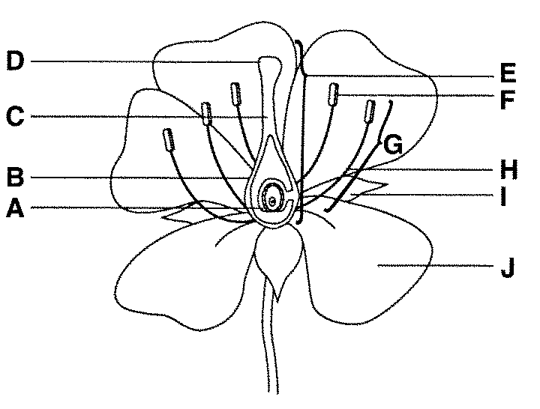
Figure 2
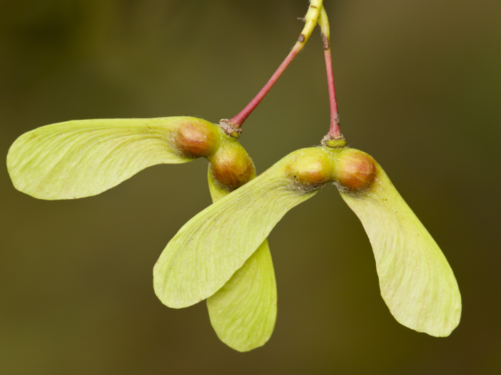
Figure 3
