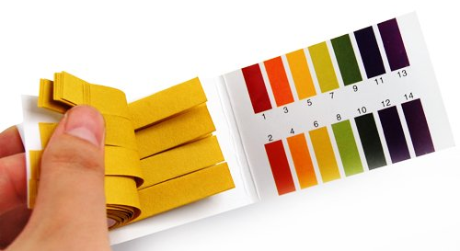
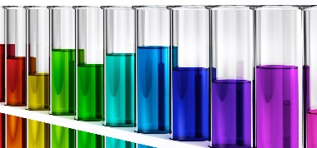
Name: _______________________________________________________________ Date: __________ Period: _______
pH Lab

Measuring pH indicates whether a solution is an acid or a base. A pH less than 7 indicates an acid and a pH more than 7 indicates a base. Acids and bases are chemical opposites but if a solution's pH is 7, it is neutral which means it is neither an acid nor a base and has an equal concentration of hydrogen and hydroxide ions.
Performance Objectives:
- Students will be able to construct a pH scale
- Define pH and understand that it is a relative measurement

Materials:
- 4, 100mL beakers
- Water
- Vinegar
- Soda
- Bleach
- pH indicator paper

Procedures:
- Hypothesize the pH of each of the solutions in the table below. Record your hypothesis for each under the column ‘Hypothetical pH”.
- Dip the tip of a strip of pH indicator paper into each beaker to test the pH of each known solution. Use a different strip of pH indicator paper for each solution. Use the color scale on the indicator paper package to estimate the pH of each solution.
- Record the actual pH of each solution in the table below.

Table 1. pH of solutions
Solutions | Hypothetical pH | pH
Water
Vinegar
Soda
Bleach

- Throw away your used pH strips and complete the post-lab questions.

Post-Lab Questions:
- Label the pH scale below using the ranges for acids, bases, and neutrals. Then label the solutions you tested on the scale below.

___________________________________________________________

0 7 14

pH scale

- Based off the data you collected, predict the pH of the following solutions.

- Tomato juice
- Detergent
- Orange juice
- Milk
- Saliva
- Toothpaste

Acidic | Neutral | Basic

- Explain your reasoning behind classifying the above solutions as acidic, basic or neutral.

