Pre-AP Plants Test Review
Refer to the following questions and vocabulary to help you to review for the test.

- Required vocabulary: transpiration, cohesion, adhesion, hydrogen bonding, vascular tissue, monocots/dicots, stomata, cuticle, guard cells, epidermis, mesophyll, xylem, phloem, osmosis, root hairs, root pressure, auxin, apical meristem, ground tissue, ethylene, gibberellins, cytokinin, and capillary action

- How do ancient plants differ from current plants?
  - What challenges are unique to early land plants?
- What organelle is present in plants that is responsible for cellular respiration?
- What organelle is present in plants that is responsible for photosynthesis?
- Examine the picture below and answer the following questions.
  - Which organism is more closely related to flowering plants?
  - Which organism is more distantly related to flowering plants?
  - Which organism(s) contain vascular tissue?
  - Plants evolved _____ after they evolved seeds

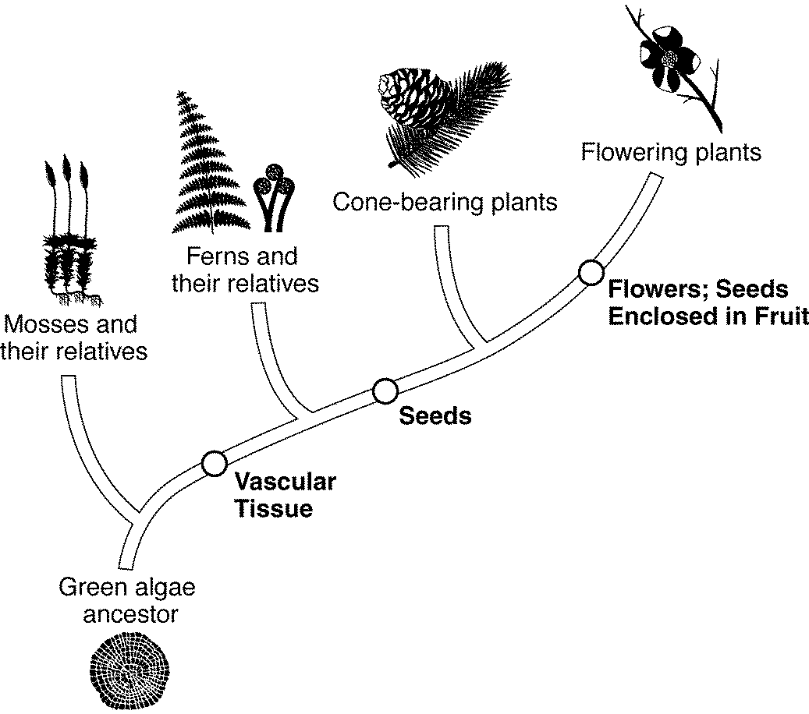

- Where can you find ground tissue in a plant?
- What are the types of root systems?
  - How do they differ?
  - How does this difference serve as an adaptation?
- What is the function of the plant root?
  - What are adaptations that exist that enable them to function effectively?
- Describe the movement of water in a plant.
  - How does hydrogen bonding, cohesion, and adhesion contribute to the movement of water in a plant?
  - How does this process differ from the movement of nutrients?
  - How does root pressure contribute to the movement of water in plants?
  - How does capillary action aid in the movement of water in plants?
- What is vascular tissue?
  - Why is it important?
  - What structures make up the vascular bundle/tissue?
    - What is the function of each?
    - How do they differ?
    - How are they similar?
- What is the direction of transport in each vascular structure?
  - How is each structure specialized for their function?
- What are adaptations of leaves that enable them to be efficient in photosynthesis?
- What is transpiration?
  - How is the leaf adapted to reduce its effects?
- How do differences in the proportion of chloroplasts relate to its ability to photosynthesize?
- Draw a cross-section of a leaf.
  - Label the parts and briefly summarize the function of each structure.
  - What is the role of the cuticle?
  - Which part of the leaf is responsible for photosynthesis?
- What are guard cells?
  - Where are they located?
  - How do these guard cells maintain homeostasis in the plant?
- What are possible explanations for why leaves on a tree differ in size and appearance?
  - How does this difference relate to its genes?
  - What is the effect of the environment on plant genes?
- What are adaptations that enable plants to survive in extreme environments, such as deserts, salty marshes, and anaerobic environments?
- What are tropisms?
  - What are the types of tropisms that exist?
  - What is positive and negative tropism?
  - Explain how they are collectively similar and different.
  - What is the role of auxins in tropisms?
    - Explain how each tropism is beneficial to the plant.
    - The behavior of the Venus flytrap is an example of which?
      - Why?
- How do gymnosperms and angiosperms differ?
  - What adaptations have enabled angiosperms to be more successful?
    - Explain why.
- What are the reproductive structures in gymnosperms and angiosperms?
  - How do they differ?
  - How are they similar?
  - How does this difference provide an evolutionary advantage?
    - Give an example of each.
- What is the function of a flower?
  - For the cross-section of a flower below, label its parts and specify the function of each.
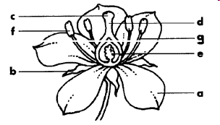

- What adaptations would seeds possess for dispersal by wind?
  - Animal?
    - State 2
  - Or water?
    - State 2
- What is the role of hormones in the plant?
  - What system produces these hormones?
  - Give an example of the effect of hormones and it’s interaction with another system.
  - What is the function of the following hormones: ethylene, gibberellins, and cytokinin?
- Are carrots examples of modified roots, stems, or leaves?
  - Explain why.
  - Are onions examples of modified roots, stems, or leaves?
    - Explain why.
- Nitrogen fixing bacteria have a mutualistic relationship with the plant kingdom.
  - Explain why.
  - How does this role relate to the macromolecules/biomolecules- protein and nucleic acids?
  - What is a mutualistic relationship?
    - How does this differ from commensalism, and parasitism?
- How does primary growth differ from secondary growth?
- What is the difference between monocots and dicots?
  - Give an example of each.
- What is the apical meristem?
  - What is the importance of the apical meristem in plants?
  - What process takes place here?

