Name: __________________________Period: ____Date: ______________ DD:_______ Worth:__________
Pre-AP Biology Fall Semester Exam Review
All answers should be neatly written on separate sheets of paper- please write out the corresponding question numbers in order, next to your answers. Staple all answer sheets to this test review!
Biochemistry
- Differentiate between micromolecule and macromolecule.
- What is a polymer? A monomer?
- Differentiate between organic and inorganic molecule.
- Differentiate between saturated and unsaturated fats.
- Identify the four macromolecules.
- For each macromolecule, identify the (a) monomer/subunit , (b) function and (c) give at least 3 examples of each macromolecule.
- Draw and label a diagram of the monomer of each macromolecule.
- Find a picture in your book showing an enzyme-substrate –complex. Copy and label it.
- What are enzymes?
- What is activation energy? What is the effect of enzymes on activation energy?
- What is/are the relationship between enzyme, temperature and pH?
- Define acids and bases. Where do acids and bases fall on a pH scale?
- What do the following enzymes catalyze? (a) lipase (b) amylase (c) protease
- Explain the effect of an inhibitor drug or a poisonous substance to the function of an enzyme.
- Differentiate between dehydration synthesis and hydrolysis. Which type would help to build cellulose? Which type would aid in the process of digestion?

Cells/Cellular Processes
- How would placing a plant cell into the following solutions affect its size & shape: Hypertonic, Hypotonic, Isotonic
- How would placing an animal cell into the following solutions affect its size & shape: Hypertonic, Hypotonic, Isotonic
- Define diffusion. Does diffusion require energy? Does it go with or against the concentration gradient?
- How are cell volume & cell surface area related? If cell volume increases, what will happen to the cell surface area?
- Draw and label cell membrane be sure to include proteins, phospholipids (phosphate heads and lipid tails), and a carbohydrate chain (identification marker). Indicate which parts are polar, nonpolar, hydrophobic, and hydrophilic.
- Differentiate between hydrophobic and hydrophilic.
- What is the function of proteins found in the cell membrane?
- Define tissue, be sure to include tissues specific function.
- What are the functions of the following organelles?
Ribosome; Nucleus; Mitochondria, Cell membrane; Cell Wall, Chloroplast, lysosome
- Sketch a picture of a graph that shows the following: As the pH of a solution increases the survival rate of cells decreases.

Energy: Photosynthesis & Cellular Respiration
- Explain HOW and WHY the cell cycles the molecule ATPADP, and from ADPATP.
- What molecules are used to “power” the Calvin Cycle?
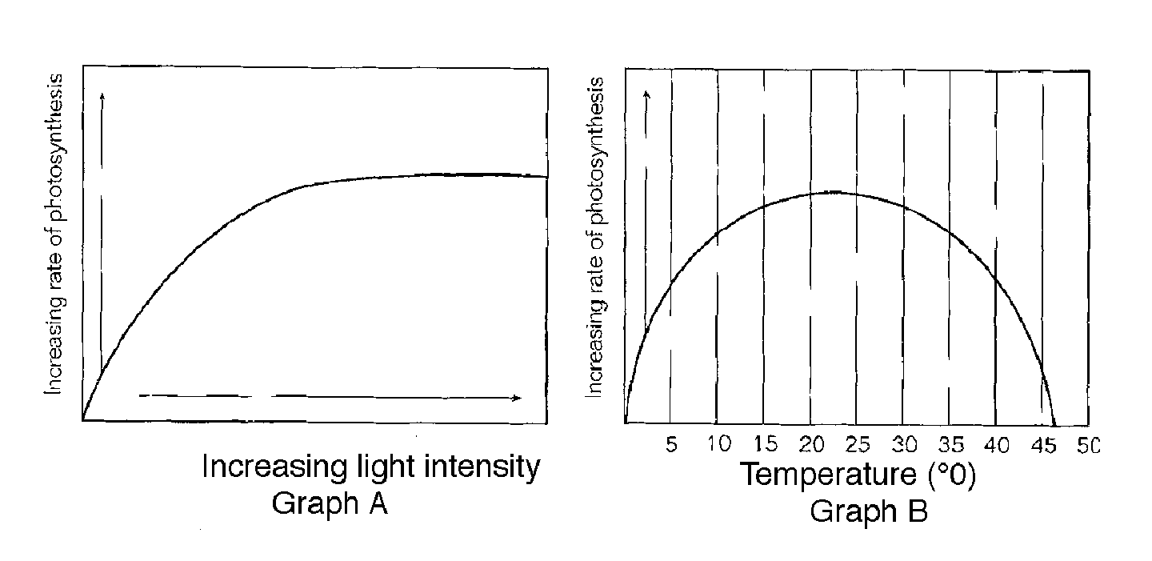
- Exactly where in a chloroplast is the chlorophyll found?

- Using the graphs above- a student is collecting a gas from a plant that is in direct sunlight at 25 degrees----which is the most likely gas that this student is collecting?
- Using the graphs above, explain how the environment is affecting the rate of photosynthesis.

- In the metabolic processes that we have studied- photosynthesis and cellular respiration, explain in which organelles- the electron transport chains would be found.
- Explain how yeast “ferments” grape juice.
- What is the MAIN purpose of cellular respiration? (in all cells)
- During the process of photosynthesis, WHERE (in the cell), and at WHAT TIME of day- does the “splitting of water” occur?
- What are the functions of the guard cells?
- Where is the majority of ATP formed in a eukaryotic cell? Draw a small picture of this organelle.
- Why are 2 molecules of ATP required for glycolysis to occur?

Nucleic Acids: DNA/RNA
- Describe the function of each type of RNA. Which types of RNA are involved in protein synthesis?
- Summarize in one statement the role RNA plays in protein synthesis. Summarize in one statement the role DNA plays in protein synthesis.
- During transcription (in protein synthesis), a section of DNA is copied in what molecule?

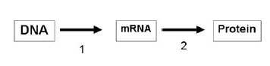
- Explain the diagram below. State which process occurs at number 1 and which occurs at number 2. Give the location that each occurs.

- The following is an mRNA sequence: GUA CUU. What is the DNA segment from which it was transcribed?
- Explain the base pairing rule. What did Erwin Chargaff discover regarding the amount of nitrogenous bases?

- The sequence AGA UCG AGU is changed to ACA UCG AGU. How will this affect the amino acid sequence?
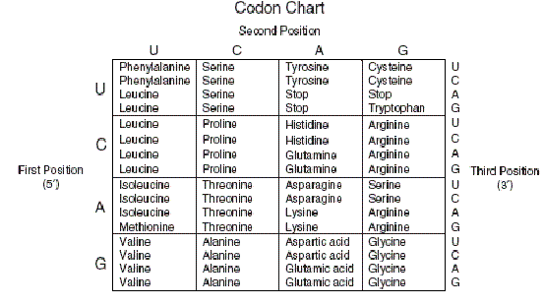

- The order of nitrogenous bases in DNA determines what?
- What is a codon? How many codons would be needed to specify four amino acids?
- Define translation and explain where in the cell it occurs.
- Briefly draw and label a diagram depicting the process of translation.
- Define transcription and explain where in the cell it occurs.
- Briefly draw and label a diagram depicting the process of transcription.
- Define mutation. Using your book and or notes, draw and label the following four types of chromosomal mutations: deletion, duplication, inversion, and translocation.

Cell Division: Mitosis & Meiosis
- How do fertilization and the process of meiosis help to ensure the survival of many species? Hint: think variations
- If a sperm cell’s genetic material contained an irregularity, such as color blindness, could this genetic disorder be passed onto its offspring? Why or why not?
- Are all mutations passed onto the offspring? Why or why not?
- Differentiate between the following pairs of terms: somatic cells & gametes, autosomes & sex chromosomes, mitosis & meiosis, diploid & haploid
- How many chromosomes should a normal human white blood cell contain? Why is this? Do white blood cells have a diploid or haploid set of chromosomes? Are these cells produced by mitosis or meiosis? Why?
- If fruit flies’ eye cells contain 8 chromosomes then how many chromosomes would be in the reproductive cells of the flies?
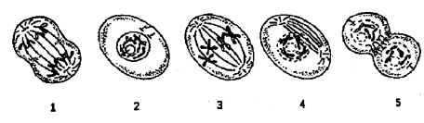

- Using a colored pen or marker- Each numbered picture represents a different stage of the mitosis cell cycle. A. Write the name of each stage under the corresponding picture. B. Place the above events in order as they occur from start to finish: ___________________________________________________________________
- Describe the relationship of the following terms: nucleus, chromosome, DNA, gene, chromatid, centromere, and chromatin.
- Differentiate between asexual and sexual reproduction. What would be an advantage of each type?
- Complete the Mitosis vs. Meiosis Chart below.
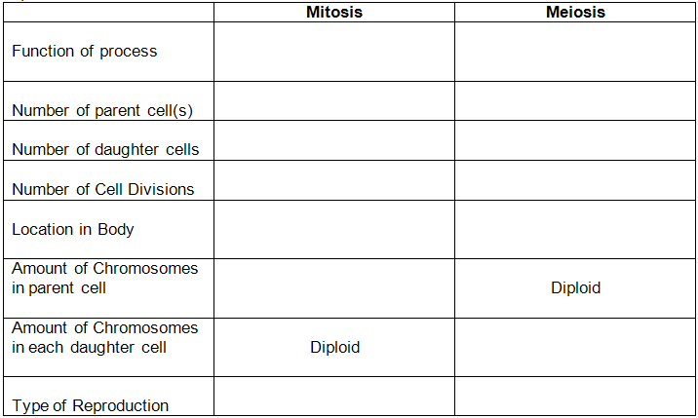

Genetics
- Differentiate between the following terms: chromosome, chromatid, homologous chromosomes, gene, allele, genotype, phenotype, autosomes and sex chromosomes.
- Differentiate between the terms homozygous and heterozygous. Indicate which is purebred and which is hybrid.
- Differentiate between the following patterns of inheritance and include one known genetic disorder associated with each type: dominant, recessive, and sex-linked.
- Indicate whether the following genotypes are Dominant, Recessive OR Sex-linked, then indicate whether they are Homozygous or Heterozygous: A. TT B. Tt C. tt D. X^{h}Y
- How many chromosomes should a healthy female egg contain? How many total chromosomes should a normal person have? What is a karyotype? Where on a karyotype would you expect to find the autosomes? On which pair could you identify the gender? Which two sex chromosomes indicate a male? A female? How many sex chromosomes are in a sperm cell? Why?
- Set up a Punnett Square for the following: A male who is diagnosed with hemophilia has children with a female who is a carrier for hemophilia. What are the genotypes for each parent? What pattern of inheritance does hemophilia fall under? What percentage of the females will be normal? How many females are carries? What percentage of the males have hemophilia? Can males be a carrier for hemophilia? Why or why not?
- Sickle-cell anemia is a recessive genetic disorder that is characterized by the formation of abnormal red blood cells which often results in the inadequate transport of oxygen gas throughout the body. If a normal male has children with a female who is a carrier for Sickle cell what is the ratio of children that are carriers to children that are normal? What is the ratio of children who have Sickle cell anemia to those who are not “infected” with this disease?
- Blood type is characterized by a co-dominant pattern of inheritance. Cross a male who has heterozygous A blood with a female who has AB blood. What is the genotype of each parent? What percentage of the offspring will have blood like the mother? How many offspring will have some type of heterozygous blood? *Could these two parents produce an O blooded child? Why or why not?
- Down syndrome is a genetic disorder caused by the presence of an extra chromosome in the body cells of humans. What type of chromosomal mutation causes result in this disorder? Where on a karyotype would you expect to find the extra chromosome for Down syndrome? Is this trisomy or monosomy?
- Is the karyotype of a male or female? Does this individual suffer from a trisomy
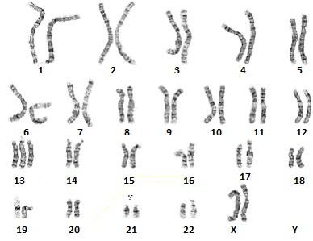
or monosomy disorder? Where is the disorder located?
- Briefly discuss the genetic engineering process of how geneticists use bacterial
plasmids to create human insulin.
- Analyze the following pedigree. Determine if the disorder is autosomal or
sex-linked. Dominant or recessive. What genotype would you assign the son?
