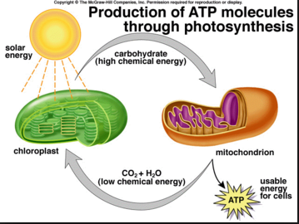

**Cellular Respiration**

* It takes place in the *mitochondria*
* Glucose and Oxygen react to produce carbon dioxide, water and ATP (energy)
* Chemical energy in glucose changes to chemical energy, ATP

**Photosynthesis**

* It takes place in the *chloroplast*
* Carbon Dioxide and water react, using light energy, to produce glucose and oxygen
* Light energy from the sun changes to chemical energy, glucose

**Photosynthesis**

* It takes place in the *chloroplast*
* Carbon Dioxide and water react, using light energy, to produce glucose and oxygen
* Light energy from the sun changes to chemical energy, glucose

**Cellular Respiration**

* It takes place in the *mitochondria*
* Glucose and Oxygen react to produce carbon dioxide, water and ATP (energy)
* Chemical energy in glucose changes to chemical energy, ATP