Name: _______________________________________________________________ Date: __________ Period: _______
Murder Meal Lab
The Case
A murder has occurred in the town of San Antonio, TX. As top-notch biology students at Johnson High School, you have been asked to assist in the investigation of this most unfortunate incident. Central to identifying the individual who committed this crime is establishing where the victim was the day of the crime so that detectives can question the individuals with whom the victim came into contact. An autopsy was performed on the victim and has revealed that the victim ate just prior to the time of death. Upon questioning the victim’s friends and family, detectives working the case have learned that the victim enjoyed eating at the following places.

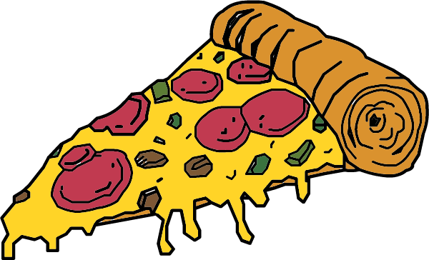
Grimaldi’s Pizzeria
The victim would never eat thin crust pizza from anywhere else! The victim would typically order a pizza with sausage, pepperoni, and bacon.
What macromolecules would you expect to find in the stomach contents of the victim if the victim’s final meal was eaten here?
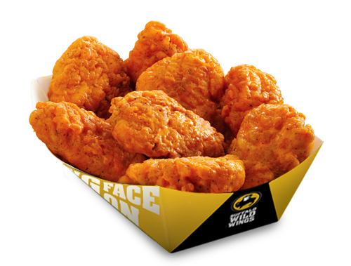
Buffalo Wild Wings
The victim would hang out here to watch sporting events while feasting on Blazin’ wings and celery.
What macromolecules would you expect to find in the stomach contents of the victim if the victim’s final meal was eaten here?

Olive Garden
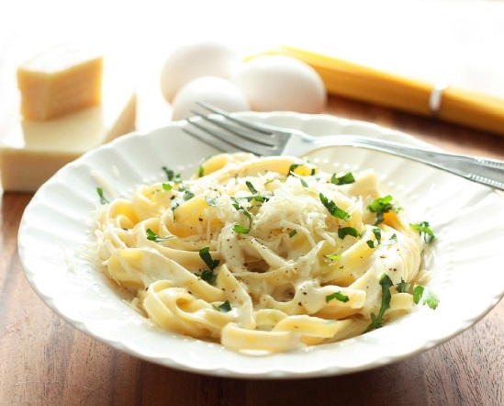
The victim loved to go here for a night of bread, fettuccine alfredo and a slice of yummy cheesecake!
What macromolecules would you expect to find in the stomach contents of the victim if the victim’s final meal was eaten here?
***The forensic pathologist has removed the contents of the victim’s stomach for you to analyze in order to determine where the victim had their last meal.***

Procedure:
Carbohydrate Test
Glucose Test
- Place 5 ml of the stomach contents into 1 test tube.
- Add 10 drops of Benedict’s solution. When heated, Benedict’s solution will change color from blue to green, yellow, orange, or red in the presence of a simple sugar (monosaccharide).
- Gently shake the contents of the test tube. *Caution: use extreme caution when using Benedict’s solution to avoid staining hands or clothing.*
- Place the test tube in the beaker of boiling water and boil for 3-5 minutes. *Use test tube clamps to remove the hot test tube from the hot-water bath and place it back in the test-tube rack.*
- Observe any color change. Record it in your chart.
- After it is cooled, wash the test tube thoroughly.
Starch Test
- Place 5 ml of the stomach contents into 1 test tube.
- Add 5 drops of Lugol’s iodine solution. Iodine will change color from yellow-brown to blue-black in the presence of starch.
- Gently shake the content of the test tube. *Caution: use extreme caution when using iodine as it is poisonous and can stain hands and clothing.*
- Observe any color change. Record it in your chart.
- Wash test tube thoroughly.
Lipid Test
- Place 5 ml of the stomach contents into 1 test tube.
- Add 5 drops of Sudan III stain to the test tube. Sudan III stain will dissolve in lipids and stain them red.
- Gently shake the contents of the test tube. *Caution: use extreme care when handling Sudan III to avoid staining hands and clothing*
- Record any color changes.
- Wash the test tube thoroughly.

Protein Test
- Place 5 ml of the stomach contents into 1 test tube.
- Add 10 drops of Biuret solution to the test tube. *Caution: Biuret reagent contains sodium hydroxide (OH-), a strong base. If you splash any reagent on yourself, wash it off immediately with water and call your for assistance.
- Gently shake the contents of the test tube. Biuret reagent changes color from yellow to blue-violet in the presence of protein.
- Observe any color change. Record it in your chart.
- Wash test tube thoroughly.

Results: Describe and record your results.
Food Substance | Reagent Used | Color after Test | Positive or Negative Test Result? (+ or -)
Sugar (5ml) | Benedict’s solution
Starch (5ml) | Lugol’s Iodine solution
Lipid (5ml) | Sudan III stain
Protein (5ml) | Biuret solution

Post-Lab Questions:
- Report your findings in discussion format. Open the discussion with a statement regarding which restaurant the victim visited for his last meal. Provide a logical explanation, using data from the tests on the stomach contents, that explains how you reached that conclusion.

- How are monomers and polymers different?

- What are the monomers and polymers of the following?
Biomolecule | Monomer | Polymer
Carbohydrates
Lipids | _______________________&______________________
Proteins

- Circle all of the following compounds that would be classified as carbohydrates.

  - Amino acids
  - Glucose
  - Glycogen
  - Enzymes
  - Fructose
  - Hemoglobin
  - Chitin
  - Starch

- Which portion of the victim’s stomach contents provided each of the following macromolecules?
  - Lipids-
  - Proteins-
  - Glucose-
  - Starch-

- Predict which macromolecules should be present in the following food substances and indicate which test reagent you would use in order to detect the presence of that macromolecule.

Food Substance | Predicted Macromolecule | Reagent to be used
Potato juice
Crackers
Egg whites
Honey

