Name: ___________________________________________________ Date: _____________ Period: ________
Mitosis Video Questions
1. The healing of your wounds, growing of your nails and the fact that you have grown quite a bit since you were 5 years old are all attributed to what process?
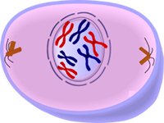
2. Why is it important for cells to divide? Give 2 reasons.

3. Mitosis is only carried out by what type of cells? What is another name for these types of cells?

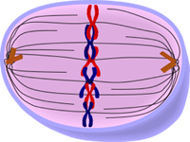
4. What is significant about the cells created in mitosis?

5. Are your cells dividing all the time? Why or why not?

6. What is uncontrolled cell growth called?

7. What are cells doing during interphase? List 3 things.
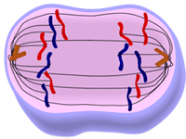

8. What percent of time are cells in the following phases?
interphase-
mitosis-
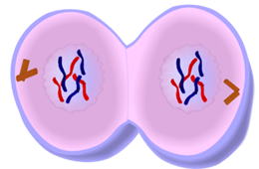
9. Do all cells in your body have identical DNA? DNA is organized into units called what?

10. In which phase do cells duplicate their DNA? This is also the phase that cells spend most of their time in.

11. What is visible during prophase?

12. What is the significance of metaphase? Use the word chromosomes in your answer.

