Name: ____________________________________________________________________ Date: ________ Period: ____
Levels of Biological Organization
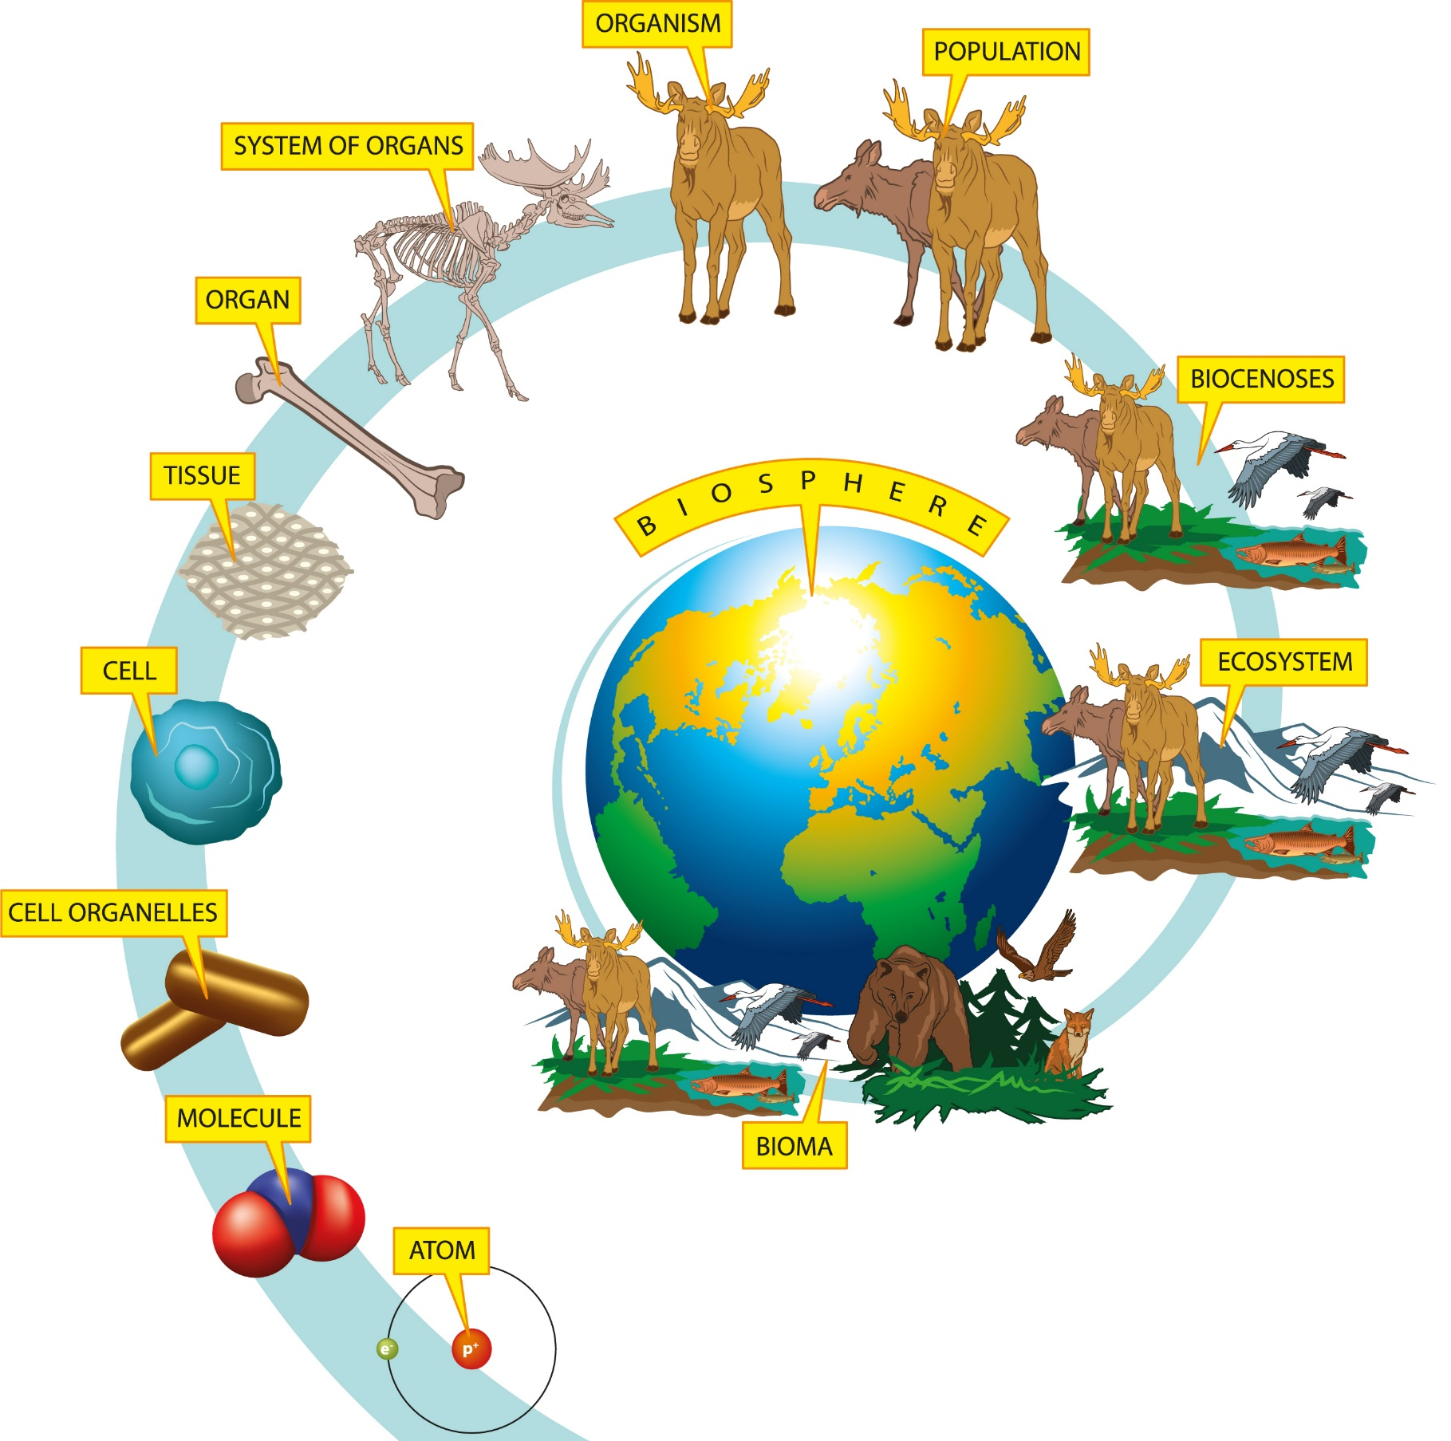
ORGANISM
POPULATION
ORGAN SYSTEMS
ORGANS
COMMUNITY
TISSUES
BIOSPHERE
ECOSYSTEM
CELLS

ORGANELLES

MOLECULES
ATOMS
BIOME

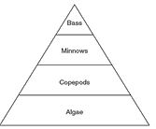
Levels of Organization Questions:
- The organisms in the food pyramid to the right most likely represent

  - An ecosystem
  - A community
  - A biome
  - An organism

- Which sequence shows the decreasing complexity of organization?
  - Community, biome, ecosystem, organism
  - Organism, community, biosphere, ecosystem
  - Biome, community, population, organism
  - Population, community, ecosystem, biome

Living Parts of the Ecosystem | Non-Living Parts of the Ecosystem
- Categorize the parts of the ecosystem on the front page into living and non-living things.

- Using your word roots list, define the following words:
  - biotic-
  - abiotic-
- Examine the picture to the right. Which of following is an example of an abiotic factor?
  - sunlight
  - tree
  - deer
  - eagle

