Evolution Practice Exam Unit 6
Please do not write on this handout.
- Which species is most likely to survive changing environmental conditions?
  - a species that reproduces sexually
  - a species that has a limited life span
  - a species that has few variations
  - a species that competes with similar species

2. Which statement describing a cause of extinction includes the other three?
- Members of the extinct species were unable to conceal their presence by camouflage
(2) Members of the extinct species were too slow to escape from predators.
(3) Members of the extinct species lacked adaptations essential for survival.
(4) Members of the extinct species were unable to compete for food.

3. Even though the environment changes, a population that occupies a given geographic area will most likely continue to be found in this area if the
(1) members of the population exceed the carrying capacity
(2) members of the population decrease in number
(3) population passes on those genes that result in favorable adaptations
(4) variations in the population decrease over time

4. Which statement is not part of the concept of natural selection?
(1) More individuals are produced than will survive.
(2) Individuals that possess the most favorable variations will have the best chance of reproducing.
(3) Genes of an individual adapt to a changing environment.
(4) Variation occurs among individuals in a population.

- Darwin's theory of evolution is based on
  - transmission of acquired characteristics
  - spontaneous genetic mutations
  - variation and natural selection
  - use and disuse

Base your answers to questions 6 through 10 on the information below and on your knowledge of biology.

Color in peppered moths is controlled by genes. A light-colored variety and a dark-colored variety of a peppered moth species exist in nature. The moths often rest on tree trunks, and several different species of birds are predators of this moth.
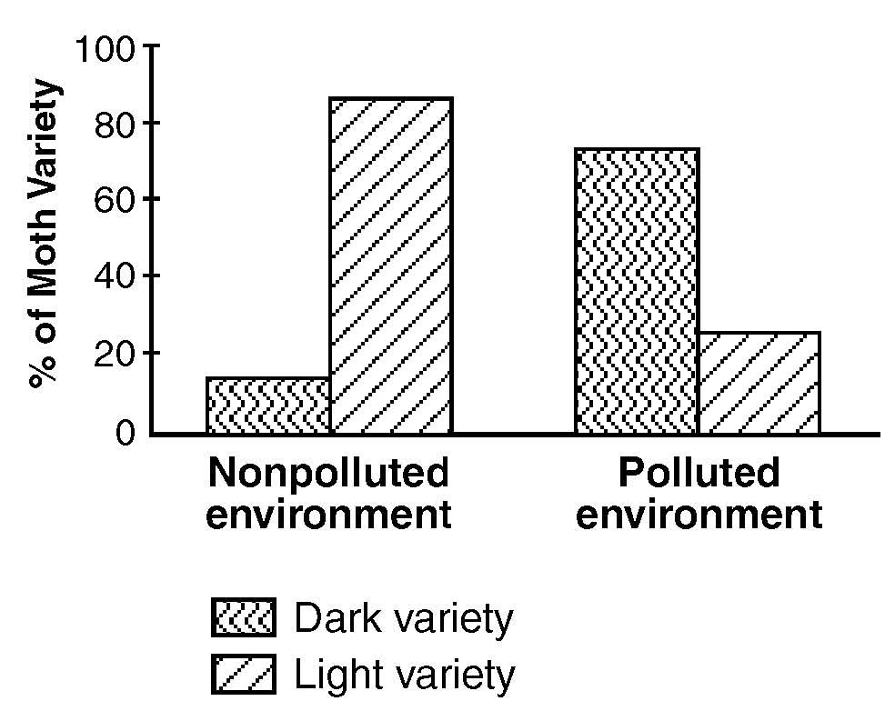
Before industrialization in England, the light-colored variety was much more abundant than the dark-colored variety and evidence indicates that many tree trunks at that time were covered with light colored lichens. Later, industrialization developed and brought pollution, which killed the lichens, leaving the tree trunks covered with dark-colored soot. The results of a study made in England are shown below.

6. State one possible reason that the light-colored variety was not completely eliminated from the polluted environment.

7. During the past few decades, air pollution control laws in many areas of England greatly limited the soot and other air pollutants coming from the burning of coal. State one way the decrease in soot and other air pollutants will most likely influence the survival of the light-colored variety of peppered moth.

8. State one possible reason that a larger number of the dark-colored variety were present in the polluted environment.

9. Which conclusion can best be drawn from the information given?
- The trait for light coloration better suits the peppered moth for survival in polluted environments.
- The trait for dark coloration better suits the peppered moth for survival in non-polluted environments.
- A given trait may be a favorable adaptation in one environment, but not in another environment.
- The variation of color in the peppered moth has no influence on survival of the moth.

10. The percentage of light-colored moths in the polluted environment was closest
(1) 42 (2) 24 (3) 76 (4) 16

Base your answers to questions 11 through 13 on the diagram below and on your knowledge of biology. Letters A through L represent different species of organisms. The arrows represent long periods of geologic time.

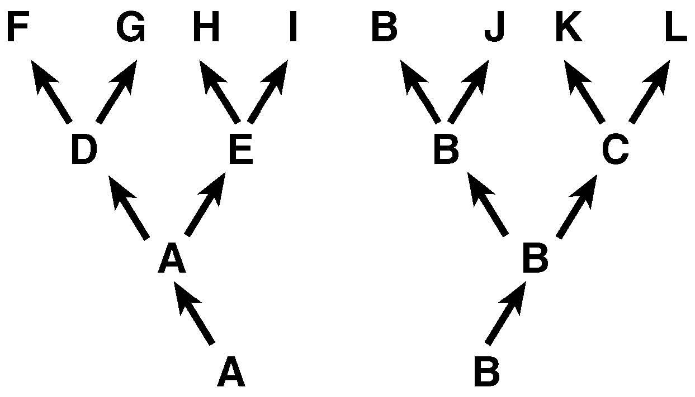

11. Which two species are the most closely related?
(1) G and L (2) F and G (3) J and L (4) F and H

12. Which species was best adapted to changes that occurred in its environment over the longest period of time?
(1) A (2)B (3)C (4) J

13. Which two species would most likely show the greatest similarity of DNA and proteins?
(1) F and L (2) G and I (3) B and J (4) J and K

14. Scientists compared fossil remains of a species that lived 5,000 years ago with members of the same species living today. Scientists concluded that this species had changed very little over the entire time period. Which statement best accounts for this lack of change?

- The environment changed significantly and those offspring without favorable characteristics died.
- The environment did not change significantly and those offspring expressing new characteristics survived their natural enemies.
- The environment changed significantly, but the species had no natural enemies for a long period of time.
- The environment did not change significantly and those offspring expressing new characteristics did not survive.

15. The dichotomous key shown below can be used to identify birds W, X, Y, and Z.

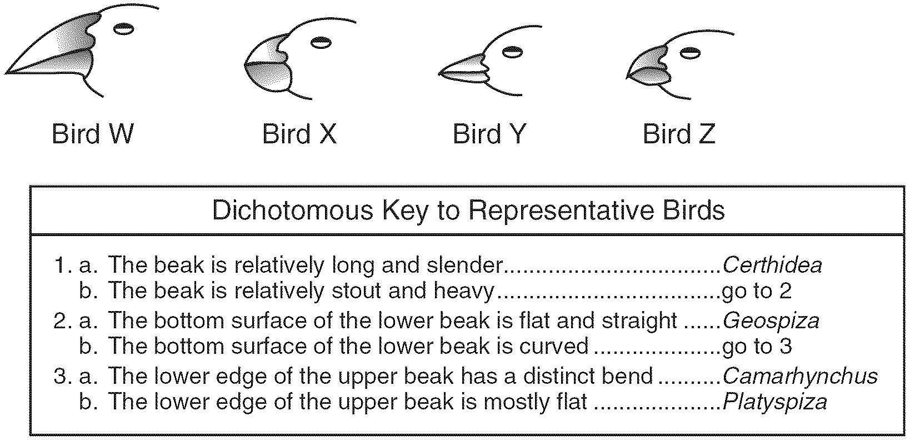
Bird X is most likely
- Platyspiza (2) Camarhynchus (3) Certhidea (4) Geospiza

16. Similarity in the skeletal structures of whales, bats, and humans leads to the conclusion that they
(1) have the same chromosome number (2) belong to the same order of mammals
(3) originated in the same environment
(4)descended from a common ancestor

17. If mitotic cell division is the only way a particular species of single-celled organism can reproduce, it is most likely that
- this species belongs to the animal kingdom
- mutations can not occur in this species
- the number of organisms of this species in an area will remain constant
- the rate of evolution in this species is slower than in one that reproduces sexually

18. The Florida panther, a member of the cat family, has a population of fewer than 100 individuals and has limited genetic variation. Which inference based on this information is valid?
- These animals are easily able to adapt to the environment.
- Over time, these animals will become less likely to survive in a changing environment.
- Over time, these animals will become more likely to be resistant to disease.
- These animals will begin to evolve rapidly.

Base your answers to questions 19 and 20 on the passage below and on your knowledge of biology.

When Charles Darwin traveled to the Galapagos Islands, he observed 14 distinct varieties of finches on the islands. Darwin also observed that each finch variety ate a different type of food and lived in a slightly different habitat from the other finches. Darwin concluded that the finches all shared a common ancestor but had developed different beak structures.

19. The different beak structures mentioned in the last sentence were most likely influenced by
(1) abnormal mitotic cell division
(2) characteristics that are acquired during the bird’s lifetime
(3) environmental conditions identical to those of the common ancestor
(4) selection for favorable variations

20. The 14 varieties of finches are most likely the result of
(1) biological evolution (3) lack of competition
(2) asexual reproduction (4) absence of biodiversity

21. When penicillin was first introduced, it was very effective in destroying most of the bacteria that cause gonorrhea. Today, certain varieties of this bacterium are resistant to penicillin. Which statement best explains the appearance of these resistant varieties?

(1) Penicillin killed the susceptible bacteria, while naturally resistant varieties survived and reproduced.
(2) Penicillin stimulated the production of antigens in the resistant bacteria.
(3) Penicillin used today is not as strong as the penicillin used when it was first introduced.
(4) Penicillin stimulated the bacteria to become resistant, and this resistance was passed to the offspring.

22. Differences between the members of a population will most likely be passed to future generations if they are
(1) due to genetic changes and result in favorable variations
(2) not due to genetic changes and result in favorable variations
(3) not due to genetic changes and result in unfavorable variations
(4) due to genetic changes and result in unfavorable variations

Base your answers to questions 23 and 24 on the information below and on your knowledge of biology.

Based on their analysis of the differences in amino acid sequences of one kind of protein, scientists prepared the evolutionary tree shown below.

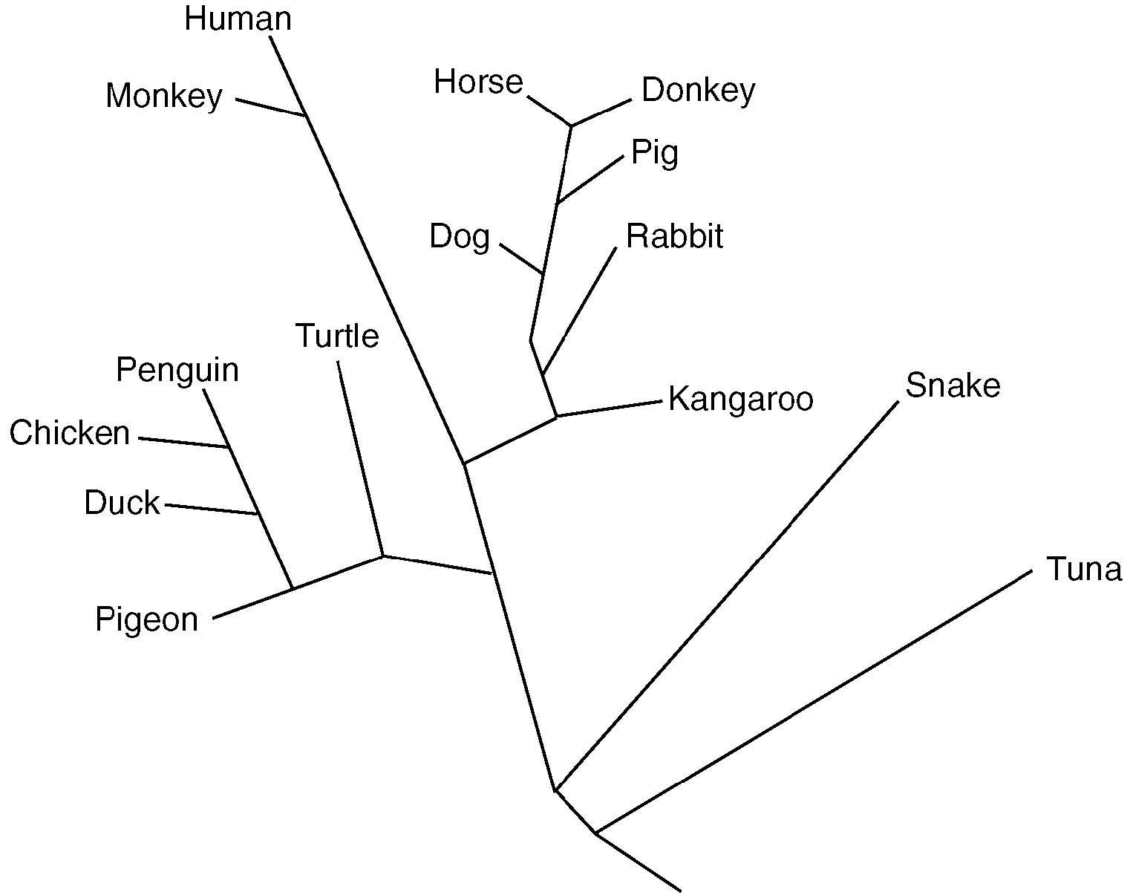
23. According to this diagram, is the pig more closely related to the dog or the kangaroo? Justify your answer.

24. According to this diagram, the DNA of which pair of organisms would show the greatest similarity?
(1) horse and donkey (2) turtle and rabbit (3) penguin and turtle (4) snake and tuna

25. Which statement represents the major concept of the biological theory of evolution?
(1) Every location on Earth’s surface has its own unique group of organisms.
(2) Every period of time in Earth’s history has its own group of organisms.
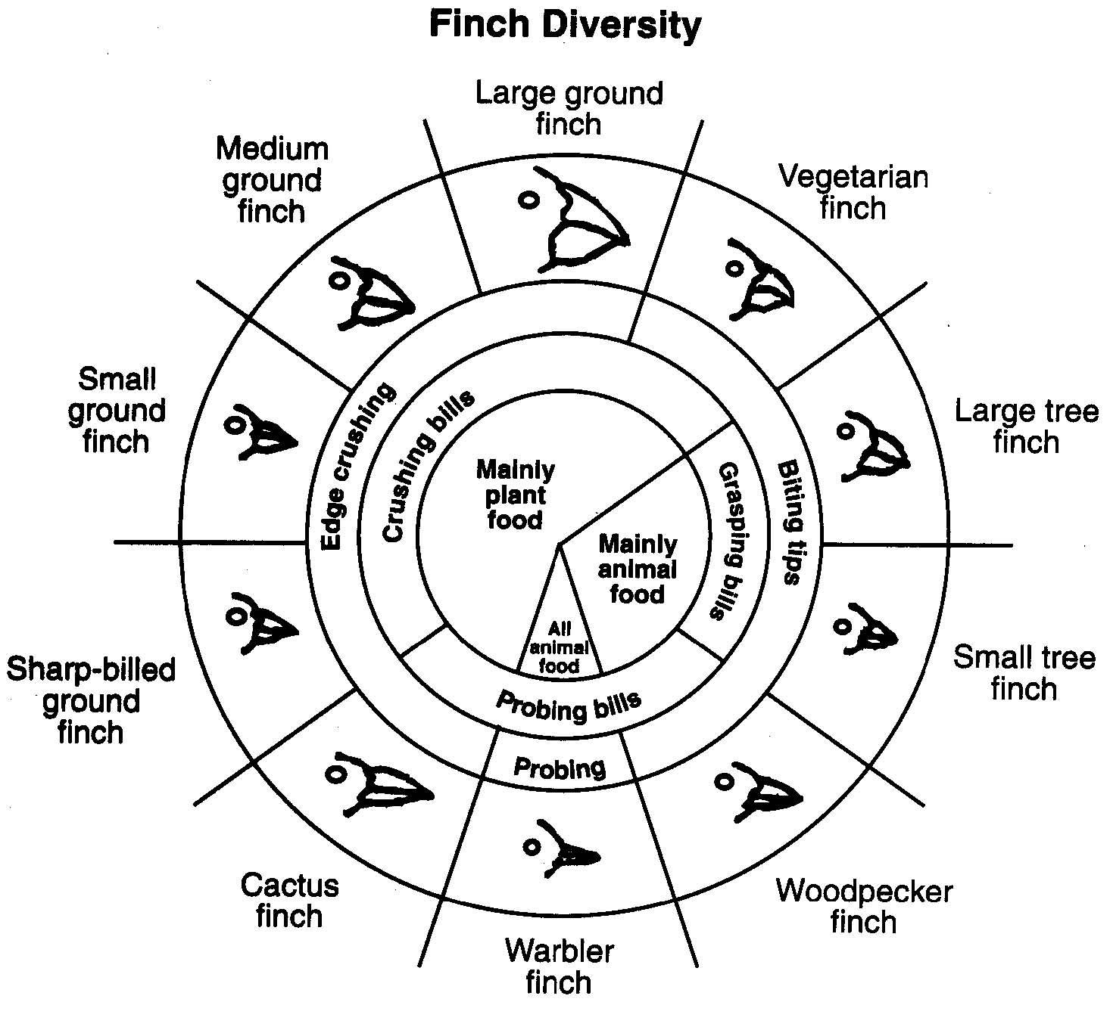(3) Present-day organisms on Earth developed from earlier, distinctly different organisms.
(4) A new species moves into a habitat when another species becomes extinct.

26. After the Industrial Revolution, dark-colored moths outnumbered light-colored moths in certain regions of England. Within the past 40 years, factories in these regions have added scrubbers and air purifiers to their smokestacks, and the relative number of light-colored moths has increased. The probable reason for this increase is that
(1) the environment favored the survival of light colored moths over dark-colored moths
(2) dark-colored moths turned light because they needed to survive
(3) over population occurred and most of the light-colored moths died, leaving only dark colored moths to reproduce
(4) the allele for light color became dominant over the allele for dark color
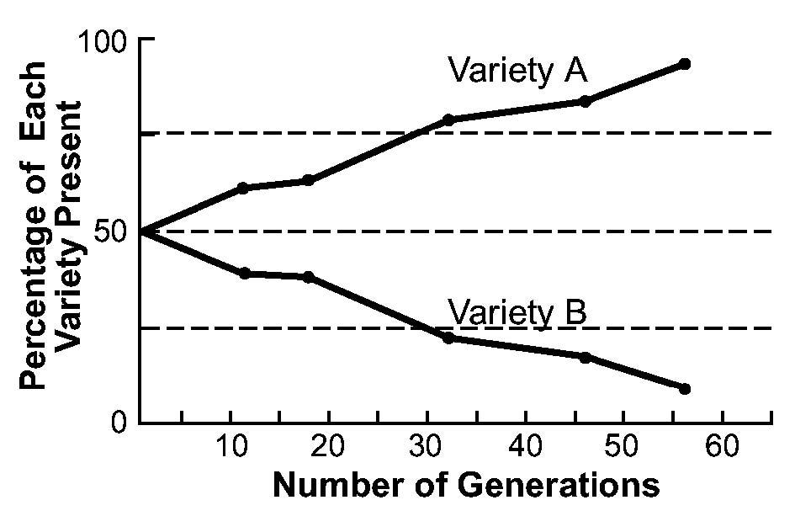
27. What is the most probable reason for the increase in the percentage of variety A in the population of the species shown in the graph below?

(1) There is no chance for variety A to mate with variety B.
(2) Variety A has some adaptive advantage that variety B does not have.
(3) Variety A is less fit to survive than variety B is.
(4) There is no genetic difference between variety A and variety B.

28. The diagrams below show the bones in the fore limbs of three different organisms.

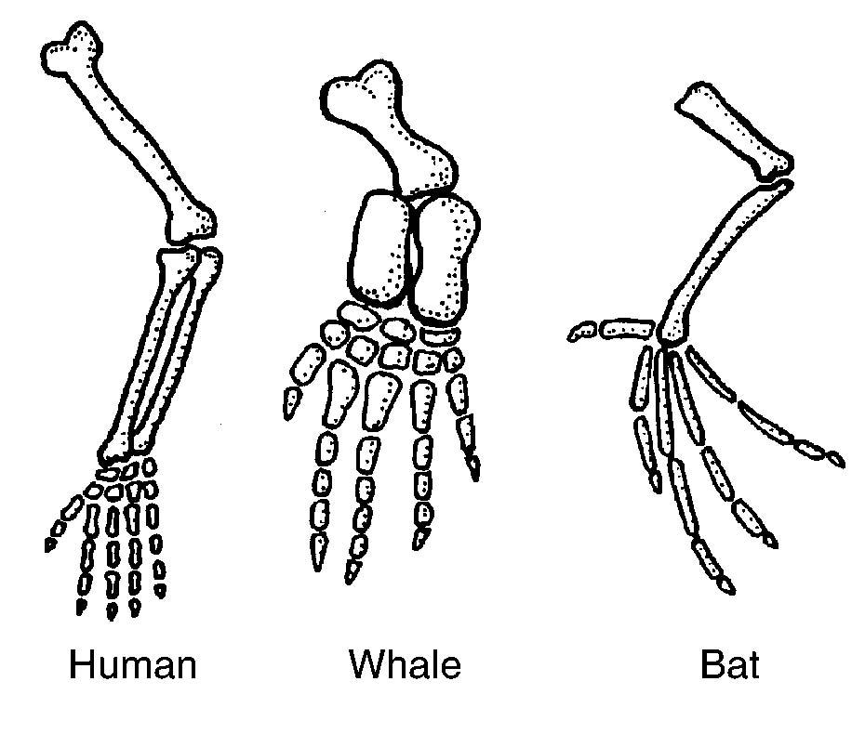
Differences in the bone arrangements support the hypothesis that these organisms
(1) are members of the same species
(2) have adaptations to survive in different environments
(3) may have descended from the same ancestor
(4) all contain the same genetic information

29. According to the theory of natural selection, why are some individuals more likely than others to survive and reproduce?
(1) Some individuals pass on to their offspring new characteristics they have acquired during their lifetimes.
(2) Some individuals are better adapted to exist in their environment than others are.
(3) Some individuals do not pass on to their offspring new characteristics they have acquired during their lifetimes.
(4) Some individuals tend to produce fewer offspring than others in the same environment.

Base your answer to the following question on the finch diversity chart below, which contains information concerning the finches found on the Galapagos Islands.

30. Identify one bird that would most likely compete for food with the large tree finch. Support your answer.

31. State what could happen to a species in a changing environment if the members of that species do not express any
genetic variations.

32. Base your answer to the following question on the information provided and on your knowledge of biology.

A student observed the physical characteristics of seven organisms and prepared the data table below. One of the student's classmates sorted the seven organisms into two groups as shown below.
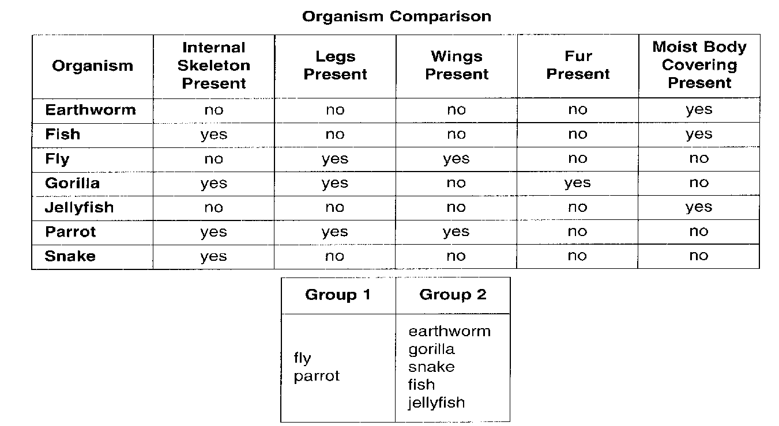
Another classmate suggested that the earthworm is more closely related to the jellyfish than to any other organism observed. State the evidence from the data table that the student most likely used for this suggested relationship.

33. A hawk has a genetic trait that gives it much better eyesight than other hawks of the same species in the same area. Explain how this could lead to evolutionary change within this species of hawk over a long period of time. In your answer, be sure to include an explanation of:
(1) competition within the hawk population
(2) survival of various individuals in the population
(3) how the frequency of the better-eyesight trait would be expected to change over time within the population
(4) what would most likely happen to the hawks having the better-eyesight trait if they also had unusually weak wing muscles

