Name: __________________________________________________ Date: __________________ Period: ________

Genetic Engineering Application

**Karyotyping**

Karyotype**:** picture of chromosomes taken during metaphase of mitosis and grouped

* *Mono*somy-missing a chromosome
* *Tri*somy- having an extra chromosome

Genetic abnormalitiescan be detected by looking at a karyotype of a person’s chromosomes.

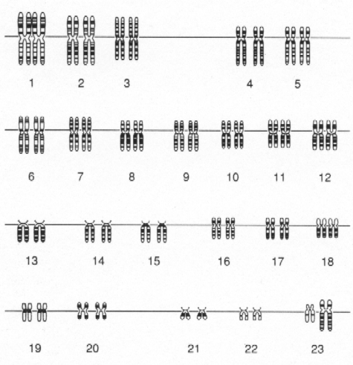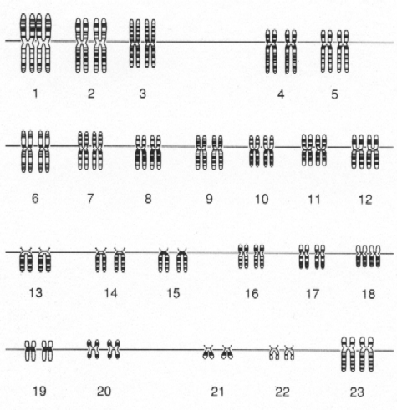 **Normal Female Karyotype Normal Male Karyotype**

**Chromosome Pair 23: Sex Chromosomes**

X chromosome- larger in size

Y chromosome- smaller in size

Two X’s = female

XY = male

(note the smaller Y chromosome)

Analyze the following karyotypes and identify their abnormalities. Circle where the abnormality occurred.

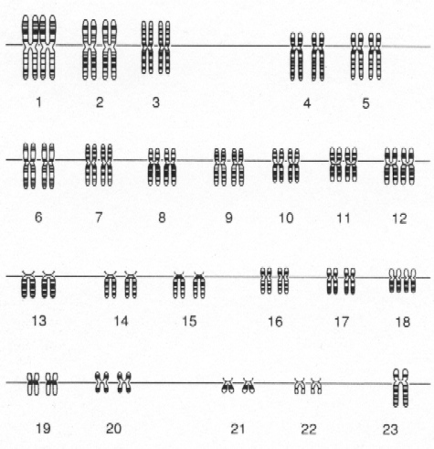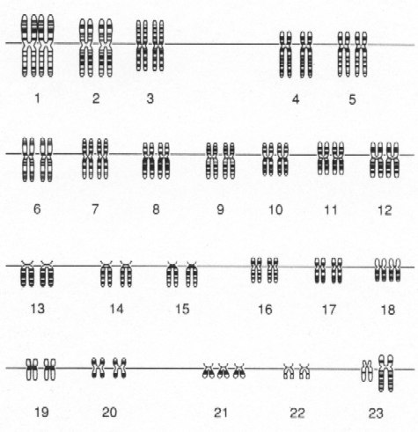

3. During which process do these genetic abnormalities occur?

_______________________

4. Monosomy and Trisomy are what type of mutation?

______________________

1.______________________ 2._______________________

**Fingerprinting**

**DNA Fingerprinting** is a specific form of genetic testing used mostly by forensic scientists.

1. Lt. Russ is investigating a murder scene. The felon was scratched by his victim & some of his skin (somatic) cells were found under the victim’s fingernails. A DNA test was performed. Which of the suspects is the murderer?



Murderer: _____________________________

1. The DNA fingerprints below were made from blood samples taken from a puppy and four possible sires of this puppy in an effort to determine the puppy’s pedigree. According to this information, which sire was probably the father of this puppy?

Sire: ________________________________

**Pedigrees**

Use the pedigree to answer the following questions.

1. Is this trait dominant or recessive?

__________________________

1. Is this trait autosomal or sex-linked? __________________________
2. How many offspring are produced by I-1 and I-2? __________
3. What is the genotype of III-4? _________
4. What is the genotype of II-6? __________



Use the pedigree to answer the following questions.

1. Is this trait dominant or recessive?

____________________________

1. Is this trait autosomal or sex-linked? ____________________________

Identify the genotypes of the following individuals using the pedigree above. Determine their genotypes AND whether they are homozygous dominant, homozygous recessive or heterozygous.

1. III-3: __________,________________________
2. II-1: ___________,________________________
3. How can you know for sure that individuals II-3 and II-4 are heterozygous? _________________

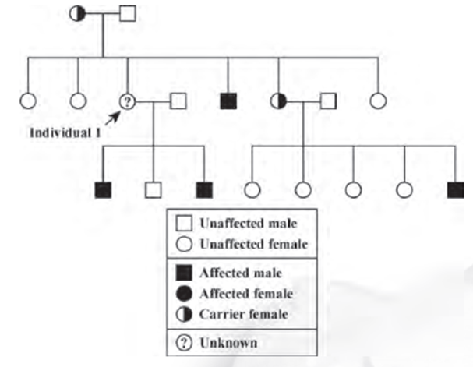

I.

II.

III.

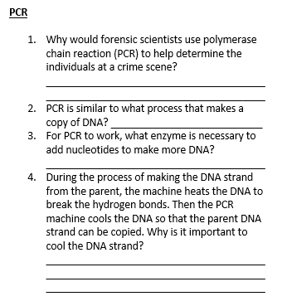

Use the pedigree to answer the following questions.

1. Is this trait dominant or recessive? __________________________
2. Is this trait autosomal or sex-linked? __________________________
3. Give the genotypes of the following individuals. Use any letter for the alleles. (Hint: Use the sex chromosomes (X and Y))

II-1:______________

III-1:______________

1. Why are no males half-shaded? ___________________________
2. How did III-1 inherit this trait? ___________________________

**Mutations**

Answer the following questions on mutations.

1. During which process do genetic mutations arise? _________________________________
2. Mutations in what type of cell can be passed on to offspring? ____________________________
3. The boxes below each show a step to explain how genetic disorders have a molecular basis. Number them so that the steps are in the correct order.

A change in phenotype results.

A gene’s DNA sequence changes.

The amino acid sequence that alters a protein changes.

**Cloning**

A **clone** is a member of a population of genetically identical cells produced from a single cell.

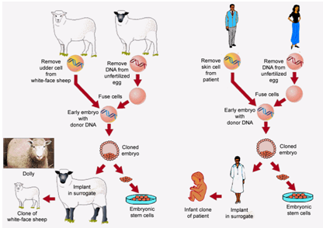

Answer the following questions on cloning.

1. What type of reproduction is cloning? _______________________________________
2. According to the picture, why is the clone identical to the patient? _______________________________________
3. Why was the DNA from the skin cell used instead of DNA from a sperm or egg? _______________________________________

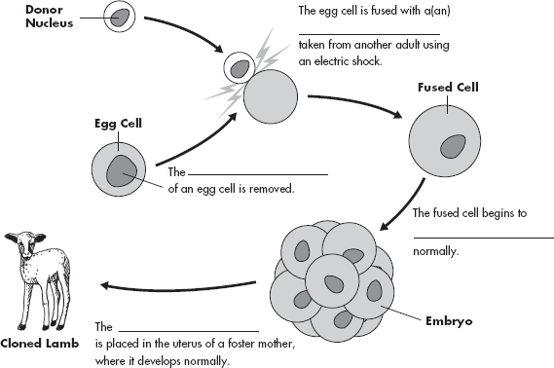

1. Complete the

sentences in the

diagram below to

show the steps in

cloning a sheep.

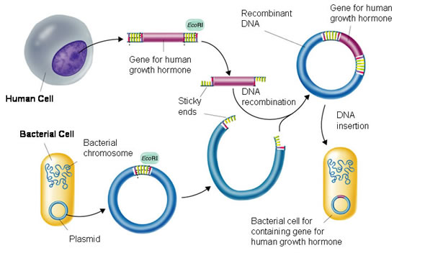

**Genetic Engineering**

1. During genetic engineering, human genes can be inserted into bacterial genes. Therefore, what does this indicate about the structure of DNA? ____________________________________________________________________
2. What type of enzyme is required to piece the two segments of DNA together? ________________________
3. Name one disease in which recombinant DNA is used to produce a human hormone. ____________________
4. Human growth hormone is a protein. In this picture, the gene that codes for human growth hormone is inserted into bacterial DNA. Therefore, this gene will undergo what 2 steps to produce human growth hormone? ___________________________________________________________________________________________