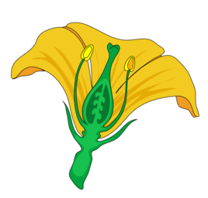
Name: ___________________________________________________ Date: _____________ Period: ________
Flower Dissection Lab
Objective: Dissect a flower to discover how its various structures aid in reproduction.
Materials:
- Flower
- Tweezers
- Magnifying glass
- Tape
- Ruler
Please read this overview before you begin your flower dissection:
Flower parts are arranged in a circular pattern. Each circle is called a whorl. The whorls are attached at the enlarged receptacle located at the base of the flower. As you examine your flower, you will be carefully removing parts beginning with the outer whorl and working your way in towards the pistil. You will arrange, tape and label each whorl into position on the plain paper. As each whorl is observed and removed, you will complete the appropriate information in the Observations column of the chart. Use the information in the handout/notes to complete the Function column of the chart.
Procedure:
- The sepals form the outermost whorl of the flower. The sepals are leaf-like structures that are usually green in color. Sometimes, the sepals are the same color as the petals, or appear to be another set of petals of a different color. The function of the sepals is to protect the inner part of the flower before it blossoms. Gently remove the sepals, tape them into position onto the paper, and label them. On the chart, record the following observations:

- How many sepals does your flower have?
- Describe the appearance of the sepals (color, markings, etc.).

- The petals are found directly under the sepals. The color and odor of the petals help to attract birds and insects to the flower for pollination. Gently remove the petals, tape them into position onto the paper, and label them.

On the chart, record the following observations:
a) How many petals does your flower have?
b) Describe the appearance of the petals (color, markings, etc.).

- The stalk-like structures inside the petals are the stamens, the male reproductive organs. Depending on the species, the stamens may be attached to the receptacle, to the petals, or to the pistil. The enlarged portion at the top of the stamen is the anther. Inside the anther are pollen sacs that produce pollen grains. When the pollen grains mature, the pollen sacs split open, releasing the dust like pollen grains. The filament is the thin structure that supports the anther. Gently remove the stamens, tape them into position onto the paper, and label them. On the chart, record the following observations:

a) How many stamens does your flower have?
b) To which structure(s) were the filaments attached?
c) Have the pollen sacs opened? How can you tell?
d) If pollen grains are visible, describe their appearance.

- The central structure of the flower is the female reproductive organ, the pistil. The top of the pistil is the stigma. When mature, the stigma is enlarged and its surface is moist and sticky. The style is the middle portion of the pistil; it supports the sigma. Some flowers lack a style. The ovary is the enlarged structure at the bottom of the pistil. The ovary contains one or more hollow compartments known as locules. The locules contain ovules, which in turn, contain the egg nuclei. Carefully remove the pistil by cutting it from the stem just under the ovary. Using a pencil, make a life-sized sketch of the entire pistil (just the outline) in the center of the plain paper and label it. Cut the style just at the top of the ovary, tape it next to your sketch, and label the stigma and style. Using the ruler, measure the length of the style in millimeters. Cut a thin cross-wide section of the ovary and tape it under the stigma and style. Label the ovary wall, locules and ovules. Using the dissecting tweezers, carefully pick the ovules out of one of the locules. On the chart, record the following observations:

a) What color is the pistil?
b) Describe the appearance of the stigma.
c) How long is the style (in mm)?
d) Describe the appearance of the ovary.
e) How many locules does the ovary contain?
f) Approximately how many ovules are contained in one locule?

- Check your flower parts sheet and your chart for the following:
• All flower parts are correctly taped in place.
• All flower parts are labeled correctly (in pencil).
• The pistil is drawn on the paper (in pencil).
• Your name(s) and class period are written on the paper.
• The Observations column of your chart is completed.
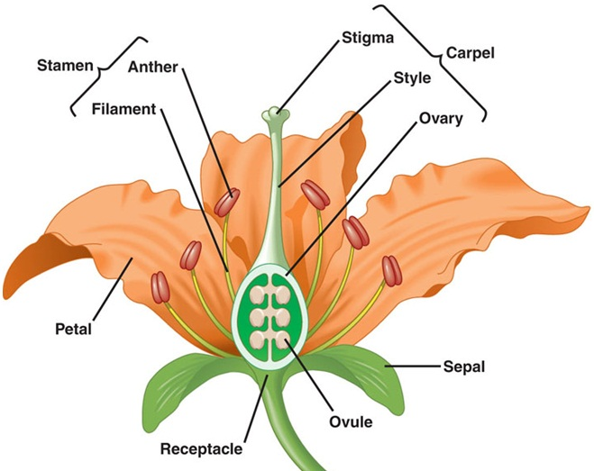
Pistil

Name: ___________________________________________________ Date: _____________ Period: ________
Structure | Function | Observations
Receptacle
Sepals |  | 1a)  1b)
Petals |  | 2a)  2b)
Stamens |  | 3a)
Filament
Anther |  | 3b)
Pollen grains |  | 3c)  3d)
Pistil |  | 4a)
Stigma |  | 4b)
Style |  | 4c)
Ovary |  | 4d)
Locule |  | 4e)
Ovule |  | 4f)
Tape & Label your Flower parts on this page:

