Name: ______________________________________________________ Date: _______________ Period: __________

Evolution Practice

_____ 1. The process in which organisms with traits well suited to an environment are more likely to survive and to produce offspring is

    - trait mechanisms
    - origin of species
    - genetic principles
    - natural selection

_____ 2. The hypothesis that evolution of a species occurs when long stable periods are interrupted by brief periods of more rapid change is

    - divergent evolution
    - gradualism
    - isolation
    - punctuated equilibrium

_____ 3. The accumulation of differences between species or populations is called

    - gradualism
    - punctuated equilibrium
    - divergent evolution
    - observational species

_____ 4. The hypothesis that the evolution of different species occurs at a slow, constant rate is called

    - punctuated equilibrium
    - gradualism
    - divergence
    - transitionism

_____ 5. The condition in which two populations of the same species cannot breed with one another is called reproductive

    - infertility
    - extinction
    - isolation
    - selection

_____ 6. The evolution of one or more species from a single ancestor species is

    - convergent evolution
    - natural selection
    - coevolution
    - speciation

_____ 7. Evolution that produces similar characteristics in unrelated species is

    - adaptive radiation
    - convergent evolution
    - divergent evolution
    - restrictive

_____ 8. A problem in all populations influenced by the bottleneck effect is that

    - genetic variation is lost
    - alleles can’t become fixed
    - offspring inherit harmful alleles
    - chance no longer affects them

_____ 9. Stable allele frequencies in a population that is not evolving is called

    - genetic equilibrium
    - significant mutation
    - convergent evolution
    - genetic drift

_____ 10. A small number of birds, blown off course during migration, find an island and colonize it. This population will most likely experience genetic drift as a result of the

    - founder effect
    - bottleneck effect
    - sexual selection
    - mutations

_____ 11. Chance changes in allele frequencies within a population are called

    - gene flow
    - gene pool
    - genetic drift
    - sexual selection

_____ 12. The wings of robins and the wings of dragonflies are examples of

    - divergent adaptation
    - convergent evolution
    - adaptive radiation
    - punctuated equilibrium

_____ 13. The evolution of hummingbirds’ beaks and plants with deep tubes in their flowers is an example of

    - convergent evolution
    - coevolution
    - speciation
    - radiation

_____ 14. What occurs when some elephants in a population migrate into another area and join another population?

    - genetic drift
    - speciation
    - gene flow

_____ 15. A river has cut a deep canyon that has separated a population of rodents into two groups. This separation is an example of what type of isolation?

    - temporal
    - behavioral
    - geographic
    - founder

_____ 16. The chart to the right shows a graph of reproductive success versus tail feather length for male widow birds. What type of selection is shown by this data?

    - sexual
    - disruptive
    - stabilizing
    - divergent

_____ 17. The illustration shows how the organisms in a particular geographic area became more diverse over time. The diversity was most likely due to which factor?
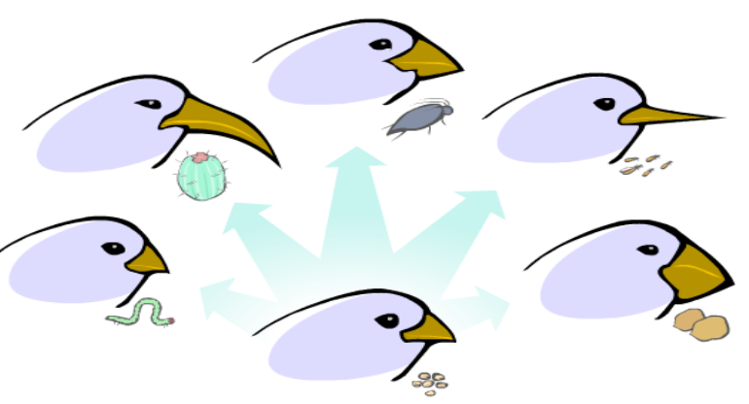
    - limited amount of food resources in the area
    - interbreeding of different species
    - introduction of new species into the area
    - a reduction in the number of predators in the area

_____ 18. The illustration shows several mutations that occur in fruit flies. Which mutation is least likely to eventually produce a new species of fly in the wild through the processes of evolution?
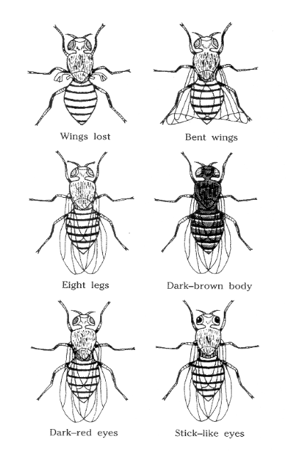

    - dark brown body mutation
    - wings lost mutation
    - dark red eyes mutation
    - stick like eyes mutation

_____ 19. The diagram below does not represent natural selection because

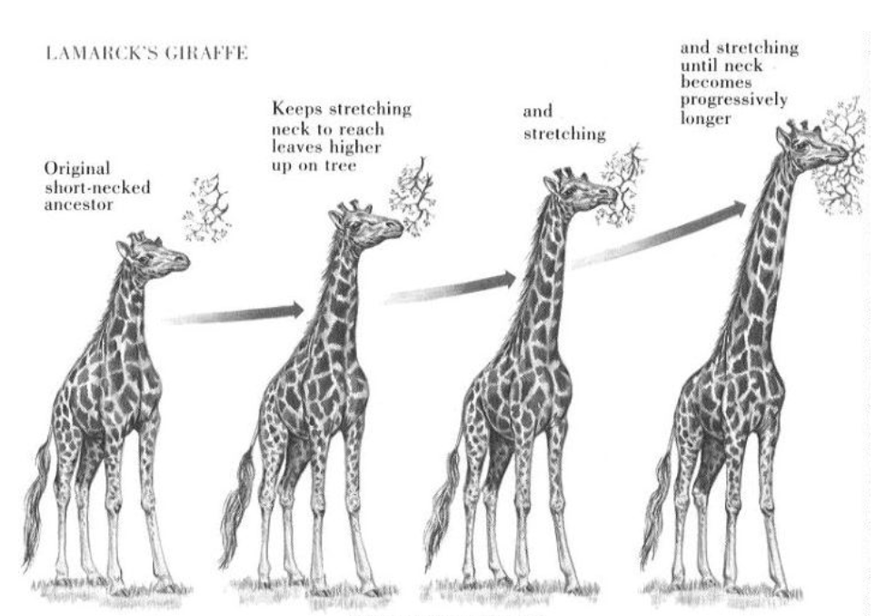
    - primitive giraffes had a choice of food at both low and upper heights so did not face the challenge of limited resources
    - natural selection is a process which creates change in whole populations rather than individual organisms
    - natural selection produces change in more than one trait at a time
    - only plants can experience natural selection over such a short period of time

_____ 20. The illustration shows the evolution of two different organisms. Which statement is most valid in regard to the evolutionary mechanisms acting upon these organisms?
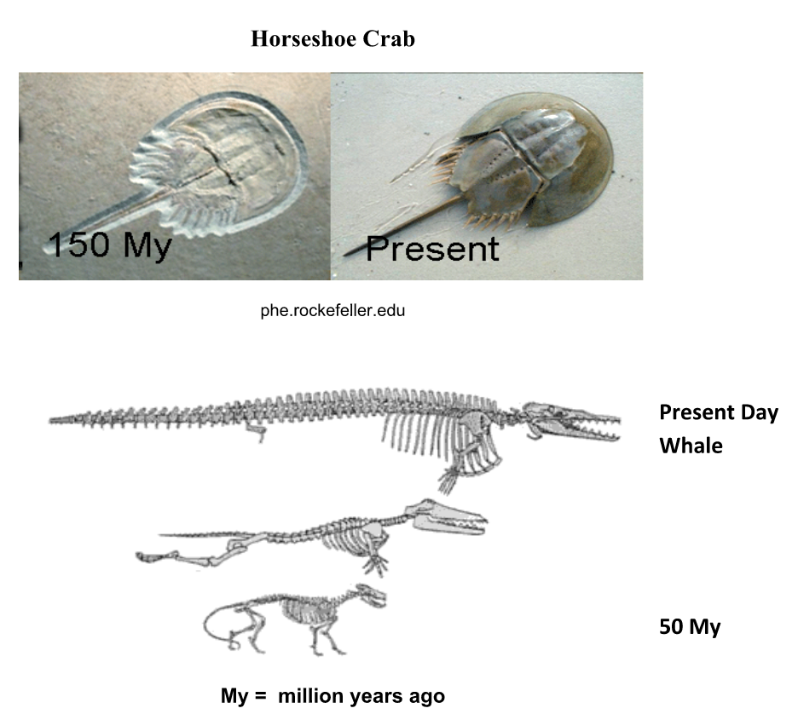

    - both organisms experienced extensive genetic drift during their evolution

    - whales appear to have been subject to more mutations than horseshoe crabs

    - only the sea urchin’s evolution was impacted by recombination

    - gene flow occurred between these two organisms as they share the same environment

EXPLAIN.

21. What are the 5 evidences that support the theory of evolution?

4.

5.

22. What is the order of evolution of organisms on Earth?

23. What are some effects of Genetic Drift? (Hint: are the traits that get passed on always the most advantageous?)

24. What are the three types of isolation? Give an example of each.

      - ________________________ Isolation
        - Ex:
      - ________________________ Isolation
        - Ex:
      - ________________________ Isolation
        - Ex:
- The survival of a species depends on its ability to adapt to changes in the environment. A species must be capable of surviving and reproducing despite changes to food sources, climate, or threats from predators. Which statement correctly describes a way that mutations increase the likelihood that a species will survive in a changing environment?

A. Mutations are a source of variation in the species.
B. Mutations are the cause of disease in the species.
C. Mutations are not harmful when they occur in somatic cells of the species.
D. Mutations are always passed on to subsequent generations of the species

- The green frog (Lithobates clamitans clamitans) is found in many parts of the United States. The table contains some information about this frog.
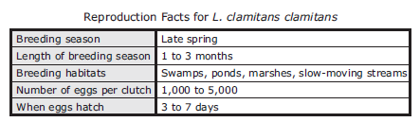

Why does the ability to lay 1,000 to 5,000 eggs increase the fitness of the species L. clamitans clamitans?
A. It increases opportunities for offspring to compete for limited resources.
B. It increases the probability that some offspring will survive long enough to reproduce.
C. It increases the probability that moving water will promote gene flow from one population to another
D. It increases the chance of the recombination of alleles, leading to genetic drift in the population.

- Bactrian camels, dromedaries, llamas, and alpacas are all members of the same taxonomic family, Camelidae. Members of this family all have two toes, no hooves, true canine teeth, and a split upper lip. The family Camelidae originated in North America. The physical features of animals in this family and the family’s geographical origin provide evidence that all these animals —

      - live in the same type of ecosystem
      - have slowly evolved to become herbivores
      - have a common ancestor
      - exchanged DNA at some point in the past

- A prey population consists of individuals with a variety of running speeds. The adaptation that allows some of these animals to run fast would be an example of natural selection if it helps them —
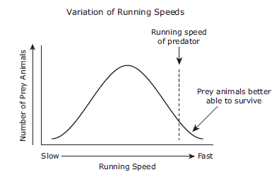

        - survive and undergo mutations in their DNA
        - lower the mortality rates of the population
        - produce offspring that run at average speeds
        - reproduce and increase the frequency of their genes in the population

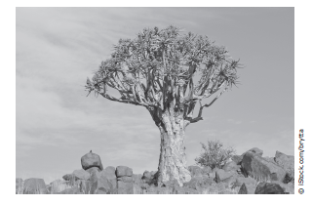
- The quiver tree grows in desert areas in southern Africa. In recent decades, average temperatures have been rising in southern Africa. Scientists predict that this warming trend will continue. Quiver trees in the hottest parts of their range near the equator are dying, but quiver trees at high elevations or in parts of the range that are farther from the equator are growing and reproducing. Which of these best explains what is happening to the quiver tree population in southern Africa?
A. Individual quiver trees are unable to adjust to the rising temperatures, and only those in cooler parts of the range will survive.
B. The quiver tree species is unable to survive rising temperatures throughout its range. The species is likely to undergo rapid extinction.
C. Individual quiver trees can quickly adapt to rising temperatures. Individual trees will change their method of seed dispersal in cooler parts of the range.
D. The quiver tree species will survive by producing offspring suited for warmer temperatures.

- In 2010, scientists excavated a skull fossil that provides evidence of a newly discovered species of big cat. Based on the evidence, scientists hypothesize that big cats branched off from smaller wild cats about 6 million years ago. Which of these resources did the scientists most likely rely on to form their hypothesis?
          - A food web showing feeding relationships of organisms where the fossil skull was found
          - Population and migration data for small wild cats living in the ecosystem where the skull was found
          - The fossil record and DNA comparisons of big cats and small cats
          - The historical record of interactions between different species of big cats

- Nudibranchs are marine gastropods that lack shells. Many of these gastropods retain the foul-tasting poisons of their prey and secrete them when threatened. The bright coloration of the nudibranchs warns predators to avoid them.
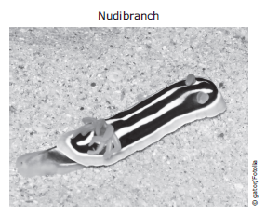

Based on this information, how has adaptation allowed marine gastropods to be successful without a shell?
A. They find enough food as they move through the marine environment.
B. They blend in with their environment to hide from their predators.
C. They are not attacked by most predators and are able to reproduce successfully.
D. They have bright colors that attract a mate.

