Name: ________________________________________________________ Date: _______________ Period: _________
Enzyme Questions
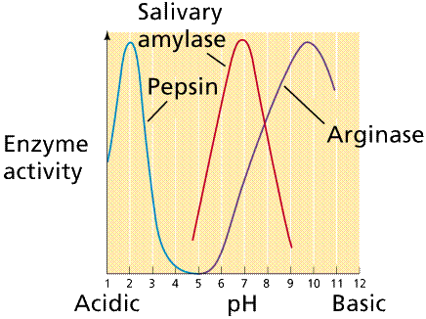
- What is the optimal pH for the enzyme salivary amylase?

- What is the job of the enzyme salivary amylase?

- Enzymes make reactions go __________ by ___________ the activation energy of the reaction.

  - Faster, slower
  - Slower, raising
  - Faster, lowering
  - Slower, lowering

Examine the picture below and answer the following questions.
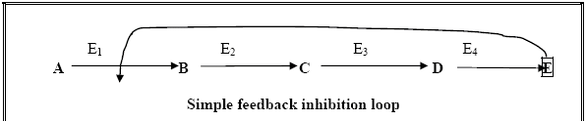

- What is the substrate for enzyme E₃?

- What enzyme produces the product C?

- What product indicated will impact on the entire enzymatic pathway?

- This diagram is an example of which characteristic of life? Explain.

Examine the picture to the right and answer the following questions.
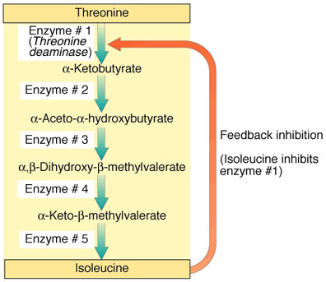

- If enzyme #2 is denatured, what substance will increase?

- If enzyme #2 is denatured, what substance will decrease?

- If enzyme #5 is denatured, how will it affect enzyme #2 and enzyme #3?

Examine the picture below and answer the following questions.
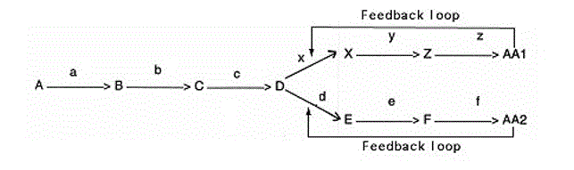

- What do the letters “a”, “b”, “y”, and “z” represent?

- What product inhibits enzyme x?

- If enzyme f is denatured, what substance will increase?

- Which substance can serve as a reactant for two enzymes?

