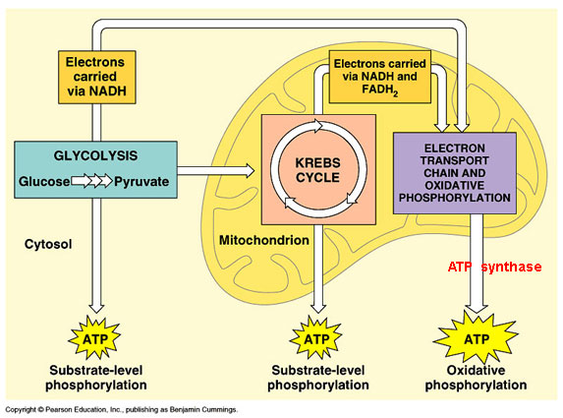
Check Yourself!
Cellular Respiration
- What is the first step in which energy is released from
glucose in the cell?

- If oxygen is available, list the steps of cellular
respiration, in order, and indicate how many ATP
molecules are made in each step.

- ________________, ________ ATP
- ________________, ________ ATP
- ________________, ________ ATP
- What is the starting molecule for cellular respiration?

- If no oxygen is available, which type of cellular respiration follows?

- What are the two types of fermentation?

- How many total ATP are made during aerobic respiration?

- How many total ATP molecules are made during anaerobic respiration?

- Cellular respiration occurs in which organelle?

Photosynthesis
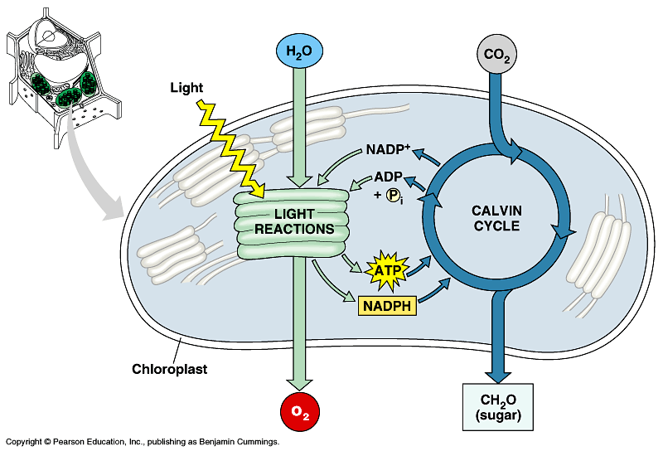
- What is the main source of energy for photosynthesis?
- Which gas is produced during the light-
dependent reaction?

- What are 2 other names for the Calvin Cycle?
- What does the Calvin Cycle convert carbon dioxide into?
- In which organelle does photosynthesis occur in?

- Which 2 raw materials are used during photosynthesis?

- Which molecule is broken down to synthesize the oxygen we breathe?

