Sort Me Out!
Directions: Use the cards and sort them based on the description of each energy process.

Energy Process | Equation | Reactants | Products | Label the Organelle | Source of Energy | Summary of Steps
Photosynthesis |  |  |  | ________________ |  | 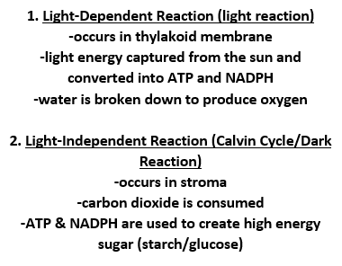
Cellular Respiration |  |  |  |       