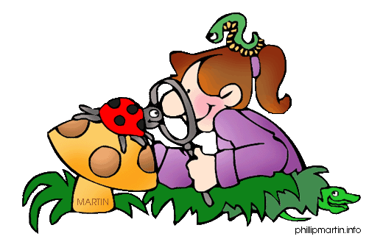
Name: _______________________________________________ Date: __________________ Period: _____
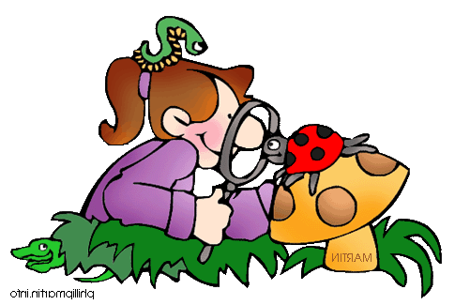
Ecology
Webquest- Part 2

Biogeochemical Cycles

Carbon Cycle

- Why is carbon so significant?

- How do plants use carbon dioxide?

- How has burning fossil fuels changed the composition of the atmosphere?

- Examine the picture of the carbon cycle and summarize how carbon flows through an ecosystem.

Water Cycle

- How do plants and animals play a part in the water cycle?

- What is the process of transpiration?

- Examine the picture of the water cycle and summarize how water flows through an ecosystem.

Nitrogen Cycle

- Where can nitrogen be found?

- What role do nitrogen-fixing bacteria play in the nitrogen cycle?

- What role do decomposers play in the nitrogen cycle?

- Explain the process of denitrification.
Phosphorus Cycle

- Why is phosphorus a concern in surface waters?

- How does phosphorus reach surface waters?

Play Eco-Detectives to investigate The Peril River Problem & discover what Eutrophication & Biomagnification is. Click “Start a New Game”
Eutrophication & Biomagnification

- What can you conclude about species abundance and diversity in the Peril River Watershed area?

- What can you conclude about dissolved oxygen in the Peril River Watershed area?

- How does dissolved oxygen affect living organisms in the river?

- How effective has monitoring and regulating nitrate runoff been at addressing the problem of low species diversity and abundance?

- Compared to the original condition of the river, how has monitoring and regulating nitrate fertilizer runoff affected water quality in the Peril River Watershed?

- How effective has reducing DDT been at addressing the problem of low species diversity and abundance?

- Compared to the original condition of the river, how has the reduction in DDT affected water quality in the Peril River Watershed?

