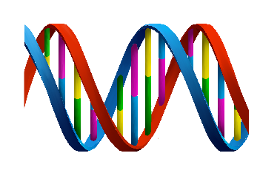
Name: ______________________________________________________ Date: ________ Period: __________

DNA Extraction Lab

Objective: Today you will extract DNA from some of your cells and learn more about DNA.

Extracting the DNA from Your Cells
Cells from the lining of your mouth come loose easily, so you will be able to collect cells containing your DNA by swishing a liquid around in your mouth.
The cells from the lining of your mouth also come off whenever you chew food. To extract DNA from your cells, you will need to separate the DNA from the other types of molecules in your cells. You will be using the same basic steps that biologists use when they extract DNA. You will follow these easy steps to extract DNA.

Procedure:

Step 1: Getting Your Sample of Cells

- Obtain a cup with sports drink. You will need to get thousands of your cheek cells in the sports drink in order to extract enough DNA to see. Therefore, you should swish the sports drink around in your mouth vigorously for at least one minute. Then, spit the drink back into the cup.

Step 2: Soap

- Add a small amount of soap to a test tube (about 0.25mL). Put a glove on the hand you will use to hold your test tube, not the hand you will use to pour. Now carefully pour the drink containing your cheek cells into the test tube with soap until the tube is half full.

Why am I adding soap?

To get the DNA out of your cheek cells you need to break open both the cell membranes and the nuclear membranes. Cell membranes and nuclear membranes consist primarily of lipids.

All soaps break up lipids. This is why you use dishwashing liquid (soap) to remove fats (which are lipids) from dirty dishes. Adding soap to your cheek cell solution will break open the cell and nuclear membranes and release your DNA into the solution.

Step 3: Enzymes

- Add a pinch of enzyme (meat tenderizer) to your test tube. With your gloved thumb (or palm) covering the top of the test tube, gently invert the tube five times to mix everything together. Let the mixture sit for 5-10 minutes. While you are waiting, start answering the questions at the end. Remove your glove and throw it in the garbage.

Why am I adding enzymes?

The nucleus of each of your cells contains multiple long strands of DNA with all the instructions to make your entire body. If you stretched out the DNA found in one of your cells, it would be 2-3 meters long. To fit all this DNA inside a tiny nucleus, the DNA is wrapped tightly around proteins. The enzyme in meat tenderizer is a protease, an enzyme that cuts proteins into small pieces. As this enzyme cuts up the proteins, the DNA will unwind and separate from the proteins.

The protease in meat tenderizer actually comes from plants, but animals also make proteases.

Step 4: Alcohol

- Using a dropper, slowly add cold rubbing alcohol into the test tube; let the alcohol run down the side of the test tube so it forms a layer on top of the soapy liquid. Add alcohol until you have about 2cm of alcohol in the tube. Alcohol is less dense than water, so it floats on top. Do not mix or bump the test tube for 5-10 minutes.

DNA molecules will clump together where the soapy water below meets the cold alcohol above and you will be able to see these clumps of DNA as white strands. While you are waiting, continue answering the questions at the end.

The cold alcohol reduces the solubility of DNA. When cold alcohol is poured on top of the solution, the DNA precipitates out into the alcohol layer, while the lipids and proteins stay in the solution.

Step 5: Making your Necklace

- By now, your DNA should be visible as clumps of white strands floating in the alcohol layer. There may be air bubbles attached to the strands. Use a dropper to suck up your DNA from the test tube and transfer it to the small capsule. Fill the small capped tube the rest of the way with alcohol. Close the cap of the tube around a piece of string. Now you have a necklace with your very own DNA!

DNA Extraction Lab Questions:

- How do you think your body replaces the cells that come off the lining of your mouth when you eat?

- What was the purpose of adding soap to your DNA sample?

- What was the purpose of adding meat tenderizer (enzymes) to your DNA sample?

- Where in your body do you think you make protein-cutting enzymes?

- What was the purpose of adding alcohol to your DNA sample?

The drawings below show a very small section of the DNA double helix from three very different organisms: a plant, a mammal, and a bacterium. Each strand of DNA shown contains five nucleotides.
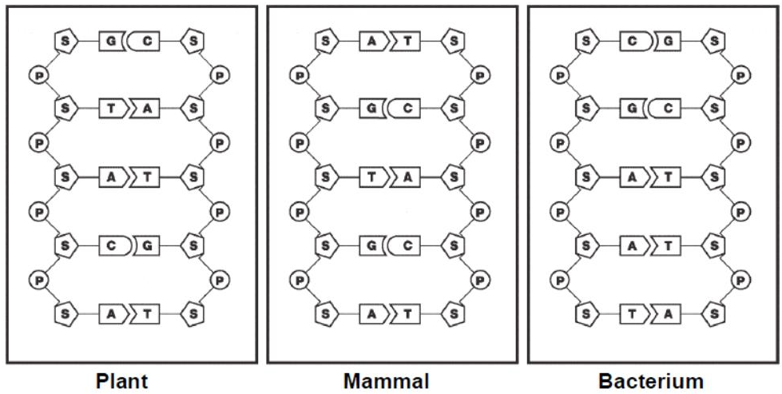

- Compare the sugar-phosphate arrangement in the backbone of the DNA from the plant, the mammal and the bacterium. Are there any differences?

- Which bases are present in the DNA of the plant? The mammal? The bacterium?

- Are the same bases present in all three organisms?

- Are the bases in the same order for each organism?

- Using the information in the previous questions, determine what exactly in DNA contributes to the diversity of organisms.

- What is the enzyme’s name that separates the DNA double helix?

- What is the enzyme’s name that adds nucleotides to the template strand in order to complete DNA replication?

- Why must DNA replication happen prior to a cell dividing?

- Sometimes during DNA replication, mistakes are made and the wrong nucleotide is added to the new strand of DNA. What can this lead to?

