Name: __________________________________________________ Date: ______________ Period: _______

Dichotomous Key Practice

A. Find and match the scientific names of the organisms’ common names using the following key:
Common Name | Scientific Name | Common Name | Scientific Name
1. dog |  | 8. turkey
2. shark |  | 9. oyster
3. pine tree |  | 10. mosquito
4. skunk |  | 11. mushroom
5. canary |  | 12. cow
6. dolphin |  | 13. ivy
7. eagle |  | 14. rose

Use this Dichotomous Key for Part A:
1. animal  not an animal | go to 2  go to 11
2. has wings  no wings | go to 3  go to 6
3. has feathers  no feathers | go to 4  Ochloerotatus taeniorhynchus
4. flies high  does not fly high | go to 5  Meleagris gallopavo
5. often yellow  not yellow | Serinus canaria  Haliaeetus leucocephalus
6. lives in water  lives on land | go to 9  go to 7
7. has fluffy fur  no fluffy fur | go to 8  Bos taurus
8. common pet  not a common pet | Canis familiaris  Mephitis mephitis
9. has fins  no fins | go to 10  Haematopus ostralegus
10. razor sharp teeth  pegged, pointy teeth | Carcharodon carcharias  Tursiops truncates
11. green  not green | go to 12  go to 13
12. grows tall  does not grow tall | Pinus ponderosa  Rhus toxicodendron
13. can be poisonous  not poisonous | Boletus edulis  Rosa sylvestris

B. Answer the following questions using the scientific names from the animals listed in Part A:
- Which organisms would you like to sing with? ________________________________________________
- Which organisms would you like to eat? _____________________________________________________
- Which organisms would you like to play with? ________________________________________________
- Which organisms would you stay away from? _________________________________________________
- Which organisms have a pleasant odor? ______________________________________________________
- Which organisms have an unpleasant odor? ___________________________________________________
- Which organisms do you see during the holidays? ______________________________________________
- Which organisms possess valuable fashion items (i.e. jewelery)? __________________________________
- Which organisms are you likely to see on a farm? ______________________________________________
- Which organisms are you likely to see at Sea World? ___________________________________________
- Which organisms are likely to make you itchy? ________________________________________________

C. Use the Candy Dichotomous Key to identify the "scientific names" of the 3 pieces of candy:
Common Name | Scientific Name
1. Tootsie Roll
2. Dum Dums
3. Jolly Ranchers
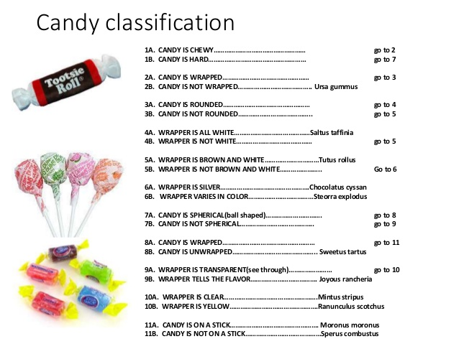

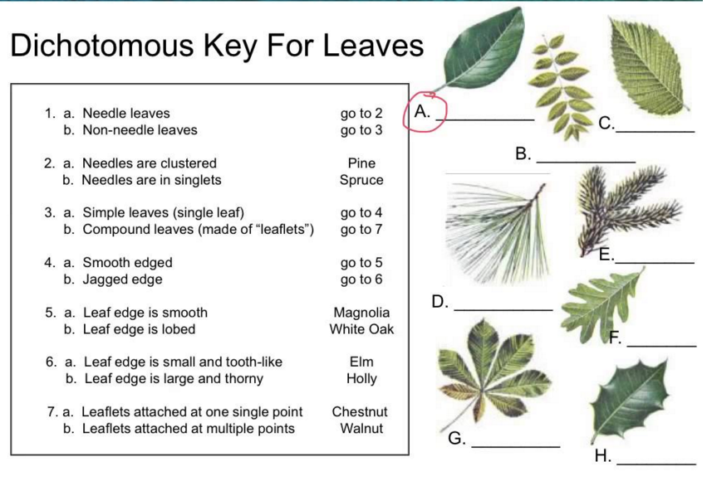
D. Use the Dichotomous Key to identify these leaves. List the common name on the line provided under each leaf.

