Name: ______________________________________________ Date: _____________________ Period: _____

Characteristics of Life Stations

READ AND HIGHLIGHT THE MAIN IDEAS IN EACH PASSAGE THEN ANSWER THE QUESTIONS.

Most people feel confident that they could identify a living thing from a nonliving thing, but sometimes it’s not so easy. Scientists have argued for centuries over the basic characteristics that separate life from non-life. Some of these arguments are still unresolved. Despite these arguments, there do seem to be some generally accepted characteristics common to all living things. Anything that possesses all these characteristics of life is known as an organism.

- The scientific term for a living thing is a(n) _____________________.

STATION 1: CONTAINS ONE OR MORE CELLS

The smallest unit of organization of an organism is the cell. A cell is a collection of living matter enclosed by a barrier known as the plasma membrane that separates it from its surroundings.
Cells are organized and contain specialized parts that perform particular functions. Cells are very different from each other. A single cell by itself can form an entire living organism.
Organisms consisting of only a single cell are called unicellular. A bacterium or a protist, like amoebas and paramecia are unicellular. However, most of the organisms you are familiar with, such as dogs and trees, are multicellular.
Multicellular organisms contain hundreds, thousands, even trillions of cells or more. Multicellular organisms may have their cells organized into tissues, organs, and systems. Whether it is unicellular or multicellular, all structures and functions of an organism come together to form an orderly living system.
Functional cells are not found in nonliving matter. Structures that contain dead cells or pieces of cells are considered dead. For example, wood or cork cut from a tree is made up largely of cell walls. The cells are no longer functional.

- What is the simplest level at which life may exist?

- Are all cells alike? Use evidence from the paragraph to support your answer.

- Using the paragraph, complete the concept map below, fill in the missing information.
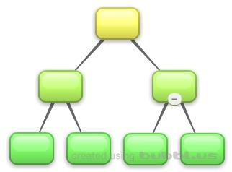

- Which of these are made up of cells? (Circle all that apply).

Cork Sponge Wood Plastic Tree

- Examine these 2 organisms. Which one is unicellular and which is multicellular? (Label each).
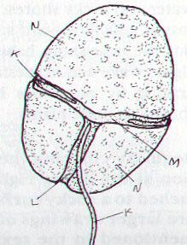
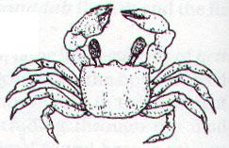

POND ORGANISM CRAB
(Under a microscope)
_______________ _______________

STATION 2: REPRODUCTION

Perhaps the most obvious of all the characteristics of life is reproduction, the production of offspring. Organisms don’t live forever. For life to continue, organisms must replace themselves. Reproduction is not essential for the survival of an individual organism. However, it is essential for the continuation of an organism’s species. A species is a group of similar-looking organisms that can interbreed and produce fertile offspring. If individuals in a species never reproduced, it would mean an end to that species’ existence on Earth.

- Must EVERY member of a particular species (one kind of organism) be able to reproduce in order for the species to survive? Explain why or why not.

- What would happen if all individuals in a species were sterile (not able to have babies)?

- Reproduction is NOT essential for the survival of an individual ______________ but is essential for the survival of the _____________.

There are two basic kinds of reproduction: sexual and asexual. Sexual reproduction requires that two cells (sperm and egg) unite to produce the first cell of the new organism. Organisms reproducing sexually do not always have “sex!” In many cases sperm and egg are released into the water where they meet. Most familiar organisms – from maple trees to birds and bees – reproduce sexually. In asexual reproduction, a single organism can reproduce without the aid of another. Sometimes these organisms can just divide themselves in two!

- Name and define the two basic kinds of reproduction.

- Use the pictures below to identify which organisms are reproducing sexually (S) and which are reproducing asexually (AS).

BACTERIA HYDRA SEA URCHIN
__________ ____________ __________________
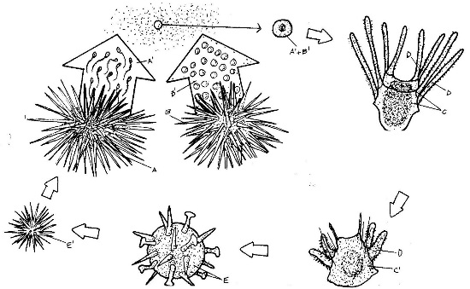
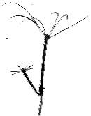
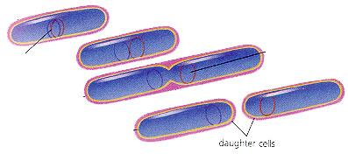

STATION 3: GROWTH & DEVELOPMENT

Adults don’t always look like the babies of a species. All organisms begin their lives as single cells. Over time, these organisms grow and take on the characteristics of their species. Growth results in an increase in the amount of living material and the formation of new structures.
All organisms grow, and different parts of organisms may grow at different rates. Organisms made up of only one cell may change little during their lives, but they do grow. On the other hand, organisms made up of numerous cells go through many changes during their lifetimes. Think about some of the structural changes your body has already undergone in your short life. All of the changes that take place during the life of an organism are known as its development.

- What is the difference between growth and development?

- Do unicellular organisms GROW? Do unicellular organisms DEVELOP? Explain.

- Do multicellular organisms GROW? Do multicellular organisms DEVELOP? Explain.
- Identify which graphic BEST shows growth and which BEST shows development.
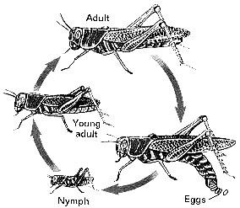
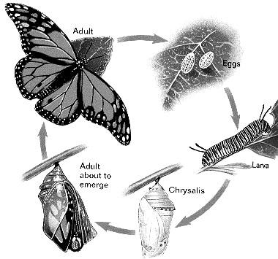

_________________________ ________________________
A snowball grows when you roll it over fresh snow! Why isn’t it a living thing? The growth of the snowball is not internal. It does not grow by producing more cells like organisms. It just adds on more material to the outside. Someone has to roll the snowball. It won’t grow bigger by just sitting there and it certainly cannot change liquid water or solid ice into new snow from which it can grow larger. This is one of the differences between growth of a living thing and growth of a nonliving thing.

- How is the growth of a living thing different from the growth of a nonliving thing? Explain.

STATION 4: OBTAIN AND USE ENERGY

Energy is the ability to make things change. Energy is important because it powers life processes. It provides organisms with the ability to maintain balance, grow, reproduce, and carry out other life functions. Some organisms obtain energy from the foods they eat or, in the case of plants and several other types of organisms, the foods that they produce. Organisms that get energy from the food they eat are called heterotrophs. Organisms that use energy from the sun to make their own food (which they then use for energy) are called autotrophs. The process is called photosynthesis.
As you’ll learn, energy doesn’t just flow through individual organisms; it also flows through communities of organisms, or ecosystems, and determines how organisms interact with each other and the environment.

- Why is energy important to a living organism?

- What is the difference between an autotroph and a heterotroph?

- What is the name of the process that plants use to make their own food using energy from the sun?

- Identify each of the organisms below as either a heterotroph or an autotroph.
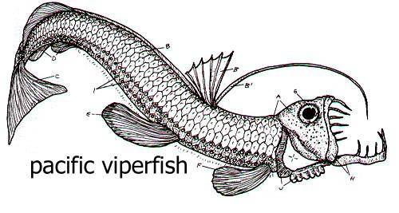
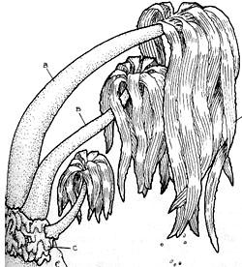

_________________________ ________________________

STATIONS 5 & 6: RESPOND TO THE ENVIRONMENT/ MAINTAIN HOMEOSTASIS

Living things live in a constant connection with the environment, which includes the air, water, weather, temperature, any organisms in the area, and many other factors. These external environmental factors act as stimuli and can cause a response from living things. Organisms need to respond to the changes in order to stay alive and healthy. For example, if you go outside on a bright summer day, the sun may cause you to squint. Perhaps the bark of an approaching dog causes you to turn your head quickly. Just as you are constantly sensing and responding to changes in your environment, so are all other organisms. For example, a specialized leaf of the Venus’ flytrap senses the light footsteps of a soon-to-be-digested green bottle fly. The plant responded to this environmental stimulus by rapidly folding the leaf together.
An organism must respond to changes in the internal environment as well. Internal conditions include the level of water, nutrients, and minerals inside the body. It also refers to body temperature and hormone levels. Adjustments to internal changes help organisms maintain a stable internal environment. The regulation of an organism’s internal environment to maintain conditions suitable for life is called homeostasis. Or you can just think of it as keeping everything in BALANCE! For example, you have a “thermostat” in your brain that reacts whenever your body temperature varies slightly from 37°C (about 98.6°F). If this internal thermostat detects a slight rise in your body temperature on a hot day, your brain signals your skin to produce sweat. Sweating helps cool your body.
The ability of mammals and birds to regulate body temperature is just one example of homeostasis. Mechanisms of homeostasis enable organisms to regulate their internal environment, despite changes in their external environment.
- What are some environmental factors (stimuli) that organisms respond to?

- What are two internal factors that organisms respond to?

- Give two examples from the reading of how living things respond to changes in their environment.

- If light is applied to a human eye, how does it respond?

- Describe homeostasis.

STATION 7: BASED ON A UNIVERSAL GENETIC CODE

The drawings below show a very small section of the DNA from three very different organisms: a plant, a mammal, and a bacterium. Each strand of DNA shown contains five nucleotides (which is analogous to 5 paragraphs that may make up an essay). Each nucleotide is made up of 3 parts:
S = sugar molecule called deoxyribose
P = phosphate group
+ one of the four bases: A = adenine, C = cytosine, G = guanine, or T = thymine

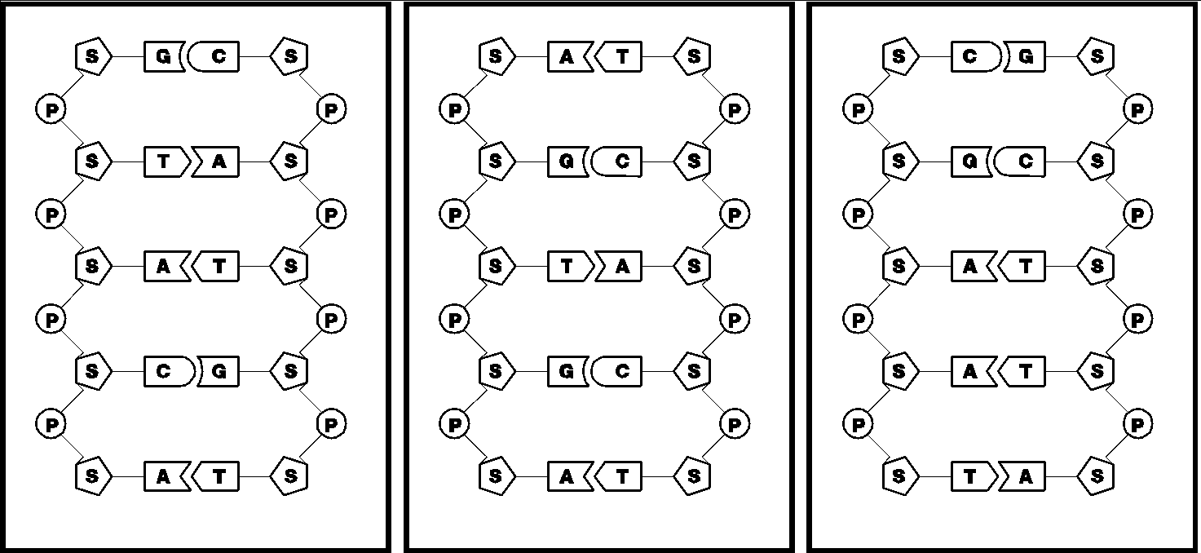

Plant Mammal Bacterium

25. Complete the following sentences to describe the structure of DNA.

In the backbone of each strand in the DNA double helix molecule, the sugar of one nucleotide is bonded to the __________________ in the next nucleotide.

A in one strand always pairs with _____ in the other strand, and G in one strand always pairs with ______ in the other strand. This is called base pairing.

26. DNA has the same structure in all living organisms. However, we know that a plant, mammal and bacterium must have different genes in their DNA to result in the very different characteristics of these different organisms. So, the question is: What is different in the DNA of these different organisms? Complete the following table to identify what is different between the DNA of the plant, mammal and bacterium.

 | Compare the plant and mammal DNA. | Compare the mammal and bacterium DNA.
Is the arrangement of the sugar and phosphate groups the same in each type of DNA?
Does each type of DNA contain the same four bases (A, C, G, T)?
Is the sequence of bases the same in each type of DNA?
Are the base-pairing rules the same in each type of DNA?

27. What is the only characteristic that differs between these segments of DNA from a plant, a mammal and a bacterium?

STATION 8: CHANGE OVER TIME/EVOLVE

Basic genetic characteristics of an individual organism do not change over time; however, populations of organizations do adapt or evolve through time to improve their chances of survival. For example, evolution is often a slow process in which the changes are not always easy to observe. However, we now have many excellent examples where scientists have caught evolution in the act of changing a species. One great case is that of the melanism in the peppered moth, which has two color morphs – one mottled white and one black. As pollution levels rose and fell in Britain the numbers of these two morphs changed. Let’s examine this further.
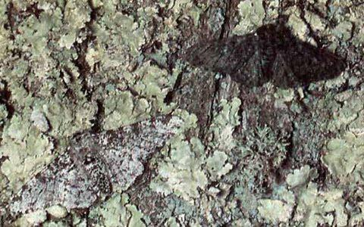
The peppered moth (Biston betularia) is a moth which flies during the night and rests on trees during the day, where it is camouflaged avoiding preditors. The two most common forms are called typical, a pale speckled moth which is well-disguised on light-colored lichens growing on trees, and carbonaria, a black (or melanic) moth which is easy to see on the same background. Both are different forms of the same species, like humans with blonde or brown hair. Before the Industrial Revolution, when there was much less pollution, many trees were covered in lichen and the typical form was well-camouflaged when resting on them. Because the carbonaria form stood out against this pale background, birds found carbonaria moths much more easily than typical, so carbonaria were more likely to be eaten, and so less likely to survive to pass on their genes. This meant that the carbonaria form was rare.
As coal-burning factories were built during the Industrial Revolution, air pollution increased significantly, which killed off the lichens and blackened the trees with soot. On this dark background, the pale typical moths were no longer well-camouflaged and were easily caught by birds, but the carbonaria moths were harder for birds to see, so more carbonaria survived to breed and pass on their genes, and this dark type of peppered moth became more common. By 1895, 98% of moths in heavily-polluted Manchester were carbonaria.

28. Can an organism evolve? Highlight evidence from the paragraph.

29. Explain why the population of carbonaria increased over time.

