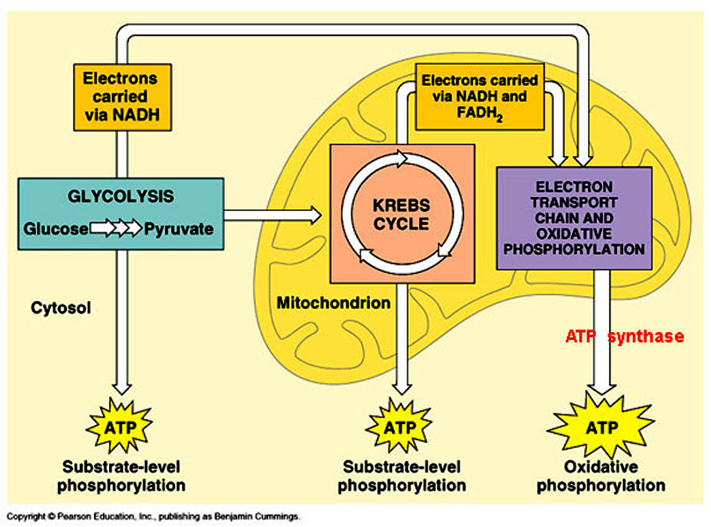

**Overview**

**Cellular Respiration**

Electron Transport Chain

(ETC)

Krebs cycle /

Citric Acid Cycle

Location: outer membrane of the Mitochondria

Produces: 2 ATP’s, electron carrier molecules (NADH, FADH2)

Location: inner membrane of Mitochondria

Produces: 34 ATP’s

H2O

Aerobic

**Glucose**

Glycolysis

Location: Cytoplasm

Produces: 2 ATP’s

Lactic Acid/ Alcohol Fermentation

Anaerobic

Location: Cytoplasm

Lactic Acid Fermentation: pyruvic acid is converted to Lactic Acid which builds up in the cells of muscles (burning sensation)

Alcohol Fermentation: produces ethyl alcohol and CO2 (done by yeast)