Cell Cycle Writing Prompt
Why would a cell enter the cell cycle? Describe the entire process (each step) from start to finish.
Write your response in your notebook below.
(Discuss vocabulary first in your groups, then write your response.)
Use ALL of these terms:

- G0
- Interphase
- G1
- S
- G2
- Chromosomes

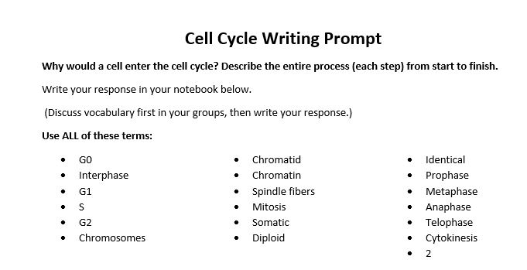

- Chromatid
- Chromatin
- Spindle fibers
- Mitosis
- Somatic
- Diploid

- Identical
- Prophase
- Metaphase
- Anaphase
- Telophase
- Cytokinesis
- 2

