Name: _______________________________________________________________ Date: ____________ Period: ___
Cell Cycle Questions
Directions:
- Use the outer, circular arrows to label and color the two major stages of the cell cycle: Interphase and Mitosis.
- Label the stages of interphase: G₁, S and G₂, include G₀
- Label the stages of cell divsion: Prophase, Metaphase, Anaphase, Telophase and Cytokinesis

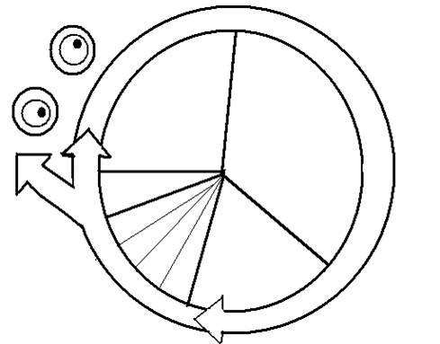
I think I will take a little “rest.”
Use the word bank to complete the following questions (yes, there are 2 questions with mitosis as an answer):
S phase cleavage furrow G₁ phase cell plate
G₂ phase mitosis centrioles somatic
cancer diploid mitosis
cytokinesis metaphase anaphase

___________________ 1. division of the nucleus
___________________ 2. cytoplasm divides
___________________ 3. during cytokinesis, a groove forms from outside to inside pinching the parent cell into two
________________________ 4. additional organelles are made as the cell prepares for cell division
________________________ 5. cell grows quickly and begins to carry out routine metabolic functions
________________________ 6. sister chromatids are aligned at the middle center
________________________ 7. DNA is replicated
________________________ 8. sister chromatids are pulled apart and move to opposite sides of the cell
________________________ 9. the cell does not receive a protein signal from cyclin to re-enter the cell cycle but carries on routine functions ; cells do not go to G₀ phase
________________________ 10. organelle found only in animal cells that aids in cell division; they are typically found in pairs
________________________ 11. during cytokinesis, this forms in the cell to completely separate a plant cell into two new cells
____________;____________ 12-13. mitosis produces 2 _______ cells that are genetically identical and __________
________________________ 14. the time during the cell cycle in which chromosomes become visible

List the phases of the cell cycle in the correct order from beginning to end. Place a bracket around the 4 phases that represent the process of mitosis and label the bracket “mitosis.”

Indeed, ________________________________

Please ________________________________ In each box below, label the correct phase of mitosis.

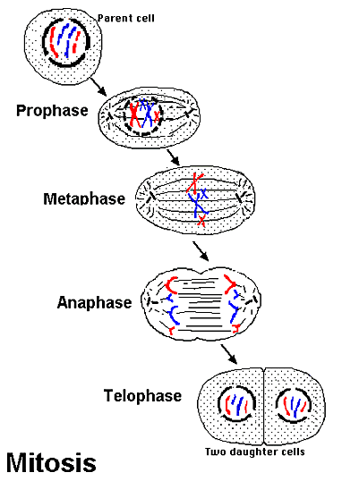
Make ________________________________

Another________________________________

Two ________________________________

Cells ________________________________

What saying did we learn in class to remember the 4
phases of mitosis?

Name: _____________KEY______________________ Period: ____ Date: __________________
Cell Cycle Quiz Study Sheet
Directions:
- Use the outer, circular arrows to label and color the two major stages of the cell cycle: Interphase and Mitosis.
- Label the stages of interphase: G₁, S and G₂, include G₀
- Label the stages of cell divsion: Prophase, Metaphase, Anaphase, Telophase and Cytokinesis

I think I will take a little “rest.”
Use the word bank to complete the following questions (yes, there are 2 questions with mitosis as an answer):
S phase cleavage furrow G₁ phase cell plate
G₂ phase mitosis centrioles somatic
cancer diploid mitosis
cytokinesis metaphase anaphase

mitosis 1. division of the nucleus
cytokinesis 2. cytoplasm divides
cleavage furrow 3. during cytokinesis, a groove forms from outside to inside pinching the parent cell into two
G₂ phase 4. additional organelles are made as the cell prepares for cell division
G₁ phase 5. cell grows quickly and begins to carry out routine metabolic functions
metaphase 6. sister chromatids are aligned at the middle center
S phase 7. DNA is replicated
anaphase 8. sister chromatids are pulled apart and move to opposite sides of the cell
cancer 9. the cell does not receive a protein signal from cyclin to re-enter the cell cycle but carries on routine functions ; cells do not go to G₀ phase
centrioles 10. organelle found only in animal cells that aids in cell division; they are typically found in pairs
cell plate 11. during cytokinesis, this forms in the cell to completely separate a plant cell into two new cells
somatic; diploid 12-13. mitosis produces 2 _______ cells that are genetically identical and __________
mitosis 14. the time during the cell cycle in which chromosomes become visible

List the phases of the cell cycle in the correct order from beginning to end. Place a bracket around the 4 phases that represent the process of mitosis and label the bracket “mitosis.”

I Interphase

Pray Prophase In each box below, label the correct phase of mitosis.

More Metaphase

A Anaphase

T Telophase

Church Cytokinesis

What saying did we learn in class to remember the 4
phases of mitosis?

PMAT

