Station # 1
Name the phases of the cell cycle, in order.
1. _________________
2. _________________
3. _________________
4. _________________
5. _________________
6. _________________

Looking at the 6 phases above, which 4 are the stages of Mitosis?
List the phases in order from first (#7) to last (#10)
7. _________________
8. _________________
9. _________________
10. ________________
Station # 2
Look at the picture of the 4 phases of Mitosis:

11. Mitosis occurs in what type of cells?

12. Which phase is the arrow pointing to?

13. How do you know it is that phase?

14. What phase occurs before the phase from #13?

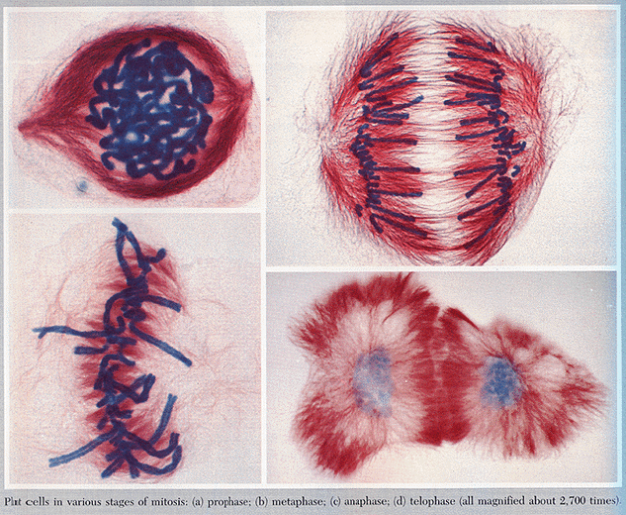
#2
Station # 3
15. What phase of Mitosis is pictured?

16. What is the significance of this phase?

17. What phase comes AFTER this phase?

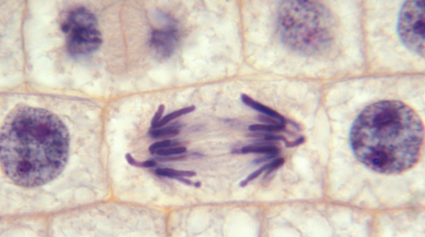
#3
Station # 4
Look at the picture.

18. What phase is pictured?

19. What phase of the cell cycle occurs after this phase to complete cell division?

20. What key events occur during this phase?

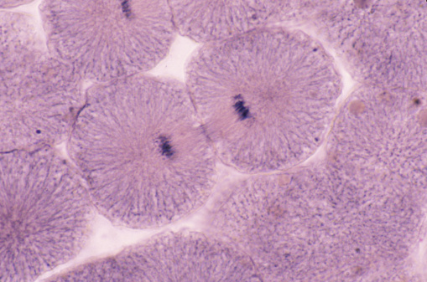
#4
Station # 5
21. What phase is pictured?

22. How do you know it is in that phase?

23. Is the cell pictured a plant or animal cell?

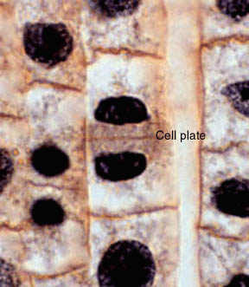
#5

Station # 6
Look at the picture.

24. What phase of Mitosis is this?

25. What becomes visible during this phase?

26. What phase of the Cell Cycle comes BEFORE this phase?

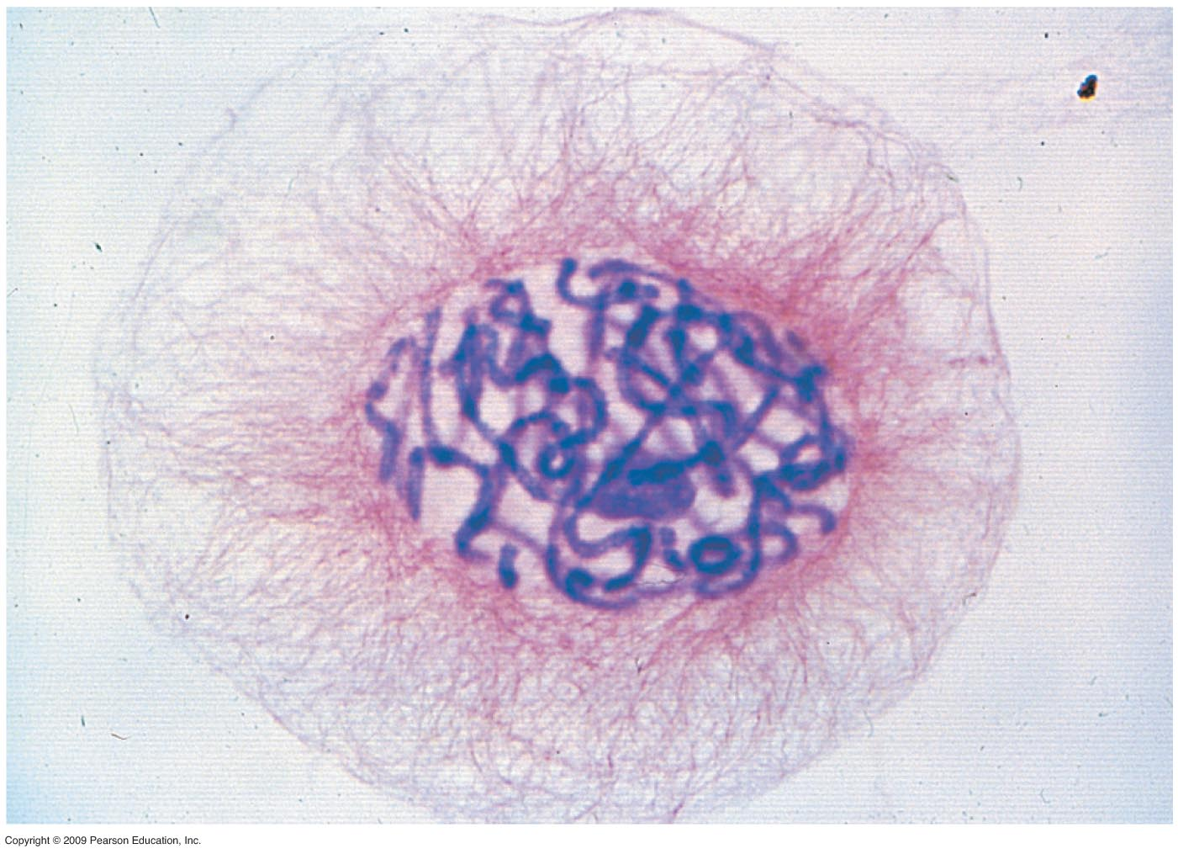
#6
Station # 7
Look at the picture of Cytokinesis.

27. Does the picture show Cytokinesis in a plant cell or an animal cell?

28. How do you know?

29. Mitosis in animal cells is different from plant cells in that, animal cells have a specific structure present that plant cells do NOT that aid in cell division. What structure are these?

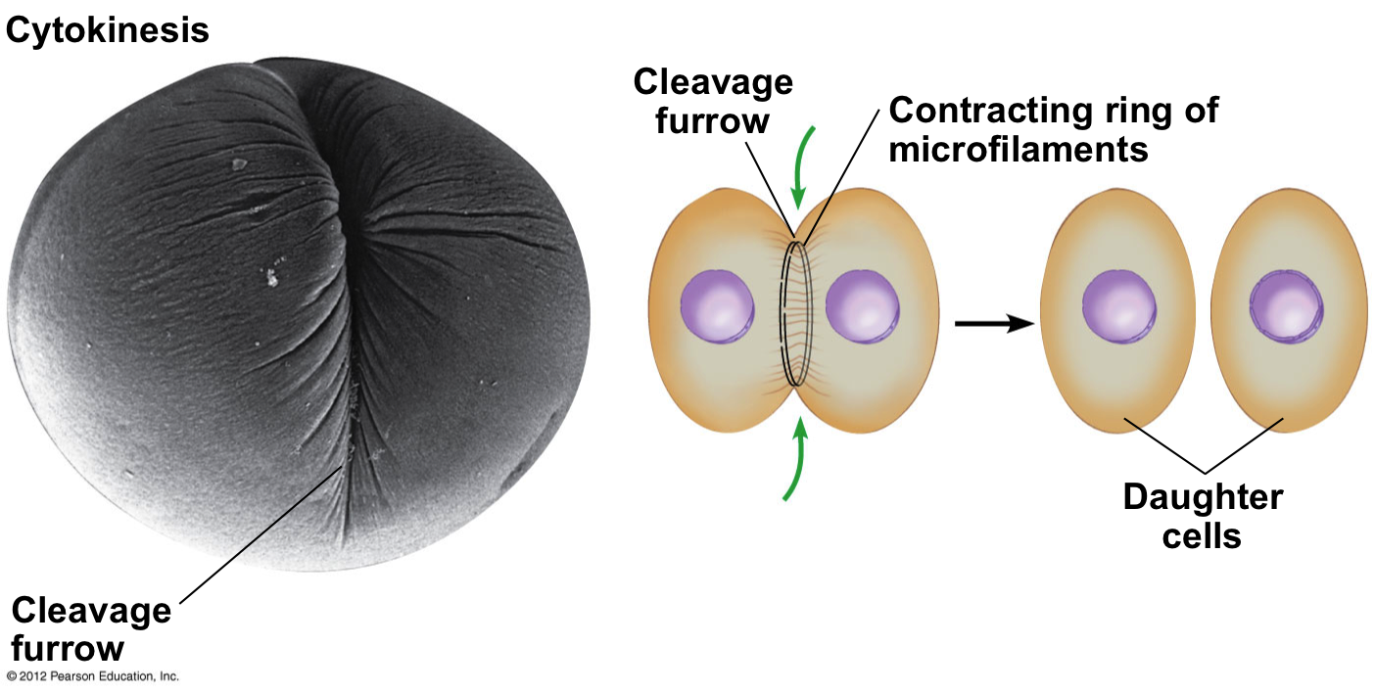
#7
Station # 8
Look at the picture. This is a breast cancer cell.

30. What phase of Mitosis is this?

31. What phase of the Cell Cycle occurs almost simultaneously (at the same time) with this phase?

32. How many daughter cells are created at the end of the cell cycle?

33. How do these daughter cells compare to each other as well as to the parent cell?

34. Are the cells diploid or haploid?

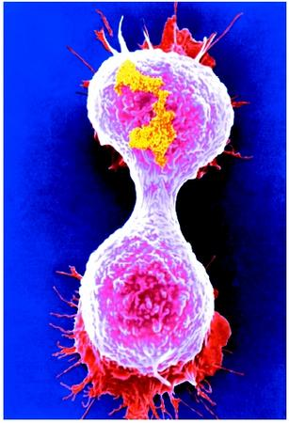
#8
Station # 9
Look at the picture.

35. What phase is pictured?

36. In this phase DNA is not yet organized into chromosomes. Therefore, it is called what?

37. A cell spends ___ percent of its time in this phase.

38. Name the 3 phases that occur during this phase.

39. What is synthesized during this phase?

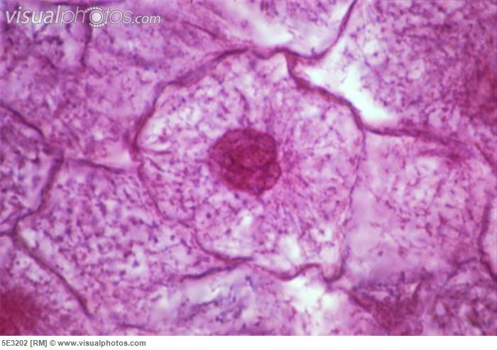
#9
Station # 10
Compare & Contast the Cell Cycle and Meiosis.

40. Mitosis is the creation of genetically identical somatic cells, while meiosis creates genetically different ____________ (sex cells).

41. Mitosis is asexual reproduction while meiosis is sexual reproduction. What occurs in prophase I of meiosis to produce genetic diversity?

