Biology I Taxonomy and Microbes Test Review
Refer to the following questions and vocabulary to help you to review for the test.

- Required vocabulary: binomial nomenclature, dichotomous key, taxonomy, chitin, heterotrophs, cell wall, Mycorrhizae, pseudopod, cilia, flagella, algae, phytoplankton, , Paramecium, amoeba, zooplankton, pathogen, peptidoglycan, cocci, bacillus, spirilla, binary fission, Cyanobacteria, transduction, transformation, binary fission, conjugation, nitrogen fixing bacteria, denitrifying bacteria, pasteurizing, antigen, antibodies, memory cells, white blood cell, retrovirus, prophage, capsid, endospore, bacteriophage, plasmid, pili, flagella, and pathogen.

- What is taxonomy?
- Describe the goals of binomial nomenclature and systematics.
  - What is a binomial nomenclature?
  - In the two-word naming system, the first word refers to ____ and the second word refers to ____
  - Describe how the scientific name is written
  - What is the importance of using scientific name of organisms instead of their common names?
- Using a dichotomous key, classify an organism
- How did Linnaeus group species into larger taxa?
- What were some of the problems with traditional classification?
- What is phylogeny?
  - What is the goal of phylogeny?
  - What is a clade?
- What is cladogram?
  - What is a cladogram?
  - What is a derived character?
  - In the cladogram below, which organism is closely related to ray-finned fishes?
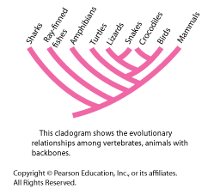
- How are DNA sequences used in classification?
- Name the taxon levels, in order.
  - What is the largest and most inclusive category?
    - Name the 3 domains.
      - Describe the characteristics
  - Name the 6 kingdoms.
    - Describe the characteristics
    - Which kingdom contains a heterotrophic organism with chitin cell walls?
    - Which kingdom contains Mycorrhizae?
    - Which kingdom contains an organism with pseudopods?
    - Which kingdom contains an organism with ciliar? Flagella?
    - Which kingdom contains phytoplankton and zooplankton?
    - Which kingdom contains algae?
  - What is the smallest and least inclusive category?
- What is a virus?
  - How is a virus classified, as a living or a non-living thing?
    - Why?
  - What are the typical “parts” of a virus?
    - What term is used for the protein coat of a virus?
    - What structure do viruses have that is found in all living things?
  - Which of the following diagrams is an example of bacteria? A virus? An eukaryotic cell?
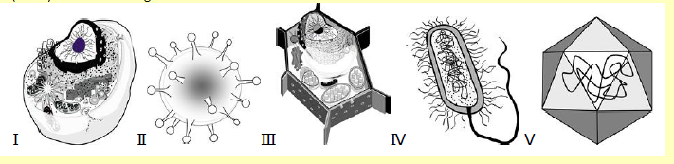
- Refer to diagram II above, what do you think are the projections for?
  - How is a virus different from a prokaryotic cell?
  - What happens after a virus infects a cell?
    - What are the 2 major types of infections?
      - How are they similar?
      - How do they differ?
        - Explain how a prophage is completely not a part of a lytic infection.
    - What is common with all viruses on how they affect cells?
  - Explain how a retrovirus replicates.
  - Explain what happens when an influenza virus infects a cell.
  - Explain what happens when a HIV virus infects a cell.
  - What term is given for a disease causing agent?
  - Should mass vaccination (such as for smallpox) be required?
    - Why or why not?
  - How do humans prevent diseases?
  - List all of the viral diseases that infect humans
  - What are some animal viral diseases?
  - What are some plant viral diseases?
  - Differentiate between viroids and prions.
  - If a person have contracted a viral infection, which treatment is appropriate, a vaccination or an antibiotic? Why? Explain your answer.
- What is a prokaryote?
  - Why have the prokaryotes been divided into two kingdoms?
  - What is the difference between eubacteria and archaebacteria?
    - Which has a peptidoglycan cell wall?
- What are the three shapes of the prokaryotes and what are the names of the shapes?
- What staining technique is common to use on prokaryotes and what does it look like?
- Are all prokaryotes motile?
  - And if so how?
- What is Cyanobacteria?
  - What process does this organism engaged in?
- What is the relationship between antigens and antibodies?
- How do all of the prokaryotes “acquire food”?
- What characteristic of life does bacteria have that is not found in viruses?
- Explain what is meant by obligate aerobes, obligate anaerobes, facultative aerobes, and facultative anaerobes.
- What are the methods of reproduction of the prokaryotes?
- What is an endospore?
  - Under which conditions will an endospore form?
- How are the three groups of bacteria- decomposers, nitrogen fixers, and human uses- beneficial for life?
- How do humans prevent diseases?
- Give an example of a bacterial disease
- What is Anthrax- why is it possible to weaponize this organism?
- How do we control the growth of bacteria and how do we control it for food?
- If a person have contracted a bacterial infection, which treatment is appropriate, a vaccination or an antibiotic? Why? Explain your answer.
- Give 2 important roles of bacteria in each of the following: maintaining homeostasis in the environment, food industry, human body, and medicine.

