Virus Practice Questions
Part A: Use your PowerPoint to match the terms with the correct description:
1.______Infectious particles that cause disease in plants
- Retrovirus
- Virus
- Lysogenic Cycle
- Capsid
- Bacteriophage
- Vaccines
- Lytic Cycle
- Prion
- Viroid

2. ______ A virus’ protein coat/shell
3. ______ Contains RNA instead of DNA as their nucleic acid so the genetic information is copied backwards
4. ______ Destroys the infected cell by bursting it open and releasing copies of the virus
5. ______ A non-living particle made up of nucleic acid, protein, and in some cases lipids.
6. ______ Virus is dormant and becomes a permanent part of the host’s DNA
7. ______ Viruses that infect bacteria
8. ______ Infectious particle made only of proteins that can cause other proteins to fold incorrectly; often causes brain diseases
9. ______ Made of weakened versions of the virus, or parts of the virus, that will cause the body to produce an immune response to prevent viral infections

Part B: Answer the following questions using your knowledge of Biology and Viruses.
10. Viruses are assigned to the kingdom
- Archaebacteria c) Protista
- Eubacteria d) Fungi e) none of the above

11. Viruses are denied a kingdom of their own because
  - they are too poorly understood c) they are too small
  - their genetics cannot be determined d) they are not living organisms

12. Which of the following characteristics of living things is NOT true about viruses?
a) contain genetic material b) evolve over time
c) obtain and use energy d) able to reproduce on their own

13. What is the main difference between the lysogenic and lytic cycle?
a. Only lytic injects their genetic material into the host cell.
b. Lysogenic does not lyse the host cell right away.
c. Lytic does not infect host cells.
d. There are no differences.

14. Examine the picture below and answer the following questions

. 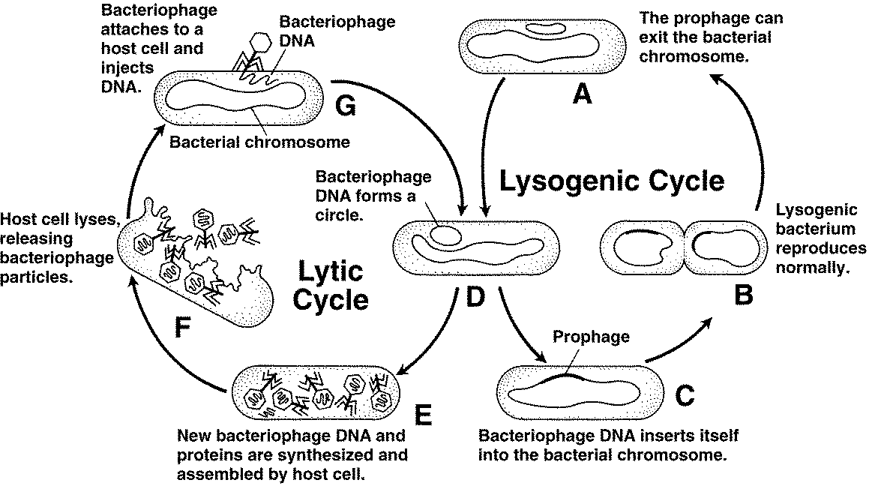

Figure 20–7

  - Look at both cycles shown in Figure 20–7. During which cycle is the host cell destroyed? (Circle one).
- Lytic Cycle
- Lysogenic Cycle
  - Each stage of the cycles is labeled with a letter. Which letter indicates the stage at which the bacteriophage’s DNA becomes a part of the host cell’s DNA? ___________
  - Which letter indicates the stage at which a host cell begins producing new bacteriophages? ___________
  - Which letter indicates the stage at which a bacteriophage injects its DNA into a host cell? ___________
  - Which letter indicates the stage at which symptoms of the viral disease will occur? ___________
  - Which letter in Figure 20–7 indicates the stage at which the organism that is infected will have the disease for the rest of their life? ___________

15. What is the main difference between the lysogenic and lytic cycle?
a. Only lytic injects their genetic material into the host cell.
b. Lysogenic does not lyse the host cell right away.
c. Lytic does not infect host cells.
d. There are no differences between them

16. Read the following statements that describe an HIV infection. What is the correct order in which they occur?

1) Reverse transcriptase uses viral RNA as a template to make viral DNA.
2) Virus coat fuses with cell membrane and viral RNA enters the cell.
3) Virus attaches to host cell membrane.
4) The new viruses bud off from the host cell membrane.
5) Viral DNA enters nucleus and inserts itself into host DNA.
6) Viral mRNA directs the host cell to assemble viral proteins.

a) 2,3,6,1,5,4 b. 2,3,1,5,6,4
c. 3,2,1,6,5,4 d. 3,2,1,5,6,4

17. Viral diseases can be
a. treated with antibiotics and prevented with vaccines.
b. treated with vaccines and prevented with antibiotics.
c. prevented with antibiotics but not treated with vaccines.
d. prevented with vaccines but not treated with antibiotics.

18. How do viruses cause disease?
a. by releasing toxins
b. by destroying cells or affecting cellular processes
c. by changing normal proteins into misfolded proteins
d. by inserting prophages into human DNA

19. Viral infections can be prevented by vaccines, which are
a. chemicals that destroy viral DNA.
b. substances that cause viral proteins to misfold.
c. drugs that control the growth and reproduction of viruses.
d. preparations of weakened or killed viruses.

20. How does a virus differ from a cell?
a. viruses are much larger than the largest cells.
b. a virus cannot copy itself unless it is inside a living cell.
c. cells make people sick, but viruses heal them.
d. cells have genetic material while viruses do not

21. A virus causes disease by
a. forcing human cells to make copies of viruses which eventually destroys the human cells
b. causing immune cells to divide too rapidly
c. changing the cell cycle so cells in the body grow into tumors
d. attacking the cells of major organs like the liver until they fail and cause death

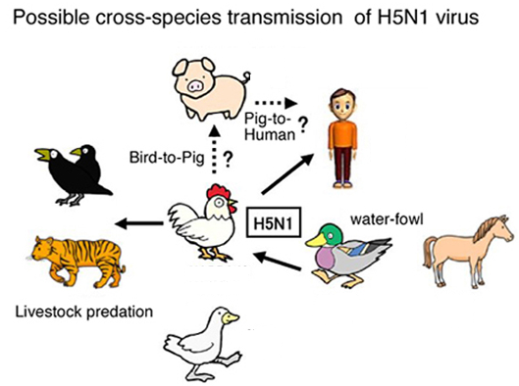
22. H5N1 is a deadly virus. Only about 50% of persons infected with this virus survive. The chart below shows some possible ways H5N1 can be transmitted. An H5N1 outbreak may be difficult to contain and control because

a. there are no antibiotics available which are effective against H5N1
b. H5N1 can be transmitted to many different species
c. H5N1 is transmitted by eating an infected organism
d. chickens are highly mobile species so spread H5N1 over large geographic areas

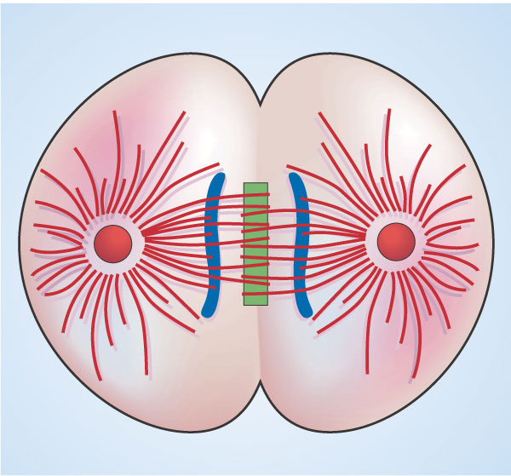
23. The cell in the diagram above is infected with a virus. It is in the process of dividing normally. This cell is most likely infected with
a. a lysogenic virus b. a lytic virus
c. a living virus d. a mitosis virus

24. Examine the picture below of 3 different types of viruses.
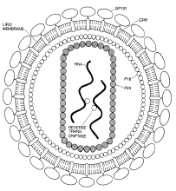
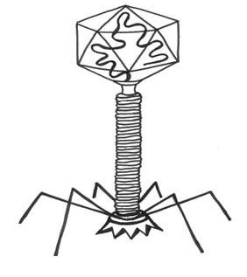
What 2 structures do all viruses have in common?
1. ___________________________
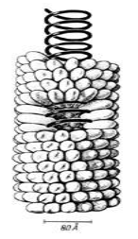
2. ___________________________

How does a typical virus get inside a cell?
____________________________________
____________________________________________________

