Name: ________________________________ Period: ____ Date: _________________
Biology Fall Semester Exam Review
You may complete your answers on this sheet of paper OR write the question number and answer on a separate sheet of paper. However, NO typed answers will be allowed. This handout can be used as a reference during the Semester exam.
Biochemistry
- Differentiate between micromolecule and macromolecule.

- What is a polymer? A monomer?

- Identify the four macromolecules.

- For each macromolecule, identify the (a) monomer/subunit , (b) function and (c) give at least 3 examples of each macromolecule.

- Draw and label a diagram of the monomer of each macromolecule.

- On page 58 of your textbook, look at the picture showing an enzyme-substrate complex. Copy and label it.

- What are enzymes?

- How do enzymes alter activation energy?

- What is/are the relationship between enzyme, temperature and pH?

- What do the following enzymes catalyze? (a) lipase (b) maltase (c) protease

- What is meant by denatured enzyme?
Cells/Cellular Processes
- Bacterial cells are _________________________ (prokaryotic or eukaryotic) cells.

- What are the functions of the following organelles? Ribosome; Nucleus; Mitochondria, Cell membrane; Cell Wall, Chloroplast

- List in order, the movement of proteins in a cell. Begin with the organelle that makes proteins.

- Name the levels of organization from smallest to largest starting with cells & ending with organ systems (4 levels).

- In active transport, what is the function of carrier proteins in the cell membrane? (HINT: Are substances moved up or down their concentration gradient? Is energy used?)

- Define diffusion. Does it require energy?

- What organelles do plant & animal cells have in common?

- True or False:
______All cells have the same shape
______All cells are surrounded by a cell wall
______All cells belong to organ systems
______All cells require energy to survive

- What is the MAIN difference between prokaryotic cells & eukaryotic cells?

- Bacteria that contain chlorophyll have what in common with plants?

- What happens when a cell is placed in a:
  - Hypotonic solution?
  - Hypertonic solution?
  - Isotonic solution?
Energy: Photosynthesis & Cellular Respiration
- Reading pg 111, explain what cells “do” with the energy released from glucose? Why can’t they use the energy all at once?

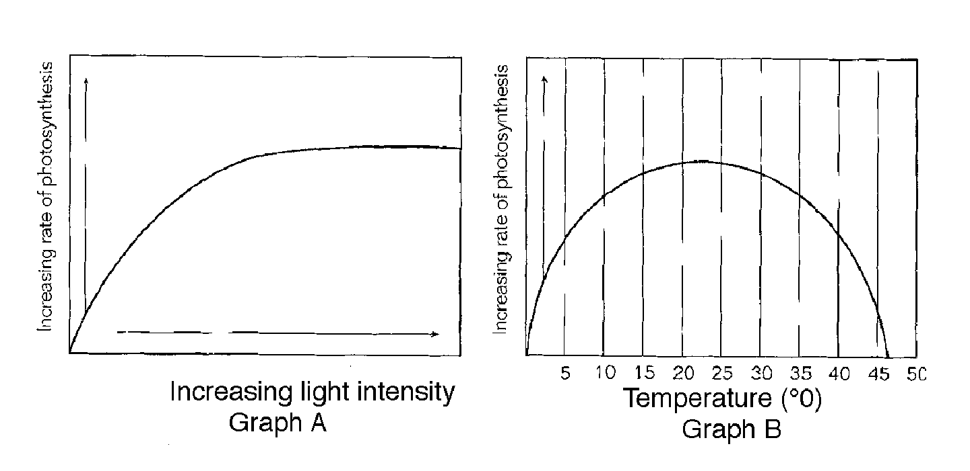
- In the graphs above, what happens to the rate of photosynthesis as light intensity increases? What happens to the rate of photosynthesis as the temperature increases?

- Look at the graph above. A student collects a gas coming off of a plant at 25 degrees in bright sunlight. Most likely, which gas is this?

- Write the formula for cellular respiration. Where is this reaction completed? (which organelle)

- What is the difference between anaerobic and aerobic? In which condition does glycolysis occur?

- What are the 2 types of anaerobic respiration? State 2 products of each.

- Why are there chloroplasts and mitochondria? How do these two organelles work together in plants? see pg 119 in your book

- What are the three smaller molecules that make up an ATP molecule? See page 98

- Photosynthesis enables plants to convert carbon dioxide and water into what?

- If a plant was placed in an environment lacking carbon dioxide, what would happen to its production of sugars and starches?

- Using page 631, how do guard cells maintain homeostasis?

- What are the reactants and the products of cellular respiration?

- How many ATP does it take to start glycolysis? What is the net gain of ATP after the process of glycolysis?

Nucleic Acids: DNA/RNA
- Draw and label the parts of a nucleotide.

- During DNA replication, a complementary strand of DNA is made for each original DNA strand. Thus, if a portion of the original strand is 5’ TAGCTAGC 3’, then the new strand will be?

- If a DNA segment is 5’ TAG CAT ATT 3’, then the corresponding mRNA strand will be?

- What nitrogenous base is present in RNA but absent in DNA?

- Describe the function of each type of RNA. Draw a picture to represent each type of RNA.

- Which type of biomolecule (lipid, protein, nucleic acid, or carbohydrate) functions to store and transmit genetic information?

- What are the 4 nitrogenous bases in DNA? In RNA?

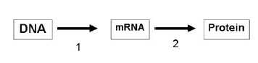
- Explain the diagram below. Tell which process occurs at number 1 and which occurs at number 2. Give the location that each occurs.

- The following is an mRNA sequence: GUACUU. What is the DNA segment from which it was transcribed?

- Explain the base pairing rule. What did Erwin Chargaff discover regarding the amount of nitrogenous bases?

- Know how to use a codon chart. The sequence AGA UCG AGU is changed to ACA UCG AGU. How will this affect the amino acid sequence?
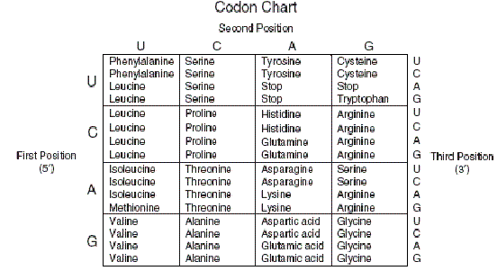

- The order of nitrogenous bases in DNA determines what?

- What is a codon? How many codons would be needed to specify four amino acids?

- Define translation and explain where in the cell it occurs.

- Define transcription and explain where in the cell it occurs.

- Define mutation. Explain all types of mutation.

- To determine the molecular sequence of a gene for a protein, a scientist should analyze what? (Hint: 3 letters—what has the instructions for making a protein?)

Cell Division
- When a neuron (nerve cell), a white blood cell, and a lung cell are compared, the DNA is identical in each, yet they have different shapes and functions. Why?

- Before a cell enters M phase or mitosis, what must happen during S phase?

- Examine the picture below and label each phase.
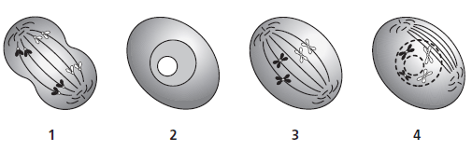

- If a cell with 49 chromosomes undergoes mitosis, how many chromosomes will each cell have at the end?

- If mutations occur in a cell located in your skin, can those mutations be passed on to your children?

- What is the effect of the sorting and recombination of genes during meiosis and fertilization on genetic diversity?

- If a somatic cell has 22 chromosomes, how many chromosomes will a gamete have?
Genetics
- Differentiate between the following terms: chromosome, chromatid, homologous chromosomes, gene, allele, genotype, phenotype, autosomes and sex chromosomes.

- Differentiate between the terms homozygous and heterozygous. Indicate which is purebred and which is hybrid.

- Differentiate between the following patterns of inheritance and include one known genetic disorder associated with each type: dominant, recessive, and sex-linked.

- Indicate whether the following genotypes are Dominant, Recessive OR Sex-linked, then indicate whether they are Homozygous or Heterozygous: A. TT B. Tt C. tt D. X^{h}Y

- How many chromosomes should a healthy female egg contain? How many total chromosomes should a normal person have? What is a karyotype? Where on a karyotype would you expect to find the autosomes? On which pair could you identify the gender? Which two sex chromosomes indicate a male? A female? How many sex chromosomes are in a sperm cell? Why?

- Set up a Punnett Square for the following: A male who is diagnosed with hemophilia has children with a female who is a carrier for hemophilia. What are the genotypes for each parent? What pattern of inheritance does hemophilia fall under? What percentage of the females will be normal? How many females are carries? What percentage of the males have hemophilia? Can males be a carrier for hemophilia? Why or why not?

- Sickle-cell anemia is a recessive genetic disorder that is characterized by the formation of abnormal red blood cells which often results in the inadequate transport of oxygen gas throughout the body. If a normal male has children with a female who is a carrier for Sickle cell what is the ratio of children that are carriers to children that are normal? What is the ratio of children who have Sickle cell anemia to those who are not “infected” with this disease?

- Blood type is characterized by a co-dominant pattern of inheritance. Cross a male who has heterozygous A blood with a female who has AB blood. What is the genotype of each parent? What percentage of the offspring will have blood like the mother? How many offspring will have some type of heterozygous blood? *Could these two parents produce an O blooded child? Why or why not?

- Down syndrome is a genetic disorder caused by the presence of an extra chromosome in the body cells of humans. What type of chromosomal mutation causes result in this disorder? Where on a karyotype would you expect to find the extra chromosome for Down syndrome? Is this trisomy or monosomy?

- Is the karyotype of a male or female? Does this individual suffer from a trisomy
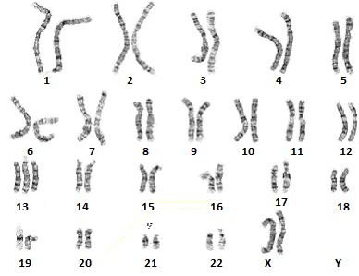
or monosomy disorder? Where is the disorder located?

- Briefly discuss the genetic engineering process of how geneticists use bacterial
plasmids to create human insulin.

- Analyze the following pedigree. Determine if the disorder is autosomal or
sex-linked. Dominant or recessive. What genotype would you assign the son?
