Name: __________________________________________________________ Date: ______________ Period: ________
Bikini Bottom Genetics- Monohybrid Crosses
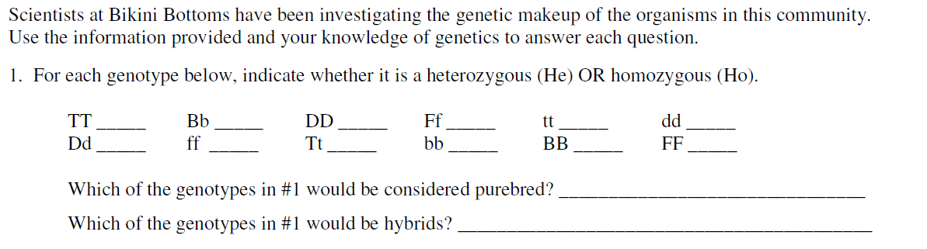

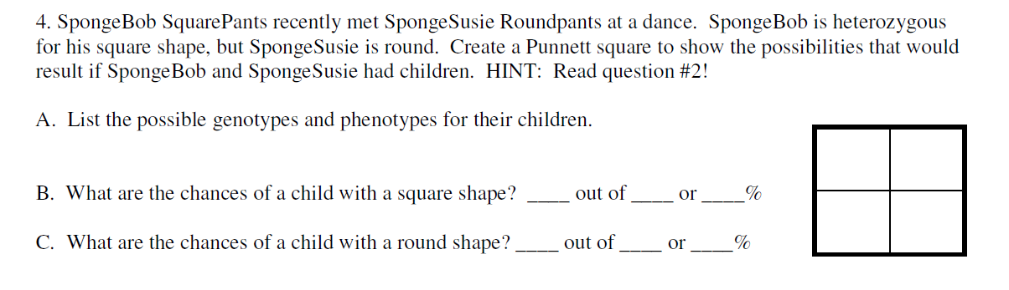
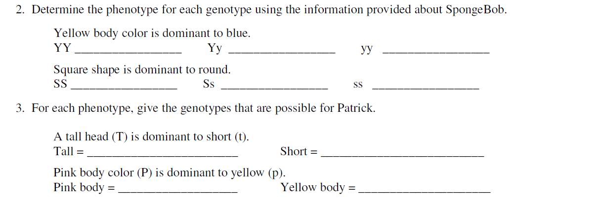
D. Determine the genotypic ratio of the offspring. ____________________
E. Determine the phenotypic ratio of the offspring. ____________________
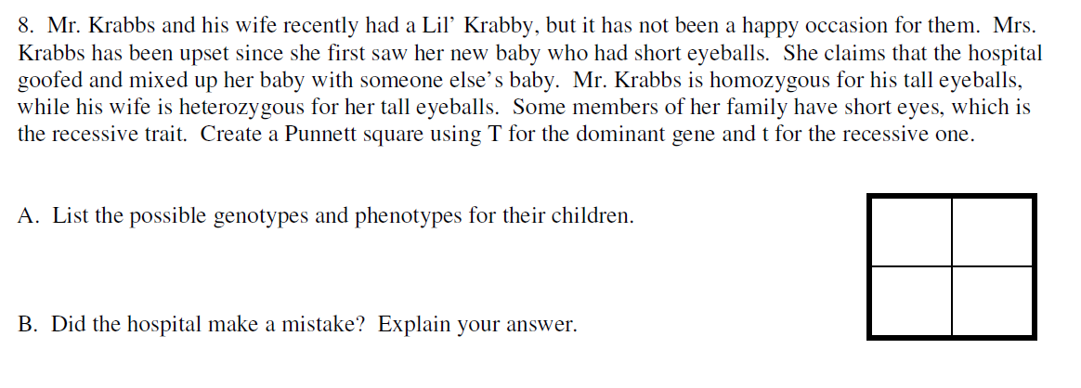
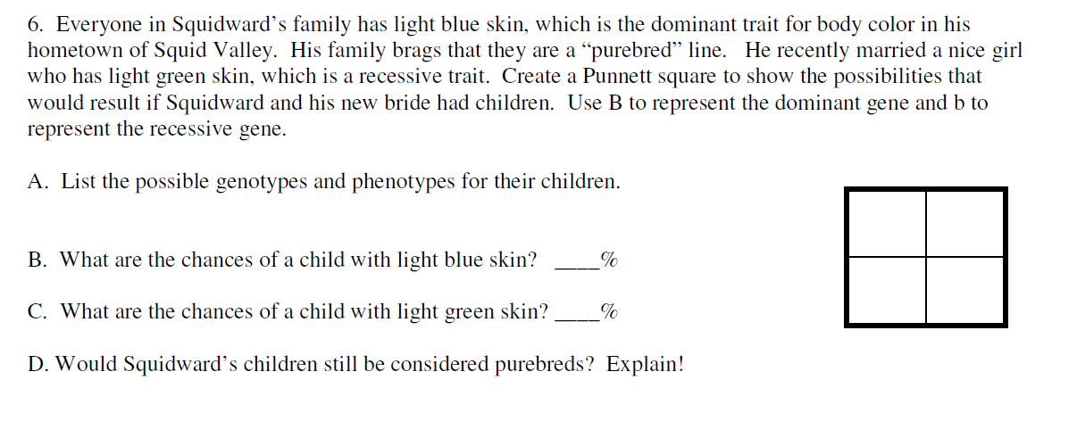
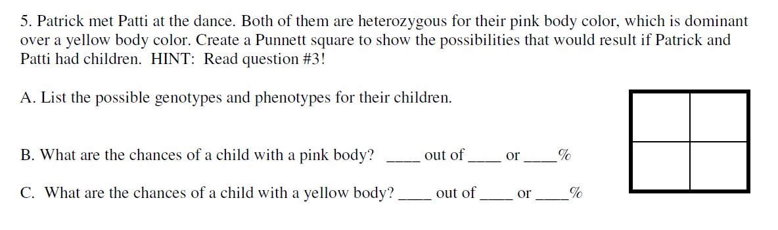
7.
E. Determine the genotypic ratio of the offspring. ____________________
F. Determine the phenotypic ratio of the offspring. ____________________
D. Determine the genotypic ratio of the offspring. ____________________
E. Determine the phenotypic ratio of the offspring. ____________________

