SKELETAL SYSTEM
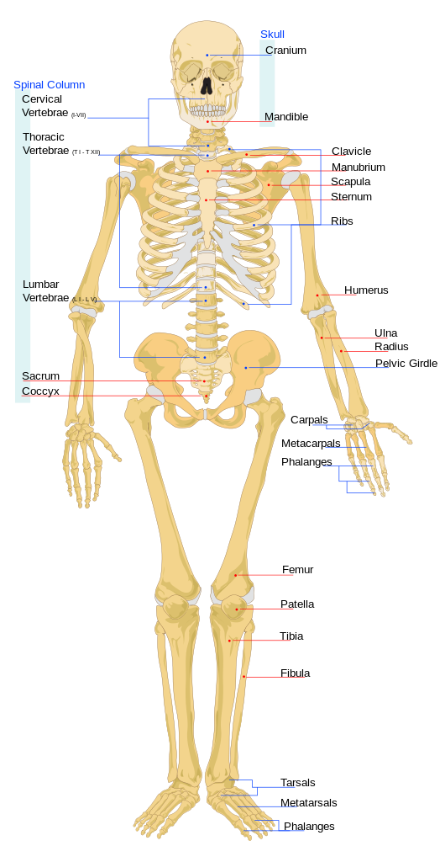
THE SKELETAL SYSTEM PROVIDES STRUCTURE AND SUPPORT. IT PROVIDES ATTACHMENT SITES FOR MUSCLES AND TENDONS WHICH ALLOWS FOR THE LEVERAGE THEY NEED TO MOVE US AROUND. INSIDE THE BONES CELLS AND OTHER SUBSTANCES ARE MADE WHICH HELP US FIGHT OFF INFECTION AND PERFORM OTHER IMPORTANT FUNCTIONS IN THE BODY.

URINARY SYSTEM
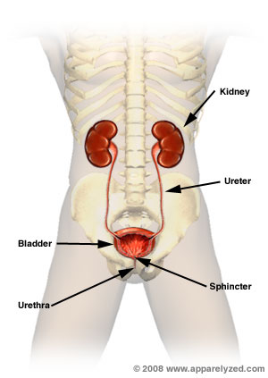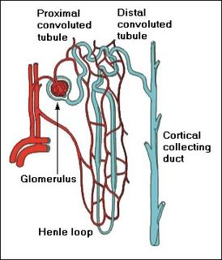s605.photobucket.com

THE URINARY SYSTEM IS PART OF THE EXCRETORY SYSTEM IN WHICH WASTES ARE REMOVED FROM THE BODY. THE KIDNEYS FILTER WASTE AND TOXINS FROM THE BLOOD. THE WASTE IS THEN STORED IN THE BLADDER UNTIL IT IS EXCRETED. THE KIDNEYS ALSO HOLD BACK OR EXCRETE WATER ACCORDING TO THE BODY’S NEEDS AT THE TIME

A nephron is where the kidney interacts with the circulatory system.

NERVOUS SYSTEM

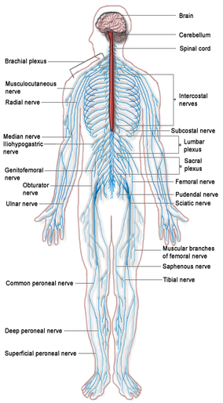
THE NERVOUS SYSTEM GENERATES AND CARRIES MESSAGES BACK AND FORTH FROM THE BODY TO THE BRAIN ALLOWING US TO RESPOND TO STIMULI SUCH AS COLD, THIRST OR DANGER. IT ALSO TRANSMITS MESSAGES BETWEEN ORGANS TO KEEP US ALIVE BY KEEPING US BREATHING AND KEEPING OUR HEART BEATING. IT ALSO ALLOWS US TO CONCIOUSLY CONTROL MUCH OF OUR MOVEMENT AND INTERACTIONS WITH THE WORLD.

CARDIOVASCULAR SYSTEM
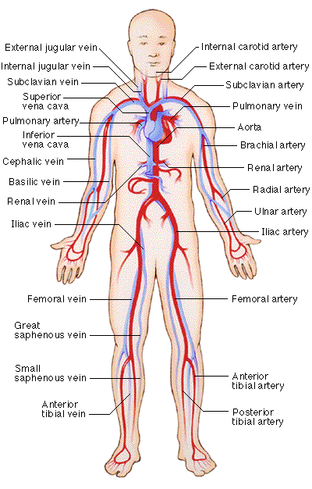
THE CARDIOVASCULAR SYSTEM FUNCTIONS DELIVER NUTRIENTS, WATER, HORMOMES AND OXYGEN TO THE BODY’S CELLS. IT ALSO CARRIES AWAY WASTES PRODUCED BY CELLS TO BE EXCRETED.

DIGESTIVE SYSTEM
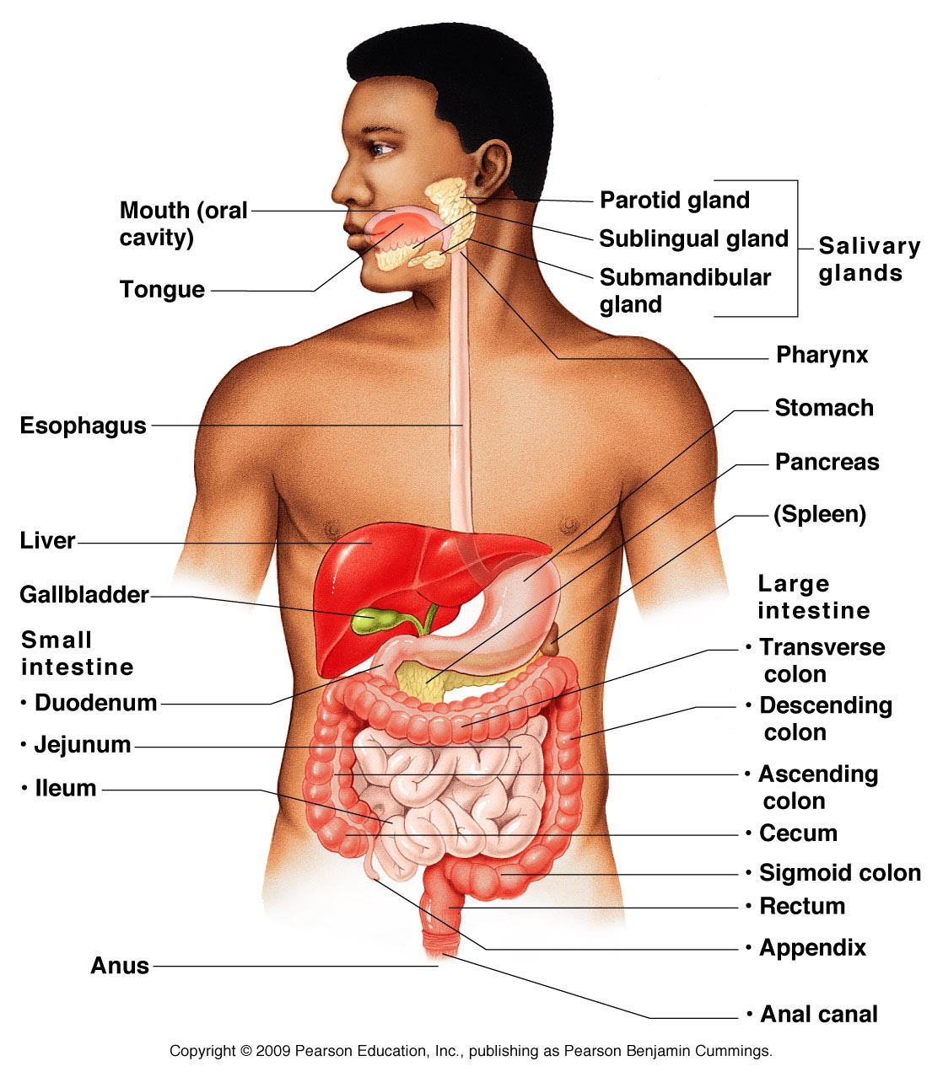

THE DIGESTIVE SYSTEM TAKES IN FOOD AND LIQUIDS AND BREAKS THEM DOWN INTO A FORM THE BODY’S CELLS CAN USE. THIS SYSTEM ALSO FUNCTIONS TO EXCRETE WASTES PRODUCED BY THE BODY.

REPRODUCTIVE SYSTEM
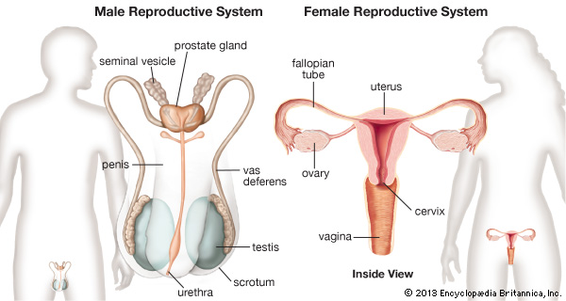

THE REPRODUCTIVE SYSTEM CREATES SPECIALIZED CELLS WHICH CARRY GENETIC INFORMATION FROM THE MALE AND FEMALE. WHEN THE CELLS COMBINE TO CREATE A ZYGOTE THE FEMALE REPRODUCTIVE SYSTEM FUNCTIONS TO NOURISH, PROTECT AND SUPPORT THE ZYGOTE AS IT DEVELOPS INTO A NEW PERSON. THE FINAL FUNCTION IS TO DELIVER THE NEW PERSON OUT OF THE BODY.

MUSCULAR SYSTEM
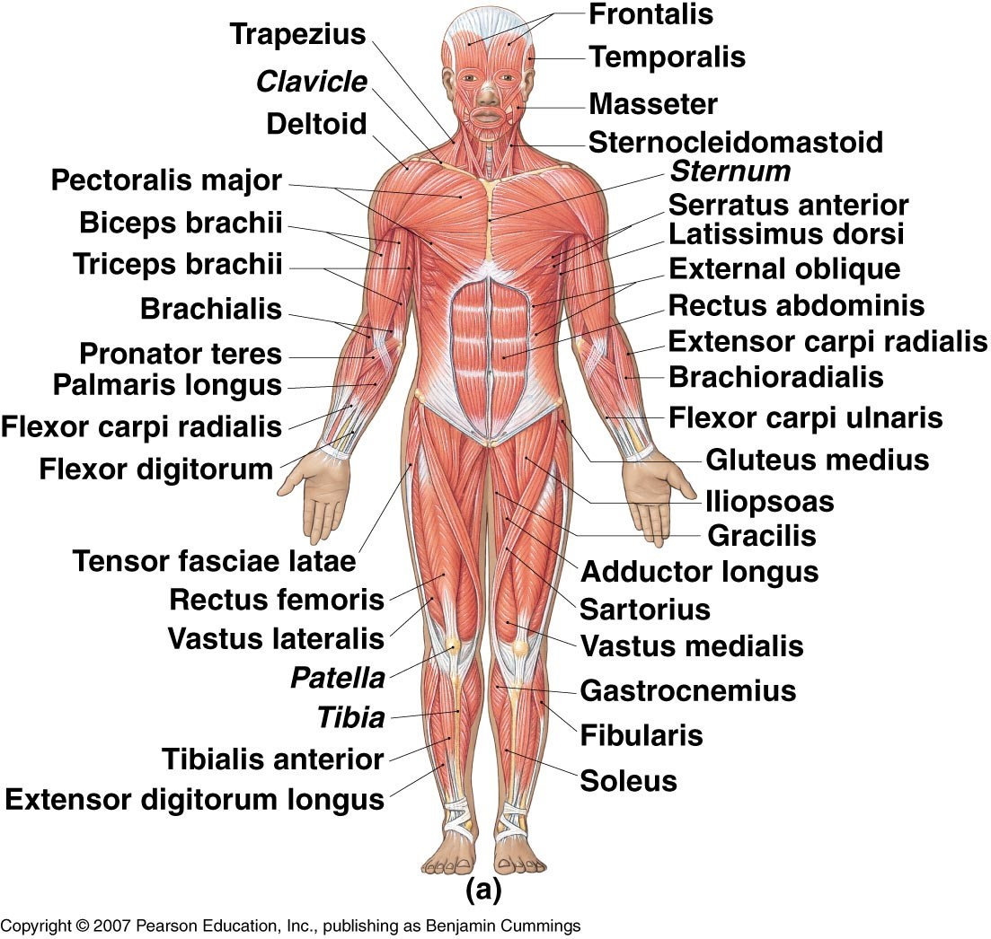

THE MUSCULAR SYSTEM IS RESPONSIBLE FOR THE MOVEMENT NECESSARY FOR US TO SURVIVE. IT ALLOWS US TO WALK, BLINK, TALK, TAKE A BREATH AND MOVE FOOD THROUGH OUR DIGESTIVE SYSTEM AND MAKE MANY OTHER MOVEMENTS.

ENDOCRINE SYSTEM
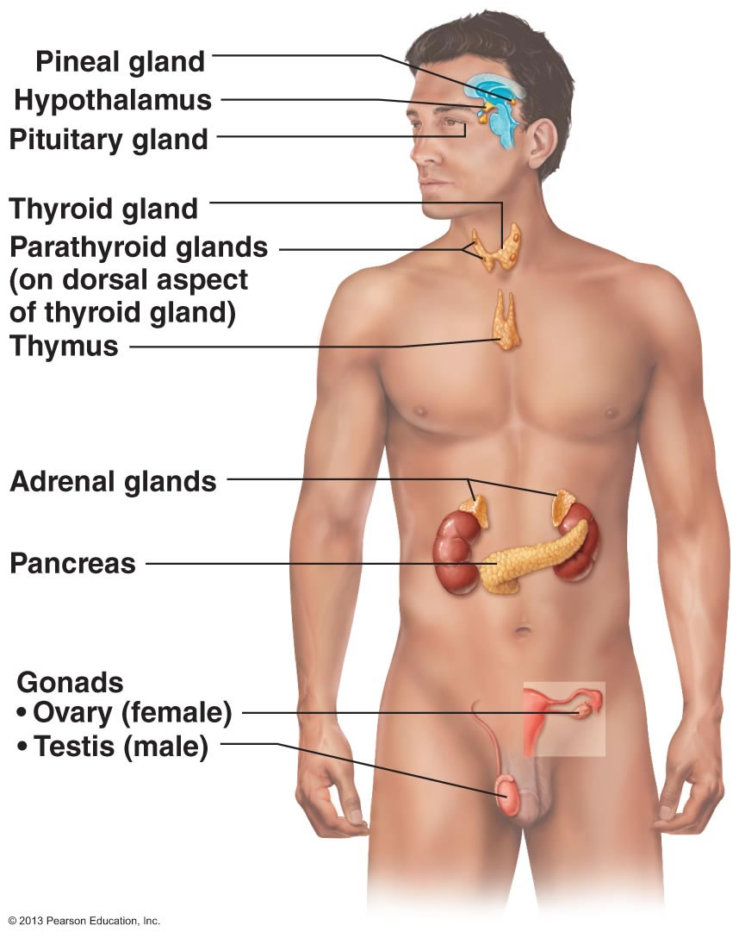
THE ENDOCRINE SYSTEM FUNCTIONS TO SECRETE HORMONES WHICH CONTROL AND REGULATE MANY PROCESSES THE BODY REQUIRES TO FUNCTION AND SURVIVE. SOME OF THE FUNCTIONS REGULATED BY THE HORMONES & SECRETED BY THE ENDOCRINE SYSTEM ARE GROWTH, REPRODUCTION, AMOUNT OF FLUID RETAINED AND LEVELS OF SALTS IN THE BLOOD.

INTUGEMENTARY SYSTEM
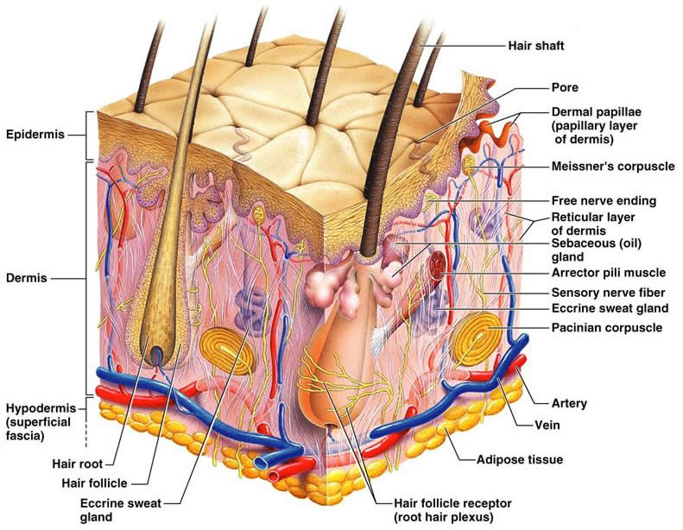

THE INTUGEMENTARY SYSTEM FUNCTIONS AS A BARRIER. IT HELPS PREVENT FLUID LOSS AND INFECTION. IT HELPS KEEP US COOL BY PRODUCING SWEAT AND WARM BY CONSTRICTING BLOOD VESSELS TO REDUCE HEAT LOSS. ITS MANY NERVE ENDINGS ALLOW US TO SENSE THINGS ABOUT OUR WORLD.

IMMUNE SYSTEM
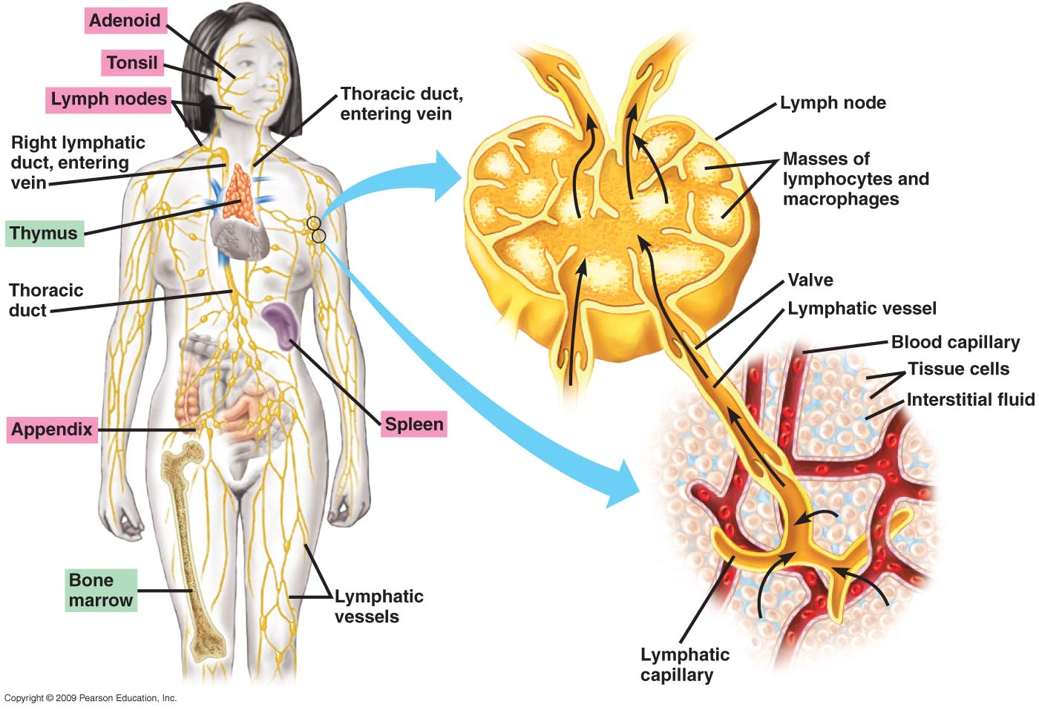

THE IMMUNE SYSTEM PROVIDES PROTECTION AGAINST VIRUSES, BACTERIA AND ABNORMAL CELLS SUCH AS CANCER CELLS. IT IS MADE UP OF SPECIAL CELLS WHICH CAN RECOGNIZE AND DESTROY DANGEROUS INVADERS IN THE BODY AND THE ORGANS WHICH REGULATE AND PRODUCE THOSE PROTECTIVE CELLS.

RESPIRATORY SYSTEM
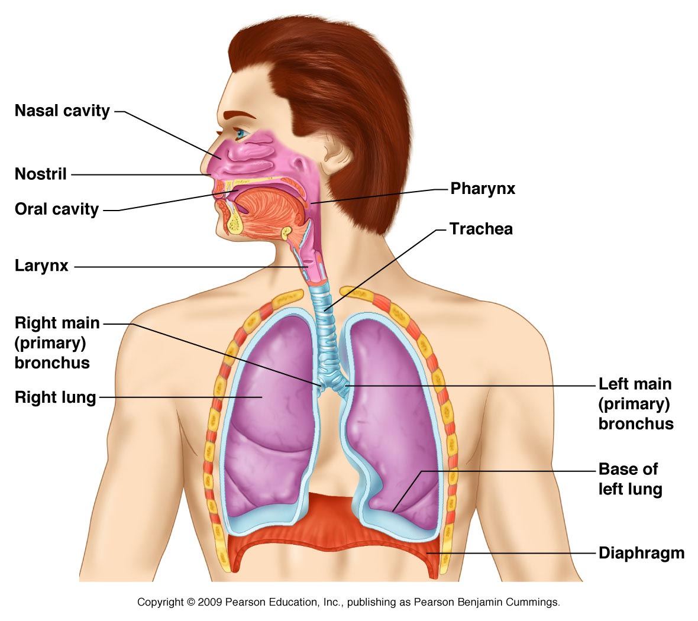
THE RESPIRATORY SYSTEM FUNCTIONS TO BRING IN OXYGEN THE BODY’S CELLS NEED TO FUNCTION AND DISPOSE OF CARBON DIOXIDE WASTE. THESE GASES ARE EXCHANGED IN THE LUNGS WHERE THE RESPIRATORY SYSTEM IS IN DIRECT CONTACT WITH THE CIRCULATORY SYSTEM.

STATION 1
INTERACTION OF BODY SYSTEMS
RESPIRATORY AND CARDIOVASCULAR SYSTEMS
USE THE BODY SYSTEMS CARDS TO HELP YOU ANSWER THE FOLLOWING QUESTIONS
1. A basketball player sits on the bench after a long play. His breathing is very fast. Which of the following statements best explains his condition?

    - His respiratory system is trying to catch up to the oxygen demands of his heart which has been beating rapidly during the play.

    - His respiratory system is trying to catch up to the carbon dioxide demands of his heart which has been beating rapidly during the play.

    - Breathing rapidly massages and stimulates the heart to pump more effectively.

    - Breathing rapidly serves to warm the cardiovascular system and increase its efficiency.

2. When doing CPR a doctor must compress the heart and give breaths by blowing air into the lungs of the patient. Why would just giving breaths be ineffective and lead to the patient’s death?
STATION 2
INTERACTION OF BODY SYSTEMS
URINARY AND CARDIOVASCULAR SYSTEMS
USE THE BODY SYSTEMS CARDS TO HELP YOU ANSWER THE FOLLOWING QUESTIONS
1. A marathon runner is running through a desert area in between rest stops. It has been two hours since he has had a chance to drink water. Which of the following statements best describes what is going on in his body?

    - His urinary system is taking more water from his bloodstream to keep him cool.
.
    - His urinary system is taking less water from his bloodstream to prevent dehydration.

    - His cardiovascular system is producing less toxins for his kidneys to filter out.

    - His cardiovascular system is delivering the extra carbon dioxide his kidneys require when stressed.

2. Explain why a person whose kidneys are failing become very ill due to high levels of toxins in their blood.

STATION 3
INTERACTION OF BODY SYSTEMS
RESPIRATORY AND MUSCULAR SYSTEMS
USE THE BODY SYSTEMS CARDS TO HELP YOU ANSWER THE FOLLOWING QUESTIONS
1. A person with pneumonia has blockages in the passageways of their respiratory system. How would this affect their ability to do physical exercise?

    - The blockages in the respiratory system may migrate to the blood vessels preventing blood from reaching the muscles reducing the amount of exercise the person could do.
.
    - The blockages in the respiratory system will prevent enough oxygenated blood from reaching the muscles reducing the amount of exercise the person could do.

    - The blockages in the respiratory system will cause a build-up of oxygen in the blood increasing the amount of exercise the person could do.

    - The blockages in the respiratory system will cause a build-up of carbon dioxide in the blood increasing the amount of exercise the person could do.

2. Explain why a person’s breathing rate increases as they use their muscles more and more while exercising.
STATION 4
INTERACTION OF BODY SYSTEMS
MUSCULAR AND SKELETAL SYSTEMS
USE THE BODY SYSTEMS CARDS TO HELP YOU ANSWER THE FOLLOWING QUESTIONS
1. A weight lifter is able to bend his arm and lift a weight because

    - The bones in his arm act as levers for his muscles to pull against.
.
    - The muscles in his arm are not attached to the bones.

    - The muscles in his arm receive oxygen and nutrients from the bones.

    - The bones in his arm receive oxygen and nutrients from his muscles.

2. When a person has a major break in the large bones of the legs the muscles of that leg become smaller and weaker while the person is healing. Explain why this happens.

STATION 5
INTERACTION OF BODY SYSTEMS
REPRODUCTIVE AND ENDOCRINE SYSTEMS
USE THE BODY SYSTEMS CARDS TO HELP YOU ANSWER THE FOLLOWING QUESTIONS
1. A girl does not experiences the signs of puberty (menstruating, breast development). This is most likely due to

    - Endocrine system glands producing sex hormones.
.
    - Endocrine system glands not producing sex hormones.

    - A lack of glucose from the endocrine glands to the reproductive organs.

    - A lack of blood produced in the endocrine system.

2. Some athletes use anabolic steroids. Anabolic steroids are normally produced in the body by the testes, part of the endocrine system. When additional anabolic steroids are taken by mouth or injected, an athlete’s body responds by building more lean muscle mass. Other effects of anabolic steroids not naturally produced by the body are growth of breasts in men and testes which become smaller and don’t function normally. Define anabolic metabolism and discuss how the use of anabolic steroids can affect a male’s ability to reproduce normally.
STATION 6
INTERACTION OF BODY SYSTEMS
NERVOUS AND INTUGEMENTARY SYSTEMS
USE THE BODY SYSTEMS CARDS TO HELP YOU ANSWER THE FOLLOWING QUESTIONS
1. When exposed to the cold the skin responds by contracting small muscles which make hairs stand on end. These bumps are sometimes called “goose pimples”. Which of the following most accurately reflects the process which results in “goose pimples”?

    - Nerve endings in the skin sense the cold and send a signal to the brain to raise body hairs to keep warm.
.
    - Nerves in the skin contract causing hairs to stand up.

    - Skin cells clump together to make hairs stand on end.

    - Nerve cells in the brain sense cold and send signals to raise hairs on the skin’s surface. .

2. When a person becomes overheated the skin produces sweat to help cool the body? How do you think the skin “knows” when to begin producing sweat?

STATION 7
INTERACTION OF BODY SYSTEMS
DIGESTIVE AND CARDIOVASCULAR SYSTEMS
USE THE BODY SYSTEMS CARDS TO HELP YOU ANSWER THE FOLLOWING QUESTIONS
1. Waste from the body’s cells is excreted in the digestive system. Which statement below most accurately describes this process?

    - Cells migrate to the lower digestive system and “dump” their waste materials.

    - Waste from cells is carried to the digestive system through the blood vessels.

    - Only cells of the cardiovascular system produce waste which is then pumped by the heart to the digestive system.

    - Only cells of the digestive system create waste. The cardiovascular system provides oxygen to assist these cells in processing their waste.

2. It was commonly thought that the amino acid tryptophan in turkey would cause people to become lethargic after eating Thanksgiving dinner. However, this was found to be false when scientists realized that people become tired due to the amount of food eaten. When a person eats a large amount of food, the circulatory system sends blood to the stomach and intestines in order to speed up the digestive process. Based on your knowledge of the body systems, which two systems are involved and why is this necessary? (Hint: blood carries oxygen).

STATION 8
INTERACTION OF BODY SYSTEMS
RESPIRATORY AND IMMUNE SYSTEMS
USE THE BODY SYSTEMS CARDS TO HELP YOU ANSWER THE FOLLOWING QUESTIONS
1. White blood cells are special cells that attack foreign invaders in the body. How might the body respond to a person with a bacterial infection of the respiratory system?

    - The immune system would decrease the number of white blood cells.
    - The immune system would increase the number of white blood cells in the lungs.
    - The immune system would send hormones to the lungs to fight the infection.
    - White blood cells would cause lung cells to begin dividing rapidly.

2. Below are blood test results from two different patients. One of them has an infection in their respiratory system. Which one has the infection and how do you know?
Blood Test Results
Patient B
Red Blood Cell  Count | 6.2 m
Sodium | 137
Oxygen level | 89%
White Blood Cell  Count | 22,000 m

Blood Test Results
Patient A
Red Blood Cell  Count | 4.2 m
Sodium | 134
Oxygen level | 98%
White Blood Cell  Count | 5200 m

