Name: _______________________________________Date: ____________Period: ___________
Animal System Interactions

Directions: Part 1: Refer to the pictures of the animal systems below and label them using the word bank provided to you.
Part 2: For each of the following scenarios, highlight any hints that help you determine the two body systems interacting together. These hints can be hormones, glands, macrophages or any of the following:
1). the system’s function (transport, protect, movement, 1st line of defense, etc.)
2). the system’s organs/ tissues (heart, skin, bones, smooth muscle tissue, blood, hair, skin, nails etc.)
3). cells that make up a specific animal system (macrophages, red blood cells, white blood cells, etc.)
Part 1:
Word Bank: Circulatory, Immune, Endocrine, Skeletal, Digestive, Nervous, Respiratory, Excretory, Integumentary and Muscular

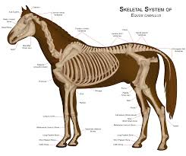  __________________________ | 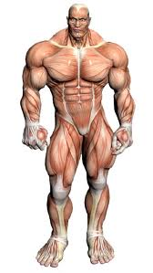  ________________________ | 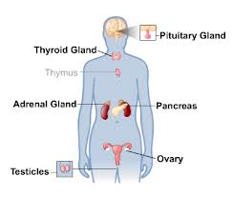  ___________________________
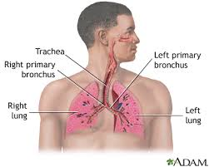  ___________________________ | 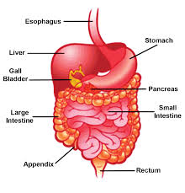  __________________________ | 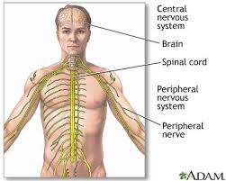  ___________________________
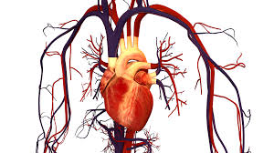  __________________________ | 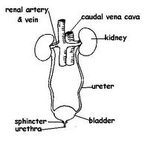  ___________________________ | 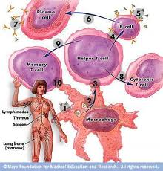  ___________________________

Part 2:
Highlight the “hints” in each of the following interactions: | Name the two systems involved.  (circulatory & immune, etc.) | Justify your answer.  Refer to the scenario and your highlighted hints and explain why you chose those systems.
1. Ingested food is broken down and absorbed nutrients are delivered to cells. | System 1:  System 2: | System 1:  System 2:
2. Humans ingest food and muscles control the contractions of many of the digestive organs to pass food along | System 1:  System 2: | System 1:  System 2:
3. The hypothalamus  maintains homeostasis by  triggering appetite  (stomach growling), digest | System 1:  System 2: | System 1:  System 2:
4. Deliver O2 from  lungs to cells and drop off CO2 from cells to lungs | System 1:  System 2: | System 1:  System 2:
5. Kidneys filter cellular waste out of blood for removal | System 1:  System 2: | System 1:  System 2:
6. Tissue transports white blood cells throughout body to fight disease | System 1:  System 2: | System 1:  System 2:
7. Red bone marrow produces blood cells | System 1:  System 2: | System 1:  System 2:
8. Controls  pumping of blood (heart) | System 1:  System 2: | System 1:  System 2:
9. Controls all  muscle contractions | System 1:  System 2: | System 1:  System 2:
10. Transports hormones to target organs | System 1:  System 2: | System 1:  System 2:
11. Moves oxygen and glucose around  the body so cells  can do work | System 1:  System 2: | System 1:  System 2:
12. Nostril hairs trap pathogens | System 1:  System 2: | System 1:  System 2:
13. During labor, there is an increase of contractions of the uterus | System 1:  System 2: | System 1:  System 2:
14. Controls  body temperature  (sweating, goose bumps) | System 1:  System 2: | System 1:  System 2:
15. White blood cells gather at the site of a wound on the skin causing inflammation | System 1:  System 2: | System 1:  System 2:
16. Lymph glands swell because of production of T helper cells. | System 1:  System 2: | System 1:  System 2:
17. The diaphragm contracts as a result of inhalation | System 1:  System 2: | System 1:  System 2:

