- The diagrams below show an investigation to find out how light affects the growth of seedlings.

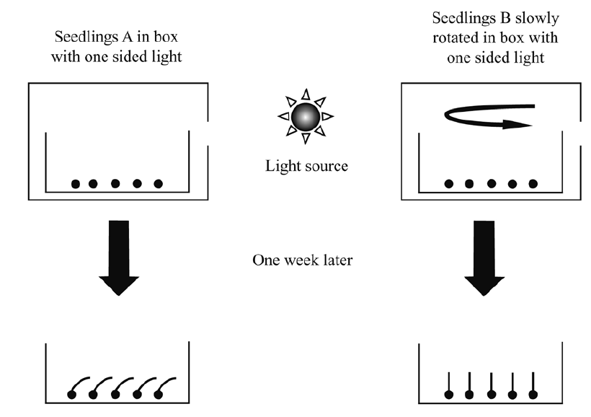

- Which of the terms below describes how the growth of the seedlings responds to light?
A Respiration
B Phototropism
C Geotropism
D Photosynthesis

- Explain how the slow rotation of the seedlings B caused them to grow straight

