- The graph shows the effect of increasing the light intensity on the rate of oxygen production, which is a method for measuring the rate of photosynthesis.
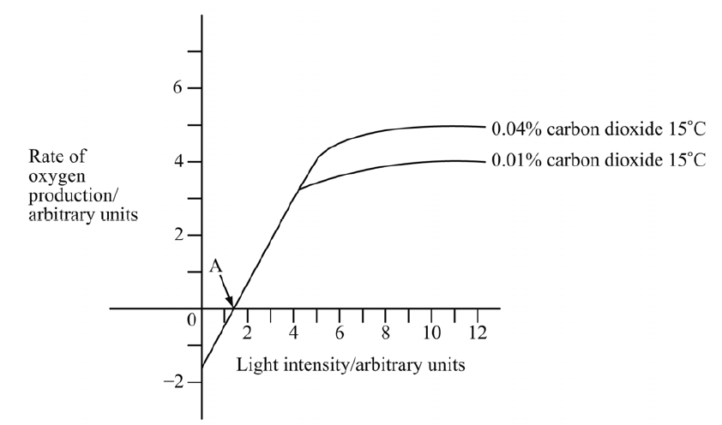

- On the graph, draw a curve showing the rate of photosynthesis at 0.04% carbon dioxide and 25°C.
- Explain why market gardeners enrich the air in their greenhouses with carbon dioxide.

- Explain why the oxygen production is zero at point A.

