Photosynthesis Practice Questions

- The image below is of an Elodea cell.
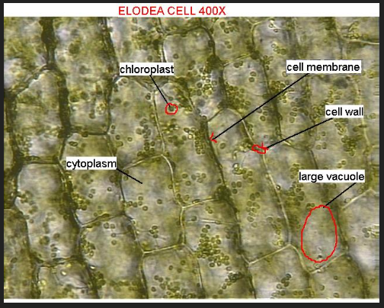 | 1. What type of cell are you viewing? Provide evidence from the slide/image.  2. What is the function of each of the cell structures labeled?  Chloroplast-  Cell wall-  3. What substances would be entering each cell?  4. What substances would be leaving each cell?

- The image below is of an Onion.
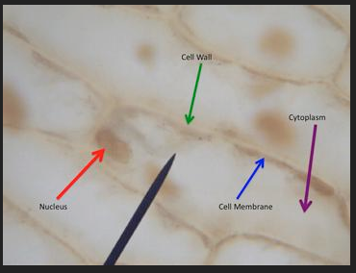 | 1. What type of cell are you viewing? Provide evidence from the slide/image.  2. There are no chloroplasts visible in this cell. How is this possible, considering the onion is a plant?

- Based on these slides (from questions 1 and 2), which cell would be specialized in producing glucose through photosynthesis? Explain.

- Based on these slides (from questions 1 and 2), which cell would be specialized in storing glucose as starch underground? Explain.

- Would a plant placed in an atmosphere of pure oxygen be able to conduct photosynthesis? Explain.
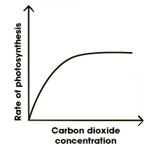
- Examine the graph to the right and answer the following questions.

  - What is the effect of increasing carbon dioxide concentration on the rate of photosynthesis?

  - What are 3 ways that you could measure the rate of photosynthesis?
1.
2.
3.

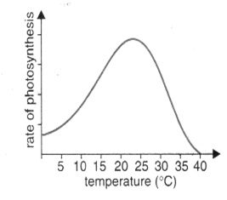
- Examine the graph to the right and answer the following questions.

  - What is the effect of increasing temperature on the rate of photosynthesis?

  - What is the optimum temperature for photosynthetic activity? ________

  - Explain the graph by clearly describing what is happening AND why it is happening.

- Suppose that you ate a hamburger on a wheat roll with lettuce, tomatoes, and onions for lunch. As you ate, you took in food molecules from plants and animals. Explain why all the energy in the food molecules of this hamburger could be traced back to the sun.

- If a plant is kept under green-colored light for an extended period of time, what will happen to the plant’s food production?

- Write down the equation for photosynthesis below.

__________+__________ ________________ + ___________

  - Where does the CO₂ originate?

  - How does CO₂ enter the plant?

  - What happens to the carbon molecules during the process of photosynthesis?

  - What happens to the oxygen molecules during the process of photosynthesis?

  - Where does the H₂O originate?

  - Through what process does the H₂O enter the plant?

  - What happens to the hydrogen atoms from water during the process of photosynthesis?

- Read the passage below and answer the following questions.
**Life hack—read the questions first then come back and read the passage so you can be looking for the answers!**
Cyanobacteria are aquatic and photosynthetic, that is, they live in the water, and can manufacture their own food. Because they are bacteria, they are quite small and usually unicellular, though they often grow in colonies large enough to see. They have the distinction of being the oldest known fossils, more than 3.5 billion years old, in fact! It may surprise you then to know that the cyanobacteria are still around; they are one of the largest and most important groups of bacteria on earth.
Many Proterozoic oil deposits are attributed to the activity of cyanobacteria. They are also important providers of nitrogen fertilizer in the cultivation of rice and beans. The cyanobacteria have also been tremendously important in shaping the course of evolution and ecological change throughout earth's history. The oxygen atmosphere that we depend on was generated by numerous cyanobacteria during the Archaean and Proterozoic Eras. Before that time, the atmosphere had a very different chemistry, unsuitable for life as we know it today.
The other great contribution of the cyanobacteria is the origin of plants. The chloroplast with which plants make food for themselves is actually a cyanobacterium living within the plant's cells. Sometime in the late Proterozoic, or in the early Cambrian, cyanobacteria began to take up residence within certain eukaryote cells, making food for the eukaryote host in return for a home. This event is known as endosymbiosis, and is also the origin of the eukaryotic mitochondrion.
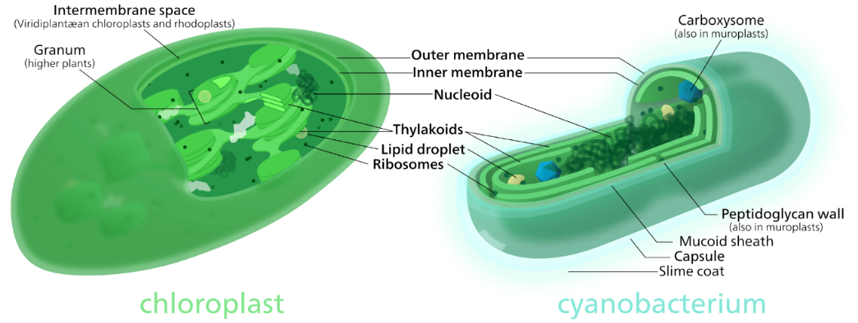
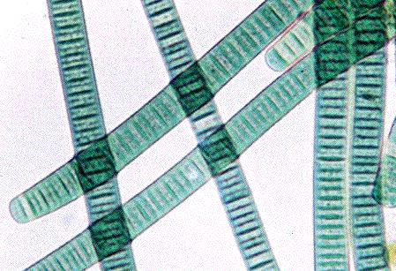
Because they are photosynthetic and aquatic, cyanobacteria are often called "blue-green algae". This name is convenient for talking about organisms in the water that make their own food, but does not reflect any relationship between the cyanobacteria and other organisms called algae. Cyanobacteria are relatives of the bacteria, not eukaryotes, and it is only the chloroplast in eukaryotic algae to which the cyanobacteria are related.

  - What is the basis of distinction between Cyanobacteria being classified as a bacteria or protist?

  - Why are Cyanobacteria considered to have had a significant influence on the evolution of life on Earth? Explain.

  - Why is the addition of the Cyanobacteria in eukaryotic cells beneficial? Explain.

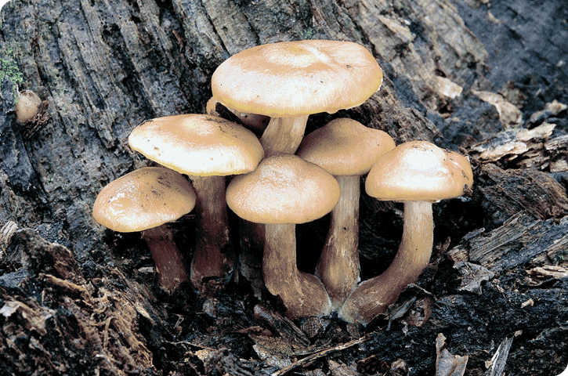
- Examine the picture to the right.

  - What can you infer about this organisms’ ability to make its own food? Explain.

