- The graph below shows changes in the area of Arctic ice.

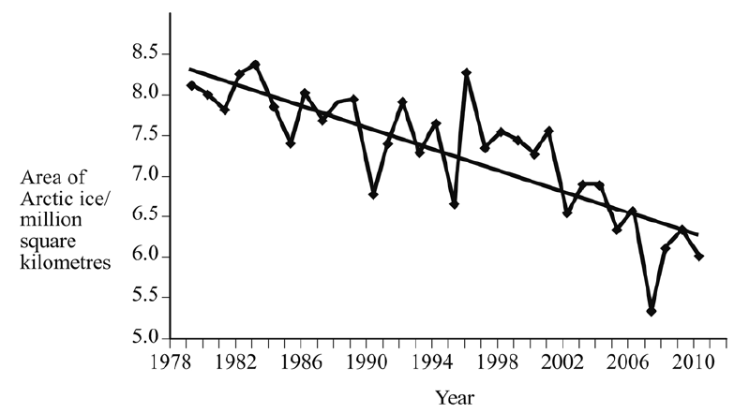

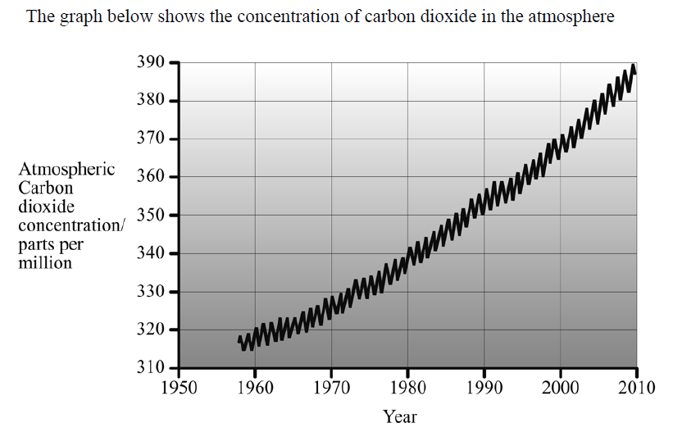
- Describe the trends shown in each of the graphs. Explain how these trends provide evidence for the theory that changing levels of carbon dioxide in the atmosphere are linked to changes in the area of Arctic ice.

