- The graph below shows the changes in the blood glucose level of two boys, Patrick and
Glen. Both have fasted (had no food intake) for 12 hours before taking an energy drink at time 0.
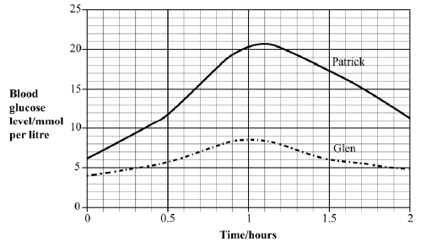

- Compare the changes that take place in Patrick’s blood glucose levels with those of Glen. Use the information in the graph to support your answer.

- Explain the changes taking place in Glen’s blood glucose levels.

- Blood glucose levels above 10mmol per liter result in glucose appearing in the urine, a symptom of diabetes.
  - Use evidence from the graph to identify which of the boys has diabetes.

  - State another symptom of diabetes that this boy might have.

- The graph below shows the average changes (based on measurements from 10 healthy people) for blood glucose and insulin concentrations over a six hour period.

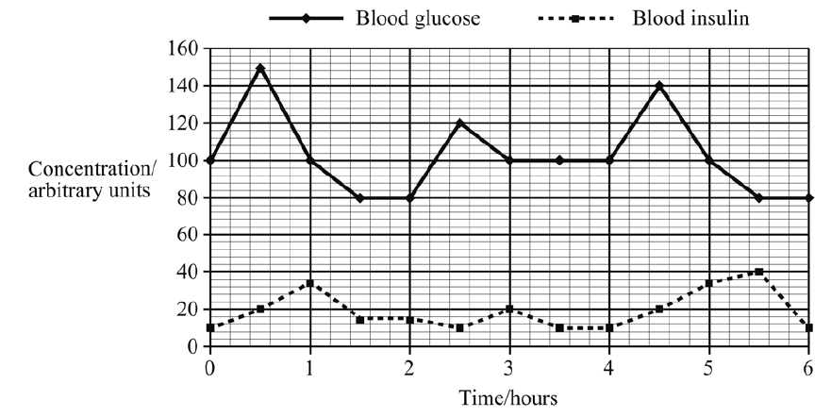
- What evidence is shown in the graph to support the conclusion that changes in glucose concentration cause changes in insulin concentration?

- Explain how the body reduces the blood glucose concentration between 4.5 and 6 hours.

