Taxonomy and Classification Practice Questions
- The largest taxonomic category in the Linnaean system of classification is the ________ , while the smallest is the _________________ .

- Similar classes are grouped into a(n) _____________ , and similar orders are grouped into a(n) _____ __________

- Which part of the name Homo erectus identifies the genus?

- Modern systematists try to group organisms based on ____ whereas old systematists grouped organisms based on _______
A. size, ecological niche.
B. evolutionary relationships, physical appearance.
C. ecological niche, size.
D. physical appearance, evolutionary relationships.

- In which group of organisms are the members more closely associated- all of the organisms in the same kingdom or all of the organisms in the same order? Explain.

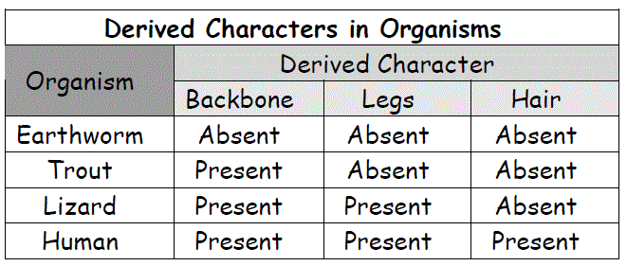
- Examine the table below and answer the following questions

  - Identify the organism in the table that is least closely related to the others

  - What trait separates the least closely related organism from the other animals?

  - Use the information in the table to construct a cladogram of these animals

  - Does your cladogram indicate that lizards and humans share a more recent common ancestor than either does with an earthworm? Explain.

  - Do you have enough information to determine where a frog should be placed on the cladogram? Explain.

- List in order from smallest to largest the seven categories in Linnaeus’s system of classification.

- How did binomial nomenclature avoid the problems of the first attempts at scientific naming?

- Both snakes and worms are tubular, with no legs. How could you determine whether their similarity in shape means that they share a recent common ancestor?

- You are a biologist who is searching for new species in the Amazon jungle. You find two new species of beetles, beetle A and beetle B, which resemble each other closely but have somewhat different markings on their wings. In addition, both beetle A and beetle B resemble beetle C, a species that has already been identified. How could DNA similarities be used to help determine whether beetle A and beetle B are more closely related to each other or to beetle C?

- Based on their names, you know that the baboons Papio annubis and Papio cynocephalus do NOT belong to the same
a. class. c. genus.
b. family. d. species.

11. Which of the following is a correct explanation of a derived character?
a. The presence of a backbone is a derived character of mammals because all mammals have a backbone.
b. The presence of four limbs is a derived character of snakes because the ancestors of modern snakes had limbs, even though modern snakes do not.
c. The presence of hair is a derived character of mammals because all mammals have hair and no animals other than mammals have it.
d. Retractable claws are a derived character of carnivores because some of the animals that are carnivores have retractable claws.

12. What is true about dissimilar organisms such as a cow and a yeast?
a. They are not related at all.
b. Their degree of relatedness cannot be evaluated.
c. Their degree of relatedness can be estimated from their genes.
d. They can interbreed and thus are the same species.

13. Examine Figure 18-2 and answer the following questions.

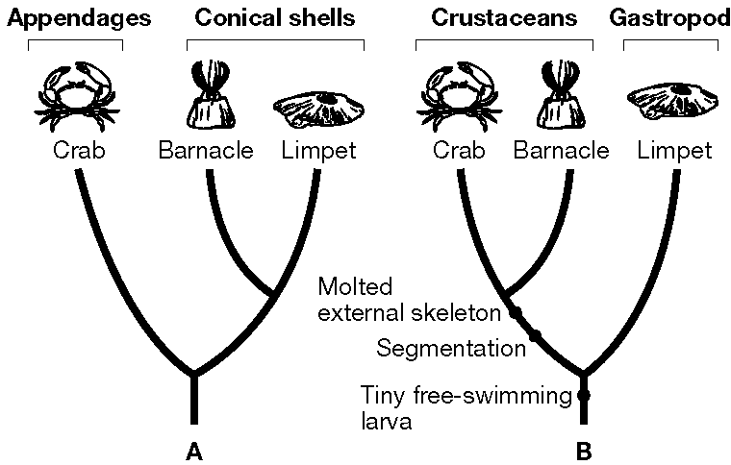
Figure 18-2

- Which grouping in Figure 18–2, A or B, shows the older, traditional, method of classifying the three animals shown? What kind of evidence was used to support that classification?

14. A scientist analyzes the insulin molecules, which are proteins, of three different species, A, B, and C. The insulin from A is different from B in six ways and from C in three ways. The insulin from B is different from C in two ways. Which two species appear to be most closely related? Explain your answer.

15. Examine Figure 18-4 below and answer the following questions

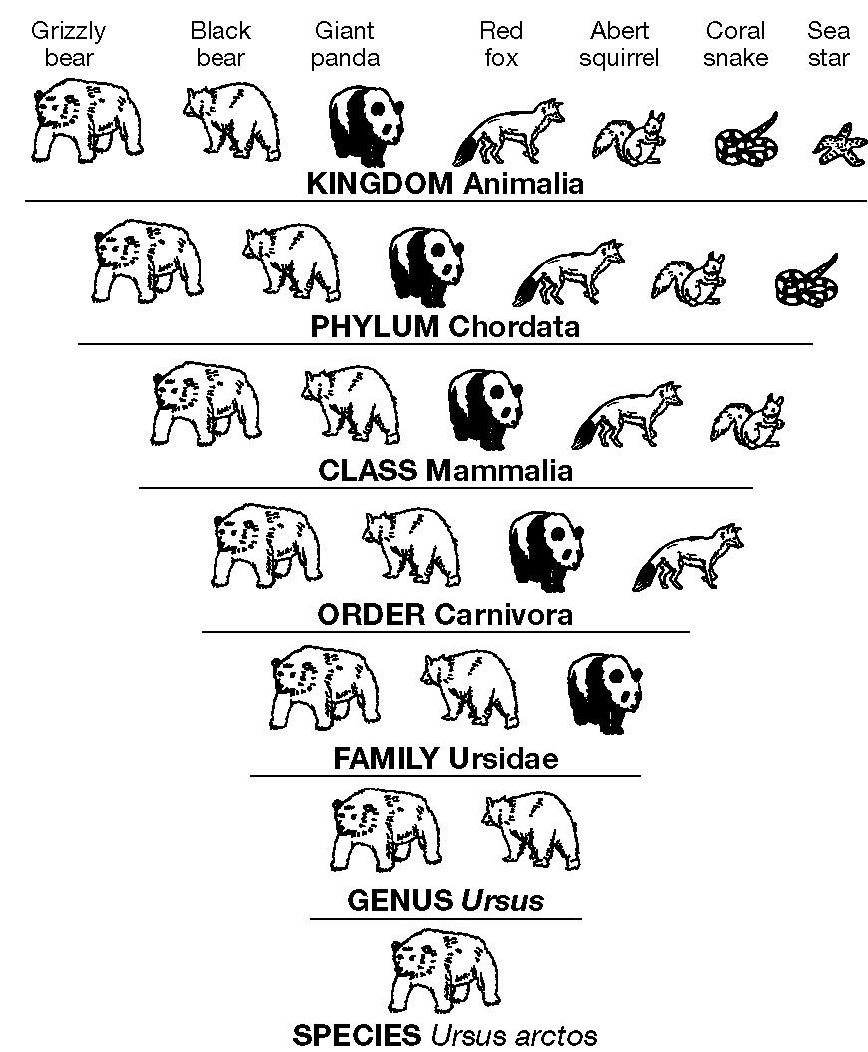
Figure 18-4

- Which level of taxonomic category shown in Figure 18–4 contains the greatest number of different organisms?

- Do all organisms shown in Figure 18–4 that belong to the order Carnivora also belong to the phylum Chordata? Explain.

- Do all organisms shown in Figure 18–4 that belong to the class Mammalia also belong to the genus Ursus? Explain.

- Based on the information in Figure 18–4, describe how the diversity at each level changes from species to kingdom.

- Examine Figure 18–4. In which group, Ursidae or Carnivora, would you expect the members to be more similar to one another? Explain your answer.
16. Which group of organisms would have the most recent common ancestor: the members of a clade corresponding to a genus or the members of a clade corresponding to an order? Explain your answer.

17. Fill in the name of each missing taxonomic category in the chart below.
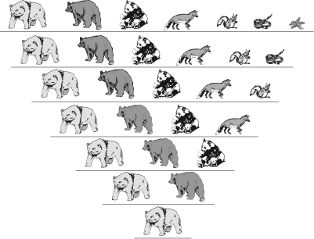
KINGDOM
Animalia

Chordata

Mammalia

Carnivora

Ursidae

Ursus

SPECIES
Ursus arctos

18. Examine the cladogram below:
- Shade in the two organisms that belong to a clade that does not include the third organism. Cross-hatch the organism that does not belong to the clade.
- Circle the point on the cladogram that shows the most recent common ancestor of the crab and the barnacle.
- Mark an X on the point on the cladogram that shows the most recent common ancestor of mollusks and crustaceans.
- Underline the characteristic that all three organisms have in common.

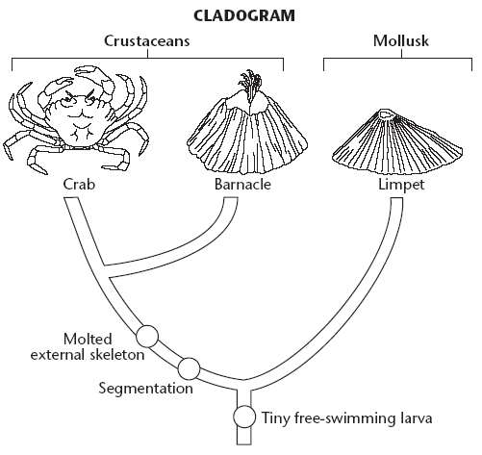

19. Examine the picture below and answer the following questions

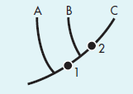

- Which groups share derived character 1?

- What does the node, or fork, between groups B and C represent?

- Which group split off from the other groups first?

20. Examine the table below and answer the following questions

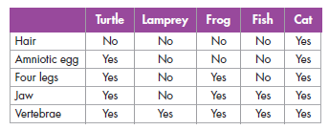
- The first column lists derived characters that can be used to make a cladogram of vertebrates. Which characteristic is shared by the most organisms? Which by the fewest?

- From the information given, place the animals in sequence from the most recently evolved to the most ancient.

- Of the following pairs— lamprey-turtle, fi sh-cat, and frog-turtle— which are probably most closely related?

21. The cladogram below shows the evolutionary relationships among four groups of plants. Use the cladogram to answer questions 21- 23.
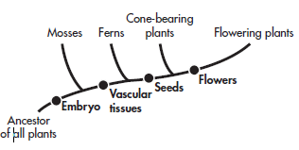
Which of the following groups, taken by themselves, do NOT form a clade?
A cone-bearing plants and flowering plants
B ferns, cone-bearing plants, and flowering plants
C mosses and ferns
D mosses, ferns, cone-bearing plants, and flowering plants

22. Which of the following groups share the most recent common ancestor?
A cone-bearing plants and flowering plants
B mosses and ferns
C mosses and cone-bearing plants
D ferns and flowering plants
23. Which derived character appeared first during the course of the plants’ evolution?
A seeds
B flowers
C embryo
D vascular tissues
24. Use the figure below to answer the following questions.
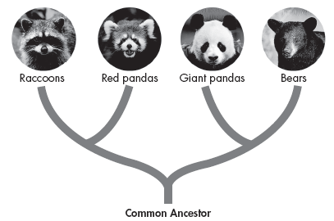

- According to the figure, which species is most closely related to red pandas?

- Although giant pandas and raccoons share some distinct anatomical similarities, they are in different clades. What type of evidence do you think was used to construct this diagram?

- Biologists had previously classified giant pandas together with raccoons and red pandas. What did DNA analysis reveal about giant pandas and bears?

25. Both humans and yeasts have a gene that codes for a myosin protein. What does this indicate about their ancestry?

26. Complete the chart below.

Classification of Living Things
Domain | Kingdom | Examples
 | Eubacteria | Salmonella typhimurium
Archaea |  | Sulfolobus archaea
 | “Protista”
 |  | mushrooms, yeasts
 | Plantae
 |  | Sponges, worms, insects, fishes, mammals

27. Match the kingdom with the description that applies to members of that kingdom.

Kingdom Description
27. “Protista” A. They feed on dead or decaying organic matter.
28. Fungi B. They have no cell walls and they move about.
29. Plantae C. They are a “catchall” group of eukaryotes.
30. Animalia D. They include mosses and ferns.

31. What characteristics led camels to be classified in the same domain and kingdom as dogs?

32. What characteristic is shared by all members of the domain Eukarya?

33. What must you find out about a prokaryote to know which domain it belongs to?

34. Study the descriptions of the following organisms, and place them in the correct kingdom.
________________ Organism A: Multicellular eukaryote without cell walls
________________ Organism B: Its cell walls lack peptidoglycan, and its cell membranes contain certain lipids that are not found in other organisms. It lives in an extreme environment and can survive only in the absence of oxygen.
________________ Organism C: Unicellular eukaryote with cell walls of chitin

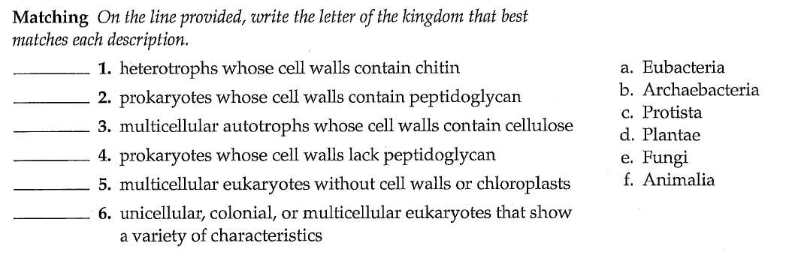
35.

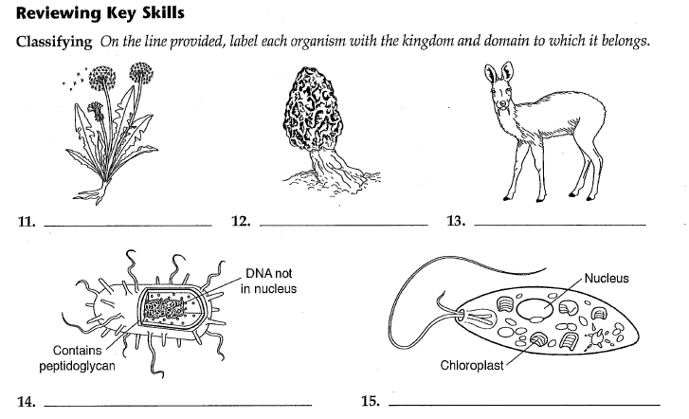
36.

37. Read the following article and answer the following questions.

GRIN AND BEAR IT
Most biologists classify the polar bear, Ursus maritimus, as a separate species from the brown bear, Ursus arctos. The teeth, body shape, metabolism, and behavior of polar bears are very different from those of brown bears. But some systematists are now questioning that classification. Are polar bears and brown bears two distinct species? The answer depends on what a species is. The usual definition of species is “a group of similar organisms that can breed and produce fertile offspring.” Polar bears and brown bears can, in fact, mate and produce offspring that are fertile. However, in the natural environment, polar bears and brown bears almost never mate. The question is complicated by DNA analysis. There are different populations of brown bears, and these different populations have somewhat different genetic makeups. DNA analysis has shown that some populations of brown bears are more closely related to polar bears than they are to other populations of brown bears. According to DNA analysis, if polar bears are indeed a separate species, brown bears by themselves do not form a single clade.

- List the evidence that supports classifying polar bears and brown bears into two different species. Then list the evidence that indicates that polar bears and brown bears belong to the same species.

- What evidence indicates that different populations of brown bears belong to different clades?

- Do you think that the classic definition of species—“a group of similar organisms that can breed and produce fertile offspring”—is still adequate? Why or why not?

38. Venn diagrams can be used to make models of hierarchical classification schemes. A
Venn diagram is shown below. Four groups are represented by circular regions—A, B, C, and D. Each region represents a collection of organisms or members of a taxonomic level. Regions that overlap, or intersect, share common members. Regions that do not overlap do not have members in common.
Use the following terms to label the regions shown in the diagram: kingdom Animalia, phylum Chordata, class Insecta, and class Mammalia.
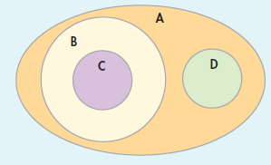

39. 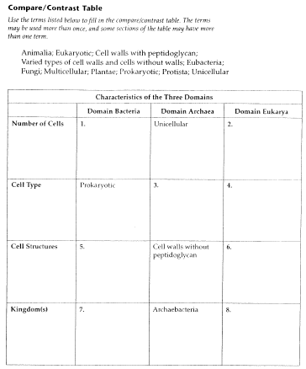

40. Read the following excerpt and answer the following questions

Classification by Aristotle and Theophrastus
Long before Carolus Linnaeus made advances in taxonomy, Aristotle and his student Theophrastus undertook the task of classifying plant and animal life. Aristotle was born in 384 BC and Theophrastus, in 327 BC. Aristotle is well known as a thinker and philosopher. He was also a pioneer in the study of zoology, and his conclusions on the subject were accepted until the nineteenth century. Aristotle traveled extensively to study and to expand his thinking. To learn more about biology, he journeyed to the island of Lesbos. There he joined forces with Theophrastus, a native of the island. They returned to Athens to undertake a pioneering study of plants and animals. Aristotle’s method of classifying animals and plants was philosophical. He assumed that all natural organisms had natural ends, or goals, and that the structure and development of an organism could be understood only when the organism’s goals were understood. Although this was his guiding principle, Aristotle also made careful observations and wrote detailed descriptions of the structures of organisms.
None of Aristotle’s writings on the topic we now call botany have survived. It is believed, however, that he wrote at least two extensive studies of plants. Some of the writings of Theophrastus have been preserved. These writings allow us to see for ourselves the extensive work in plant science that was accomplished in ancient Greece. In his Calendar of Flora, Theophrastus describes the morphology (structures), natural history, and therapeutic uses of plants. He called the external parts of plants organs, and the internal parts tissues. Because Theophrastus had no overall classification system for plants from which to work, he described over 500 plants in great detail. Until the time of Aristotle and Theophrastus, no scientific terminology existed for structures of plants or animals. Because they had no specific terminology, Theophrastus and Aristotle had to write lengthy descriptions of structures using words that they spoke every day. By giving scientific meaning to these common words, they began the development of scientific nomenclature and became pioneers in the field of modern plant classification and systematic botany.
.
- Why did Theophrastus use common words to describe plant structures? Would it have been useful for him to develop new scientific terms?

- Modern biology is not based on Aristotle’s assumption that organisms have goals. Do you think his work is still useful to today’s scientists? Explain.

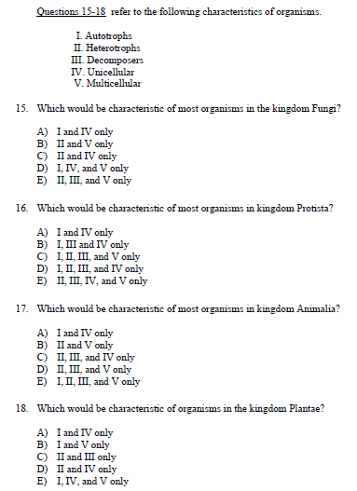
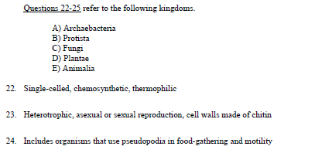
42. 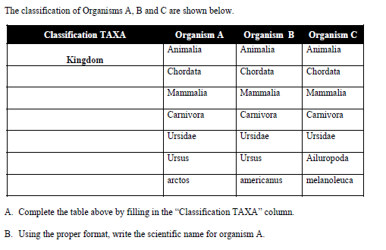
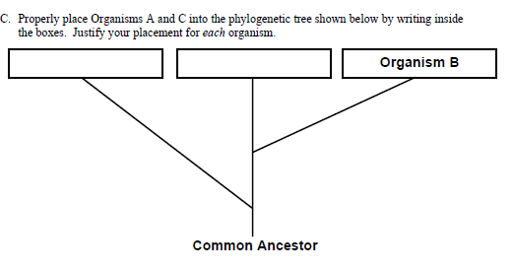

43. Examine Figure 18-5 and answer the following questions.
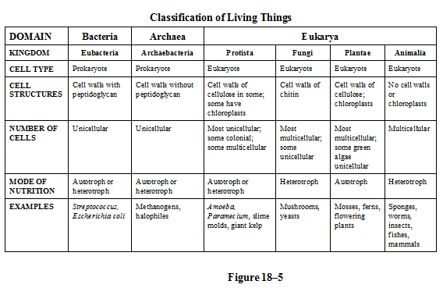
- According to Figure 18–5, what is the main difference between the domain Bacteria and the domain Archaea?

- If you know an organism has a cell wall and is a multicellular autotroph, could you use Figure 18–5 to determine the kingdom to which it belongs? Why or why not?

- Can you determine, by examining Figure 18–5, which kingdom contains the greatest number of species? Why or why not?

- If you were told only that an organism is multicellular and lacks a cell wall, could you use Figure 18–5 to determine the kingdom to which it belongs? Why or why not?

- Considering the data presented in Figure 18–5, which characteristic seems more important in assigning an organism to a specific domain—the presence or absence of a nucleus or its mode of nutrition? Why?
44. Examine Figure 18-6 and answer the following questions.
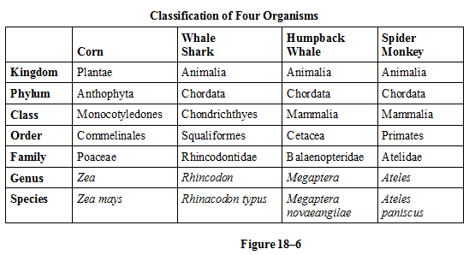
- Which two organisms listed in Figure 18–6 are most closely related to each other? Explain.

- Which level of taxonomic category shown in Figure 18–6 indicates whether an organism is a mammal or not?

- How many different kingdoms are represented by the organisms listed in Figure 18–6? What are they?

- If you were adding a column to Figure 18–6 for the protist species Amoeba proteus, would this species share any taxonomic category with any of the other organisms in the table? Explain your answer.

- Consider the following statement: “Size and shape are NOT reliable indicators of how closely different organisms are related.” What information shown in Figure 18–6 supports this statement?

45. Examine Figure 19-6 and answer the following questions.
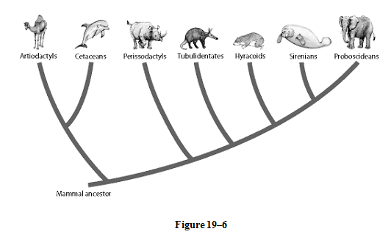
- The evolutionary tree in Figure 19–6 shows relationships among several mammal species. Which group of modern mammals is the most closely related to elephants (Proboscideans)?

- The groups of mammals shown in Figure 19–6 evolved from a common ancestor by adaptive radiation. Explain this process, using examples from this figure.

- In Figure 19–6, the groups of mammals are the result of adaptive radiation? How did the extinction of the dinosaurs contribute to this radiation?

- Study Figure 19–6. Name at least two macroevolutionary changes that could change this evolutionary tree over the next million years, and state how these changes would alter the appearance of this tree.

- What do you think was most responsible for the amount of diversity in the groups shown in Figure 19–3? Explain your answer.

