Reflex
Watch the following video: https://www.youtube.com/watch?v=wLrhYzdbbpE and answer the following questions
- Why does a reflex action occur?

- Draw a flowchart showing the pathway of a reflex arc using the following terms: interneuron, efferent neuron (motor neuron), afferent pathway (sensory neuron), sensory neuron (sensory receptor), and the effector

- Why is the brain not involved?

Watch and read the following simulation: http://www.sumanasinc.com/webcontent/animations/content/reflexarcs.html and answer the following questions
- What is the advantage of a reflex arc?

- Click on “narrated” and “play”. What structure provides information about the external environment?

- What is the role of the sensory neuron?

- What is the role of the interneuron?

- What is the equivalent of an effector in this scenario?

Maintaining Homeostasis
Examine each picture below and answer the following questions:
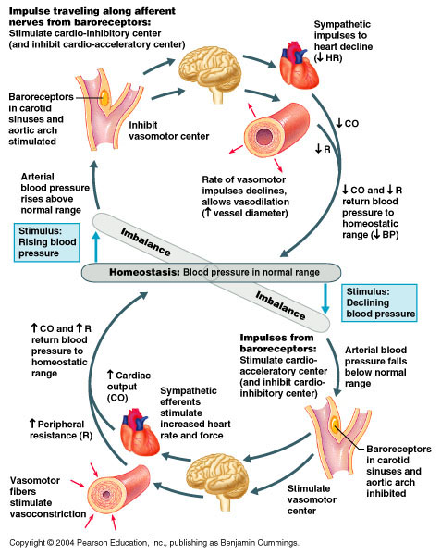
- What process is being regulated in the picture above? Cite evidence from the image.

- Explain how negative feedback is occurring when blood pressure drops below normal?

- What role does vasodilation play in maintaining homeostasis?

- If the baroreceptors stopped working, how would that affect this process? Be specific!

- What body systems are involved in this process? Cite your evidence.
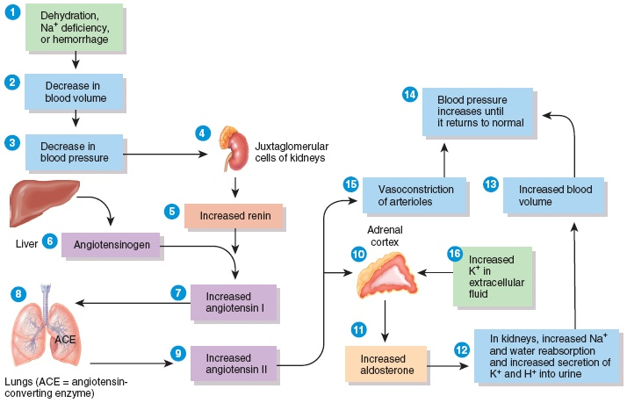

- What process is being regulated? Cite evidence from the image.

- Which organ produces angiotensinogen?

- If a competitive inhibitor of angiotensin II was added, how would this affect the process?

- If renin failed to be produced, what would be directly impacted?

- What body systems are involved in this process? Cite your evidence.

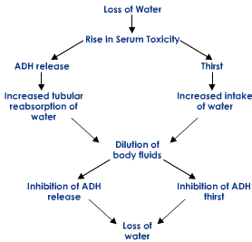

- What process is being regulated? Cite evidence from the image.

- Under which condition is ADH production increased?

- If a disease occurs which prevents the production of ADH, what would be the direct effects on the organism?

- What body systems are involved in this process? Cite your evidence.

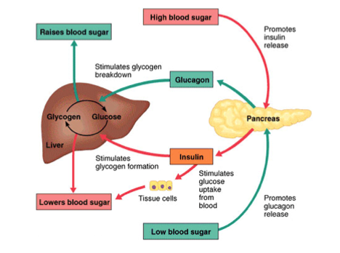

- What process is being regulated? Cite evidence from the image.

- What organs are involved in sugar regulation in humans?

- Under which condition is glucagon produced?

- What is the role of insulin?

- What body systems are involved in this process? Cite your evidence.

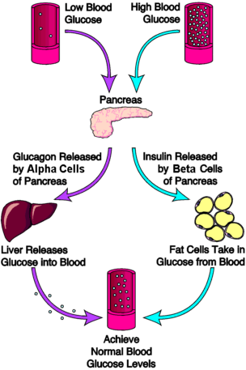

- What process is being regulated? Cite evidence from the image.

- Under which condition is insulin produced?

- Explain the role of glucagon.

- The pancreas has 2 types of cell- alpha and beta cells. How do their roles differ?

- Why is one organ capable of producing cells with different functions?

- What body systems are involved in this process? Cite your evidence.

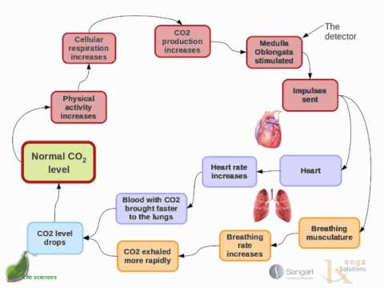

- What process is being regulated? Cite evidence from the image.

- What process increases carbon dioxide concentration?

- How does the heart respond to increased carbon dioxide concentration?

- What organs are involved in this process?

- What body systems are involved in this process? Cite your evidence.

