**Protein Synthesis Practice Questions**

1. Complete the table to contrast the structures of DNA and RNA.

|  |  |  |  |
| --- | --- | --- | --- |
|  | **Sugar** | **Number of strands** | **Bases** |
| DNA |  |  |  |
| RNA |  |  |  |

1. Although in one sense a gene codes for all aspects of a protein's structure, if you knew the sequence of nucleotides within the gene you could easily determine from this information only one aspect of the protein's structure. Which one?  
    a. primary structure b. secondary structure  
    c. tertiary structure d. none of these
2. Whether the organism is a pea plant or a human being, the information in the DNA of the cell’s nucleus directs synthesis of proteins in the cytoplasm. Why, then, are pea plants and human beings so different?
3. The master plan of a building shows how to build and place important parts of the building, such as walls, pipes, and electrical outlets. On the building site, workers use copies of the master plan called blueprints to show them what to do. The master plan is kept in the office. Explain how mRNA works like a blueprint in constructing proteins.
4. Sketch the sequence in which pre-mRNA is “edited” after it is made on the DNA template and before it is ready to function as mRNA in the cytoplasm. Show the original DNA, the pre-mRNA, and the final mRNA. Be sure to label exons and introns.
5. Use the analogy of the master plan and blueprints used by builders to identify what represents messenger RNA, where the “ribosome” is, and who performs the same kind of job as transfer RNA.
6. How would it benefit a cell to possess a sequence of DNA that could be transcribed and then edited into several different mRNA molecules?
7. What amino acid sequence would be produced from the mRNA sequence CGCUAUAGC?
8. Suppose the DNA sequence GCTATATCG was changed to GCGATATCG. How would the products of transcription and translation be affected?
9. What is the difference between transcription and translation?
10. What happens to proteins after they are made?
11. Many research studies have shown that different species may possess some of the exact same genes but show vastly different traits. How can that happen?
12. Complete the table to describe the processes and outcomes of the different types of gene (point) mutations.

|  |  |  |
| --- | --- | --- |
| **Type** | **Description** | **Outcome** |
| Substitution |  |  |
| Insertion |  |  |
| Deletion |  |  |

1. Deletion can happen as a gene mutation or as a chromosomal mutation. What is the difference?
2. Use the diagram below to answer the following questions.

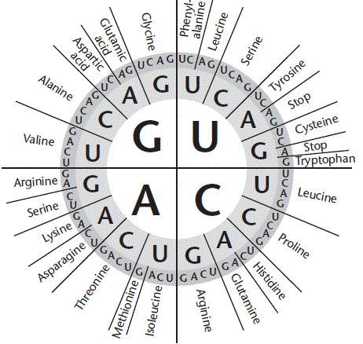

* 1. What are the words along the outside of the circle?
  2. What can you find by reading this diagram from the inside out?
  3. For which amino acid is AAA a codon?
  4. What is the codon for tryptophan?
  5. What are 4 codons for alanine?

1. Use the diagram below to answer the following questions.

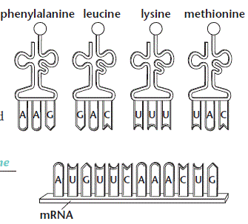

* 1. What is the anticodon for leucine?
  2. What is the codon for leucine?
  3. List the amino acids in the order they would appear in the polypeptide coded for by this mRNA.

1. A gene that codes for one of the polypeptide chains of the blood protein hemoglobin lies on chromosome 11 in humans. A substitution mutation in that gene causes the amino acid valine to be incorporated into hemoglobin in a place where glutamic acid would normally lie. The result is sickle cell disease. Explain how a change in a single base in DNA can bring about such a serious disorder.
2. Read the following excerpt and answer the following questions.
   1. Explain the type of mutation that occurs in sickle cell anemia.
   2. Explain how a mutation on chromosome 11 results in the symptoms associated with sickle cell anemia.

Sickle cell anemia is an inherited blood disorder characterized primarily by chronic anemia and periodic episodes of pain. The underlying problem involves hemoglobin, a component of red blood cells. Hemoglobin molecules in each red blood cell carry oxygen from the lungs to body organs and tissues and bring carbon dioxide back to the lungs. In sickle cell anemia, the hemoglobin is defective. After hemoglobin molecules give up their oxygen, some may cluster together and form long, rod-like structures. These structures cause red blood cells to become stiff and assume a sickle shape. Unlike normal red cells, which are usually smooth and donut-shaped, sickled red cells cannot squeeze through small blood vessels. Instead, they stack up and cause blockages that deprive organs and tissues of oxygen-carrying blood. This process produces periodic episodes of pain and ultimately can damage tissues and vital organs and lead to other serious medical problems. Sometimes pain lasts only a few hours; sometimes it lasts several weeks, requiring hospitalization. Pain is the principal symptom of sickle cell anemia in both children and adults. Normal red blood cells live about 120 days in the bloodstream, but [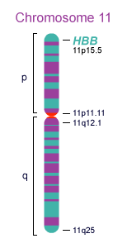](http://www.ornl.gov/sci/techresources/Human_Genome/posters/chromosome/hbb.shtml)sickled red cells die after about 10 to 20 days. Because they cannot be replaced fast enough, the blood is chronically short of red blood cells, a condition called anemia.

Sickle cell anemia Inheritance   
Sickle cell anemia is an autosomal recessive genetic disorder that affects hemoglobin. The hemoglobin molecule has two parts: an alpha and a beta. It is caused by a defect in the HBB gene on chromosome 11, which codes for the beta subunit of the hemoglobin protein. Sickle cell anemia is caused by a single code letter change in the DNA. This in turn alters one of the amino acids in the hemoglobin protein. Valine sits in the position where glutamic acid should be. The valine makes the hemoglobin molecules stick together, forming long fibers that distort the shape of the red blood cells. As a result, hemoglobin molecules don't form properly, causing red blood cells to be rigid and have a concave shape (like a sickle used to cut wheat). The presence of two defective genes (SS) is needed for sickle cell anemia.

Sickle cell anemia Incidence  
Sickle cell anemia affects millions throughout the world. It is particularly common among people whose ancestors come from sub-Saharan Africa; Spanish-speaking regions (South America, Cuba, Central America); Saudi Arabia; India; and Mediterranean countries such as Turkey, Greece, and Italy. In the Unites States, it affects around 72,000 people, most of whose ancestors come from Africa. The disease occurs in about 1 in every 500 African-American births and 1 in every 1000 to 1400 Hispanic-American births.

1. Read the following excerpt and answer the following questions.
   1. What can you infer about the amino acid sequence in dystrophin for those who are not afficted with Duchenne Muscular dystrophy and those who are not?
   2. Why are males disproportionately affected with this disease compared to females?

Duchenne Muscular dystrophyis a genetic conditions characterized by progressive muscle weakness and wasting (atrophy). The Duchenne muscular dystrophy primarily affect the skeletal muscles, which are used for movement, and the muscles of the heart. These conditions occur much more frequently in males than in females. Duchenne and Becker muscular dystrophies together affect 1 in 3,500 to 5,000 newborn males. Between 400 and 600 boys in the United States are born with these conditions each year. Females are rarely affected by these forms of muscular dystrophy.

Mutations in the DMD gene cause Duchenne and Becker muscular dystrophy. The DMD gene provides instructions for making a protein called dystrophin. This protein helps stabilize and protect muscle fibers and may play a role in chemical signaling within cells. Mutations in the DMD gene alter the structure or function of dystrophin, or prevent any functional dystrophin from being produced. Muscle cells without this protein become damaged as muscles repeatedly contract and relax with use. The damaged fibers weaken and die over time, leading to the muscle weakness and heart problems characteristic of Duchenne and Becker muscular dystrophies.

This condition is inherited in an X-linked recessive pattern. A condition is considered X-linked if the mutated gene that causes the disorder is located on the X chromosome, one of the two sex chromosomes. In males (who have only one X chromosome), one altered copy of the gene in each cell is sufficient to cause the condition. In females (who have two X chromosomes), a mutation must be present in both copies of the gene to cause the disorder. Males are affected by X-linked recessive disorders much more frequently than females. A striking characteristic of X-linked inheritance is that fathers cannot pass X-linked traits to their sons.

1. Which do you think is generally most harmful- a duplication, deletion, translocation, or inversion? Explain your answer.
2. Which do you think occurs more frequently- duplication or translocation? Explain.
3. Read the following excerpt and answer the following questions.
   1. Explain why trisomies typically result in birth defects.
   2. Explain why monosomies typically result in birth defects.

A trisomy and a monosomy are types of numerical chromosome abnormalities that can cause certain birth defects. Normally, people are born with 23 chromosome pairs, or 46 chromosomes, in each cell — one inherited from the mother and one from the father. A numerical chromosome abnormality can cause each cell to have 45 or 47 chromosomes in each cell.

What are trisomies?

The term "trisomy" is used to describe the presence of an extra chromosome — or three instead of the usual pair. For example, trisomy 21 or [Down syndrome](http://www.childrenshospital.org/az/Site803/mainpageS803P0.html) occurs when a baby is born with three #21 chromosomes. In [trisomy 18](http://www.childrenshospital.org/az/Site1789/mainpageS1789P0.html), there are three copies of chromosome #18 in every cell of the body, rather than the usual pair.

What are monosomies?

The term "monosomy" is used to describe the absence of one member of a pair of chromosomes. Therefore, there are 45 chromosomes in each cell of the body instead of the usual 46. Monosomy X, or [Turner syndrome](http://www.childrenshospital.org/az/Site1793/mainpageS1793P0.html), occurs when a baby is born with only one X sex chromosome, rather than the usual pair (either two Xs or one X and one Y sex chromosome).

1. codon: nucleotides::
2. ribosomes : binding sites
3. ribosome : DNA molecules
4. RNA : bases
5. DNA : bases
6. Given the following sequence of amino acids, use the genetic code table to determine the DNA sequence that codes for the amino acids. amino acid sequence: tyrosine - proline - aspartic acid - isoleucine - cysteine
7. AUGGGUCUAUAUACG
8. ATGGGTCTATATACG
9. GCAAACTCGCGCGTA
10. ATAGGGCTTTAAACA
11. Some events that place during the synthesis of a specific protein are listed below:
12. Messenger RNA attaches to a ribosome
13. DNA serves as a template for RNA production
14. Transfer RNA bonds to a specific codon
15. Amino acids are bonded together
16. RNA moves from the nucleus to the cytoplasm

The correct order of these events is?

1. With the exception of tryptophan, each amino acid is coded for by more than one codon. This is called
2. Translation
3. Reversal
4. Redundancy
5. Sequentialism
6. Given the original DNA strand below what would the final polypeptide chain be?



* + 1. ile-stop c. met-pro-trp-gly-arg-leu-stop
    2. met-ile-gln-val-stop d. ile-gln-val-val-stop

1. Compare the original sequence GCA CCG AGA to the mutant sequence GCA CAC GAG and determine what type of mutation has occurred.
2. Given that 600 million years after they shared a common ancestor, mice and fruit flies possess developmental genes that are very similar, what can be inferred about the effect of mutation upon these genes?
3. Read the following excerpt and answer the following questions.
4. During which cellular process do mutations arise?
5. Do all mutations affect the proteins made? Explain.
6. How does a mutation affect somatic cells differently from germ cells?

Mutations are permanent changes in the sequence of nitrogen containing bases. Mutations occur when base pairs are incorrectly matched (e.g., A bonded to C rather than A bonded to T) and can, but usually do not, improve the product coded by the gene. Inserting or deleting base pairs in an existing gene can cause a mutation by changing the codon reading frame used by a ribosome. Mutations that occur in somatic, or nongerm, cells are often not detected because they cannot be passed on to offspring. They may, however, give rise to cancer or other undesirable cellular changes. Mutations in the germline can produce functionally different proteins that cause such genetic diseases as Tay-Sachs, sickle cell anemia, and Duchenne muscular dystrophy.

1. Read the following excerpt and answer the following questions.
2. Write down the chemical equation involving the enzyme, beta-hexosaminidase A. State the substrate and product.
3. In detail, explain how a mutation results in symptoms of the Tay-Sachs disease. In your response, mention the effect of enzymes, amino acid sequence, active site, and protein synthesis.

Tay-Sachs disease is a rare inherited disorder that progressively destroys nerve cells (neurons) in the brain and spinal cord. The most common form of Tay-Sachs disease becomes apparent in infancy. Infants with this disorder typically appear normal until the age of 3 to 6 months, when their development slows and muscles used for movement weaken. As the disease progresses, children with Tay-Sachs disease experience seizures, vision and hearing loss, intellectual disability, and paralysis. An eye abnormality called a cherry-red spot, which can be identified with an eye examination, is characteristic of this disorder. Children with this severe infantile form of Tay-Sachs disease usually live only into early childhood.

Other forms of Tay-Sachs disease are very rare. Signs and symptoms can appear in childhood, adolescence, or adulthood and are usually milder than those seen with the infantile form. Characteristic features include muscle weakness, loss of muscle coordination (ataxia) and other problems with movement, speech problems, and mental illness. These signs and symptoms vary widely among people with late-onset forms of Tay-Sachs disease.

Tay-Sachs disease is very rare in the general population. The genetic mutations that cause this disease are more common in people of Ashkenazi (eastern and central European) Jewish heritage than in those with other backgrounds. The mutations responsible for this disease are also more common in certain French-Canadian communities of Quebec, the Old Order Amish community in Pennsylvania, and the Cajun population of Louisiana.

Mutations in the *HEXA* gene cause Tay-Sachs disease. The *HEXA* gene provides instructions for making part of an enzyme called beta-hexosaminidase A, which plays a critical role in the brain and spinal cord. This enzyme is located in lysosomes, which are structures in cells that break down toxic substances and act as recycling centers. Within lysosomes, beta-hexosaminidase A helps break down a fatty substance called GM2 ganglioside. Progressive damage caused by the buildup of GM2 ganglioside leads to the destruction of these neurons, which causes the signs and symptoms of Tay-Sachs disease. Because Tay-Sachs disease impairs the function of a lysosomal enzyme and involves the buildup of GM2 ganglioside, this condition is sometimes referred to as a lysosomal storage disorder or a GM2-gangliosidosis.

1. Currently you can buy DNA sequences custom made from labs for about a dollar per base pair. Suppose you wanted to produce a protein that was 50 amino acids in length. About what would it cost to get a hunk of DNA with enough information to make this protein?  
    a. $50 b. $100 c. $150 d. $17
2. What is the main dietary source of amino acids for humans?  
    a. lipids b. starches c. simple sugars d. proteins
3. Why is mRNA in the cytoplasm much smaller than mRNA in the nucleus?  
   a. noncoding regions of mRNA are edited out in the nucleus  
   b. much of mRNA is used up in the process of transcription  
   c. RNA is actually the same size in both places  
   d. the RNA in the cytoplasm is packed tightly so that certain genes can be turned off
4. Given that uracil replaces thymine, which of the following is true of uracil?  
   a. it forms three hydrogen bonds with its complement  
   b. it is a type of sugar  
   c. it is bonded to the phosphate molecule of the nucleotide  
   d. it is a pyrimidine base and thus has a single ring structure
5. What is a benefit of eukaryote DNA being so tightly packed?  
   a. it allows a huge amount of information to be fit into a tiny nucleus  
   b. it "tucks away" many genes and makes them unavailable to the RNA polymerase, in essence turning them off  
   c. it makes the formation of chromosomes easy thus helping the process of mitosis  
   d. all of the above  
   e. none of the above
6. All of these are basically saying the same thing except for one. Which?  
   a. DNA makes RNA which makes proteins  
   b. genotype determines phenotype  
   c. mutagens cause mutations which can cause cancer  
   d. one gene = one polypeptide
7. Which best describes the concept of epigenetics?  
   a. one genetic code can produce different products depending on how it is edited  
   b. there are some alleles that are dominant over other alleles  
   c. other factors besides the actual DNA code can control the expression of genes  
   d. DNA controls RNA which controls proteins  
   e. all of the above
8. Which relationship is most similarto the relationship below?

tRNA : ribosome

a. baker : pie b. delivery truck : factory c. key : lock d. book : publisher

1. The table below shows messenger RNA codons and the amino acids they code for. Use it to answer the questions that follow.



1. Indicate whether or not each of the following base pair substitutions would lead to a change in amino acid sequence by writing either *Yes* or *No* in the spaces provided.
   * 1. ______________ AAA to AAG
     2. ______________ AAA to AAC
     3. ______________ TGT to TGC
     4. ______________ TGT to TGA
     5. ______________ TGT to GGT
     6. ______________ TGT to TTT
     7. Do all mutations result in a change in a protein? Explain.
2. Suppose you overlooked #8 on this test and put the answer to #39 in #38's spot on the scantron form. Then you put all the rest of the answers in order, but one space away from where they should be on the form (OUCH!). This analogous to what mutation?  
   a. substitution  
   b. insertion  
   c. deletion  
   d. inversion
3. In humans, most genes in a particular cell are:  
   a. turned "on" because each cell need access to nearly every human protein produced  
   b. turned "on" so that the cell can get what it needs more quickly  
   c. turned "off" because our cells are specialized to do specific tasks  
   d. turned "off" because the cells can get all the proteins they need from their environment
4. Suppose that exposure to X-ray radiation causes a mutation in a gene such that the sequence TGG (codon X) is changed to GGT. This alteration will result in:  
   a. all codons following X to be misread  
   b. only codon X being misread  
   c. all codons being misread  
   d. no change in the polypeptide coded for by this gene
5. Examine the pictures below.
6. What does each letter represent?
7. On the lines provided, identify each diagram as one of the following mutations: translocation, inversion, duplication, and deletion. Then describe what happens during each mutation.
   * 1. ___________________________ i.
     2. ___________________________ ii.

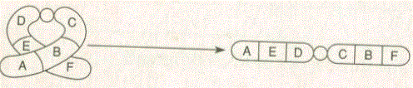

* + 1. ___________________________ iii.
    2. 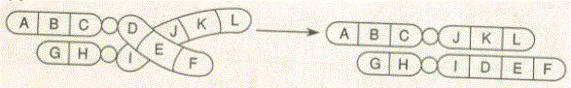___________________________ iv.

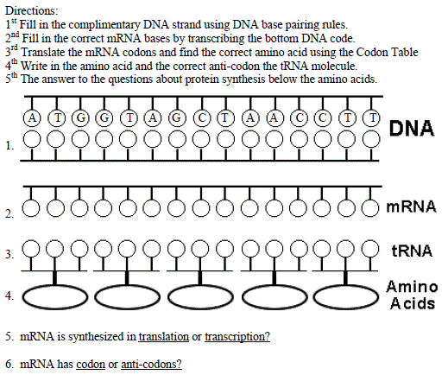

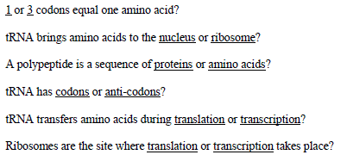

**Protein Synthesis Web quest**

1. Click on <https://www.youtube.com/watch?v=kp1bZEUgqVI>. Explain how the environment alters gene expression.
2. Click on <http://learn.genetics.utah.edu/content/epigenetics/rats/> and read the information and answer the following questions.
3. Click the “go!” button under “what kind of mother are you”. How does the type of care a pup receives during the first weeks of life change the expression of the GR gene?
4. Click on “start”. Lick your pup once a day. How does your neglect affect the expression of the GR gene? What other effects will result?
5. Click on “Go!” to lick another rat pup. Lick your pup as much as possible. How does your attention affect the expression of the GR gene? What other effects will result?
6. Click on “Go!” to investigate high and low nurtured rat pups. How does the degree of nurturing affect the hippocampus in the brain?
7. How does the degree of nurturing affect the adult pup?
8. When is it advantageous to be anxious?
9. Is gene expression reversible? Explain.
10. Relate the effect of the degree of nurturing of mom on the expression of the GR gene, brain development, and adult behaviors.
11. Based on this simulation, what can you conclude about the effect of the environment on an organism?
12. Click on <https://www.youtube.com/watch?v=ztPkv7wc3yU> and summarize the process of transcription.
13. Click on <https://www.youtube.com/watch?v=Ikq9AcBcohA> and summarize the process of translation.
14. Click on <https://www.youtube.com/watch?v=itsb2SqR-R0>
15. Explain the process of transcription using the terms: exons, introns, mRNA, RNA splicing, RNA, RNA polymerase, codon, nucleus, and promoter.
16. Explain the process of translation using the terms: cytoplasm, rRNA, tRNA, codon, anticodon, amino acids, peptide bonds, polypeptide, and mRNA.
17. Click on <https://www.youtube.com/watch?v=5bLEDd-PSTQ>
    1. Briefly describe how polypeptides are joined together at a ribosome.
18. Click on both <https://www.youtube.com/watch?v=kp0esidDr-c> and <https://www.youtube.com/watch?v=GieZ3pk9YVo>
    1. Describe the types of DNA mutations and its effect on an organism