Plant Systems Practice Questions
- How did the relative lack of water on land affect how plants evolved?

- How might the adaptation of specialized water-conducting tissue have helped land plants meet challenges to life on land? Explain.

- A friend of yours lives in one of the desert areas of New Mexico and wants to grow a garden of bryophytes. What environmental conditions would your friend need to provide the garden for it to be successful?

- See the information below.
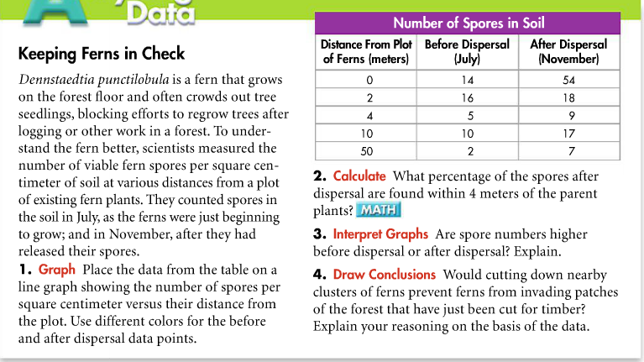

- As its name indicates, the barrel cactus is shaped like a barrel and has no leaves. Given the basic needs of plants, explain why this shape is an advantage for a plant that survives where very little water is available.

- The inside of the glass or plastic walls of a greenhouse full of plants is very wet on cool days. Where does this water come from?

- Are stomata more likely to be open or closed on a hot day? Explain your answer.

- Leaves range in size from very large to very tiny. In what type of environment would you expect to find the most plants with very large leaves? Very small leaves? Explain.

- Complete the flowchart that summarizes how guard cells help maintain homeostasis.
Guard cells are forced into a curved shape when water pressure .
The thick inner walls of the guard cells pull away from one another, opening the . Water is lost by transpiration.
Guard cells straighten out when water pressure .
The inner walls of the guard cells pull together, closing the

- Desert plants have several types of adaptations that help them conserve water. State 4 adaptations.
1. A leathery or waxy coating on the leaves and stems reduces evaporation.
2. Thick stems or other plant parts provide water storage space.
3. Small leaves or spines (modified leaves) reduce the surface area of the plant exposed to the sun. (Some plants such as the ocotillo and palo verde shed their leaves during dry spells, further reducing their surface area.)
4. Spines and fine hairs reflect heat and reduce the air flow over the plant’s surface.
Many plants have a combination of these adaptations. For example, the hedgehog cactus has enlarged stems, a thick waxy coating and a dense cover of spines.
- Use the following diagram to answer question 9.

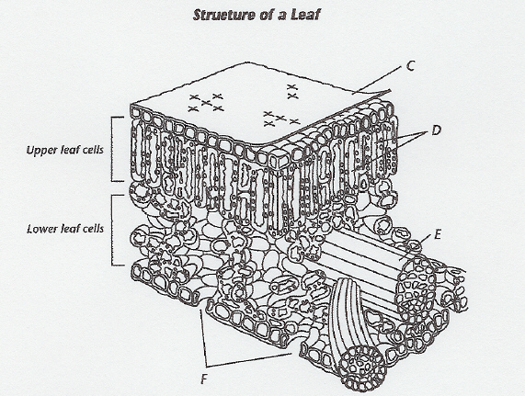

- What is structure E collectively called?
- List and state the structures involved in the regulation of water to maintain homeostasis in the plant.

- Predict the change that would be expected if structure C was found in a cacti plant. Why does this improve the fitness of the plant?

- Explain 2 ways that this leaf is adapted for its function.
- The leaves of desert plants often have two or more layers of palisade mesophyll, rather than the single layer that is characteristic of most leaves. How might this modified structure be advantageous to a desert plant?

- Answer the following questions below.
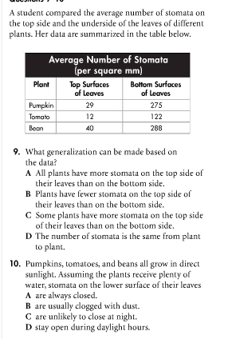
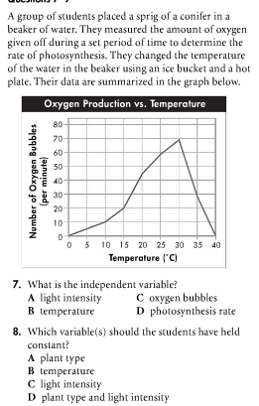
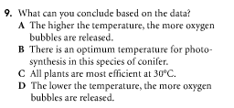

- A plant’s stomata are open early on a summer day when the air is cool and moist. By afternoon, when the air is hot and dry, the stomata are closed. Explain this observation.

- Answer the following questions below.
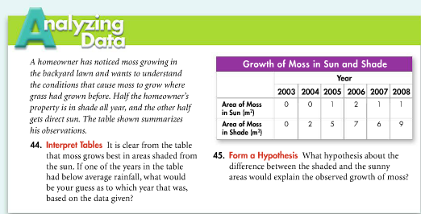

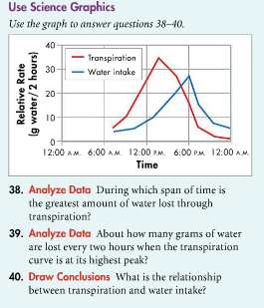
- Answer the following questions below.

- Tomatoes put in a paper bag with apples ripen much more quickly than those placed in the open air. What would this suggest about the effects of ripe apples on unripe tomatoes?

- People often give potted houseplants more fertilizer than they need. As a result, the plants begin to wilt and eventually die instead of getting larger and healthier. What could be the reason for this result?

- Answer the following questions below.
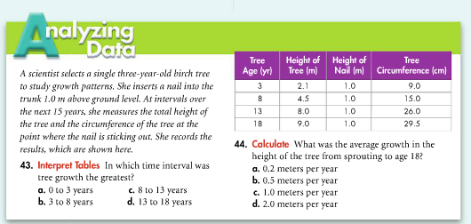

- Answer the following questions below.
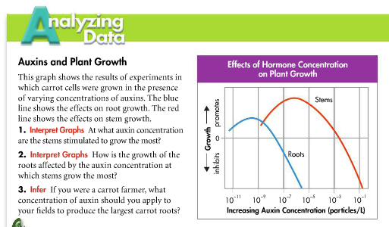

- Which is likely to happen to a plant if it starts losing more water than it can take in?
A. It will reproduce. B. It will flower.
C. It will grow. D. It will wilt.
- Which is a plant that has narrow leaves with a waxy epidermis?
A. cactus B. spruce
C. rock plant D. rose bush
- A pitcher plant's leaves are adapted for
A. conducting photosynthesis. B. limiting transpiration.
C. catching and digesting insects. D. pollination and fertilization.
- A rock plant adapts to hot, dry conditions by having very few
A. thorns. B. leaves.
C. stomata. D. nutrients.
- A cactus's thorns are actually its
A. leaves. B. stems.
C. roots. D. bark.
- Recall that growth responses of plants to external stimuli are called tropisms. A tropism is positive if the affected plant grows toward the stimulus. The response is negative if the plant part grows away from the stimulus. The experiment shown below was intended to test the effect of gravitropism on plant growth. The conclusion drawn from the experiment was that the plant stems grow upward due to negative gravitropism. Use the diagram below to answer the following questions.
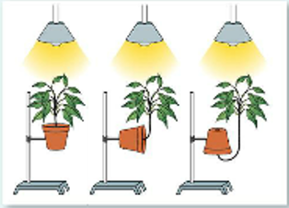
  - What was the probable hypothesis for this experiment?

  - Was the hypothesis successfully tested? Explain.

- In a laboratory experiment, fruits from five different kinds of trees were dropped from a height of 4 meters, and the time it took them to reach the ground was measured. Assume that for every second a fruit falls, it is carried 1.5 meters away from the parent tree.
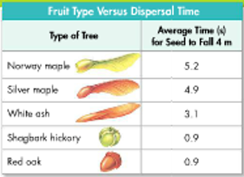
- Based on the data and the illustrations of the fruit structures, which of the following is the most reasonable conclusion?
    - Winged seeds carry more nutrition for the growing embryo than do seeds without wings
    - Wind is not very effective in carrying seeds away from the parent plant
    - Acorns are more likely to germinate if they fall close to the parent plant
    - Red oak and hickory depend on factors other than wind to achieve dispersal
- Given the same wind, which fruit type is most likely to be carried farthest from the parent tree?
    - Red oak iii. Norway maple
    - Silver maple iv. White ash
- The results of an experiment are summarized in the art below.
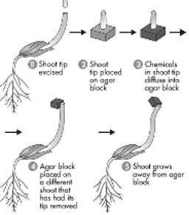
- Which of the following can be concluded from the results of this experiment alone?
  - Hormones are produced in the growing tips of plant cells
  - Plants grow toward the sun due to compounds produced in their stems
  - Agar blocks contain a variety of plant compounds
  - Compounds produced in shoot tops can cause stems to bend
- Applying your knowledge of specific plant hormones, explain the results.

- Examine the picture below and answer the following questions.

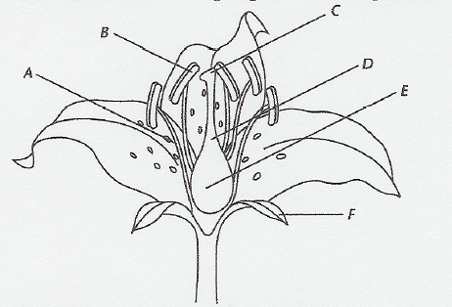

- Which structure(s) would contain haploid cells?

- Which structure represents the location where the male gamete will start the process of fertilization?

- How is this flower structured in a way that promotes co-evolution with its pollinator?

- Compare and contrast plant and human hormones.

- Germinating seeds produce a type of gibberellin called GA3, which causes the production of hydrolases, including alpha-amylase, which is an enzyme that breaks down starch. Hydrolases are enzymes that break bonds and form a water molecule in the process. Explain why a germinating seed would need to produce gibberellin to produce hydrolases and what would result if they were not produced. Knowing this, how could you detect if a seed was germinating?

- If auxins migrate to the south side of a stem, what direction will it grow? How can this explain the observation that new growth of a fallen plant will grow up toward the sky even though it is lying down horizontally? What would be the possible outcome for a plant that was genetically altered not to produce this kind of auxin?

- Read these passages from the text and answer the questions that follow.

Root Structures and Functions

The tip of a root is called the root cap. It consists of specialized cells that help regulate primary growth of the root at the tip. Above the root cap is primary meristem, where growth in length occurs. Above the meristem, the rest of the root is covered with a single layer of epidermal cells. These cells may have root hairs that increase the surface area for the absorption of water and minerals from the soil.

Beneath the epidermis is ground tissue, which may be filled with stored starch. Bundles of vascular tissues form the center of the root. Waxy layers waterproof the vascular tissues so they don’t leak, making them more efficient at carrying fluids. Secondary meristem is located within and around the vascular tissues. This is where growth in thickness occurs.

The structure of roots helps them perform their primary functions. What do roots do? They have three major jobs: absorbing water and minerals, anchoring and supporting the plant, and storing food.
• Absorbing water and minerals: Thin-walled epidermal cells and root hairs are well suited to absorb water and dissolved minerals from the soil. The roots of many plants also have a mycorrhizal relationship with fungi for greater absorption.
• Anchoring and supporting the plant: Root systems help anchor plants to the ground, allowing plants to grow tall without toppling over. A tough covering may replace the epidermis in older roots, making them rope-like and even stronger.
• Storing food: In many plants, ground tissues in roots store food produced by the leaves during photosynthesis.

- Imagine a plant’s root cap. What additional function might it have that is not described in the above passage?

- How do root hairs increase the surface area for water and mineral absorption?

- How is the circulatory system in animals similar and different to plants?

- How is plant growth similar and different in animals?

- How is the integumentary system in plants different to those in animals?

- How is the integumentary system in plants similar to those in animals?

- How is the endocrine system in plants different to those in animals?

- How is the endocrine system in plants similar to those in animals?

