**Photosynthesis Practice Questions**

1. The image below is of an Elodea.

|  |  |
| --- | --- |
| Screen Shot 2014-08-20 at 12.43.11 PM.png | 1. What type of cell are you viewing? Provide evidence from the slide/image.  2. What is the function of each of the cell structures labeled?  Chloroplast-  Cell membrane-  Cell wall-  Large Vacuole-  Cytoplasm- |

1. The image below is of an Onion.

|  |  |
| --- | --- |
| Screen Shot 2014-08-20 at 1.14.03 PM.png | 1. What type of cell are you viewing? Provide evidence from the slide/image.  2. There are no chloroplasts visible in this cell. How could that be? Why would that be? |

1. Based on these slides, which cell would be specialized in producing glucose through photosynthesis? Explain.
2. Would a plant placed in an atmosphere of pure oxygen be able to conduct photosynthesis? Explain.

1. 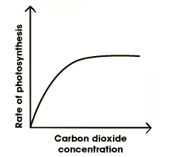Examine the graph below and answer the following questions.
   1. What is the effect of increasing carbon dioxide concentration on the rate of photosynthesis?
   2. What are 3 ways that you could measure the rate of photosynthesis?
   3. Explain why the rate of photosynthesis eventually levels off.
2. Examine the graph below and answer the following questions.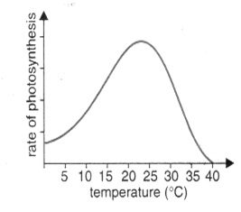
   1. What is the effect of increasing temperature on the rate of photosynthesis?
   2. What is the optimum temperature for photosynthetic activity?
   3. Explain the graph by clearly describing what is happening AND why it is happening.
3. Suppose that you ate a hamburger on a wheat roll with lettuce, tomatoes, and onions for lunch. As you ate, you took in food molecules from plants and animals. Explain why all the energy in the food molecules of this hamburger could be traced back to the sun.
4. If a plant is kept under green-colored light for an extended period of time, what will happen to the plant’s food production?
5. A plant that has a high amount of the orange pigment carotenes would have leaves of what color? Explain your answer.
6. How are photosystem I and II similar? How are they different?
7. If there is no light coming into the chloroplasts, how will this affect the Calvin cycle?
8. Write down the equation for photosynthesis below.
   1. Where does the CO2 originate?
   2. How does CO2 enter the plant?
   3. What happens to the carbon molecules during the process?
   4. What happens to the oxygen molecules during the process?
   5. Where does the H2O originate?
   6. How does the H2O enter the plant?
   7. In which structure is H2O distributed?
   8. What happens to the H atoms during the process?
   9. What happens to the O atom during the process?
   10. What happens to the carbohydrate after it is made?
   11. What happens to the O2 atom after it is made? How does it leave the plant?
9. If you place a plant in a clear, sealed box, how could you use a measurement of the gases in the boxed air to measure the rate of photosynthesis? What gas would you measure?
10. Read the following excerpt and answer the following questions.

Cyanobacteria are aquatic and [photosynthetic](http://www.ucmp.berkeley.edu/glossary/gloss3/pigments.html), that is, they live in the water, and can manufacture their own food. Because they are bacteria, they are quite small and usually unicellular, though they often grow in colonies large enough to see. They have the distinction of being the oldest known fossils, more than 3.5 billion years old, in fact! It may surprise you then to know that the cyanobacteria are still around; they are one of the largest and most important groups of [bacteria](http://www.ucmp.berkeley.edu/bacteria/bacteria.html) on earth.

Many Proterozoic oil deposits are attributed to the activity of cyanobacteria. They are also important providers of nitrogen fertilizer in the cultivation of rice and beans. The cyanobacteria have also been tremendously important in shaping the course of evolution and ecological change throughout earth's history. The oxygen atmosphere that we depend on was generated by numerous cyanobacteria during the [Archaean](http://www.ucmp.berkeley.edu/precambrian/archaean.html) and [Proterozoic](http://www.ucmp.berkeley.edu/precambrian/proterozoic.html) Eras. Before that time, the atmosphere had a very different chemistry, unsuitable for life as we know it today.

The other great contribution of the cyanobacteria is the origin of [plants](http://www.ucmp.berkeley.edu/plants/plantae.html). The chloroplast with which plants make food for themselves is actually a cyanobacterium living within the plant's cells. Sometime in the late Proterozoic, or in the early Cambrian, cyanobacteria began to take up residence within certain [eukaryote](http://www.ucmp.berkeley.edu/alllife/eukaryota.html) cells, making food for the eukaryote host in return for a home. This event is known as endosymbiosis, and is also the origin of the eukaryotic mitochondrion.

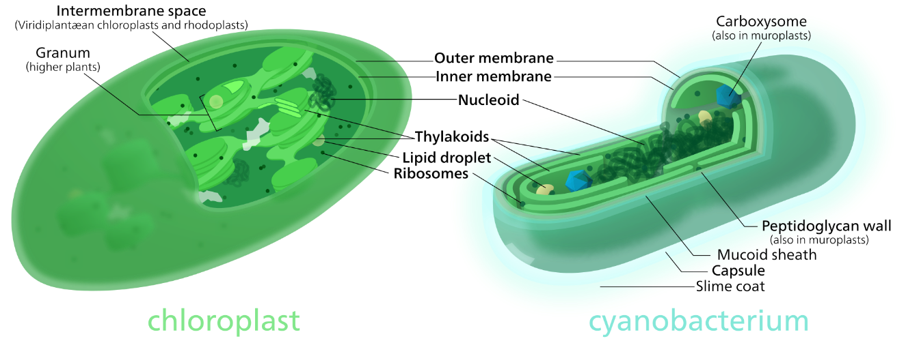Because they are photosynthetic and aquatic, cyanobacteria are often called "blue-green algae". This name is convenient for talking about organisms in the water that make their own food, but does not reflect any relationship between the cyanobacteria and other organisms called algae. Cyanobacteria are relatives of the bacteria, not eukaryotes, and it is only the *chloroplast* in eukaryotic algae to which the cyanobacteria are related.

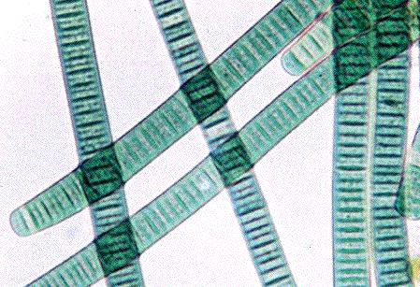

* 1. What is the basis of distinction between Cyanobacteria being classified as a bacteria or protist?
  2. Why are Cyanobacteria considered to have had a significant influence on the evolution of life on Earth? Explain.
  3. Why is the addition of the Cyanobacteria in eukaryotic cells beneficial? Explain.

1. 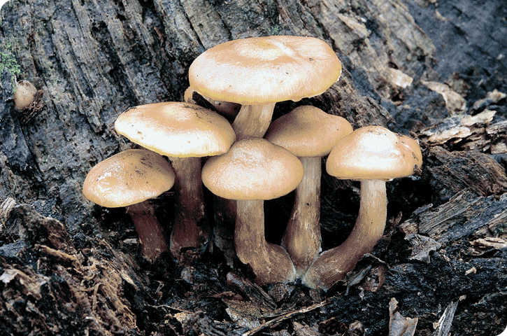Examine the picture below. What can you infer about this organisms’ ability to make its own food? Explain.
2. Explain how the plant maintains homeostasis by regulating the concentration of water within it.
3. Read the following excerpt and answer the following questions.

Some plants, such as potatoes and other tubers, and fruits like the banana and breadfruit, store starch for later use. This starch is stored by special organelles, or cell subunits, called amyloplasts. Plant starch begins as glucose, a primary product of photosynthesis, or the process by which plants produce food from sunlight. Glucose is difficult for plants to store, however, and is converted either to sucrose or starch through a process called polymerization. The polymerization and storage process in plants is performed by special cell parts---the amyloplasts. These non-pigmented organelles take glucose, turn it into starch and move it to another part of the cell, called the stroma. The stroma is the colorless, spongy cell matrix that supports the plant cell itself. In tubers, rhizomes and other starch-storing plant organs, it also acts as a place to store food for later use. When the plant needs the energy in the starch, it converts the starch grains back into glucose.

* 1. Why is the storage of starch beneficial for the plants? Explain.
  2. In the process of starch to be broken down to release glucose, write down a chemical equation to demonstrate the process.

1. Read the following excerpt below and answer the following questions.

Algae are plant-like microorganisms that preceded plants in developing photosynthesis, the ability to turn sunlight into energy. Algae cells contain light-absorbing chloroplasts and produce oxygen through photosynthesis. Although plants generally get the credit for producing the oxygen we breathe, some 75% or more of the oxygen in the planet’s atmosphere is actually produced by photosynthetic algae and cyanobacteria. Algae also play an important role as the foundation for the aquatic food chain. All higher aquatic life forms depend either directly or indirectly on microscopic gardens of algae.  
  
Most unicellular algae live in water, some dwell in moist soil, and others join with fungi to form lichens. When you think of algae, you probably think of seaweed or the [green](http://archives.microbeworld.org/microbes/protista/algae/green.aspx), slimy stuff that forms on the walls of untreated, dirty swimming pools. Here we'll focus on the microscopic algae. Algae are found in bodies of fresh and salt water across the globe. They can also grow on rocks and trees and in soil when enough moisture is available. (They also grow on the hair of the South American sloth, giving the animal a greenish color.)

Because photosynthetic algae make so much oxygen, these microbes are very helpful. But sometimes certain kinds of algae can also grow in such large numbers called blooms or red tides—that when they suddenly die off en masse, the breaking down of their cells by bacteria depletes the amount of dissolved oxygen in the water, hurting the animals and plants that live there.

* 1. What cellular structures do algae share with plants?
  2. Explain why “all higher aquatic life forms depend either directly or indirectly on microscopic gardens of algae.”
  3. Why is an algae bloom capable of “hurting” the animals and plants that live there?

1. Explain why the light dependent stage is required before the Calvin Cycle.
2. Why is sunlight necessary for photosynthesis?
3. How and where is oxygen generated during photosynthesis?
4. Label each part of the diagram of an ATP molecule below. How does a change from ATP to ADP provide an organism with energy?

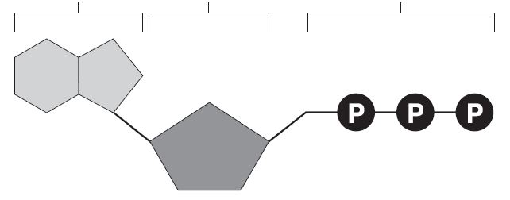

1. Examine the picture below and answer the following questions.

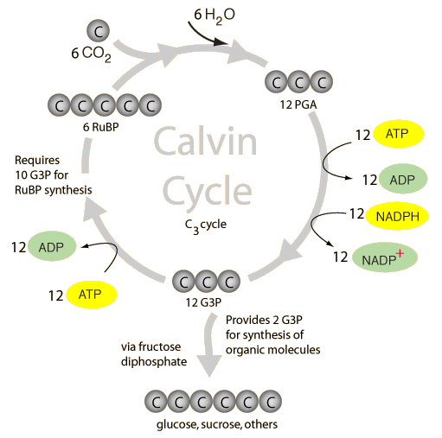

* 1. What molecules are needed for the Calvin Cycle to operate?
  2. If 12 G3P is the product in this reaction, what is the substrate?
  3. Why is water needed to create 12PGA?
  4. What substance(s) is/are required to make 6 RuBP?
  5. What important aspect is missing from this diagram?
  6. How many ATP molecules are needed to make glucose?

1. Examine the table below and answer the following questions.

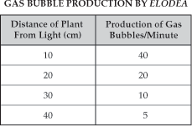

* 1. Based on the table, what is the relationship between the distance of the plant from light and the production of gas bubbles?
  2. What distance is optimum for photosynthesis to occur? Explain why.

1. Examine the table below and answer the following questions.

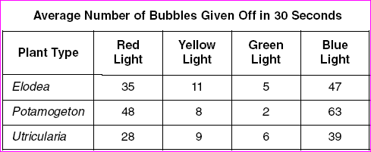

* 1. What is the dependent variable in this experiment?
  2. What gas is being produced? How do you know?
  3. Based on the table, what is the relationship between the color of light and the number of bubbles produced?
  4. Which color is best for photosynthesis? Explain.
  5. Which color is worst for photosynthesis? Explain.
  6. Which plant produced the most amount of glucose? Explain.

1. Read the following excerpt below and answer the following questions.

**No Such Thing as a Free Lunch for Venus Flytraps**

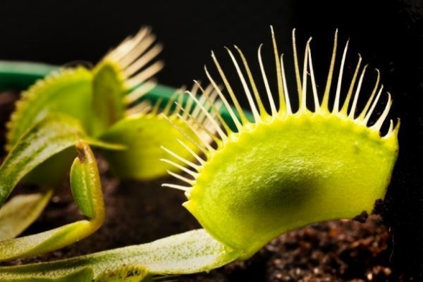ScienceDaily (Aug. 3, 2010) — Charles Darwin described the Venus Flytrap as 'one of the most wonderful plants in the world.' It's also one of the fastest as many an unfortunate insect taking a stroll across a leaf has discovered. But what powers this speed?

Dr Andrej Pavlovič of Comenius University, Slovakia, has been studying the plants with the help of some specialized equipment and a few unlucky insects. In the wild the Venus Flytrap grows in the bogs and savannahs of North and South Carolina. This is not a healthy environment for many plants as it is low in the nitrogen to needed to build proteins. The Venus Flytrap has overcome this problem by developing a taste for meat.

It has convex bi-lobed leaves with three trigger hairs on each lobe. When something knocks these hairs twice an electrical signal flips the leaves into concave shapes. If the captured creature struggles to escape it continues to tickle the trigger hairs. This causes the plant's trap to close tighter and release enzymes to digest its prey. Pavlovič looked at how the Flytraps snapped their leaves around their prey and thought that it might cost the plant energy to catch its food this way. To test his idea, he set up an infrared gas analyzer and a chlorophyll fluorescence imaging camera to watch the plants. He used a wire to make a trap snap and then simulated an insect struggling in the closed trap. Then he watched what happened as the plant caught its victim.

Pavlovič said: "When a trap was triggered, photosynthesis slowed down and then recovered over ten minutes after the traps stopped being stimulated. In addition, the gas analyzer showed an increase in respiration from the traps. To power the trap, the Venus Flytraps converted sugars they had photosynthesized back into carbon dioxide and energy. It is like an animal which also increases breathing when it has an increased demand for energy. The measurements showed that the effects are linked not to whether or not the trap is open, but to the stimulation of the trigger hairs.

The measurements are connected with electrical signals produced by trigger hair irritation. These signals are similar to the signals which spread through the animal neurons." The results mean that the plants should not been seen as entirely passive. Pavlovič added: "These results show that the plant is as active as it appears and that it has adapted to trade-off the costs of lost photosynthesis against the benefits of additional nutrients from animal prey which in turn may later stimulate photosynthesis. This agrees with my earlier studies on carnivorous plants and shows why Venus Flytraps live in sunny habitats. The energy used in eating insects means that they need a lot of opportunity for photosynthesis, otherwise they lose more than they gain." It also suggests an answer to a question posed by Darwin over a century ago. Pavlovič noticed that when the traps closed there were gaps between the 'teeth' at the edge of the trap that a small creature could escape through. He said: "This could be an adaptive trait. Victims with little useful nitrogen can escape, ensuring the plant doesn't waste energy digesting them. The Venus Flytrap is not a merciless killer."

* 1. Explain why the Venus Fly Trap and other carnivorous plants engage in carnivorous behavior.
  2. Why do carnivorous plants engage in photosynthesis? Explain.



