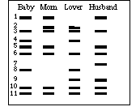
PCR Practice Questions
- Examine the picture to the side and answer the following questions
  - What does each band/line represent?

  - What was used to cut this DNA?

  - Examine the banding patterns of the baby. According to this picture, who is the father of the child? Explain.

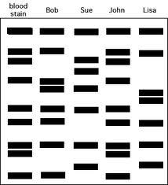
- Examine the picture to the side and answer the following question
  - Examine the banding patterns of the blood stain. According to this picture, whose blood is represented? Explain.

- Examine the picture below and answer the following question
  - Examine the banding patterns at the crime scene. According to this picture, which suspect was present at that location? Explain.
