Taxonomy and Classification Practice Questions

- Use the following table to answer the following questions
Kingdom | Animalia | Animalia | Animalia | Animalia
Phylum | Chordata | Chordata | Chordata | Chordata
Class | Mammalia | Mammalia | Mammalia | Mammalia
Order | Cetacea | Carnivora | Carnivora | Carnivora
Family | Mysticeti | Mustelidae | Felidae | Felidae
Genus | Balaenoptora | Mustela | Felis | Felis
Species | B. physalus | M. furo | F. domesticus | F. rufus
Common Name | Blue Whale | Ferret | Domestic cat | Bobcat
- How does the table indicate that a cat is more closely related to a bobcat than a ferret?

- At what level does the relationship between a blue whale and a ferret separate/diverge?
- Which two animals are most closely related? Explain.

- Which two animals are distantly related? Explain.

- What kind of animal is Balaenoptora borealis? How do you know?

- Based on the descriptions below, specify the kingdom represented.

a) Name the kingdom that contains eukaryotic organisms that can be autotrophic or
heterotrophic, very few have a chloroplast present and some can be multicellular ___________________
- Name this kingdom. It contains unicellular prokaryotes that are either autotrophic or heterotrophic. They thrive in neutral environments, are decomposers and a chlorophyll is sometimes present. ___________________
- What kingdom contains unicellular prokaryotic organisms that can heterotrophic or autotrophic and live in extreme environments? ___________________
- Name the kingdom that contains eukaryotic organisms with the characteristics of autotrophic, multicellular, chloroplast present and their cell walls are comprised of cellulose. ___________________
- What kingdom contains eukaryotic organisms with the characteristics of heterotrophic, multicellular, no chloroplasts present, and their cell membrane is composed of lipoproteins? ___________________

- Fill in the chart with the appropriate information.
Kingdom | Prokaryotic or Eukaryotic? | Autotrophic, Heterotrophic or both? | Asexual, Sexual or both? | Unicellular or Multicellular?
Archaebacteria
Eubacteria
Protist
Fungi
Plant
Animal

- Use the image below to answer the following questions
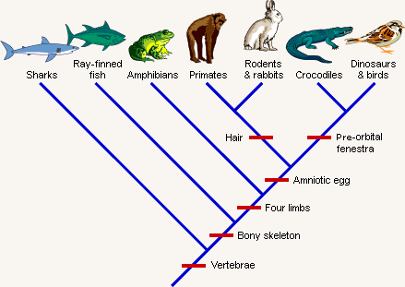
- What is the ancestral trait shown on the cladogram above?
- Infer which two organisms are most closely related. Explain your answer.
- According to the cladogram what species are primates most closely related to? Explain your answer.

- Use the image below to answer questions 5 and 6. How does cladistics taxonomy differ from traditional taxonomy?
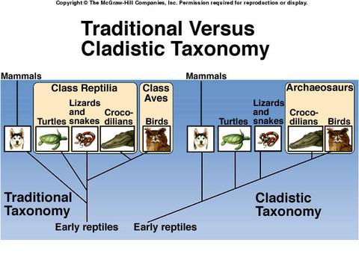
a. Cladistics emphasizes evolutionary relationships while traditional taxonomy puts more emphasis on appearance.
b. Traditional taxonomy depends on distinguishing primitive from derived characteristics.
c. Traditional taxonomy defines shared derived characteristics while cladistics does not.
d. There is little difference in these two methods, as can be seen in this figure.

6. Why does the cladistic view group birds with crocodiles?
A. They are clustered alphabetically.
B. There is a close evolutionary relationship between these two groups.
C. Crocodiles diverged later than birds.
D. Birds are substantially different than mammals and were placed at the opposite end of the scheme.

- The diagram below shows the evolutionary relationships of some organisms. Which two organisms would likely synthesize the most similar enzymes?
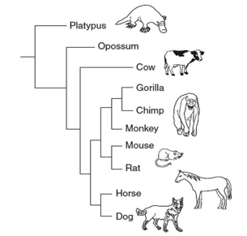
        - Monkey and mouse c. Cow and horse
        - Chimp and rat d. Horse and dog

