**Nucleic Acids Practice Questions**

**DNA Structure**

1. Using the picture below, identify the following parts of the DNA molecule: hydrogen bonds, nucleotide, and sugar-phosphate backbone by placing the corresponding number below.



* 1. Hydrogen bond _________
  2. Nucleotide ________
  3. Sugar-phosphate backbone ________

1. A double helix looks like a twisted ladder. Which parts of a twisted ladder are analogous to the hydrogen bonds and sugar-phosphate backbones of a double helix of DNA?
2. Use Chargaff’s rules to determine the approximate percentage of thymine in a DNA molecule, if 28% of the nucleotides in the molecule contain adenine.
3. Complete the table by estimating the percentages of each based on Chargaff’s rules.

|  |  |  |  |  |
| --- | --- | --- | --- | --- |
| **DNA sample** | **Percent of adenine** | **Percent of thymine** | **Percent of guanine** | **Percent of cytosine** |
| 1 | 31.5 |  |  |  |
| 2 |  | 30 | 20 |  |
| 3 |  |  |  | 17 |

1. The drawing below to the right shows half of a DNA molecule. Fill in the appropriate letters for the other half. Explain why you drew your sketch the way you did.

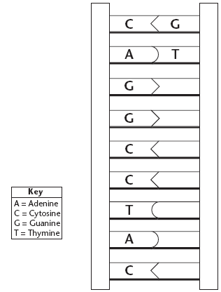

_______________________________________________________________

_______________________________________________________________

_______________________________________________________________

1. Complete this table to show how the structure of the DNA molecule allows it to perform each essential function.

|  |  |
| --- | --- |
| **Function** | **Structure of the Molecule** |
| Store information |  |
| Copy information |  |
| Transmit information |  |

1. Complete the following sentences with the appropriate terms
   1. The building blocks of DNA are __________ .
   2. Nucleotides in DNA are made of three basic components: a sugar called ______, a ____________ , and a nitrogenous ___________.
   3. DNA contains four kinds of nitrogenous bases: ________ , ____, ______ , and ______ .
   4. In DNA, can be joined in any order.
   5. The nucleotides in DNA are joined by ____________ bonds.
   6. The nitrogenous bases in DNA are joined by ____________ bonds.
   7. The purine, _________________ forms a bond with the pyrimidine, _______________. The other purine, _________________ forms a bond with the other pyrimidine, _______________.
2. For Questions 8–13, on the lines provided, label the parts of the DNA molecule that correspond to the numbers in the diagram.

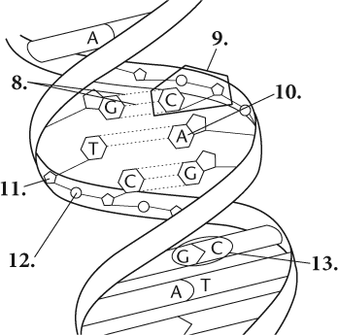



14. Examine the pictures below of DNA found in a virus, bacteria, fungi, and animal before answering the following questions.

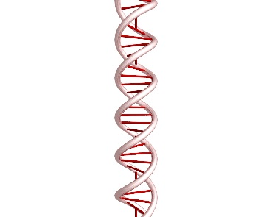Viral DNA Bacterial DNA Fungal DNA Animal DNA

1. What conclusion can you make about the DNA in viruses and all organisms?
2. Viruses, bacteria, fungi, and animals are all different, yet all are made of DNA with the same structure and function. Therefore, what part of the DNA is responsible for the differences among viruses and organisms as well as the diversity of the appearance of organisms?
3. Imagine you were a paleontologist and found the fossils of two organisms. You would like to determine whether each organism is closely related to the other using the DNA of each. How could a paleontologist use DNA to determine whether both organisms are closely or distantly related?
4. On Jerry Springer, many couples use paternity tests to determine who is the father of the child. To do so, each individual (the mother, child, and potential father) will use a buccal cotton swab to swab inside the cheek for 10 seconds. The DNA is then analyzed to determine paternity. If the DNA was taken from another part of the body (such as the skin, hair, or fingers), could the paternity of the child still be determined? Explain.

15. If an incorrect nucleotide is incorporated into a strand of DNA, will this mistake transmit to the next generation of DNA molecules that forms from this strand? Explain.

16. Describe what is meant by the antiparallel arrangement of DNA.

17. On the following page, use 10 nucleotides to construct a DNA model. The nucleotides of each strand can be in any sequence, as long as the two nitrogen bases paired together in the rung are correct. Ensure that you have used correct complementary base pairing rules and that the structure is anti-parallel. Label each strand 5’ or 3’.

18. View the following website: <http://learn.genetics.utah.edu/content/basics/> and then “What is DNA?”

a. DNA is an abbreviation of what?

b. Which part of the DNA molecule contains information/ or codes for the production of proteins?

c. How does DNA help make hearing possible? Use the terms genes and proteins.

19. Click on <http://learn.genetics.utah.edu/content/molecules/gene/> and then answer the following questions.

a. What is the function of a gene?

b. Genes are made up of?

c. How many genes are on your DNA?

d. How many proteins, then, could be produced?

e. What are possible effects of genes changing?

20. Click on <http://learn.genetics.utah.edu/content/chromosomes/intro/> and then answer the following questions.

a. How long is an individual DNA double helix?

b. How does DNA fit into a cell? Use the term histones (proteins), chromatin, and chromosomes.

c. How many chromosomes are found in humans? Onions? Carp?

**DNA Replication**

21. At the end of DNA replication, _______________ (four/two) new strands of DNA have been produced, giving a total of _________________ (four/six) strands of DNA.

22. On the lines corresponding to the numbers on the diagram, write whether the strand pointed to is an original strand or a new strand.

a. 4 ______________

b. 5 ______________

c. 6 ______________

d. 7 ______________

23. The length of a bacterium’s DNA may be 1000 times the length of the cell within which it is contained. Suggest an explanation for how this can occur.

24. If the base sequence on a separated DNA strand is 5’ CGTAGG 3’, what will the base sequence on its complementary strand be?

25. Does DNA replication take place in the same direction along both strands of the DNA molecule that is being replicated? Explain your answer.

1. Why is the pairing of bases during replication essential for the transmission of inherited traits from parent to offspring?
2. Is DNA replication always a foolproof process? Explain your answer.
3. DNA Replication occurs during S phase. Why is it important for DNA replication to occur before cell division?
4. Explain what is meant by semi-conservative replication.
5. Click on <https://www.youtube.com/watch?v=dKubyIRiN84> and answer the following questions.
6. How does DNA fit into a cell? Use the term histone, nucleosome, and chromosome.
7. What is the name of the enzyme that separates DNA?
   1. How does it separate DNA?
8. What is the direction of DNA replication in the leading strand?
9. What is the name of the enzyme that is involved?
10. Is this replication continuous or discontinuous?
11. What is the direction of DNA replication in the lagging strand?
12. Is this replication continuous or discontinuous?
    1. What are those pieces called?
    2. What is the name of the enzyme that “lays down” DNA?
    3. What is the function of DNA ligase?
13. Click on [http://highered.mheducation.com/sites/0072437316/student_view0/chapter14/animations.html#](http://highered.mheducation.com/sites/0072437316/student_view0/chapter14/animations.html) and then click on “How nucleotides are added in DNA replication” and “DNA Replication fork”

Summarize DNA Replication using the terms: antiparallel, leading strand, lagging strand, DNA helicase, hydrogen bonds, DNA polymerase, RNA primer, and DNA ligase

1. Use the diagram to answer the questions below.



* 1. Which of the labeled strands are the parent strands?
  2. Which of the label strands are newly synthesized DNA?
  3. What nucleotide will be added to strand b next?
  4. What nucleotide will be added to strand c next?

1. Explain, in detail, how DNA replication differs from the leading and lagging strand. In your response, state which direction (5’ to 3’ or 3’ to 5’) is considered leading and which is considered lagging.
2. Sometimes errors called mutations occur during DNA replication. What are some of the possible consequences of mutations?
3. If x = the number of genetic material available in the cell, how would you express the amount of genetic material available at the end of S phase? Explain.
4. When a cell divides, each daughter cell receives one copy of the original cell’s DNA. How are the duplicate and original strands divided between the two new daughter cells?
5. You will use the following diagram to show DNA replication and its semiconservative nature. Select one strand of DNA from the original (parent) cell and using a red colored pencil, color 1 strand red. Color the other strand blue. Then using your knowledge of semi-conservative replication, use those same colors (blue and red) to color the appropriate strand in each cell.

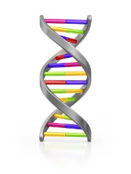





1. Watch the following video <https://www.youtube.com/watch?v=9bWjuwTiYXI> and answer the accompanying questions.
   1. What is a mutation?
   2. If a mutation occurs, explain what happens. In your response, mention the roles of Exo1, DNA polymerase, and DNA ligase.
2. Complete the flowchart for DNA replication by arranging the events listed below in the order in which they occur.

DNA polymerase joins individual nucleotides to produce a new strand; DNA helicase “unzips” and the two strands unwind; DNA polymerase proofreads the new strands; Unwound strands of DNA serve as templates for new DNA.