- During most of the cell cycle, individual chromosomes cannot be seen, even with the assistance of a microscope. However, during mitosis, a cell's chromosomes tightly coil and become visible. Which of the following best explains why it is necessary for a cell's chromosomes to tightly coil during mitosis?
Coiling allows the chromosomes to be evenly distributed in the daughter cells. | Coiling allows the chromosomes to separate without breaking during anaphase.
Coiling allows the chromosomes to easily move within a cell and not become tangled. | Coiling allows the chromosomes to line up across the middle of the cell during metaphase.

- Some eukaryotes reproduce asexually by budding. Therefore, buds must be a product of mitosis.
- True b) False

- Skin damaged by third-degree burns can no longer repair itself. However, cloned skin can be grown in a lab using a small piece of healthy skin from the victim.
The piece of skin grows larger through __________. The cloned skin matches the victim’s skin but the new skin lacks sweat glands and pores.

- Which of the following describe sets of cells that have the same number of chromosomes in their nuclei? Mark all that apply.
A growing embryo's stem cells and the nerve cells that develop later

The two offspring of a yeast cell that just underwent mitosis

A sperm cell and a skin cell belonging to the same rat

The cells in a lily plant’s pollen and the cells in its leaves

Twin embryos that developed from the same fertilized egg

- Use the words: mitosis, 2 identical, 4 identical, haploid, meiosis, diploid
In body cells, the process of _______ occurs and results in the formation of ______ cells. In humans, these cells have 46 chromosomes. This is known as the ___________ number of chromosomes. In the cells that produce sperm and ova, ____________ occurs and results in four sperm cells or one ovum. These reproductive cells have a ___________ number of chromosomes.

- After a certain stage of development, nerve cells no longer divide to form new cells. Thus, in order for a nerve to grow, its existing cells must simply increase in size. In which stage of interphase are mature nerve cells?
G 2 phase | S phase
Mitosis | G 1 phase

- The New Mexico whiptail lizard, Cnemidophorus neomexicanus, is a species composed entirely of females. The females are able to lay eggs that hatch without the involvement of a male lizard. This is an example of asexual reproduction.

True | False

- In multicellular organisms, cell differentiation begins soon after the initial rounds of cell division. For example, cells can become vascular tissue, become bone tissue, or remain undifferentiated stem cells. Which of the following can determine how a cell will develop? Mark all that apply.
The length of the cell cycle

Regulatory molecules in the cell's cytoplasm

The location of the cell in the blastula

All of the genes present in the cell's nucleus

Chemical signals from other cells

- Which of these structures help separate the doubled chromosomes during mitosis in animal cells? Mark all that apply.
Cytoplasmic fibers | Centrioles
Metaphase | Nuclear membrane

- A muscle cell can give rise to which of the following cell types?
Stem cells | Muscle cells
Nerve cells | Undifferentiated cells

- Which of the following is the end product of mitosis and cytokinesis?
One parent cell and one daughter cell that budded off the parent

Two daughter cells that are genetically identical to the original parent cell

One large cell that contains two sets of genetic information

Two daughter cells that are different from one another and the original parent cell

- You ask your friend's grandmother how to start a plant from a flower. She tells you that you must cut the flower off the stem, trim the bottom of the stem at a node below a leaf, and then place the stem in perlite, a type of potting medium. What type of tissue would you expect to find at the node?

Reproductive cells | Root cells
Undifferentiated cells | Tumor cells

- You and your friend follow these instructions and prepare several cuttings from a flower bouquet. Three cuttings survive. Which of the following can be inferred about these cuttings? Mark all answers that apply.

The cuttings will produce flowers that look different than the flowers in the bouquet.

The cuttings are genetically identical to the original plants.

The cuttings will produce offspring that have half the number of chromosomes in their nucleus.

The cuttings are clones of the original plants.

The cuttings produced plants by asexual reproduction.

- Flowers are the sex organs of plants, meaning that they produce gametes. There are half as many chromosomes in these gametes as there are in the cells in other parts of the plant.
True | False

- You see that nodules are growing on the roots of some plants from your friend's garden. She assures you that these nodules contain bacteria that provide the nitrogen necessary for the plants to grow. Which of the following statements accurately describes the bacterial cells that result from binary fission?

The cells are genetically identical to the parent bacteria. | The cells contain twice the number of chromosomes as the parent bacteria.
The cells contain completely different chromosomes than the parent bacteria. | The cells are twice the size of the parent bacteria.

- Your biology teacher thinks that your plant cuttings are an excellent beginning to a research project. He suggests that you test how environmental factors affect cell division in the roots of the cuttings.
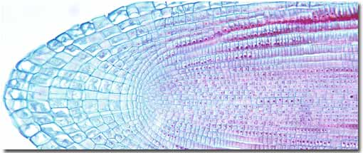
You can recognize when mitosis is taking place in a root cell because the ________ breaks down and the cell’s _________________ are visible

- Plant and animal cells both go through mitosis. What are the differences between the process of mitosis in plant cells and animal cells? Mark all that apply.
Plant cells do not reform a nuclear membrane.

Plant cells form a new cell wall between the cells after cytokinesis.

Plant cells do not go through as many stages of mitosis.

Plant cells do not have centrioles

- Tulips can reproduce asexually by producing bulbs or sexually by making seeds. Which of the following statements correctly describe tulip bulbs and seeds? Mark all that apply.
The tulip bulbs are genetically identical to the plant that produced them.

The tulip bulbs are produced through the process of meiosis.

The cells of tulip bulbs and tulip seeds contain the same number of chromosomes.

The tulip seeds are genetically different than the tulip bulbs.

The tulip seeds will result in plants with cells that have half the chromosome number.

- Although all rattlesnakes may look the same, the individuals that make up a population of rattlesnakes are actually genetically different. What type of reproduction makes this possible?
Sexual reproduction | Cloning
Asexual reproduction | Binary fission

- Most multicellular organisms usually reproduce sexually. However, all of the cells in an individual organism undergo mitosis at least once, and many cells continue to divide throughout the organism’s lifetime. What is the purpose of mitosis in an organism that reproduces sexually?
Mitosis is necessary for development and repair of damaged tissue.

Mitosis increases nutrient availability.

Mitosis allows an organism's cells to adapt to changing environments.

Mitosis increases genetic variation among an organism's cells.

- Body cells in poodles and other dogs have a diploid number of 78. How many chromosomes are in a poodle's sperm cell?
78 | 39
34 | 156

- This brain cell and white blood cell come from the same organism, and contain identical sets of genes. Why do cells that are genetically identical have such different shapes and functions?
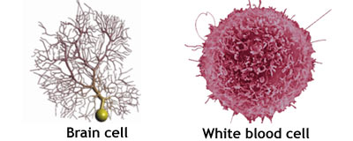
During mitosis, some of the cells' chromosomes are changed.

Different genes within the cells are expressed at different times during development.

The cells develop from different embryonic stem cells.

Different cells become dormant during some parts of development.

- Many cells within multicellular organisms never complete a full cell cycle. Where in the cell cycle do most of these cells spend their lifetime?
Mitosis | S phase
Meiosis | Interphase

- What happens after cytokinesis?
One or both of the new cells die. | The new cells enter anaphase.
The new cells enter interphase. | The nuclear membranes form.

- Why is it important for the chromosomes to line up in the middle of the cell during metaphase? Mark all statements that apply.
Each daughter cell gets a copy of each chromosome, giving each cell the same genetic information.

The chromosomes can double without touching other chromosomes.

The chromosomes are not in the way of the nuclear membrane.

The cytoplasmic fibers can attach to the chromosomes.

- You are chosen to participate in a summer internship program for future scientists at a local university. You have the opportunity to work with a research biologist who is interested in cell development and cell chemistry. She is particularly interested in how healthy cells become cancerous. As her assistant, you will help her set up experiments, report observations, and analyze results.
On the first day of your internship, you transfer several drops of liquid from a test tube to a petri dish containing nutrients needed for cell growth. Over several days, a single layer of cells grows to the edge of the dish. Compare the contents of the test tube with the cells in the dish. Where did the cells in the dish come from? How did the cells in the dish grow?
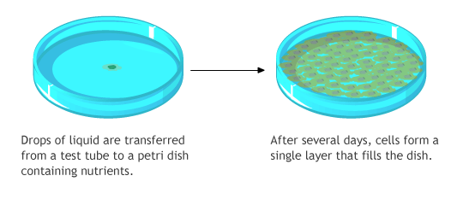
- Next, you are asked to remove some of the tissue in the petri dish. Afterward, the cells in the dish once again multiply and eventually replace the cells you removed. No new growth is observed after the initial increase, however. Explain why the cells most likely stopped growing when they reached barriers, like other cells or the walls of the petri dish.
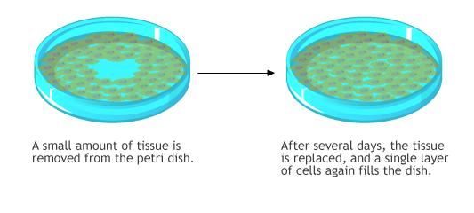
- In another petri dish, you place several drops of liquid from a test tube containing liver cells. This time, the cells grow quickly, forming multiple layers. Moreover, part of the tissue begins to grow out of the dish. Explain the type of growth this culture is exhibiting and how it could affect homeostasis.
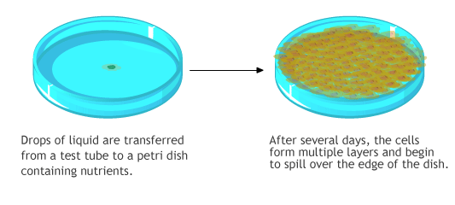
- The biologist would like to grow more complex tissue, such as sweat glands, rather than a single layer of cells. Explain why complex tissues, such as sweat glands, would be difficult to grow in a lab.

ANSWERS
- C
- TRUE
- MITOSIS
- A,B, E
- MITOSIS, 2 IDENTICAL, DIPLOID, MEIOSIS, HAPLOID
- G1
- True
- B, C, E
- FIBERS AND CENTRIOLES
- MUSC LE
- B
- UNDIFFERENTIATED
- B, D, E
- TRUE
- A
- NUCLEUS, CHROMOSOMES
- B, AND D
- A, C, D
- SEXUAL REPRODUCTION
- A
- 39
- B
- INTERPHASE
- B- NEW CELLS ENTER INTERPHASE
- A AND D

