Microbes Practice Questions
- Viruses are assigned to the kingdom
- archaebacteria
- protista
- eubacteria
- fungi
- none of the above

- viruses are denied a kingdom of their own because
  - they are too poorly understood
  - they are too small
  - their genetics cannot be determined
  - they are not organisms

3. Examine the picture below and answer the following questions

. 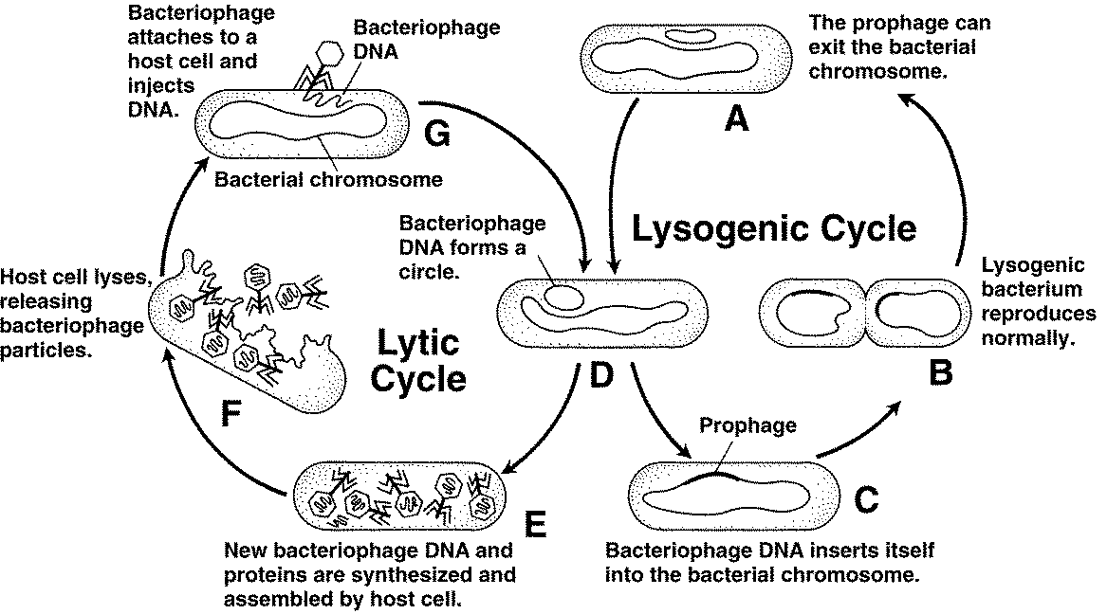

Figure 20–7

  - Look at both cycles shown in Figure 20–7. During which cycle is the host cell destroyed?

  - Each stage of the cycles shown in Figure 20–7 is labeled with a letter. Which letter indicates the stage at which the bacteriophage’s DNA becomes a part of the host cell’s DNA?
  - Which letter in Figure 20–7 indicates the stage at which a host cell begins producing new bacteriophages?

  - Which letter in Figure 20–7 indicates the stage at which a bacteriophage injects its DNA into a host cell?

4. Examine the picture below and answer the following questions

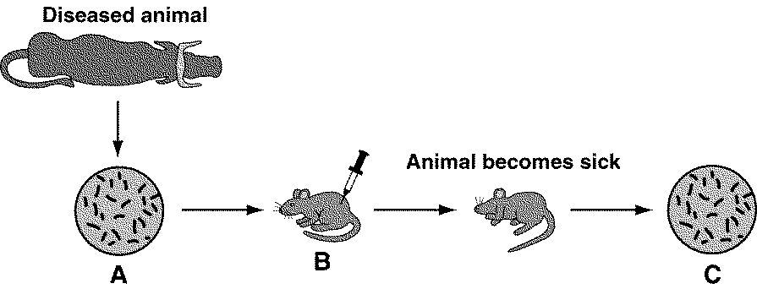

Figure 35–6
a. What is the purpose of the culture labeled A in Figure 35–6?

b. What is happening in the step labeled B in Figure 35–6?

c. What is the purpose of the culture labeled C in Figure 35–6?

d. Look at Figure 35–6. Predict what will happen if the microorganisms grown in the petri dish labeled C are injected into a healthy mouse. Support your answer using the figure.

e. Assume that the cultures in A and C in Figure 35–6 are identical. What can you conclude from this experiment based on this information?

5. A scientist used a mathematical model that describes the interaction of the human immune system with HIV to simulate the effect of HIV drugs on HIV-infected patients. Her goal was to determine the optimal time to begin treating HIV-infected patients. Graphs A, B, and C show some of the results of the scientist’s simulation.

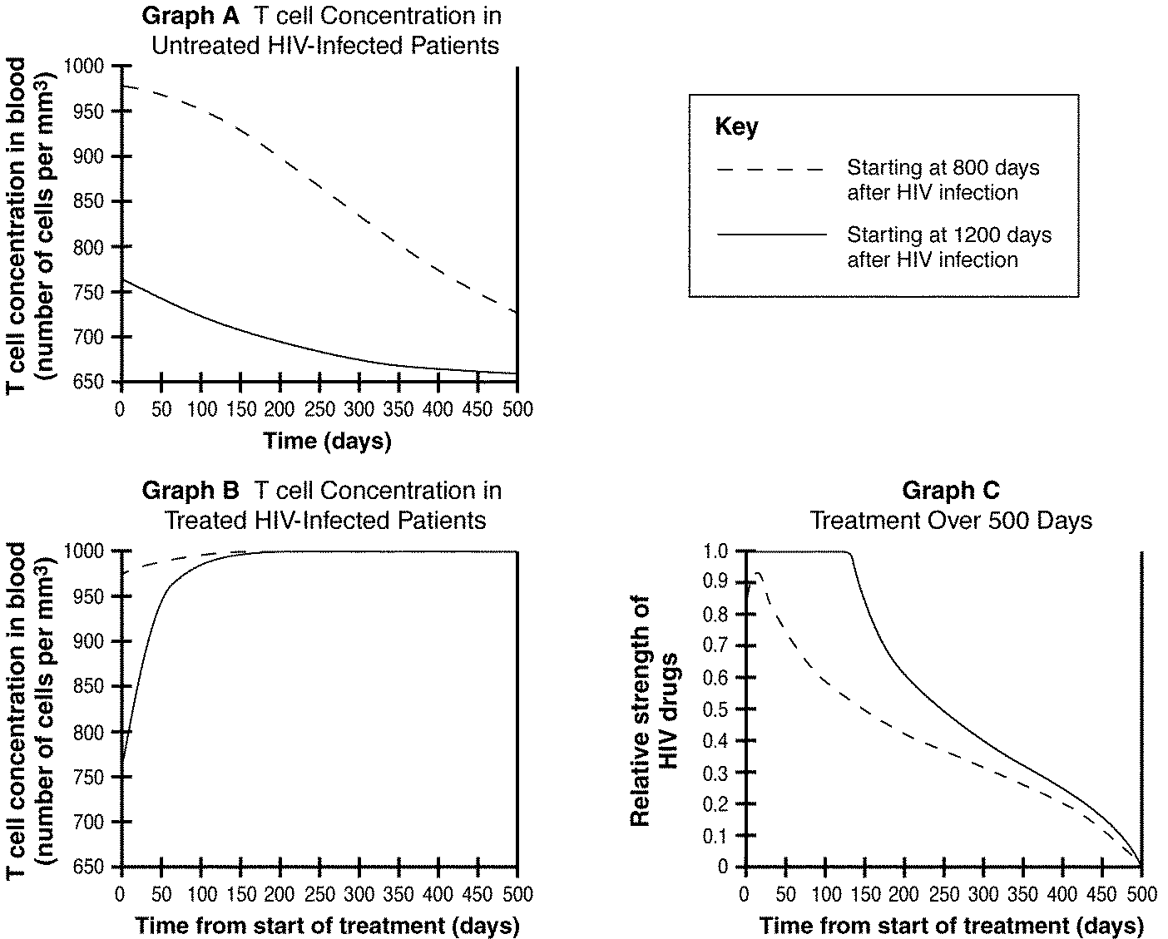

Figure 35–8

a. What do the two lines on Graph A in Figure 35–8 represent?

b. Look at Figure 35–8. Compare Graphs A and B. What do they show?

c. Based on Graphs A and B in Figure 35–8, what happens to T cell concentration between days 800 and 1200 during an HIV infection?

d. Look at Graph A in Figure 35–8. Predict the T cell concentration of an HIV-infected person at 1000 days after infection. Give a range for your answer.

e. Look at Graphs B and C in Figure 35–8. Based on these two graphs, what conclusion can you draw about the optimal time to begin drug treatment after a person becomes infected with HIV? Keep in mind that these drugs are damaging to the body and unpleasant to take. Use the data in Graphs B and C to support your answer.
6. Read the following statements that describe an HIV infection. What is the correct order in which they occur?

1) Reverse transcriptase uses viral RNA as a template to make viral DNA.
2) Virus coat fuses with cell membrane and viral RNA enters the cell.
3) Virus attaches to host cell membrane.
4) The new viruses bud off from the host cell membrane.
5) Viral DNA enters nucleus and inserts itself into host DNA.
6) Viral mRNA directs the host cell to assemble viral proteins.

a. 2,3,6,1,5,4 b. 2,3,1,5,6,4
c. 3,2,1,6,5,4 d. 3,2,1,5,6,4

7. Which of the following characteristics of living things is NOT true about viruses?
a. contain genetic material b. evolve over time
c. obtain and use energy d. able to reproduce

8. Unlike lytic viruses, lysogenic viruses do NOT
a. inject their genetic material into the host cell.
b. enter the lytic cycle.
c. lyse the host cell right away.
d. infect host cells.

9. Viral diseases can be
a. treated with antibiotics and prevented with vaccines.
b. treated with vaccines and prevented with antibiotics.
c. prevented with antibiotics but not treated with vaccines.
d. prevented with vaccines but not treated with antibiotics.

10. How do viruses cause disease?
a. by releasing toxins
b. by destroying cells or affecting cellular processes
c. by changing normal proteins into misfolded proteins
d. by inserting prophages into human DNA

11. Viral infections can be prevented by vaccines, which are
a. chemicals that destroy viral DNA.
b. substances that cause viral proteins to misfold.
c. drugs that control the growth and reproduction of viruses.
d. preparations of weakened or killed viruses.
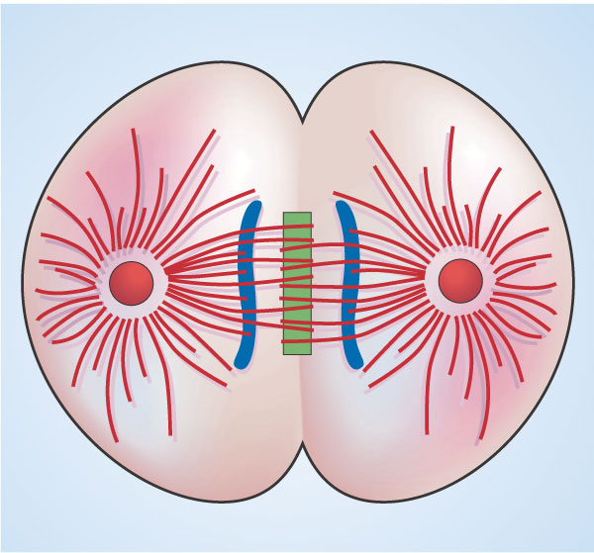
12. The cell in the diagram above is infected with a virus. It is in the process of dividing normally. This cell is most likely infected with
a. a lysogenic virus b. a lytic virus
c. a living virus d. a mitosis virus

13. How does a virus differ from a cell?
a. viruses are much larger than the largest cells.
b. a virus cannot copy itself unless it is inside a living cell.
c. cells make people sick, but viruses heal them.
d. cells have genetic material while viruses do not

14. A virus causes disease by
a. forcing human cells to make copies of viruses which eventually destroys the human cells
b. causing immune cells to divide too rapidly
c. changing the cell cycle so cells in the body grow into tumors
d. attacking the cells of major organs like the liver until they fail and cause death

15. H5N1 is a deadly virus. Only about 50% of persons infected with this virus survive. The chart shows some possible ways H5N1 can be transmitted. An H5N1 outbreak may be difficult to contain and control because
a. there are no antibiotics available which are effective against H5N1
b. H5N1 can be transmitted to many different species
c. H5N1 is transmitted by eating an infected organism
d. chickens are highly mobile species so spread H5N1 over large geographic areas
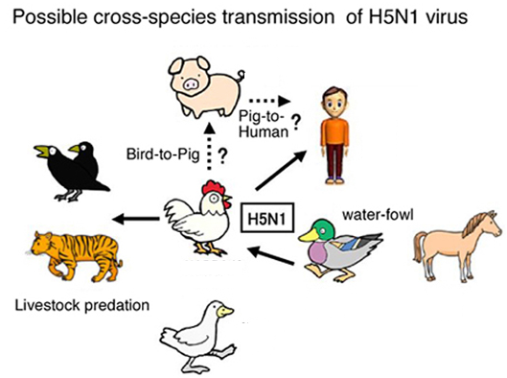

16. What would happen to a virus that never came in contact with a living cell? Explain your answer.

17. How does a typical virus get inside a cell?

- The diagram below shows the lytic cycle of a viral infection. Label the bacterial DNA, host bacterium, viral DNA, and virus. Then, circle the step that shows lysis of the host cell.

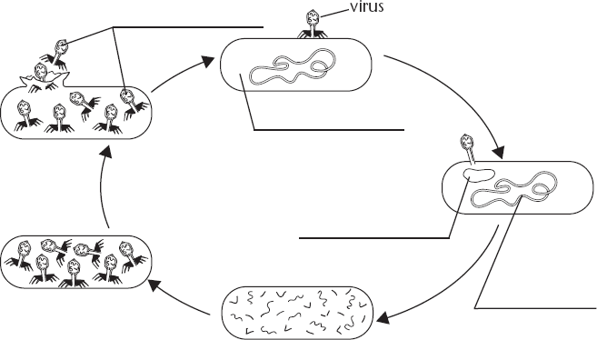

- In a lysogenic infection, how can one virus infect many cells?

- How is the common cold like the HIV virus?

- RNA viruses have shown an ability to evade antiviral drugs. How do you suppose this is possible, when viruses are not alive? How may the reproductive methods of viruses help the process?

- What are 3 ways in which archaebacterial differ from eubacteria?

23.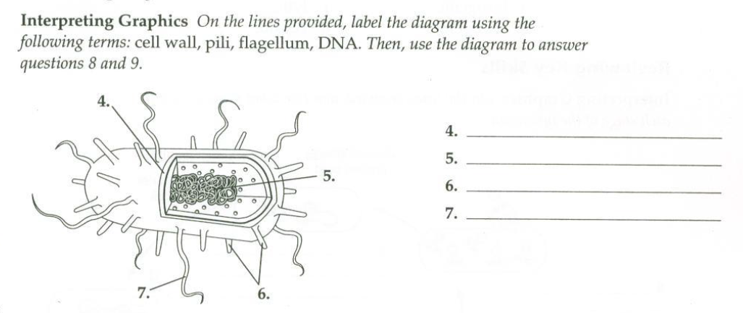

24. Is the bacterium in the diagram a bacillus, coccus, or spirillum? Explain your answer.

25. How would you expect this bacterium to move?

26. In prokaryotes, how are binary fission and conjugation different?

27. Explain how human actions facilitate outbreaks of disease caused by emerging viruses

- Composting is the process of breaking down organic materials under controlled conditions. A student set up three compost bins, one of which is shown in Figure 20–6. Into each compost bin, he added an identical combination of wood shavings, shredded paper, nitrogen, and bacteria. He mixed the materials in each bin and adjusted the insulation around the bins to maintain daily target temperatures. He then monitored the temperature, moisture, and amount of decomposition of the compost in each bin over an eight-week period. Some of his data are shown in the graph.

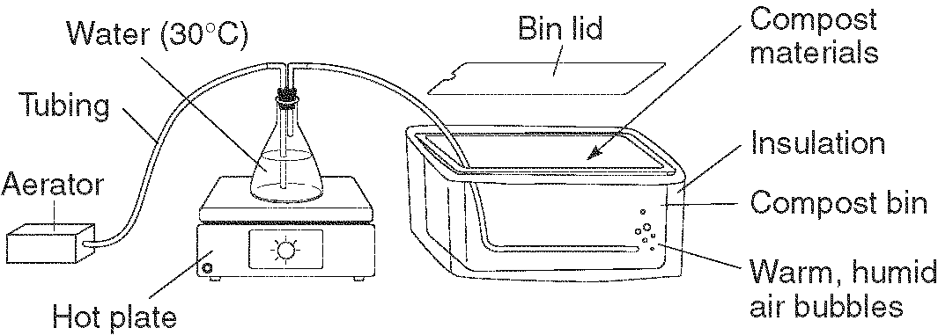

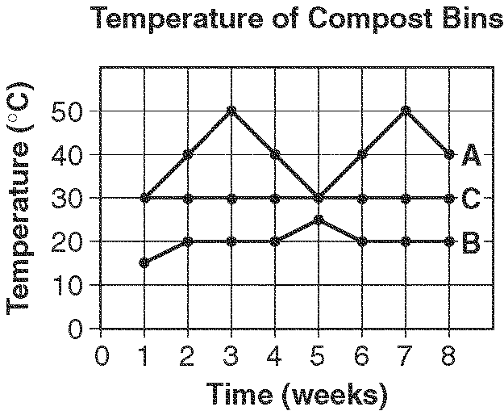

Figure 20–6

a. Based on Figure 20–6, what is the student probably trying to test? Explain your reasoning.

b. According to Figure 20–6, which compost bin is the control?

c. Look at the graph in Figure 20–6. How do you account for the 50⁰C temperature in compost bin A?

d. At the end of eight weeks, the student found that the materials in compost bin A had undergone the most decomposition. The materials in compost bin B had decomposed the least. Use the graph in Figure 20–6 to explain these results.

e. Suppose a fourth compost bin were added to the experiment. This bin was kept above 80°C. Based on Figure 20–6, predict how the decomposition in this bin would compare with that in bins A, B, and C.

- A student placed a disk of filter paper in each of the following solutions: disinfectant 1, disinfectant 2, disinfectant 3, and distilled water. While the four disks were soaking in their respective solutions, she streaked a sterile nutrient agar dish with a culture of E. coli bacteria. Then, she placed each disk carefully onto the nutrient agar dish, placed the lid on the dish, taped it shut, and incubated the dish at 37°C for several days. Figure 20–5 shows how the nutrient agar dish looked on Day 1 and Day 4.

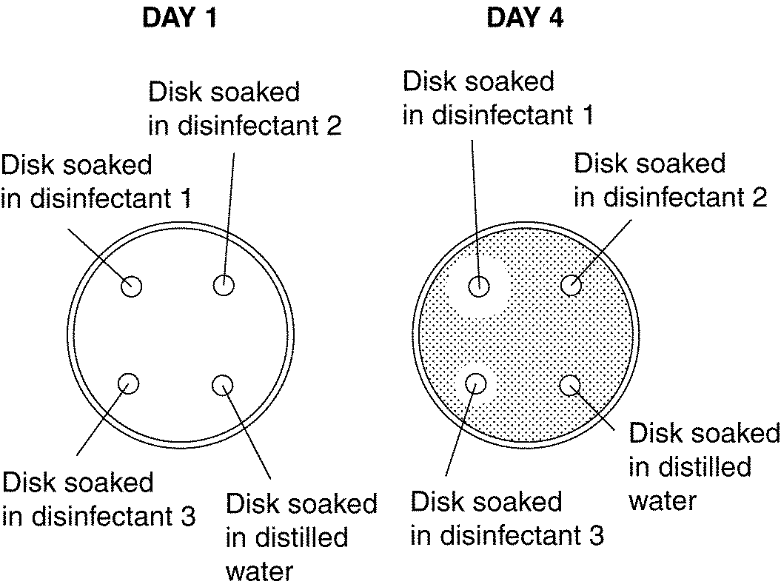

Figure 20–5
- Based on Figure 20–5, what is the student probably trying to test?

- What is the control in the experiment shown in Figure 20–5?

- Based on Figure 20–5, how can the student measure the effectiveness of each disinfectant?

- Look at the dishes in Figure 20–5. Which disinfectant was the most effective at controlling the growth of E. coli? How do you know?

- Look at the results of the experiment shown in Figure 20–5. Why do you think the different disinfectants are not equally effective against the E. coli bacteria?

30. Match the bacterial control method with an example of the method
Bacterial Control Method Example
11. physical removal A. Putting milk in a refrigerator
12. disinfectant B. Using bleach to clean a countertop
13. safe food storage C. Using boiling water to clean dishes
14. safe food processing D. Washing hands
15. sterilization by heat E. Boiling soup

31.. An advertisement on television states that you will be much healthier if you take probiotics. Your research revealed that probiotics were bacteria that you could take as a dietary supplement to help with digestion. Your friend asks if this is true. You tell them
A This is possible because many bacteria live in our digestive system and help with digestion
B This is impossible because bacteria cause disease
C This impossible because food and medicine cannot contain bacteria
D This is possible because bacteria are a major source of nutrients in our diet

32. Which of the following is the most valid statement about bacteria?
A all bacteria cause disease
B we need bacteria to maintain homeostasis
C bacteria cause disease in mammals only
D vaccines are available for all bacterial infections

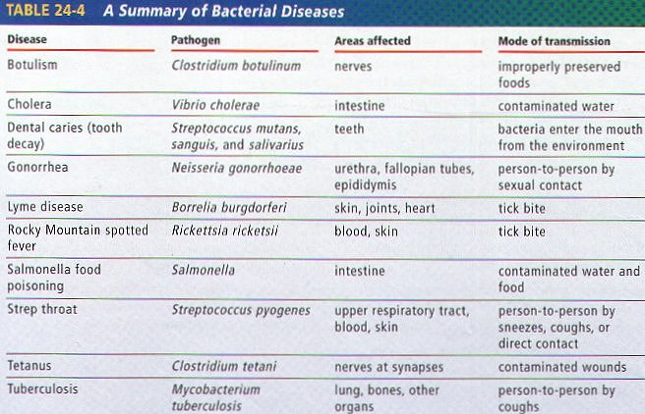
(image credit:leavingbio.net)
33. Based on the information in the table and what you know about how microorganisms cause disease, an important step in preventing microbial infection is
A cleaning infected wounds regularly and thoroughly
B taking preventative antibiotics
C identifying how the organism enters the body
D performing lab tests to detect the organism before treatment

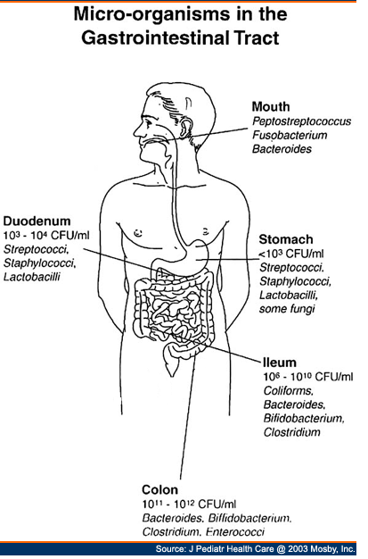

34. The illustration shows the amount and types of bacteria found in a sample of patients in a study. Based on what you know about bacteria’s effects in the body which statement is most likely true?
A The patients are suffering from a multi-microbial infection
B The patients in the study will require antibiotic treatment
C The patients in the study have a healthy digestive system
D The patients in the study are exhibiting resistance to antibiotics

