Macromolecules Practice Questions
DEHYDRATION SYNTHESIS & HYDROLYSIS
Below is an example of dehydration synthesis. In dehydration synthesis, a hydrogen atom from one molecule joins with a hydroxyl group (-OH) from another molecule to form water, leaving two molecules bonded to the same oxygen atom. For example, when glucose and glucose combine by dehydration synthesis, they form maltose and water.

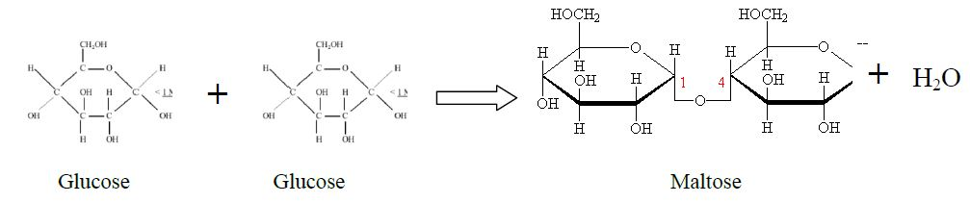

Below is an example of hydrolysis. Complex organic molecules are broken down by the addition of the components of water (H+ and OH-).
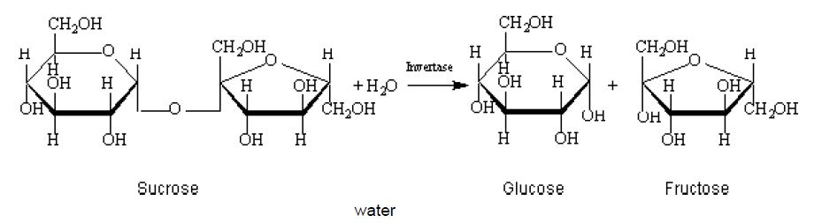

1) What are the products of the hydrolysis reaction?

- In what life process does hydrolysis occur?
- Is a bond being created or broken?

2) What are the reactants of the dehydration synthesis reaction?

3) What is the chemical formula for disaccharides?

4) Why is the chemical formula of disaccharides not double that of the monosaccharides?

5) Look at the three reactions below.
a) In reaction A, list the reactants and products.

b) In which reaction(s) is/are hydrolysis taking place? Explain.

c) Which reaction(s) is/are dehydration synthesis taking place in? Explain.

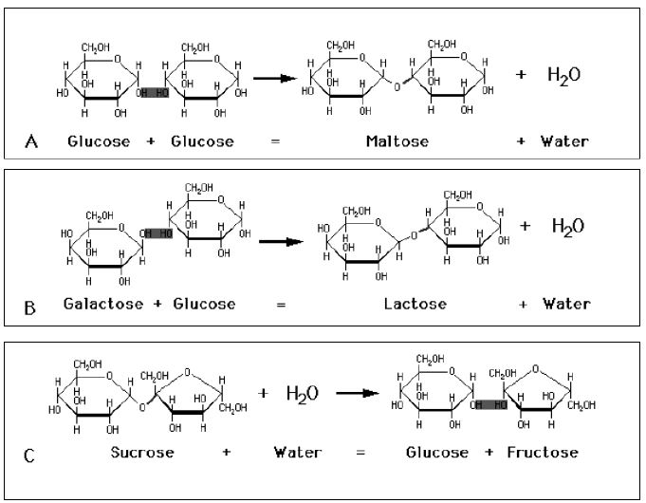

7) Examine the picture below.

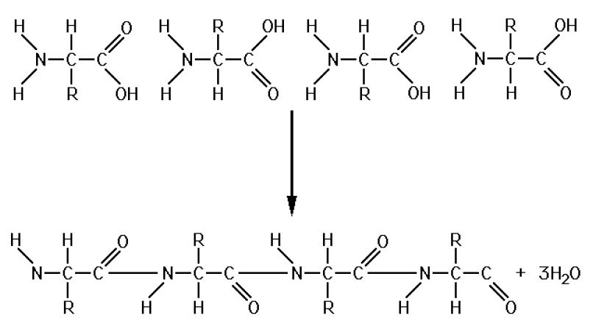
- What are the reactants?

- What are the products?

- Circle the peptide bonds. How many peptide bonds are represented?

- If a protein contained over 200 peptide bonds, how many molecules of water do you suppose would be required to break it down into its components? Explain.

- What chemical process occurred in this chemical reaction? In your explanation, refer to bonds.

8) Compare the structure of sucrose with glycogen. How are they similar? How are they different?

9) Look at the structural formulas below. These three monosaccharide sugars all have the same chemical formula (C₆H₁₂O₆).
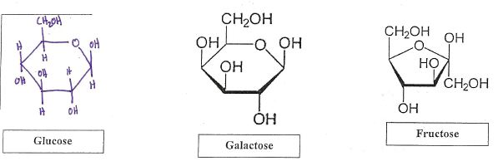

- Are the structural formulas the same?

b. Compare the proportion/ratio of elements in these monosaccharides (ex. 1 C: 2 N: 3 H).

10) Read the paragraphs below and answer the following questions.
Blood glucose homeostasis is an important biological process that involves a variety of mechanisms. The muscles, kidneys and liver all have important functions in glucose regulation. The liver is especially important for its ability to store glycogen and prevent low blood glucose.
Maintaining blood glucose within the normal range is referred to as glucose homeostasis. Your brain and nervous system depend solely on glucose for fuel and require a steady supply of glucose at all times. It is critical that your blood glucose concentration remains within the range of 70 to 110 mg/dL to supply your brain and nervous system with adequate fuel. Low blood glucose can lead to symptoms such as dizziness or lack of concentration, whereas, over time, high blood glucose can damage blood vessels and nerves.
Your liver plays a key role in blood glucose homeostasis. After a meal when blood glucose is high, the liver has the ability to remove glucose from the blood and store it as part of a molecule called glycogen. In between meals, as blood glucose begins to decline, the liver can make new glucose to release into the blood. Hormones, such as insulin and glucagon, regulate these homeostatic processes.
In your body, glycogen serves as the glucose storage molecule. Glucose is stored as glycogen when blood glucose concentrations exceed energy demands. Glycogen is found primarily in your liver, but is found in smaller amounts in your muscles. Glycogen can be synthesized, or broken down, according to the needs of your body. Insulin directs the synthesis of glycogen, thus helping to lower elevated blood glucose. In response to the hormone glucagon, stored liver glycogen can be broken down and released into the blood to help raise blood glucose.
- According to the article, how do the hormones insulin and glucagon help to maintain homeostasis?

- Which process is responsible for making glycogen- hydrolysis or dehydration synthesis? Explain using evidence from the article.

- What can you infer about the type of carbohydrate that glycogen is an example of- is it a monosaccharide, disaccharide, or polysaccharide? Explain using evidence from the article.

11. Read the following paragraphs and answer the following questions.
Cellulose is the substance that makes up most of a plant's cell walls. Since it is made by all plants, it is probably the most abundant organic compound on Earth. Aside from being the primary building material for plants, cellulose has many others uses. According to how it is treated, cellulose can be used to make paper, film, explosives, and plastics, in addition to having many other industrial uses. This paper contains cellulose, as do some of the clothes you are wearing. For humans, cellulose is also a major source of needed fiber in our diet.
Cellulose is usually described by chemists and biologists as a complex carbohydrate. Carbohydrates are organic compounds made up of carbon, hydrogen, and oxygen that function as sources of energy for living things. Plants are able to make their own carbohydrates that they use for energy and to build their cell walls. According to how many atoms they have, there are several different types of carbohydrates, but the simplest and most common in a plant is glucose. Plants make glucose (formed by photosynthesis) to use for energy or to store as starch for later use. A plant uses glucose to make cellulose when it links many simple units of glucose together to form long chains. These long chains are called polysaccharides, and they form very long molecules that plants use to build their walls.
It is because of these long molecules that cellulose is insoluble or does not dissolve easily in water. These long molecules also are formed into a criss-cross mesh that gives strength and shape to the cell wall. Thus while some of the food that a plant makes when it converts light energy into chemical energy (photosynthesis) is used as fuel and some is stored, the rest is turned into cellulose that serves as the main building material for a plant. Cellulose is ideal as a structural material since its fibers give strength and toughness to a plant's leaves, roots, and stems.

Cellulose and plant cells
Since cellulose is the main building material out of which plants are made, and plants are the primary or first link in what is known as the food chain (which describes the feeding relationships of all living things), cellulose is a very important substance. It was first isolated in 1834 by the French chemist Anselme Payen (1795–1871), who earlier had isolated the first enzyme. While studying different types of wood, Payen obtained a substance that he knew was not starch (glucose or sugar in its stored form), but which still could be broken down into its basic units of glucose just as starch can. He named this new substance "cellulose" because he had obtained it from the cell walls of plants.
As the chief constituent (or main ingredient) of the cell walls of plants, cellulose performs a structural or skeletal function. Just as our hard, bony skeletons provide attachment points for our muscles and support our bodies, so the rigidity or stiffness found in any plant is due to the strength of its cell walls. Examined under a powerful microscope, fibers of cellulose are seen to have a meshed or criss-cross pattern that looks as if it were woven much as cloth. The cell wall has been likened to the way reinforced concrete is made, with the cellulose fibers acting as the rebars or steel rods do in concrete (providing extra strength). As the new cell grows, layer upon layer of new material is deposited inside the last layer, meaning that the oldest material is always on the outside of the plant.
Despite the fact that humans (and many other animals) cannot digest cellulose (meaning that their digestive systems cannot break it down into its basic constituents), cellulose is nonetheless a very important part of the healthy human diet. This is because it forms a major part of the dietary fiber that we know is important for proper digestion. Since we cannot break cellulose down and it passes through our systems basically unchanged, it acts as what we call bulk or roughage that helps the movements of our intestines. Among mammals, only those that are ruminants (cudchewing animals like cows and horses) can process cellulose. This is because they have special bacteria and microorganisms in their digestive tracts that do it for them. They are then able to absorb the broken-down cellulose and use its sugar as a food source. Fungi are also able to break down cellulose into sugar that they can absorb, and they play a major role in the decomposition (rotting) of wood and other plant material.
- Using evidence from this article, is cellulose a monosaccharide, disaccharide, or polysaccharide?

- According to the article, what is the function of cellulose in a plant?

- If the special bacteria and microorganisms in the digestive tracts of ruminants are killed by antibiotics when a cow is sick, what effect would that have on the cow? Explain using terms such as hydrolysis, bonds, and energy.
12. Read the following paragraph and answer the following questions
Your cells are surrounded by a very important type of lipid, called phospholipids. Many lipids are non-polar, meaning that the charge distribution is evenly distributed. Non-polar molecules do not dissolve well in water; in fact, polar and non-polar molecules tend to repel each other in the same way that oil and water don't mix and will separate from each other even if they are shaken vigorously in an attempt to mix them. Therefore, phospholipids consist of a hydrophilic (or 'water loving') head and a hydrophobic (or 'water fearing') tail. Phospholipids like to line up and arrange themselves into two parallel layers, called a phospholipid bilayer. This layer makes up your cell membranes and is critical to a cell's ability to function.
Lipids all have one thing in common - they do not mix well with water. You can see this quite well if you try to combine oil and water. No matter how much or how hard you shake them together, they remain separated. This can be useful for organisms. For example, ducks produce lipids in their feathers, allowing the water to roll right off their backs and helping the ducks stay afloat.
- Based on this information, which part of the lipid is polar- is it the head or tail?

- Based on this information, which part of the lipid is nonpolar- is it the head or tail?

- Based on this information, which part of the lipid is hydrophilic- is it the head or tail?

- Based on this information, which part of the lipid is hydrophobic- is it the head or tail?

- Therefore, another interchangeable term for hydrophilic is? (Polar or non-polar)

- Examine the picture below. Using the information from the paragraph, label the phospholipid structures A and B using the following 4 terms hydrophilic, hydrophobic, polar, and non-polar.
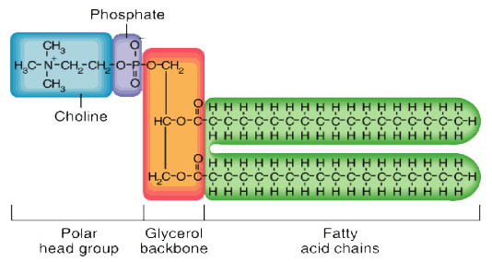

A B

- When oil is added to water, what part of the structure is touching the water? Use the terms polar/nonpolar and hydrophobic/hydrophilic.

- Draw a picture to represent how the oil droplet is formed in by showing the structures of the lipid.

13. Compare the structure and function of phospholipids with triglycerides. How are they similar? How are they different?

14. Read the paragraph below and answer the following questions
Proteins are large organic molecules that are built as a chain (or polymer) of amino acids. The behavior and function of the protein is caused by the specific amino acids that are linked together in the chain. These amino acids react with each other and cause the protein chain to twist and fold up into a large 3-D shape, forming a globular protein. The “R” groups (or side groups) of each amino acid can be either hydrophobic (water-fearing) or hydrophilic (water-loving). When a section of the protein is made of hydrophobic amino acids, it will cause that part of the protein to try to stay away from water. When a section of the protein is made of hydrophilic amino acids, it will cause that part of the protein to try to stay in water. The protein molecules in milk, called caseins, are very hydrophobic. They try to get away from the watery liquid of the milk, so they fold in on themselves a lot to hide from the water. This folding makes the milk protein molecules into globules in the milk. You can’t see them because even though they are large molecules, molecules are still too small to see with the human eye. Because pH (the acidity of a liquid) and high temperature both disrupt chemical bonds, they can affect how a molecule forms or how it behaves. This is especially true for proteins, since how they are shaped directly controls how well they function. When a protein loses its 3-D shape and unravels back into a long chain, it is called “denaturing.”

pH
Vinegar is a mild acid. It has a lower pH than water. An acid affects how the milk protein molecule holds together. When you add a mild acid to milk, the hydrogen atoms (H⁺) floating in the acid try to bond with parts of the amino acids in the milk protein globules. They break some of the internal bonds that hold the milk protein in a 3-D shape and force the protein to unravel back into a long chain. This “denatures” the proteins in the milk. All these long protein chains in the milk start to twist around each other trying to get away from the watery part of the milk, like lots of loose string getting all tangled up. All the proteins clump up and coagulate. You see this as milk curds, or cheese curds like in cottage cheese.

Temperature
Some proteins can be denatured by heat alone. Egg proteins are a good example. The behavior of eggs in the kitchen is also all about protein chemistry. The protein in egg whites is called albumen. The albumen proteins are also long chains of amino acids that are folded up onto themselves in a compact, 3-D, globular shape. Each protein molecule is held in this shape by various kinds of bonds between different parts of its chain. The bonding that shapes the egg protein molecules is very easily disturbed by changes in temperature (or pH or salt). These changes can cause the protein molecules to bond together into a solid mass — to coagulate. Take as an example the changes that occur during cooking. When eggs are heated, the increased energy of all the molecules in the egg breaks some of the bonds that keep the albumen proteins in their 3-D shape, and the individual protein molecules begin to unfold. This unfolding exposes more of each molecule's length to others, and so bonding between different protein molecules can occur. As the temperature of the egg rises, then, the proteins unfold more, bump into parts of each other more, and bond to each other more. Eventually, the initially separate, globular protein molecules floating around in the egg white form a mass of extended, intricately interconnected proteins. The liquid has become a solid, because the proteins have clustered together. In other words, the egg coagulates into a boiled egg.

- Are caseins polar or nonpolar? Cite evidence from the paragraph.

- What protein structure is represented of a 3D shape? (Refer to primary, secondary, tertiary, and quaternary structures).

- According to the article, how are milk curds formed? Explain your answer in relation to bonds.

- According to the article, explain how does temperature denatures proteins. ? Explain your answer in relation to bonds.

- Would cold temperature denature proteins? Explain why or why not.

- Why when you cool the egg down after cooking does it not become liquid again and why when you neutralize the pH of the cheese, does it not become liquid milk again?

15. There are 20 different amino acids. Compare the pictures of 4 amino acids below and answer the following questions.

Serine Alanine Methionine Arginine
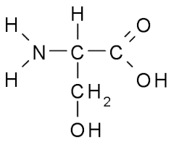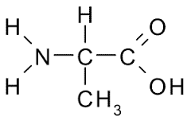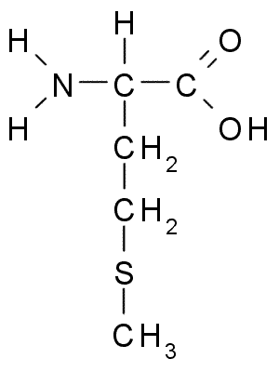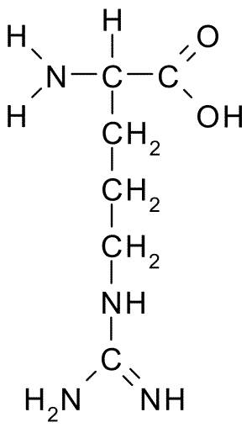

- Which part of the amino acid varies- is it the amino group, carboxyl group, or R group?

- Therefore, what is the relationship between this structure and the types of amino acids?

16. Read the paragraph below and answer the following questions
By the 1950s, scientists were in hot pursuit of the origin of life. Around the world, the scientific community was examining what kind of environment would be needed to allow life to begin. In 1953, Stanley L. Miller and Harold C. Urey, working at the University of Chicago, conducted an experiment which would change the approach of scientific investigation into the origin of life.
Miller took molecules which were believed to represent the major components of the early Earth's atmosphere and put them into a closed system
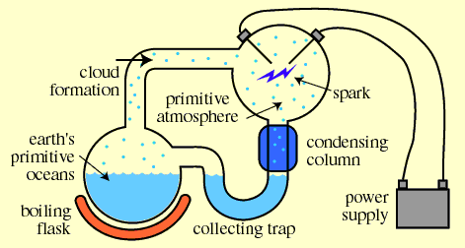

The gases they used were methane (CH₄), ammonia (NH₃), hydrogen (H₂), and water (H₂O). Next, he ran a continuous electric current through the system, to simulate lightning storms believed to be common on the early earth. At the end of one week, Miller observed that as much as 10-15% of the carbon was now in the form of organic compounds. Two percent of the carbon had formed some of the amino acids which are used to make proteins. Perhaps most importantly, Miller's experiment showed that organic compounds such as amino acids, which are essential to cellular life, could be made easily under the conditions that scientists believed to be present on the early earth. This enormous finding inspired a multitude of further experiments.
- According to the article, amino acids were produced from simulating early earth conditions. Therefore, what can you infer about the composition of atmospheric gases that served as the source of organic molecules?

17. Humans get the protein they need from foods, including beans and milk. A bean is a plant seed which contains a tiny plant embryo, together with food to help the plant embryo grow. Cows and other mammals produce milk to provide the food their babies need to grow. Seeds and milk contain proteins, fats, sugars and/or starch. Explain how the fats, sugars and/or starch contained in seeds or milk are useful for the plant sprouting from the seed or the baby mammal.

18. Draw and label the parts of a nucleotide.

19. Which structural part of a nucleotide varies? How does this variation affect the organism? Explain.

20. Read the information below and answer the following questions.
In a cell, nucleic acids are represented by two separate yet equally important forms: the DNA that stores information in the nucleus and RNA that is used to translate that information into proteins. These are their stories.

Nucleic Acids
Miss Crimson: Good day, ladies and gentlemen of the jury. My name is Miss Crimson, and I'm here to prove to you without a shadow of a doubt that my client, Colonel Custard, is not guilty of the most heinous crime of murdering poor Mr. Bones. The host of the International Cookbook Writers Convention was cruelly murdered with a lead pipe in a spiral staircase while on his way to deliver his award-winning cookbook to the kitchen. However, the defendant, Colonel Custard, was not responsible. The testimony of my expert witness will not only clear my client of all wrong-doing but will also reveal the identity of the true killer of our poor departed Mr. Bones.
Your honor, I call to the stand Professor Pear, an expert in DNA structure and function! Professor, could you please explain to us what DNA is?
Professor Pear: Why, yes. I'd be happy to tell you about DNA. DNA stands for 'deoxyribonucleic acid,' and it's a fascinating molecule. It's one of two basic types of nucleic acids, the other being RNA, or 'ribonucleic acid.' Nucleic acids are the molecules that cells use to store, transfer and express genetic information.
Miss Crimson: That's very nice, Professor, but could you elaborate on the DNA molecule?
Professor Pear: Yes, yes, of course. It's the molecule that stores genetic information in an organism. It's essentially providing directions? Like a recipe, if you will? For pretty much everything that makes us, well, us. If proteins are like the building blocks for structures, enzymes and other cool things in a cell, DNA is like a recipe that tells a cell how to create those building blocks.
Miss Crimson: So, you're saying that everyone has this DNA stuff inside his or her body?
Professor Pear: Oh my, yes. DNA is an integral part of every organism, just like other types of organic molecules found in our body, such as carbohydrates, lipids and proteins. But the structure of DNA is very distinct from those other types of organic molecules. Deoxyribonucleic acid gets its name from the fact that DNA possesses a sugar called deoxyribose. That sounds like a fancy name, but really it's very easy to remember that it's a sugar like other sugars you may have encountered, such as sucrose and fructose. Just remember that all sugars end in '-ose.' A monomer of DNA is called a nucleotide.
- Based on this excerpt, what is the relationship between DNA and RNA?

- What are the “building blocks” that DNA serves as a recipe to make?

