Hardy Weinberg Problem Set
p² + 2pq + q² = 1 and p + q = 1
p = frequency of the dominant allele in the population
q = frequency of the recessive allele in the population
p² = percentage of homozygous dominant individuals
q² = percentage of homozygous recessive individuals
2pq = percentage of heterozygous individuals
1. View the Dragons below. The winged trait is dominant.
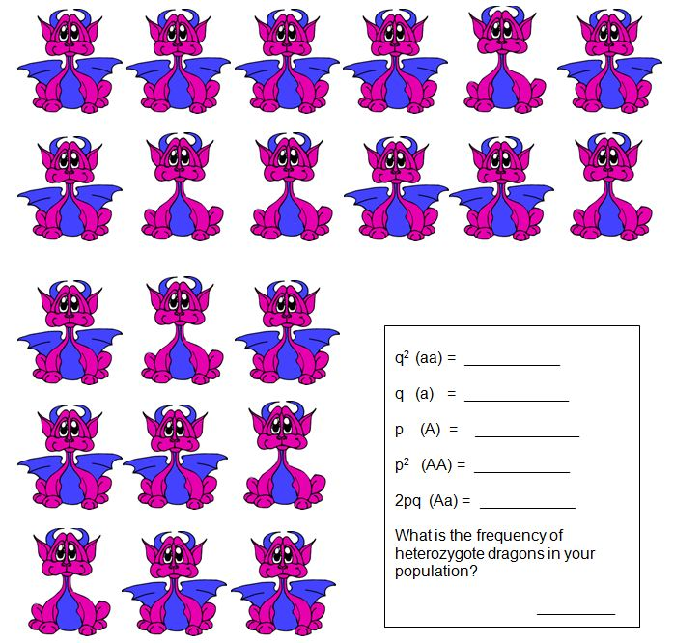

2. You have sampled a population in which you know that the percentage of the homozygous recessive genotype (aa) is 36%. Using that 36%, calculate the following:
A. The frequency of the "aa" genotype.
B. The frequency of the "a" allele.
C. The frequency of the "A" allele.
D. The frequencies of the genotypes "AA" and "Aa."
E. The frequencies of the two possible phenotypes if "A" is completely dominant over "a."
3. There are 100 students in a class. Ninety-six did well in the course whereas four blew it totally and received a grade of F. Sorry. In the highly unlikely event that these traits are genetic rather than environmental, if these traits involve dominant and recessive alleles, and if the four (4%) represent the frequency of the homozygous recessive condition, please calculate the following:
A. The frequency of the recessive allele.
B. The frequency of the dominant allele.
C. The frequency of heterozygous individuals.
4. Within a population of butterflies, the color brown (B) is dominant over the color white (b). And, 40% of all butterflies are white. Given this simple information, which is something that is very likely to be on an exam, calculate the following:
A. The percentage of butterflies in the population that are heterozygous.
B. The frequency of homozygous dominant individuals.
5. After graduation, you and 19 of your closest friends (lets say 10 males and 10 females) charter a plane to go on a round-the-world tour. Unfortunately, you all crash land (safely) on a deserted island. No one finds you and you start a new population totally isolated from the rest of the world. Two of your friends carry (i.e. are heterozygous for) the recessive cystic fibrosis allele (c).
Assuming that the frequency of this allele does not change as the population grows, what will be the incidence of cystic fibrosis on your island? ______
6. Cystic fibrosis is a recessive condition that affects about 1 in 2,500 babies in the Caucasian population of the United States. Please calculate the following.
The frequency of the recessive allele in the population. ______
The frequency of the dominant allele in the population. ______
The percentage of heterozygous individuals (carriers) in the population. ____
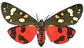7. This is a classic data set on wing coloration in the scarlet tiger moth (Panaxia dominula). Coloration in this species had been previously shown to behave as a single-locus, two-allele system with incomplete dominance. Data for 1612 individuals are given below:
White-spotted (AA) =1469 Intermediate (Aa) = 138 Little spotting (aa) =5. Calculate the allele frequencies ( p and q )
8. The allele for a widow's peak (hairline) is dominant over the allele for a straight hairline. In a population of 500 indiviuals, 25% show the recessive phenotype. How many individuals would you expect to be homozyous dominant and heterozygous for the trait?

9. The allele for a hitchhiker's thumb is recessive compared to straight thumbs, which are dominant. . In a population of 1000 individuals, 510 show the dominant phenotype. How many individuals would you expect for each of the three possible genotypes for this trait.
***Key
1. View the Dragons below. The winged trait is dominant.
7 of 21 are aa = q² = .33
q = .58
p = .42
p² = .18
2pq = .49--> number of heterozygotes
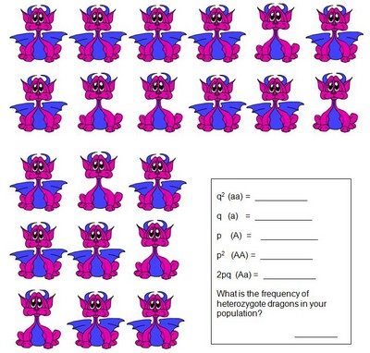
2. You have sampled a population in which you know that the percentage of the homozygous recessive genotype (aa) is 36%. Using that 36%, calculate the following:
A. The frequency of the "aa" genotype. .36
B. The frequency of the "a" allele. .6
C. The frequency of the "A" allele. .4
D. The frequencies of the genotypes "AA" and "Aa." .16 and .48
E. The frequencies of the two possible phenotypes if "A" is completely dominant over "a." .36 will show recessive trait, .64 will show the dominant trait
3. There are 100 students in a class. Ninety-six did well in the course whereas four blew it totally and received a grade of F. Sorry. In the highly unlikely event that these traits are genetic rather than environmental, if these traits involve dominant and recessive alleles, and if the four (4%) represent the frequency of the homozygous recessive condition, please calculate the following:
A. The frequency of the recessive allele. .04 = q²; therefore q = .2
B. The frequency of the dominant allele. p = .8; therefore p² = .64
C. The frequency of heterozygous individuals. 2pq = .32
4. Within a population of butterflies, the color brown (B) is dominant over the color white (b). And, 40% of all butterflies are white. Given this simple information, which is something that is very likely to be on an exam, calculate the following:
A. The percentage of butterflies in the population that are heterozygous.
.4 is the frequency of white (bb) butterflies. This is q²
taking the square root of .4 gives you q = .63
1-.63 = .37; this is p
2pq = .47 (number of heterozygotes)
B. The frequency of homozygous dominant individuals. p² = .14
5. After graduation, you and 19 of your closest friends (lets say 10 males and 10 females) charter a plane to go on a round-the-world tour. Unfortunately, you all crash land (safely) on a deserted island. No one finds you and you start a new population totally isolated from the rest of the world. Two of your friends carry (i.e. are heterozygous for) the recessive cystic fibrosis allele (c).
Assuming that the frequency of this allele does not change as the population grows, what will be the incidence of cystic fibrosis on your island? ______
Here we are looking for the number of recessives (q²)
Given that the heterozygotes in your population or 2 out of 20, that means that 2pq = .1
6. Cystic fibrosis is a recessive condition that affects about 1 in 2,500 babies in the Caucasian population of the United States. Please calculate the following.
The frequency of the recessive allele in the population. 1 / 2500 = .0004 <---- this is (q²) , then q = .02
The frequency of the dominant allele in the population. p + .02 = 1, p = .98
The percentage of heterozygous individuals (carriers) in the population. 2pq = 2(.98)(.02) = .04
7. This is a classic data set on wing coloration in the scarlet tiger moth (Panaxia dominula). Coloration in this species had been previously shown to behave as a single-locus, two-allele system with incomplete dominance. Data for 1612 individuals are given below:
White-spotted (AA) =1469 Intermediate (Aa) = 138 Little spotting (aa) =5
Calculate the allele frequencies ( p and q )
5/1612 = .003 = (q²)
q = .06 --> less than one percent of the populations has a little spotting
p+q = 1
p + .06 = 1
p = .94
p² =.88 --> 88% of the population will be white spotted
2pq = .11 --> 11% of the population will be intermediate
8. The allele for a widow's peak (hairline) is dominant over the allele for a straight hairline. In a population of 500 indiviuals, 25% show the recessive phenotype. How many individuals would you expect to be homozyous dominant and heterozygous for the trait?

9. The allele for a hitchhiker's thumb is recessive compared to straight thumbs, which are dominant. . In a population of 1000 individuals, 510 show the dominant phenotype. How many individuals would you expect for each of the three possible genotypes for this trait.

