From Molecule to Phenotype
1. The boxes below each show a step to explain how genetic disorders have a molecular basis. Number them so that the steps are in the correct order.

A change in phenotype results.
A gene’s DNA sequence changes.
The amino acid sequence that alters a protein changes.

2. Most of the genetic disorders you have learned about are the result of a change in DNA sequence, as with cystic fibrosis, or the presence of an extra chromosome, as with Down syndrome. The exception is Turner’s syndrome. Women with Turner’s syndrome have only 45 chromosomes. They are missing an X chromosome. This disorder is the only case in which a person can survive with one less chromosome. What does this tell you about how genetic information is inherited in humans?

Manipulating DNA
For Questions 3–6, write True if the statement is true. If the statement is false, change the underlined word to make the statement true.
3. Bacteria produce restriction enzymes that cut the DNA molecule into smaller pieces.
4. Restriction fragments are always cut at a particular sequence of proteins.
5. The technique that separates differently sized DNA fragments is gel
electrophoresis.
6. The enzyme that copies DNA is DNA restrictase.

Selective Breeding
For Questions 1–5, write True if the statement is true. If the statement is false, change the underlined word or words to make the statement true.
7. Selective breeding works because of the natural genetic variation in a population.
8. Hybridization crosses similar individuals to bring together the best of both.
9. The individuals produced by crossing dissimilar parents are purebreeds.
10. The continued crossing of individuals with similar characteristics is hybridization.
11. Inbreeding increases the risk of genetic defects
12. Complete the table describing the types of selective breeding.

Selective Breeding
Type | Description | Examples
 | Crossing dissimilar individuals to bring together the best of both organisms
 | The continued breeding of individuals with similar characteristics

For Questions 13–16, match the example with the probable method used to introduce the mutation. Each answer can be used more than once.
13. Bacteria that clean up radioactive substances
14. Larger, stronger banana trees
15. Bacteria that clean up metal pollution
16. Watermelons that grow faster and larger

A. radiation or chemicals
B. polyploid
17. Is it easy for breeders to produce mutants with desirable mutations? Explain.

18. Why are radiation and chemicals useful techniques for producing mutant bacteria?

19. What technique do scientists use to produce mutant plants?

20. What are polyploid plants?

Apply the Big idea
21. The muscles that racehorses use to move their legs are strong, heavy, and powerful. The bones of racehorses are very lightweight. How are these traits advantageous in racehorses? Describe a process that breeders might have used, over time, to produce racehorses with these characteristics.

22. Why is DNA ligase so important in recombinant DNA technology?
A. It causes DNA to make multiple copies of itself.
B. It joins two DNA fragments together.
C. It shapes bacterial DNA into a circular plasmid.
D. It cuts DNA into restriction fragments.
23. A recombinant plasmid can be used to
A. prevent nondisjunction at meiosis.
B. double the number of chromosomes in a plant cell.
C. cut DNA into restriction fragments.
D. transform a bacterium.
24. Why must a genetically engineered plasmid contain a genetic marker?
A. to prevent the construction of an artificial chromosome
B. to separate cells that contain recombinant DNA from those that do not
C. to produce multiple copies of the recombined plasmid after heat treatment
D. to break apart the circular plasmid and introduce another DNA fragment

On the lines below, write T next to an example of a transgenic organism, and C next to an example of a clone.
25. A goat that produces spider’s silk in its milk
26. A plant that is grown from a cell into which Agrobacterium has incorporated recombinant DNA
27. A lamb that is born with the same DNA as a donor cell
28. A colony of bacteria that grows from one bacterium
29. A bacterium that can produce human insulin

30. Complete the sentences in the diagram below to show the steps in cloning a sheep.
THINK VISUALLY

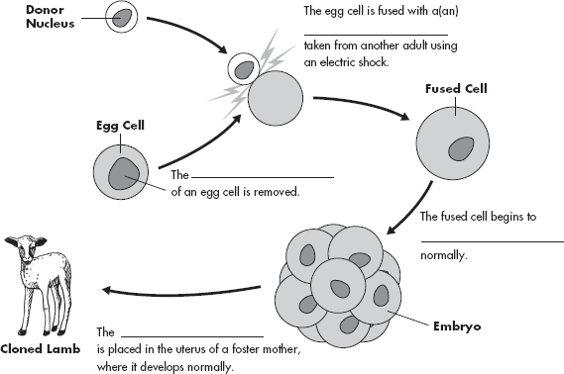

Apply the Big idea

31. The most successful heart transplants occur when proteins in the donor heart closely match those of the recipient’s original heart. If the proteins don’t match, the recipient’s immune system may reject the transplanted organ. Scientists would like to develop a strain of transgenic pigs that could provide donor hearts for humans. How might such an animal be developed? How might cloning help provide hearts for human recipients?

32. Name two other benefits that may be gained from genetically engineering food crops.
a.
b.

Personal Identification
33. Complete the flowchart about how DNA fingerprints are made.
Restriction are used to cut the DNA into fragments containing genes and repeats.
The restriction fragments are separated according to size using gel .
The DNA fragments containing repeats are then labeled using radioactive . This labeling produces a series of bands—the DNA fingerprint.

Increasing Variation
34. Complete this concept map about biotechnology.

Biotechnology
is
which can increase genetic variation through
an example of which is
an example of which is

Radiation and chemicals increase the mutation rate in bacteria, producing new strains that can perform useful functions, such as cleaning up oil spills.

35. The complete set of genetic information an organism carries in its DNA is its
A. karyotype.
B. genome.
C. chromosomes.
D. autosomes.
36. From what is a karyotype made?
A. A photograph of cells in mitosis
B. A series of X-diffraction images
C. A preparation of gametes on a microscope slide
D. A Punnett square
37. How many chromosomes are in a normal human karyotype?
A. 23
B. 46
C. 44
D. 2 (either XX or XY)
38. Which of the following genetic abbreviations denotes a male human?
A. 23, XX
B. 23, XY
C. 46, XX
D. 46, XY
39. Why is the ratio of male to female births roughly 50:50?
A. All egg cells carry an X chromosome.
B. Half of all egg cells carry a Y chromosome.
C. All sperm cells carry an X chromosome.
D. Half of all sperm cells carry a Y chromosome.
40. How are the X and Y chromosomes different?
A. Only one is an autosome.
B. The X is smaller than the Y.
C. The Y carries fewer genes than the X.
D. Only females have a Y.
41. All human cells carry
A. at least one X chromosome.
B. at least one Y chromosome.
C. a pair of X chromosomes.
D. one X and one Y chromosome.

For Questions 42–47, match the labels to the parts of the pedigree chart shown below. Some of the labels may be used more than once.

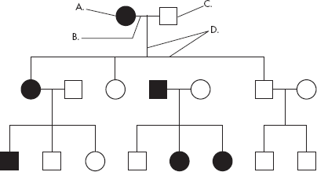

42. A person who expresses the trait
43. A male
44. A person who does not express the trait
45. A marriage
46. A female
47. A connection between parents and offspring

Apply the Big idea

48. Dimples in the cheeks are inherited as a dominant trait on an autosome. Using the proper form and symbols, draw a pedigree chart, beginning with a heterozygous, dimpled father (Dd), and a nondimpled mother (dd). Show four children of the expected types: boys, girls, dimples, and no dimples. Label your pedigree with phenotypes and genotypes.

