**ENZYMES PRACTICE QUESTIONS**

1. The food we eat contains many different types of molecules, including two types of sugars: monosaccharaides and disaccharides. For example, fruits contain the monosaccharaides, glucose and fructose, and the disaccharide, sucrose.

In the diagrams below:

* circle the name of each monosaccharide
* use arrows to indicate the names of the disaccharides.

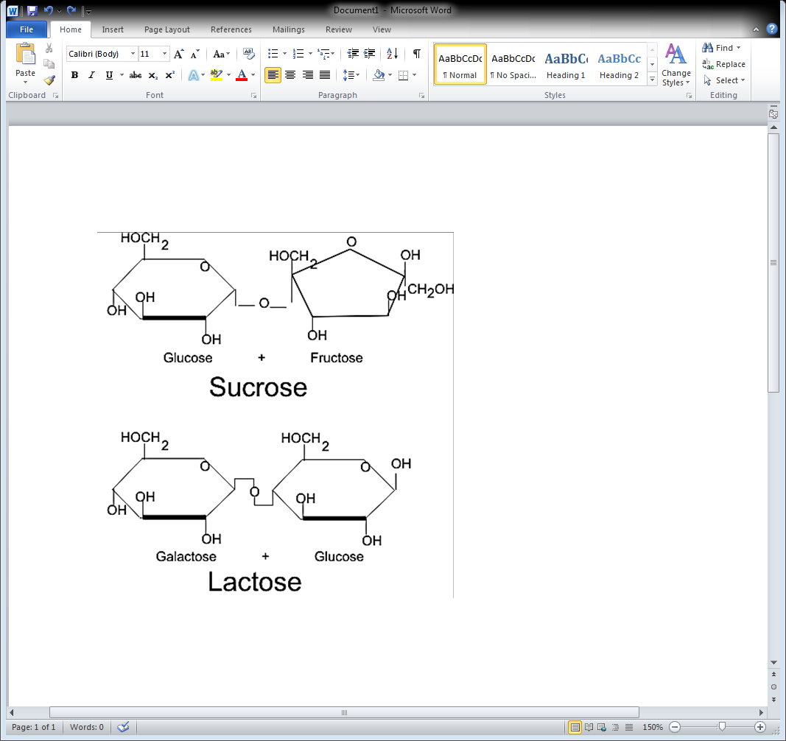 

1. Monosaccharaides from the food you eat are absorbed from your small intestine into your blood and carried to all the cells in your body where they are used for energy. Each disaccharide molecule must be broken down or digestedinto its monosaccharide components before it can be absorbed into the blood.

When a sucrose molecule is digested, is this an example of hydrolysis or dehydration synthesis? Include in your explanation a reference to bonds.

1. Write down a “word” chemical equation to describe the process of digesting sucrose. Example, water + sugar = more water + more sugar (see # 4 below as a reference).
2. An enzyme speeds up a chemical reaction which converts a substrate or substrates to a product or products. The products are released from the enzyme and the enzyme returns to its original state, so the enzyme is ready to act on another substrate molecule. Thus, an enzyme molecule can be reused over and over. For example, a single molecule of the enzyme lactase can speed up the digestion of many molecules of lactose.

The following equation shows the digestion of lactose.

**Lactase**

**Lactose --------- > Glucose + Galactose**

Use E to indicate the enzyme, S to indicate the substrate, and P to indicate the products. Circle the molecule that is a protein, and use arrows to indicate the molecules that are sugars.

1. Most enzymes in the human body work best at 370C. Imagine scientists have discovered an enzyme in the body that works best at 390C. What processes or functions might this enzyme be involved in?
2. Examine the picture below and answer the following questions.

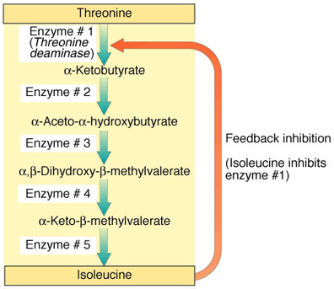

1. What is the reactant for enzyme # 1?
2. What is the product for enzyme # 3?
3. If enzyme # 2 is denatured, what substance will increase?
4. If enzyme # 2 is denatured, what substance will decrease?
5. If enzyme # 5 is denatured, how will it affect enzyme # 1 and enzyme # 2?
6. **Read the following paragraphs and answer the questions that follow using information from the article.**

Researchers working in a research project within the Academy of Finland's Research Program on Substance Use and Addictions have been developing a targeted drug that could aid in smoking reduction therapy. The new drug slows down the metabolism of nicotine, which would help smokers to cut down their smoking.

Nicotine is absorbed rapidly through the lining of the mouth but most readily through the lungs, from where it quickly passes through the body and into the brain. Once the nicotine reaches the liver, it is metabolized by an enzyme called CYP2A6. Preliminary studies by the Canadian partner of the research project have shown that inhibitors of the nicotine-metabolizing CYP2A6 enzyme can help smokers curb the need to smoke. Unfortunately, current CYP2A6 inhibitors are not viable options for anti-smoking therapy, as they involve too many adverse effects.

"We're working on developing a CYP2A6 inhibitor, a targeted drug that would only be effective in specific parts of the body. Thankfully, we have a very clear picture of the structure of CYP2A6, and we'll be able to use computer-aided modeling methods to design molecules that will bind specifically to the target without disturbing other functions in the body. We've now finished our four-year project and have discovered several molecules of an until-now-unknown structure. Along the way, we've gained new insights into how the molecules bind to the active center of the CYP2A6 enzyme. However, it'll take a good while -- and money -- before these molecules can be developed into a targeted drug," says Hannu Raunio, the principal investigator of the research project and Professor of Pharmacology at the University of Eastern Finland.

Traditional anti-smoking therapy has long been focused on smoking cessation. At present, there are a wide variety of treatments available to help smokers quit. Nicotine, buproprion and varenicline are among the most common drugs used in the treatment of smoking addiction. The idea behind pharmaceutical nicotine products is to relieve and prevent withdrawal symptoms so as to pave the way for smoking cessation. However, such forms of treatment are often unsuccessful, which has led to suggestions that new methods are needed, methods that would help in smoking reduction. It is this type of targeted drug that Raunio's project is developing.

1. According to the article, what substrate does CYP2A6 catalyze?
2. Where does that occur in the body?
3. What type of inhibition is discussed in this article? Cite evidence from the article.
4. If the researchers were able to develop this drug, what would be the dependent variable in this study?
5. Name 2 factors that must be controlled in an experiment involving CYP2A6.
6. Refer to the following graph, which shows the energy changes during a chemical reaction that has not been catalyzed by an enzyme and the energy changes for the same chemical reaction that has been catalyzed by an enzyme.

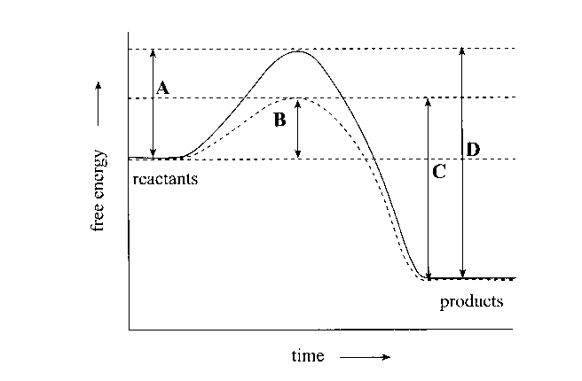

Which letter on the graph indicates the energy of activation for the chemical reaction that has been catalyzed by an enzyme?

1. **B**. **C**. **D**.
2. Examine the picture below and answer the following questions.

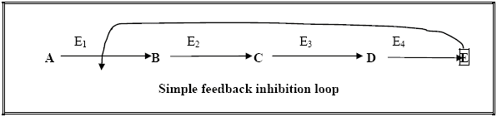

1. What is the substrate for enzyme E3?
2. What enzyme produces the product C?
3. What product indicated will impact on the entire enzymatic pathway?
4. This diagram is an example of which characteristic of life? Explain.
5. Refer to the graph below which shows the effect of different levels of pH on the activity of the human enzymes urease and trypsin at 35oC.

1 2 3 4 5 6 7 8 9 10

' ' ' ' ' ' ' ' ' '

pH of solution

Enzyme activity at 35° C

urease

trypsin

Which one of the following combinations of changes in pH and in temperature would result in the greatest increase in activity of the enzyme named?

|  |  |  |  |
| --- | --- | --- | --- |
|  | **Enzyme** | **Change in pH** | **Change in temperature** |
| J | Trypsin | 7 to 8 | 35°C to 25°C |
| K | Urease | 5 to 6 | 25°C to 35°C |
| L | Urease | 4 to 5 | 35°C to 25°C |
| M | Trypsin | 6 to 5 | 25°C to 35°C |

1. When body tissue is damaged the surrounding cells release the enzyme cyclo-oxygenase 2 (COX-2). COX-2 catalyzes a reaction that manufactures prostaglandins, hormone-like substances that trigger pain and swelling.

Aspirin is a COX-2 inhibitor designed to relieve pain. Aspirin is able to

1. bind to the active site on the substrate molecules that form prostaglandins.
2. have the same molecular shape as the active site on the COX-2 enzyme.
3. have a molecular shape complementary to that of the active site on the COX-2 enzyme.
4. have a molecular shape complementary to that of prostaglandins.
5. When soft-centered chocolates are made, the enzyme invertase is used to convert sucrose into the smaller molecules glucose and fructose. This causes the centers of the chocolates to become softer and sweeter.
6. State why the invertase must not be heated to temperatures above 45 o C.
7. State how invertase increases the rate of conversion of sucrose into glucose and fructose.

(c) Explain why the effect of an inhibitor on an enzyme may be reduced by increasing the concentration of the substrate.

1. An enzyme and four different molecules are shown in the diagram below.

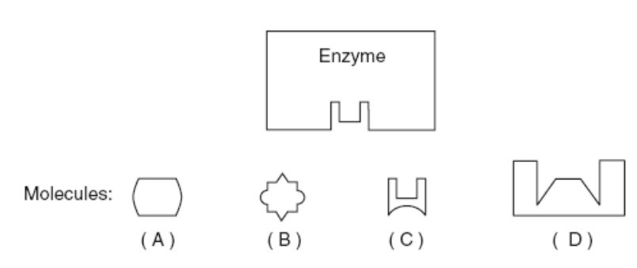

1. The enzyme would most likely affect reactions involving

(1) molecule *A*, only (2) molecule *C*, only

(3) molecules *B* and *D* (4) molecules *A* and *C*

1. Base your answers to questions 13 through 15 on the diagram below that represents a human enzyme and four types of molecules present in a solution in a flask.

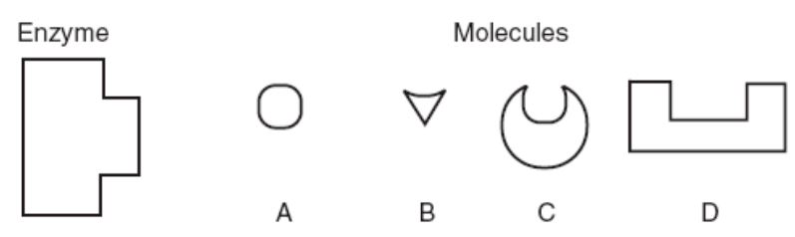

Which molecule would most likely react with the enzyme?

1. Explain your answer to question 13. What principle about how enzymes work does the question illustrate?
2. Match the enzymes with their substrates and functions.

_____ A. amylase 1. synthesizes DNA

_____ B. protease 2. digests sugar in beer (maltose)

_____ C. lactase 3. digests starch (amylose)

_____ D. DNA polymerase 4. synthesizes ATP

_____ E. maltase 5. digests milk sugar (lactose)

_____ F. ATP synthase 6. digests proteins

1. Base your answers to the following questions on the graph below and on your knowledge of biology.



1. What is the optimal pHfor pepsin?
2. Is this pH acid or basic?
3. In what organ of the digestive system does pepsin work?
4. What is the optimal pH for trypsin?
5. In what organ of the digestive system does trypsin work?
6. Is this pH acid or basic?
7. Neither enzyme works at a pHs of?
8. An incomplete graph is shown below. What 2internal body conditions could appropriately be used to replace letter *Z* on the axis?

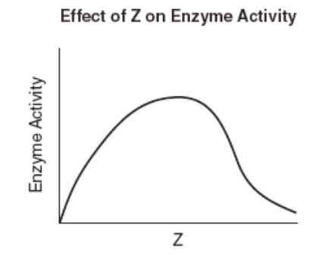

1. What kind of organic molecule is an enzyme?
2. List 2 internal environmental factors that affect how well enzymes function.
3. What happens to water when you heat it to 100°C?
4. What happens to proteins dissolved in that water when you heat it to 100°C?
5. What specific change happens to an enzyme that stops it from working when you heat it?
6. Explain why changing the shape of an enzyme could affect the ability of the enzyme to

function.

1. Examine the picture below and answer the following questions.

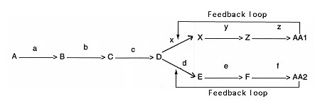

1. What do the letters “a”, “b”, “y”, and “z” represent?
2. What product inhibits enzyme X?
3. If enzyme f is denatured, what substance will increase?
4. Which substance can serve as a reactant for two enzymes?
5. Draw a generalized graph of the action of an enzyme from the human body as the temperature changes from 0°C to 100°C. Mark the temperature of optimal enzyme activity.



1. What most likely happens to the rate of reaction of a human enzyme when the temperature is increased gradually from 10°C to 30°C. Explain your answer.
2. What most likely happens to the rate of reaction of a human enzyme when the temperature is increased gradually from 40°C to 90°C. Explain your answer.
3. What is the optimal temperature for the functionality of a human enzyme?
4. An important cause of the deterioration in flavor, texture, and vitamin content of frozen fruits and vegetables during storage is the action of hydrolytic enzymes released from the vacuoles of the cells. Blanching (a quick dip in boiling water) prior freezing improves the keeping qualities of produce. How do you suppose blanching works?
5. Some fruits and vegetables turn brown when peeled because they contain the enzyme catecholase, which catalyzes a reaction between oxygen and a colorless compound, catechol. The product of this reaction is benzoquinone, which forms the red and brown pigments responsible for the browning. When preparing fruit salads, some cooks sprinkle the sliced fruits with lemon juice to prevent discoloration. How might lemon juice act to prevent the browning of fruit?
6. Commercial meat tenderizers often contain papain, a proteolytic (protein-digesting) enzyme derived from papayas. How might such products make meat more tender?
7. Meat tenderizers are sometimes used as a home remedy for treating stings inflicted by the Portuguese man-of-war. Based on this information, to what class of organic compounds do you suppose the toxins released by the man-of-war belongs?
8. The following table shows the relative activity of two digestive enzymes, pepsin and salivary amylase, at various pH levels. On graph paper, plot the pepsin data, connect the points with straight lines, and label the curve “Pepsin”. On the same graph, plot the salivary amylase data, connect the point with straight lines, and label the curve “salivary Amylase”. Then answer the questions that follow.



1. According to these data, what is the pH optimum of pepsin?
2. Relate this to the environment in which pepsin acts during digestion.

c. Salivary amylase breaks down starch (a polysaccharide). The digestion of starch by salivary amylase begins in the mouth, ceases in the stomach, and resumes in the small

intestine. Refer to your graph to explain why.

1. Why is it important for your body to maintain a stable internal temperature?
2. Read the following excerpt and answer the following questions.





1. What inferences can you make regarding the pH of a particular part of the digestive system and the type and relative size of the carbon-based molecules that are broken down there?
2. If the optimal pH range of most enzymes is between 6 and 8, is there possibly some advantage to having certain enzymes, such as pepsin, active in the low pH of the stomach?
3. The stomach is a relatively small muscular organ compared to the small intestine that can be as long as 6 meters. Yet food tends to be held in the stomach and released in only small amounts into the small intestine. What does that suggest to you about where nutrients are absorbed? How do the products of enzyme action described in the table support your thinking?
4. Review the following graph below on the effect of temperature on enzyme activity. In one paragraph, describe the graph and explain why enzyme activity is affected by increasing temperatures.

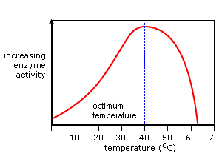

1. Review the following graph below on the effect of substrate concentration on enzyme activity. In one paragraph, describe the graph and explain why enzyme activity is affected by substrate concentration.

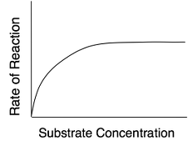

1. Review the following graph below on the effect of pH on enzyme activity.
   1. In one paragraph, describe the graph and explain why enzyme activity is affected by increasing pH.
   2. Which enzyme operates best in acidic environments? Explain.
   3. What would be the effect of placing the aforementioned enzyme in the small intestine (which has a basic pH)?
   4. How could you measure the rate of reaction of these 2 enzymes?

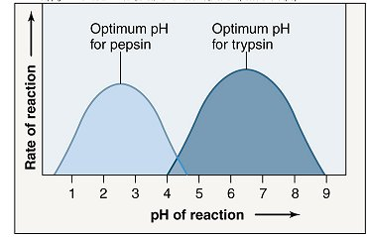

1. Review the following graph below on the effect of inhibitors on enzyme activity.
   1. In one paragraph, describe the graph and explain why enzyme activity is affected by competitive and noncompetitive inhibitors.
   2. Which of the two, competitive or noncompetitive inhibitors, is more effective on preventing the production of products? Explain citing evidence from the graph below.

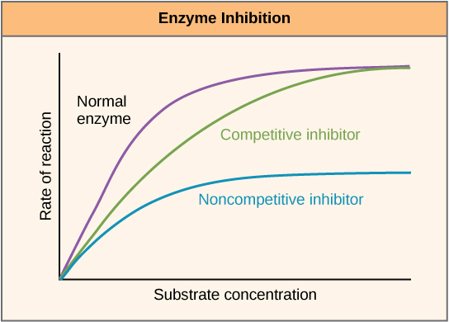

1. In a paragraph, explain the role of enzymes and how this role affects the 2 macromolecules- carbohydrates and proteins. You MUST refer to the following 20 words: activation energy, activation site, enzyme-substrate complex, reactant, product, bonds, macromolecule, carbohydrate, protein, monosaccharide, disaccharide, polysaccharide, amino acids, monomer, polymer, acid, base, pH, heat, and cold.