Ecology Practice Questions

- What organism is typically excluded from all food webs and chains, yet plays a very important role within them?

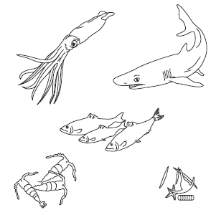
- Draw arrows between the organisms to show how energy moves through this food chain. Write producer, herbivore, or carnivore under each organism.

- Explain how energy flows through this food chain.

- What do ecologists mean when they say that sharks indirectly depend on krill for their survival?

- What would happen to this food chain if a disturbance caused a serious decline in the shark population?

- What would happen to this food chain if the fish population doubled? Describe the effect on ALL organisms.

- People who explore caves where there is running water but no sunlight often find them populated with unique types of fishes and insects. What hypothesis can you make to explain the ultimate source of energy for these organisms

- Which group of organisms is always found at the base of a food chain or web? Explain why.

- Why is the transfer of energy in a food chain usually only about 10 percent efficient?

- Can some organisms survive without energy from the sun? Explain your answer.

- Write True or False on the line provided.
a. Primary consumers always make up the first trophic level in a food web.
b. Ecological pyramids show the relative amount of energy or matter contained within each trophic level in a given food web.
c. On average, about 50 percent of the energy available within one trophic level is transferred to the next trophic level.
d. The more levels that exist between a producer and a given consumer, the larger the percentage of the original energy from producers is available to that consumer.

- Use the diagram below to answer the following questions. Match the organism with its trophic level. A trophic level may be used more than once.
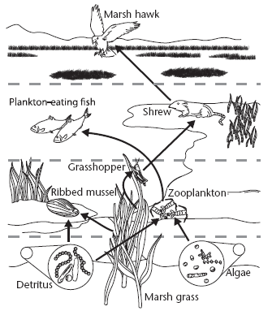

Organism Trophic Level
i. algae
ii. grasshopper A. primary producer
iii. marsh grass B. first-level consumer
iv. marsh hawk C. second-level consumer
v. plankton-eating fish D. third-level consumer
vi. ribbed mussel
vii. shrew
viii. zooplankton

- What trophic level has the most significant impact on the organisms in an ecosystem? Explain.

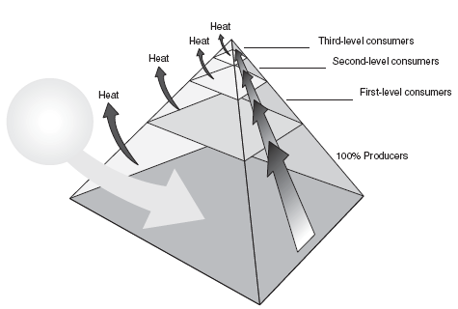
- Complete the energy pyramid by writing the source of the energy for the food web and how much energy is available to first-, second-, and third-level consumers.

- If producers in an energy pyramid produce ten million Calories of energy, how many Calories of energy would be available at the fourth trophic level?

- Why do you think populations decrease at higher levels of the food chain?

- The diagram below shows a woodland food web. The arrows in the diagram illustrate
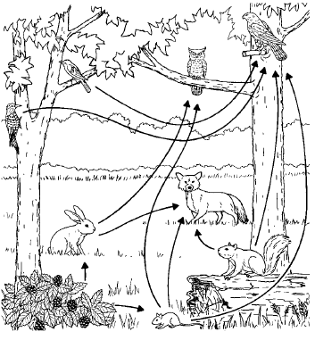
  - The direction the organisms move as they feed and ingest energy
  - The direction photosynthesis takes as it moves through the chain
  - The direction energy flows through the food web
  - The arrows in this web are incorrect, they should be pointing the opposite direction
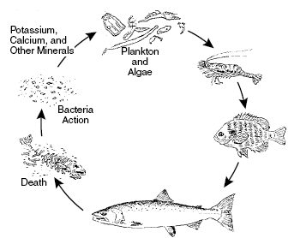

- The bacteria in an ecosystem like the one above are important because
  - all living organisms feed on bacteria or other microorganisms
  - all organisms require nutrients and minerals made available by bacteria or other organisms
  - they control levels of plankton and algae in the Earth’s oceans
  - plankton and algae must ingest bacteria in order to perform photosynthesis

- Ecologists discovered that trout were dying in a stream that ran through some farmland where nitrogen fertilizer was used on the crops. How might you explain what happened?

- ____ The carbon in coal, oil, and natural gas came from
A. the combustion of fossil fuels.
B. the remains of dead organisms.
C. carbon-fixing bacteria in swamp soil.
D. carbon dioxide dissolved in ocean water.
- ___ How does most of the carbon in an organism’s body return to the
environment after the organism dies?
A. Decomposers break the body down into simpler compounds.
B. Heat from the sun causes the carbon in the body to evaporate.
C. Geological processes cause the body to turn into a fossil fuel.
D. Rainwater dissolves the carbon in the body and carries it to the ocean.
- ____ Human processes mainly contribute to the
A. release of carbon dioxide into the atmosphere.
B. decrease of the total amount of carbon found on Earth.
C. depletion of carbon dioxide reserves in the atmosphere.
D. increase in the amount of carbon contained in rock materials.

- Write True if the statement is true. If the statement is false, change the underlined word or words to make the statement true.
a. Nitrogen, in the form of ammonia, nitrate, and nitrite, is found in the soil.
b. Nitrogen fixation is the process in which certain bacteria convert nitrogen gas into nitrates.
c. Denitrification is the process by which some soil bacteria convert nitrates into nitrogen gas.
__ d. All organisms require nitrogen to make amino acids, which in turn are used to build carbohydrates.
e. Phosphorus is the most abundant gas in the atmosphere.

- The organisms in the food pyramid most likely represent
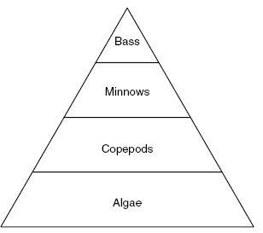
A. an ecosystem B. a community
C. a biome D. an organism
21. Which population of organisms in this energy pyramid is responsible for the initial introduction of energy into the system?

A. Copepods B Algae
C. Minnows D. Bass
- Which population of organisms is most likely to increase if the shrew population increases?
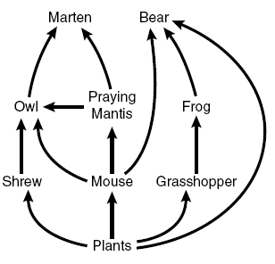
A. plants B praying mantis
C. owl D. mouse
23. The pyramid shows the amount of biomass for the different classifications of how organisms on earth obtain energy. Which level is most likely to contain producers?
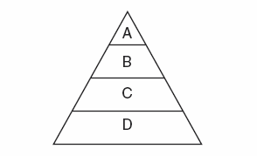
A. A B. B
C. C D. D

- The diagram shows a simplified nitrogen cycle. What part of the cycle would be impacted first by burning fossil fuels?
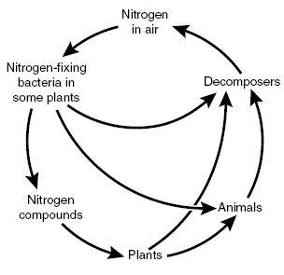
  - Decomposition c. atmospheric nitrogen levels
  - ingestion of nitrogen by animals d. nitrogen fixation by bacteria

- The diagram shows an African food web. An example of two organisms which may compete with one another from the diagram is
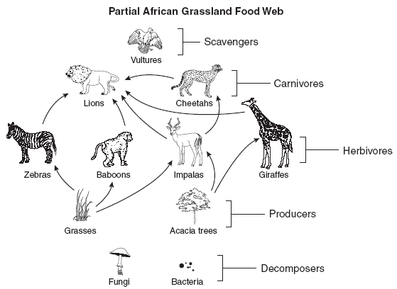

A. The fungi and the grasses B. The acacia trees and the bacteria
C. The giraffes and the vultures D. The cheetahs and the lions

- Some students are studying a chart about Earth’s ecology. What ecology topic are they studying?
? | Description
temperate deciduous forest | dominant plants lose their leaves every autumn
tropical rain forest | has greatest variety of organisms on Earth
taiga | cold, dry, treeless in the far north
tundra | populated by caribou, reindeer, snowy owls, geese

A. ecosystems B. organisms
C. communities D. biomes
- Levels of CO₂ in Earth’s atmosphere are kept relatively constant primarily by

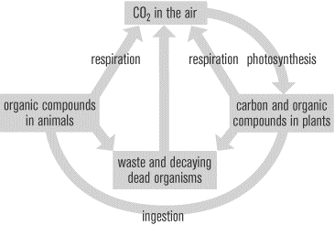

A. respiration and photosynthesis B. ingestion of plants by animals
C. decomposition D. eutrophication

- What would be the first consequence on Earth if the nitrogen cycle were disrupted by removal of soil bacteria?

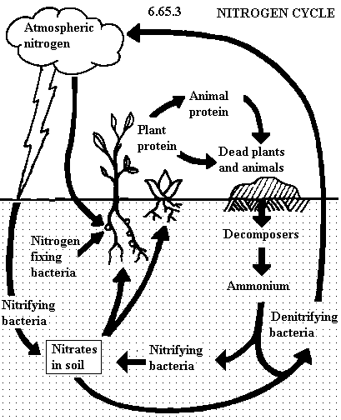
A. Consumers would starve B Global temperatures would rise
C. Producers would die D. Atmospheric nitrogen levels would increase

- What would be the first consequence on Earth if the carbon cycle were disrupted by removal of all heterotrophs?
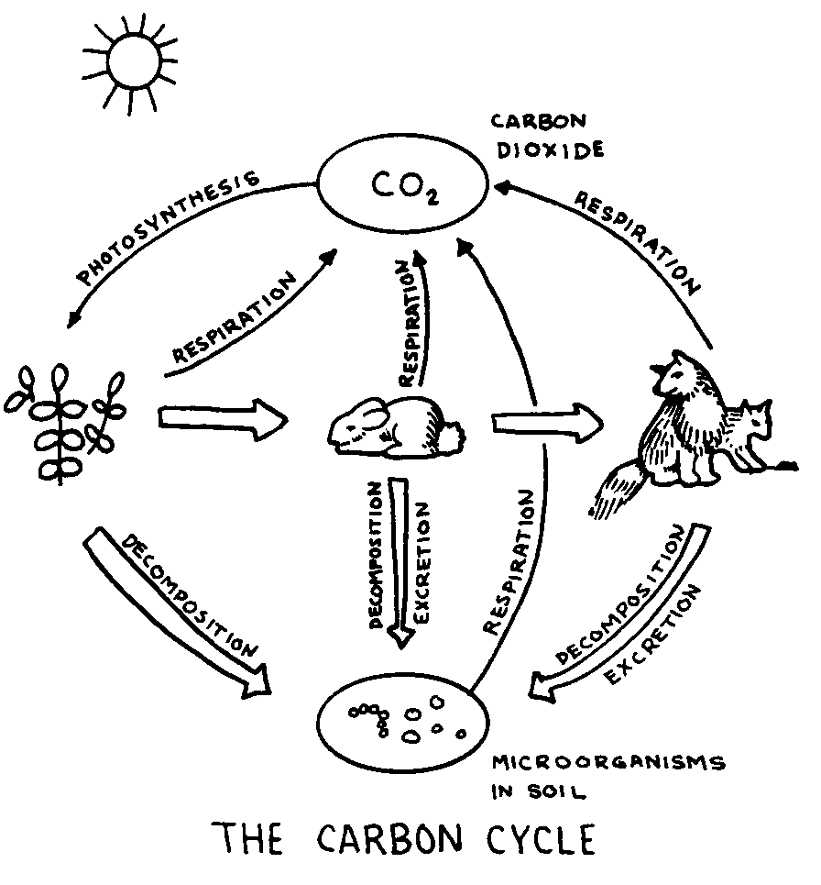

A. increase in atmospheric carbon B decrease in atmospheric carbon
C. increased soil carbon D. decreased soil carbon

- The illustration above shows the levels of organization of a particular ecosystem. Which statement best describes how one level of organization relates to the other levels of organization?
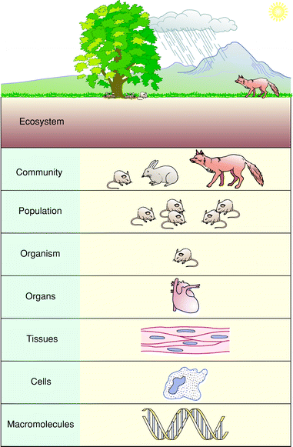
A. There are more individuals in a population than in a community
B. Abiotic factors in the overall ecosystem such as soil and climate determine the makeup of the communities
C. The organisms within a community can breed and reproduce with all of the organisms within a population
D. DNA is the smallest known organism
31. Based on the information in the data table and the diagram where is the nitrogen cycle being most impacted by human sources of nitrogen?

Global Sources of Available (Fixed) Nitrogen)
HUMAN SOURCES | ANNUAL RELEASE OF NITROGEN
Fertilizer | 80
Legumes and other plants | 40
Fossil fuels | 20
Biomass burning | 40
Wetland draining | 10
Land clearing | 20
Total from human sources | 210
NATURAL SOURCES
Soil bacteria, algae, lightning, etc | 140
Adapted from Source: Peter M. Vitousek et al., “Human Alteration of the Global Nitrogen Cycle: Causes and Consequences,” Issues in Ecology, No. 1 (1997), pp. 4-6.

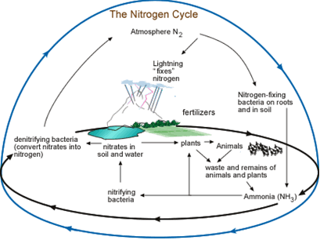

  - growth of producers c. action of decomposers
  - levels of atmospheric nitrogen d. nitrogen fixation by bacteria

- Compare and contrast the flow of energy through an environment with the flow of matter through that same environment.
- Explain why fungi and other decomposers play a vital role in biogeochemical cycles.

- How do humans add nitrogen to the biosphere?

- What would happen if the bacteria that cause denitrification were removed from the nitrogen cycle?

- What is the importance of nitrogen fixation?

- How are bacteria important to the nitrogen cycle?

- Complete the chart about the carbon cycle.
Processes That Cause Carbon to Move into the Atmosphere |  | Processes That Cause Carbon to Move out of the Atmosphere
Process | Description | Process | Description
Respiration |  | Photosynthesis
 | the release of CO₂ and other gases into the atmosphere through vents in Earth's crust

- Examine the picture below and answer the following questions:
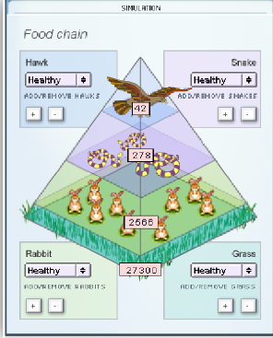
- Predict what would happen to the grass, snakes, and hawks if the rabbit population doubled initially.

- Predict what would happen to the grass, snakes, and hawks if the rabbit population doubled over time.

- Predict how the changes below will affect the other animals. Write wither “increase” or “decrease” in the table.
Change | Grass | Prairie dogs | Ferrets | Foxes
Add prairie dogs

Add ferrets

Add foxes

- Predict what would happen to the prey population if a predator is removed.

- In North America, many top predators, such as wolves, have been driven nearly to extinction. What effect do you think this has on their main prey, deer?

- Examine the picture below and answer the following questions.
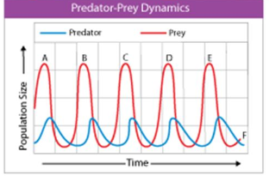

  - Suppose a bacterial infection kills off most of the prey at point B on the graph. How would this affect the predator and prey growth curves at point C? Point B?

  - Suppose a viral infection kills all the prey at point D on the graph. What effect would this have on the predator and prey growth curves at point E? What will happen in future years to the predator population? How could ecologists ensure the continued survival of the predators in this ecosystem?

- Examine the picture below and answer the following questions
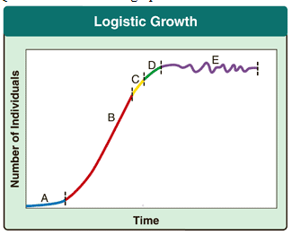
  - Which time interval(s) in the graph shows exponential growth?
    - D and E iii. C and D
    - A and B iv. E only
  - Which time interval(s) in the graph depicts the effects of limiting factors on the population?
    - A only iii. C, D, and E
    - A and B iv. C and D

- What factors might cause the carrying capacity of a population to change?

- Give three examples of density-independent factors that could severely limit the growth of a population of bats living in a cave.

- Why would a contagious virus that causes a fatal disease be considered a density-dependent limiting factor?

- Would a density-independent limiting factor have more of an effect on population size in a large ecosystem or in a small ecosystem? Explain.

- What shape population growth curve would you expect to see in a small town made up mainly of senior citizens? Compare this growth curve to that of a small town made up of newly married couples in their twenties. Explain.

- Explain why secondary succession usually proceeds faster than primary succession.

- A poisonous pesticide was introduced into the water of an ecosystem. The illustration above shows the levels of this pesticide poison in the bodies of different organisms that live in the ecosystem. The illustration also represents a food chain as shown by the arrows. The grebes have a higher level of pesticide in their bodies than other organisms because
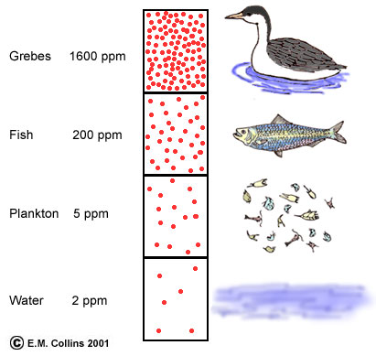
ppm = parts per million
- it has a larger body mass than other organisms
B. the poison is concentrated as it moves through the food chain
C. grebes drink more water than other organisms
D. Grebes do not have a special adaptation to remove toxins from their bodies
54. A new species is introduced into an area. This can have harmful effects on species already inhabiting the area. The harmful effects are most likely a result of
A. succession B. mutualism
C. competition D. commensalism
55. The desert climate is caused by geographic conditions such as location, high atmospheric pressure, and proximity of mountain ranges. Average desert rainfall amounts are usually less than 50 cm per year. Soil in deserts is coarse, sandy, and rocky. Desert plants and animals have specialized characteristics that help them survive in the harsh environment. An example is the Saguaro cactus. The Saguaro has a shallow root system with a main taproot and other roots that radiate out and collect surface water. The trunk of the Saguaro has the ability to expand while storing water. The sweet-nectar flowers of the Saguaro attract white-winged doves, bats, and other animals. These animals feed on the nectar. They are necessary for cross-pollination. Cross-pollination occurs when the pollen of a flower is carried to a flower on another plant. The illustration below shows the Saguaro cactus.
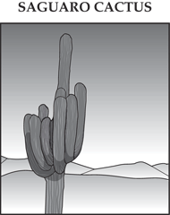
Which of these best describes the ecological relationship between white-winged doves and the Saguaro cactus? (Maryland released item)
A. mutualism B. competition
C. parasite–host D. predator–prey

56. Aphids are insects that feed on fluids from the stems of plants. After the aphids ingest the plant fluids, they excrete a liquid called honeydew.
Some species of ants protect aphids from predators. The ants benefit by feeding on the honeydew produced by the aphids. Which of these terms best describes the relationship between the aphids and the ants? (Maryland released item)
A. mutualism B. parasite–host
C. predator–prey D. commensalism

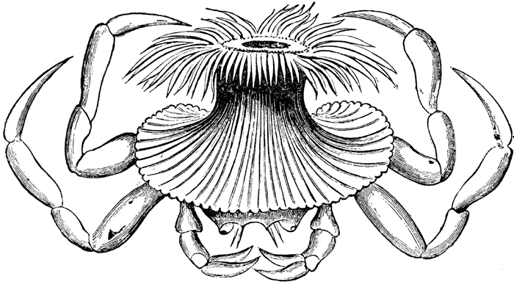
57. Some crabs pick up an animal that looks like a feathery flower and attach it to their shell. This animal, known as an anemone, helps camouflage the crab. The anemone feeds on bits of food the crab drops as it eats. This relationship can best be described as
A. mutualism B. parasite–host
C. predator–prey D. commensalism

